**ASSIGNMENT 1**

**Problem Statement:** Create an account in AWS and configure a budget.

**Create an account in AWS**

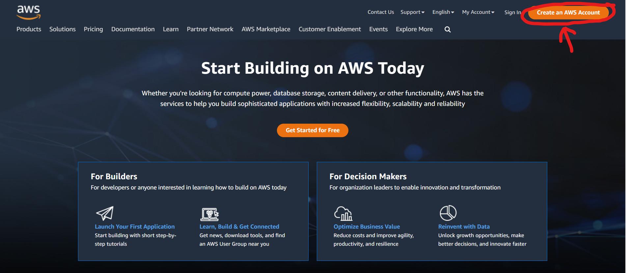

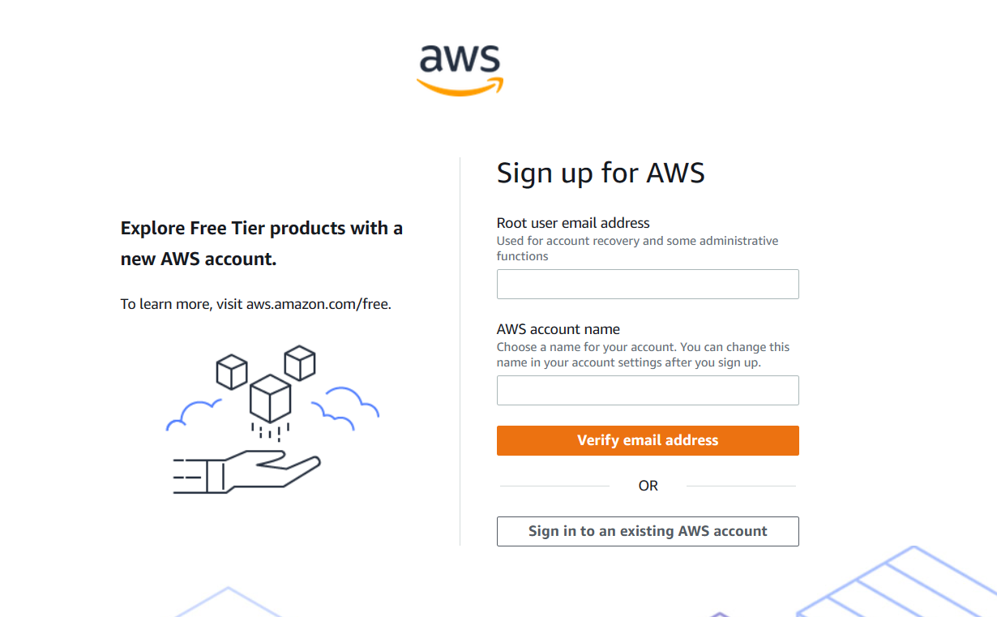

1. Open the [Amazon Web Services home page](https://aws.amazon.com/).

2. Choose **Create an AWS account**. Make sure to create the account as a **root user** to unlock full functionality of the newly created AWS account.

3.Enter your account information, and then choose **Continue**. Be sure that you enter your account information correctly, especially your email address.

4.Choose **personal** account.

5. Enter your personal information.

6. Read and accept the **AWS Customer Agreement**.

7. Choose Create Account and Continue.

8. On the Payment Information page, enter the information about your **payment method**, and then choose **Verify and Add**. You can't proceed with the sign-up process until you add a valid payment method.

9. Next, you must **verify** your **phone number**. Choose your country or region code from the list, and enter a phone number where you can be reached in the next few minutes.

10. Enter the code displayed in the CAPTCHA, and then submit.

11. When the automated system contacts you, enter the PIN you receive and then choose Continue.

12. On the **Select a Support Plan** page, **choose the free tier**.

13. Finally, wait for your new account to be **activated**. This usually takes a few minutes but can take up to **24 hours**.

14. When your account is **fully activated**, you receive a **confirmation email message**. Check your email and spam folder for the confirmation message. **After you receive this email message, you have full access to all AWS services**.

**Configure a Budget**

1. Sign in to the console using your credentials for your newly created account.

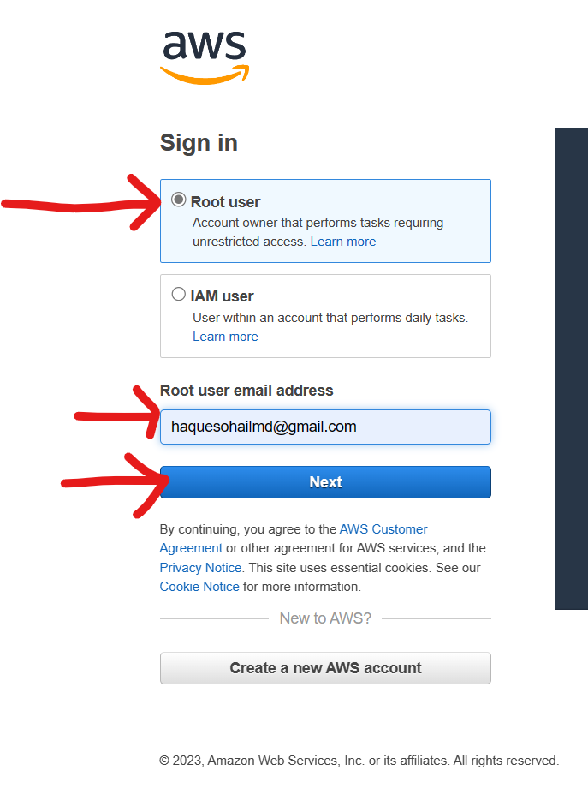

1. Now after successfully signing in we will arrive at the home page. Then click on down arrow beside your account name on the top right corner of the home page.

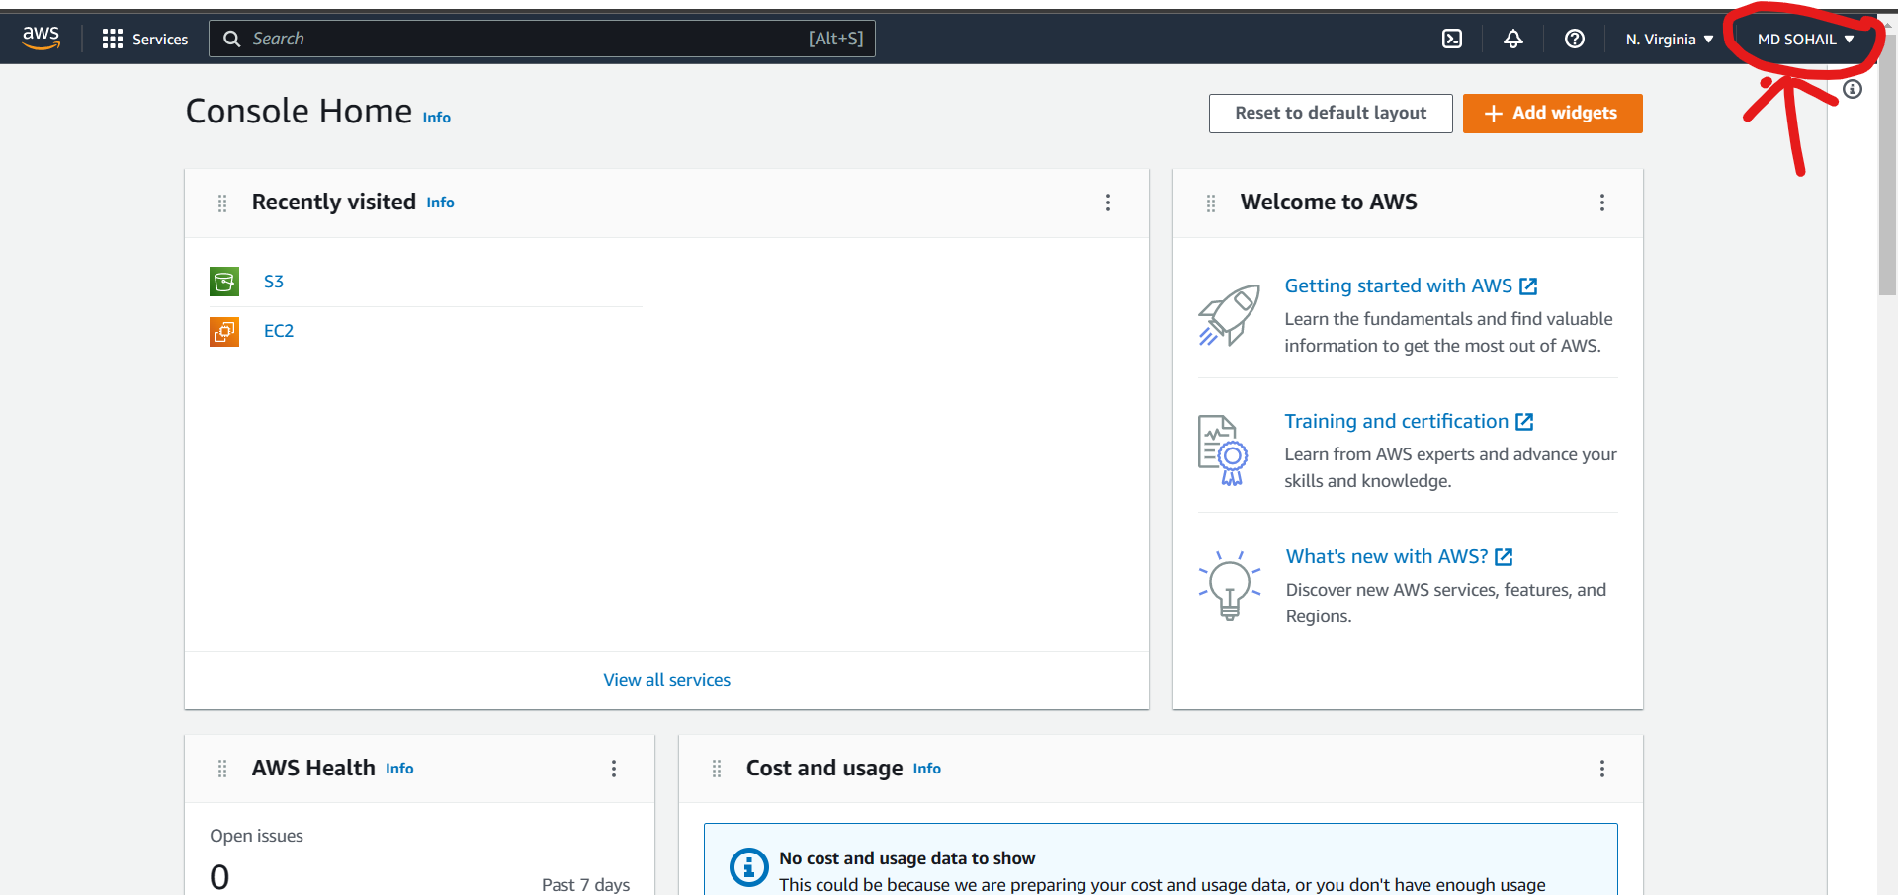

1. A drop down will appear and select **Billing** **Dashboard** from the list.

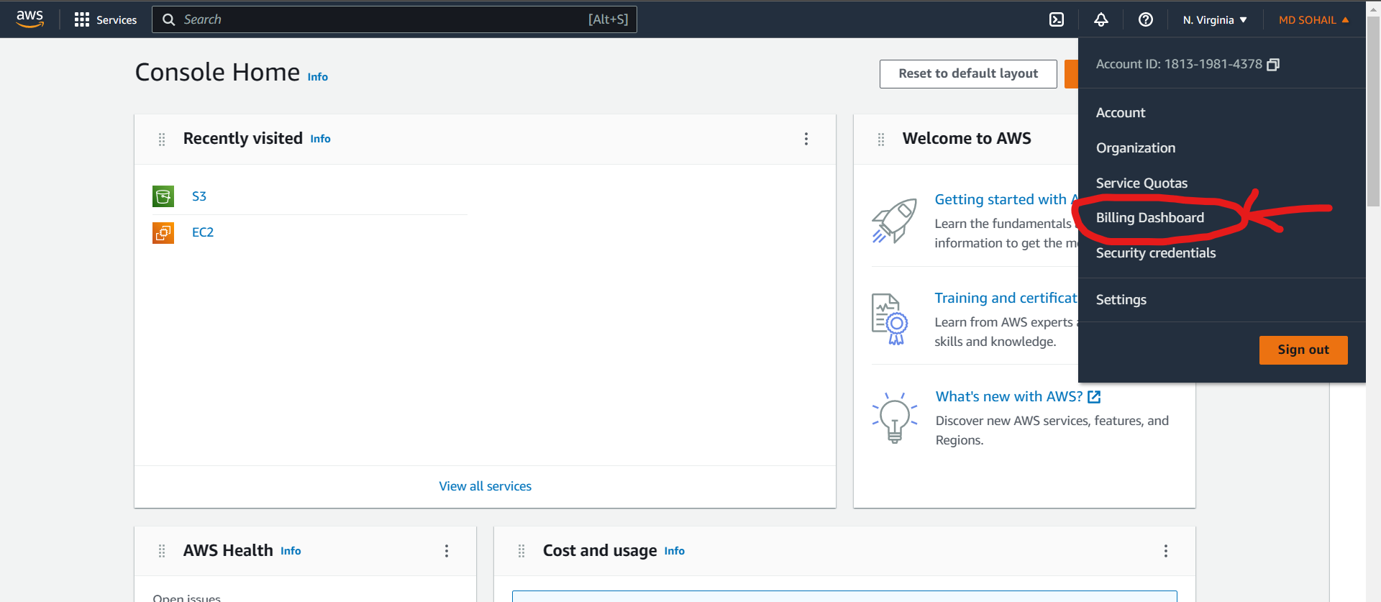

1. After arriving in Billing Dashboard, go to the **Budgets** section on the left side panel under cost management. Click on the **Create Budget** button in the **overview page** to start creating a new budget for your AWS account.

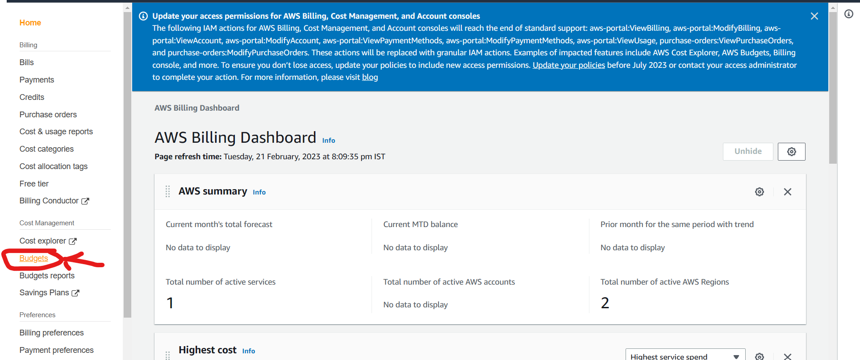

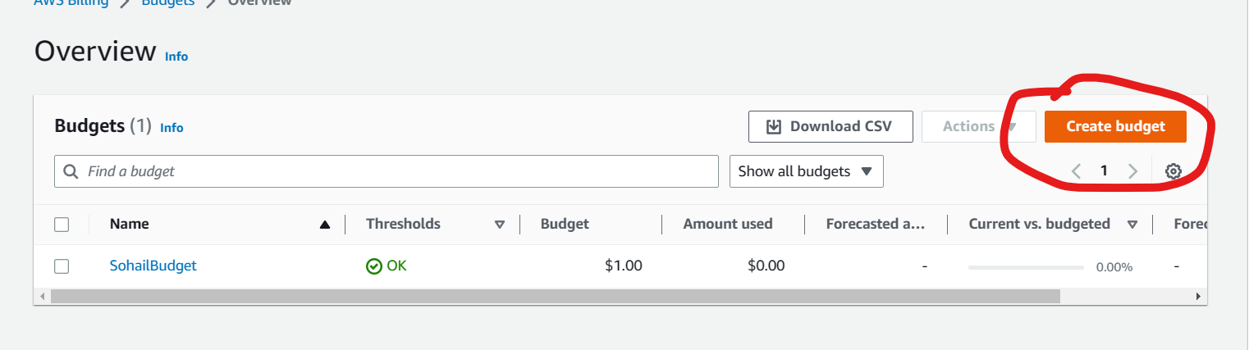

1. Select **Customize** in Budget Setup section and **Cost Budget** in the Budget Types section. Then click on **Next.**

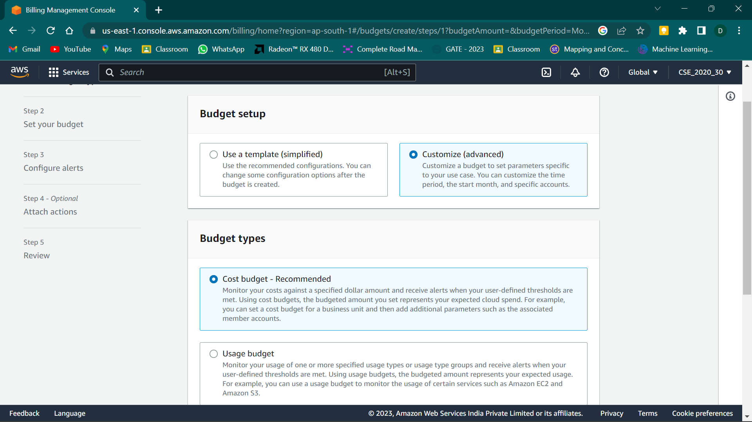

1. Enter **Budget Name.** Then set your **Budget Period**, preferably **Monthly** and set **Renewal Type** to **Recurring.**
2. Scroll down and Enter your Budgeted amount. For best free usage enter 1 in the box. (All amounts are automatically considered in dollars “$”)

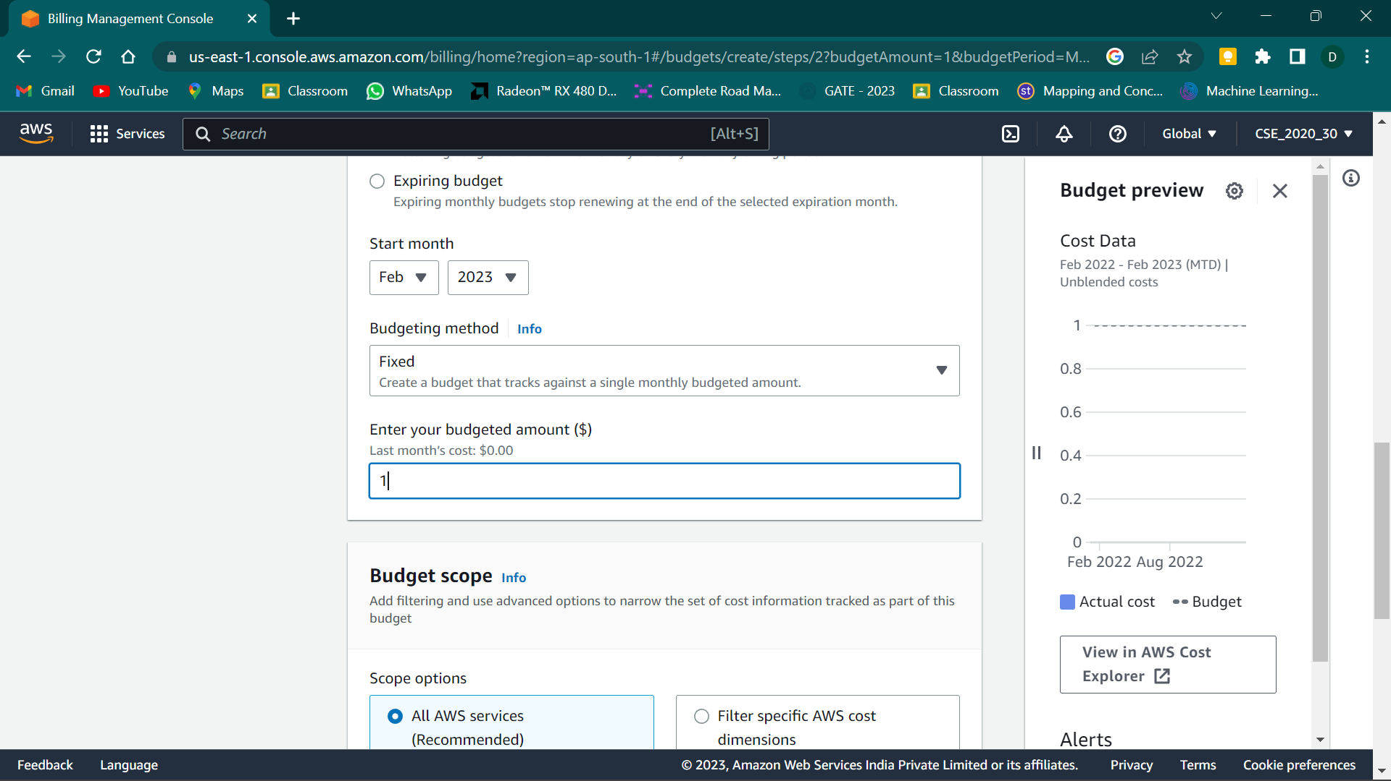

1. No need to change any other options in the page. So, now we click on **Next**.
2. Next, we move on to Configure Alerts. This is required to let AWS know when to show us a warning when we reach a certain limit or threshold of our budgeted amount in our stipulated time period. Here, we select **Add an Alert Threshold** button.

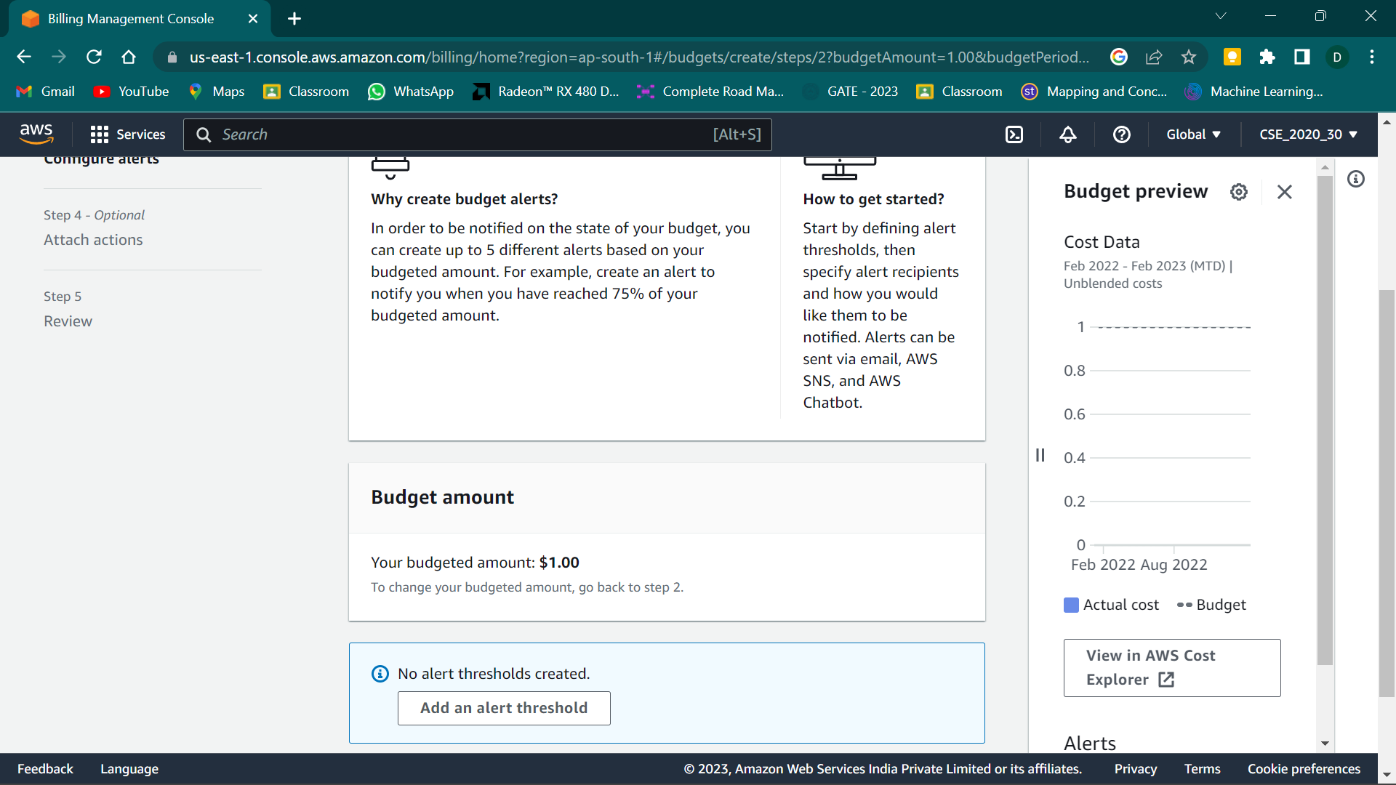

1. Now set Alert #1. Give a suitable threshold value in percentage of the actual budgeted amount. If that threshold is reached an alert will be send by AWS. Also, mention the email address(/es) where AWS should send you the alerts.

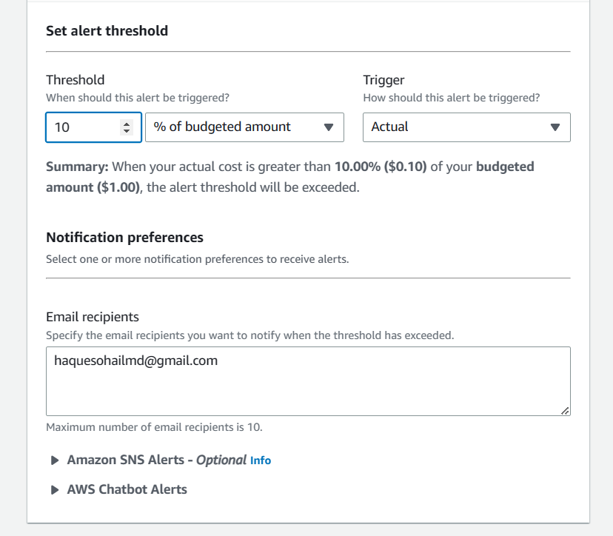

1. Click on Next.
2. Again, click on Next after reviewing yours alert summary.
3. Now, we are finally at the review or summary page of the whole budget. Click on **Create Budget** button to finally create your Budget!
4. After this step you will be redirected to the **overview page** where all your budgets will be shown. You can see your newly created budget in the table format with various information related to it. Our Budget creation is complete!

