ASSIGNMENT 10

***Problem Statement: Deploy a project from GitHub to EC2 by creating a new security group and user data.***

1. Sign in to your Github account.

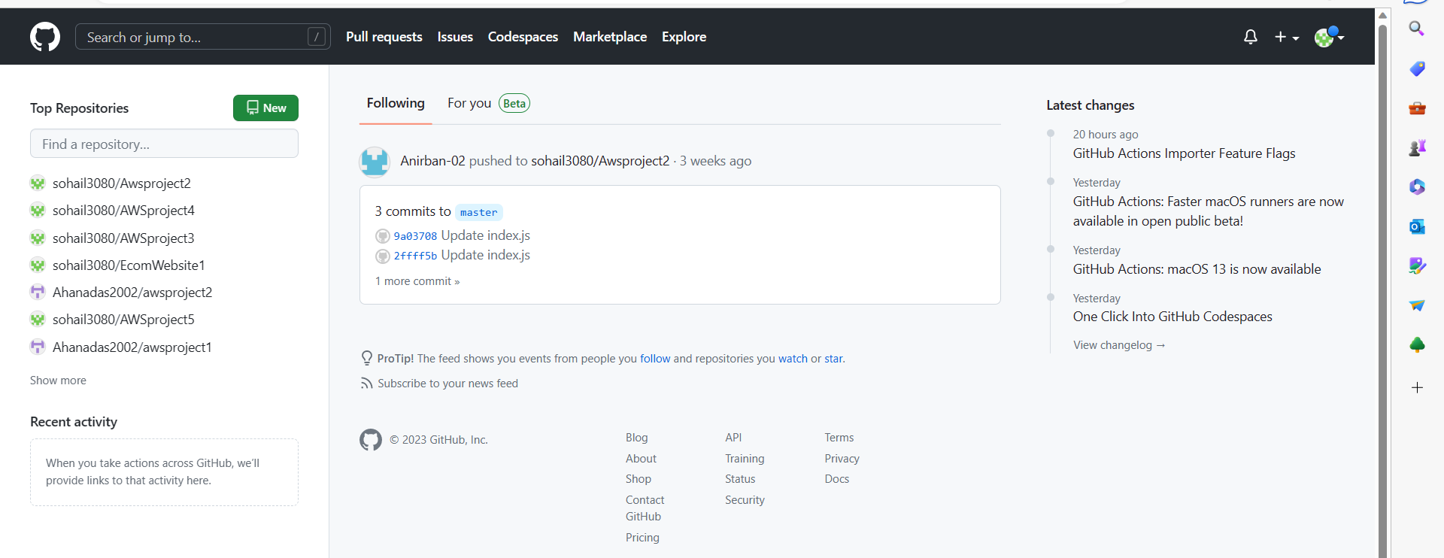

1. Open the Repository which you want to use and make sure it is public.

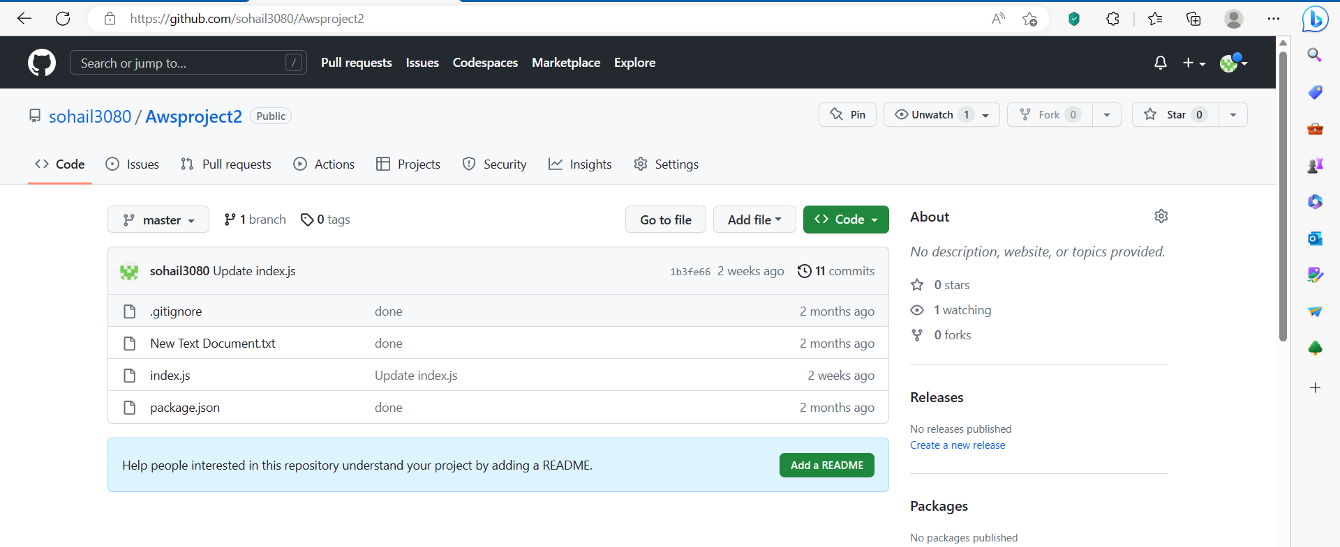

1. If the repository is not public, then go to Settings.





Next, scroll to the bottom in the Danger Zone. Click on Change visibility -> Change to Public ->I want to make this repository Public->I have read and understand these effects-> Make this repository public. At last, give the Password. [My repository is already public so I have not followed these steps]

1. **Sign in** to your AWS account.

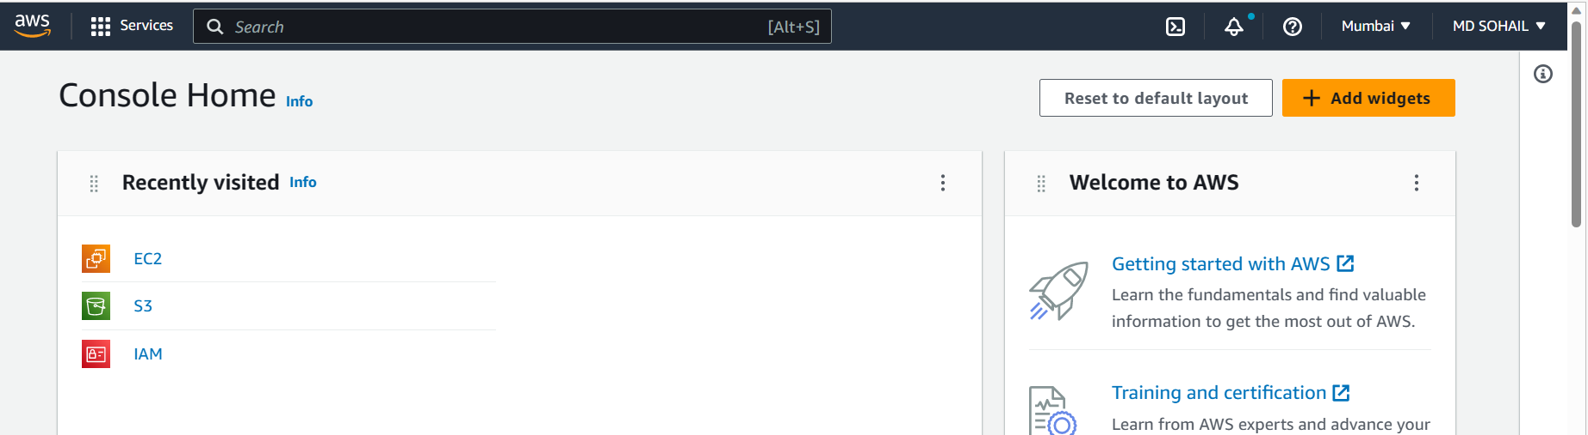

1. Go to EC2 Dashboard and Click Security Groups there.

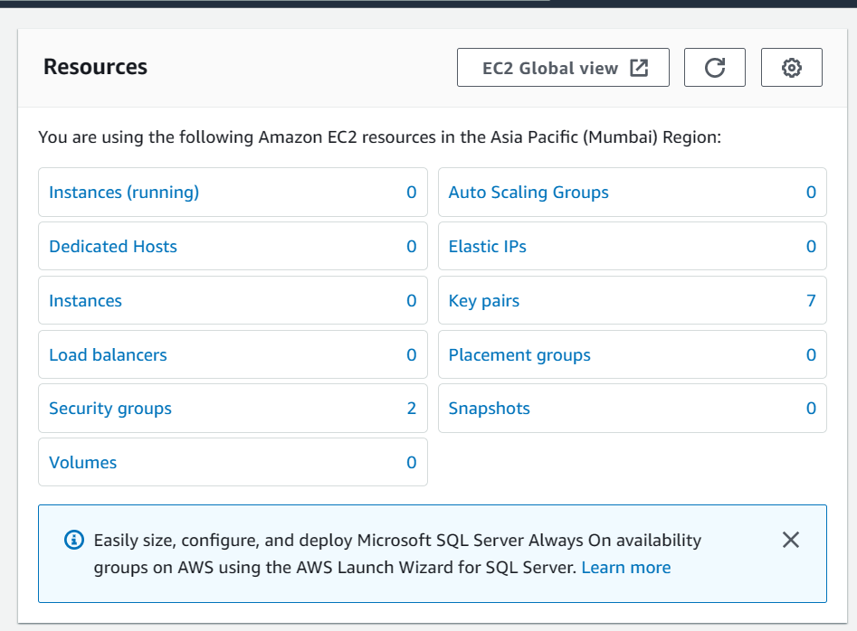

1. Delete all the Security Groups except the default. If you have already created one, then you can keep that one and create a new one. [*But here we are deleting the previously created one also*]

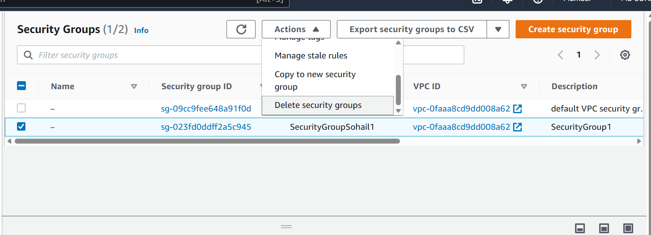



1. Now, Select **Create security group**.

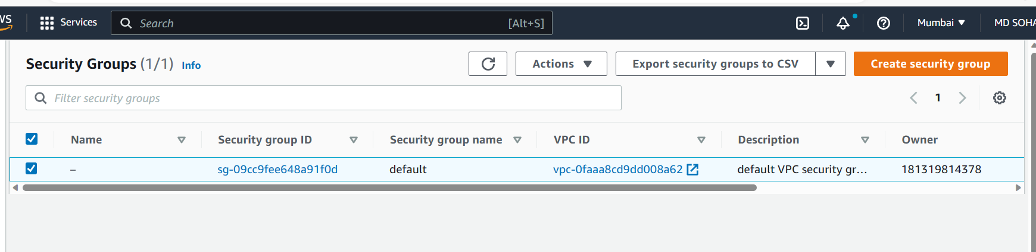

1. Now, Enter the Security group name.

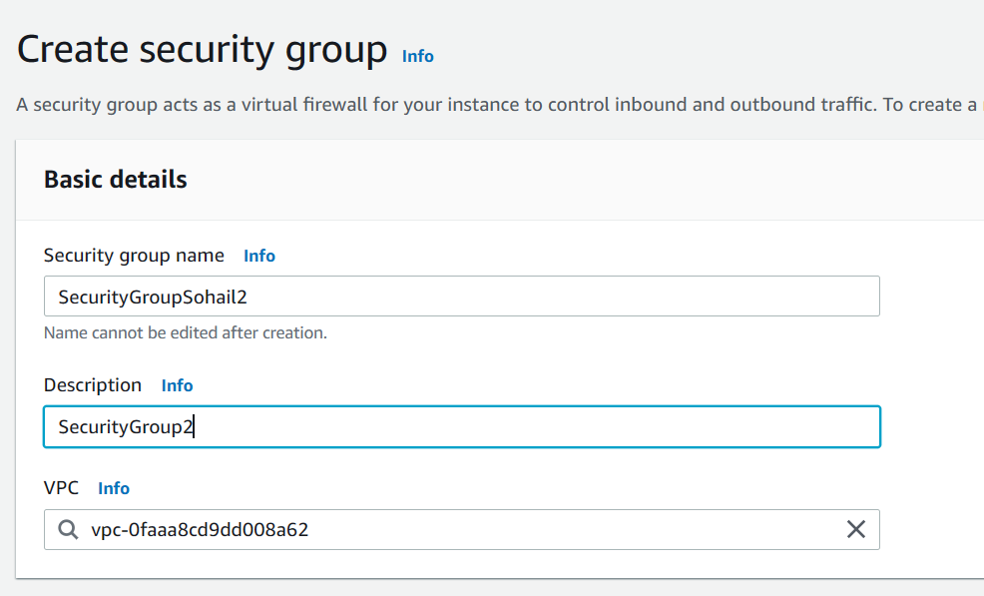

1. Go to ***Inbound Rules.*** Click on ***Add rule*** to create them.



1. Create the following.

i)Custom TCP with Port range 4000. Give Source 0.0.0.0/0.

ii)SSH with default Port range 22 and Source 0.0.0.0/0.

iii)HTTP with default Port range 80 and Source 0.0.0.0/0.

iv)HTTPS with default Port range 443 and Source 0.0.0.0/0.

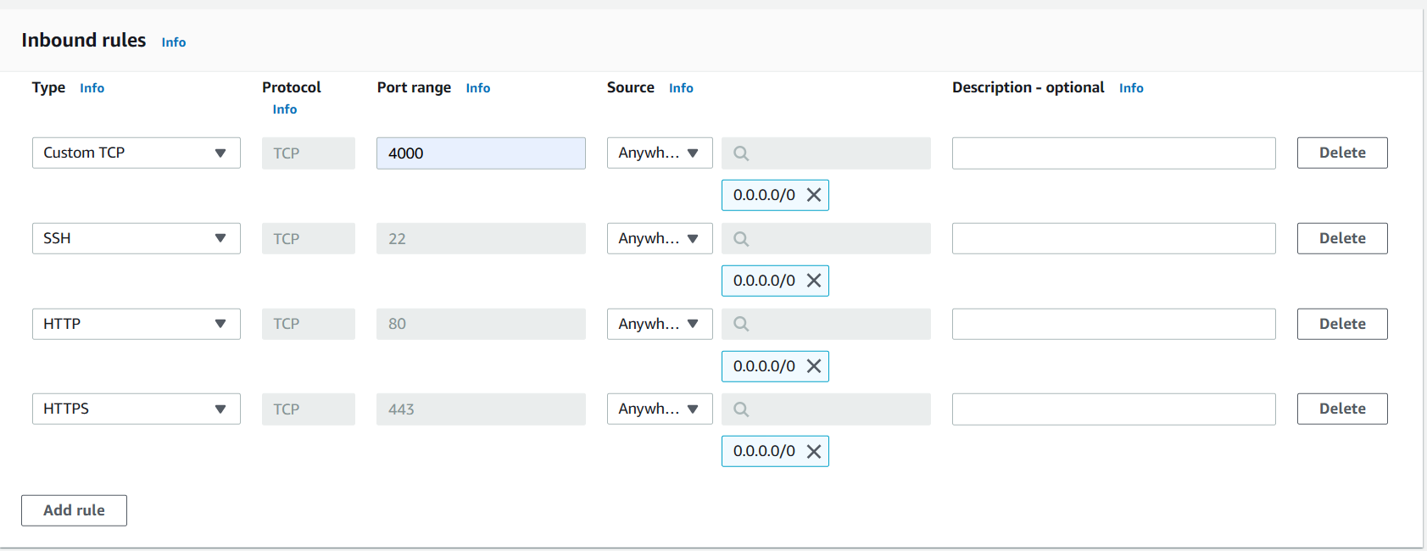

Go to the bottom and click on **Create Security Group**.

1. The Security Group was successfully created.



1. Now, Go to Instances and Click on **Launch instances**.

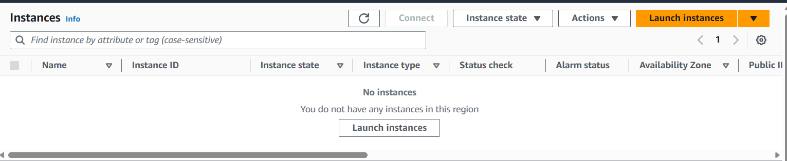

1. Give a name to the new Insance.

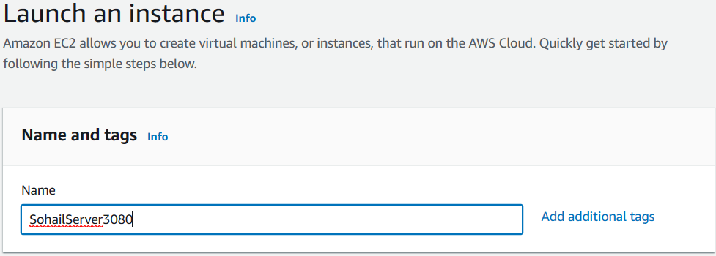

1. Select Ubuntu as the Operating System of the EC2 server.

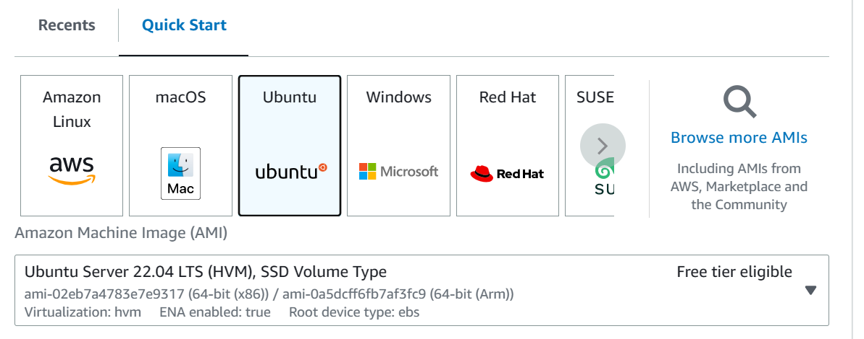

1. Select instance type as t2.micro if not already in default.

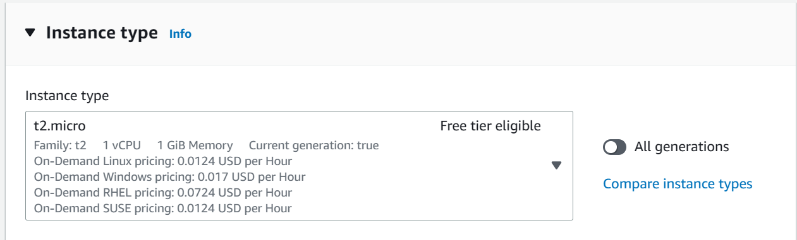

1. Select a key pair you have previously created and if not, create a new pair.

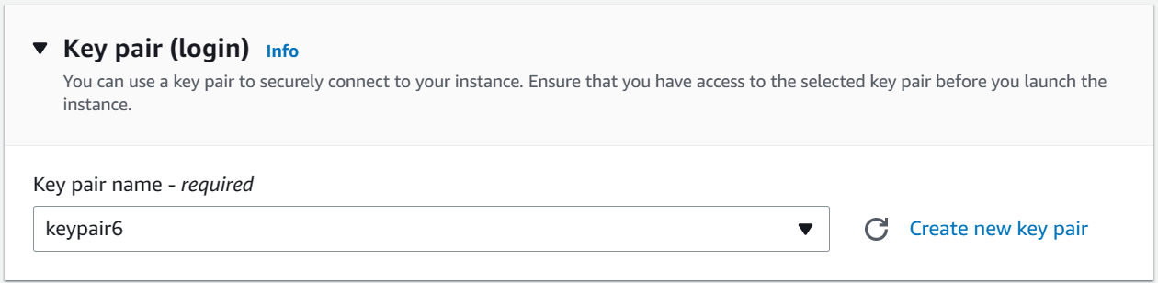

1. In Network settings field, Click on **Select existing security group** and select the security Group you previously created (SohailGroupSohail2).

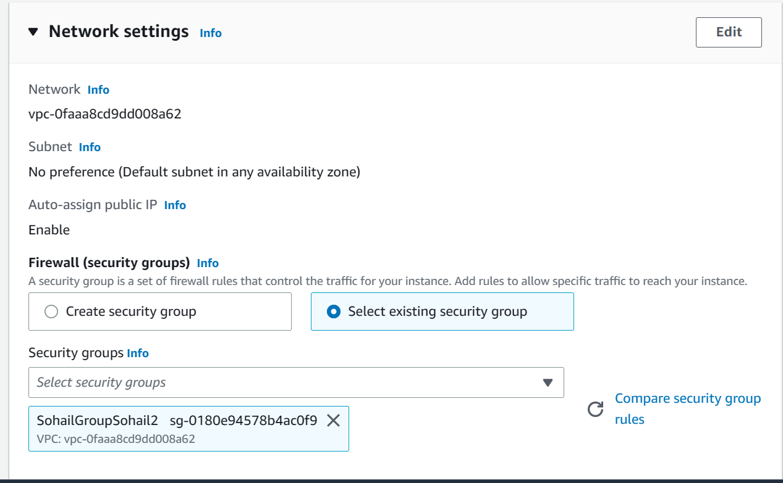

1. Go to the **Advance details** field and scroll down to its last until you see the **User data** field.



1. Within the User data field, enter the following codes.

#!/bin/bash

apt-get update

apt-get install -y nginx

systemctl start nginx

systemctl enable nginx

apt-get install -y git

curl -sL https://deb.nodesource.com/setup_18.x | sudo -E bash -

apt-get install -y nodejs

cd /home/ubuntu

git clone <https://github.com/sohail3080/Awsproject2.git>

cd Awsproject2

npm install

node index.js

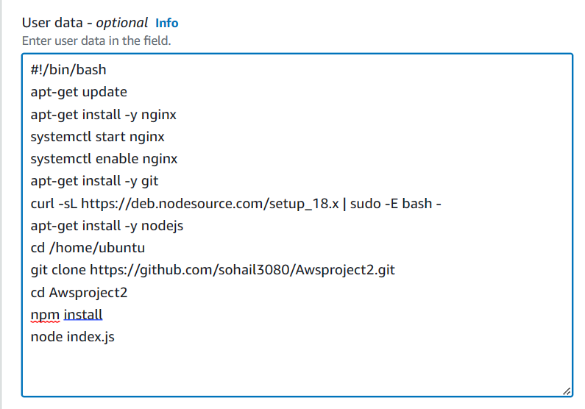

The link after git clone is the HTTPS link of the Github repository.

1. Now, Click on ***Launch instance.***

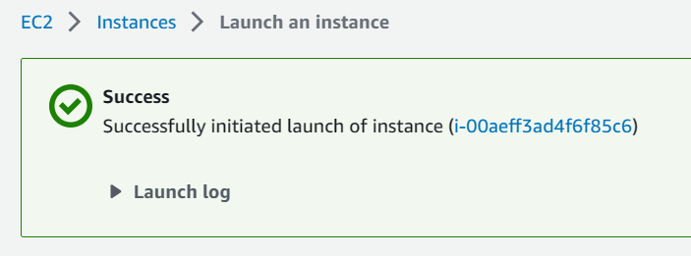

1. Click on the Running Instance.

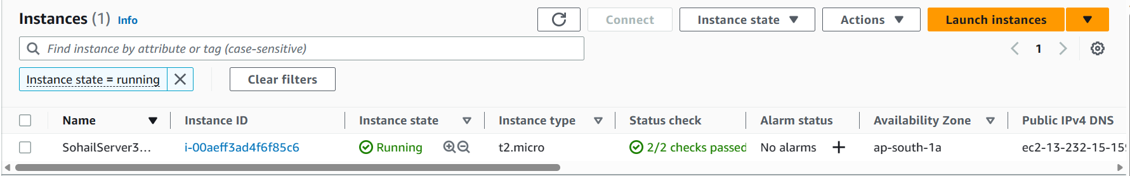

1. Copy the IPv4 address.

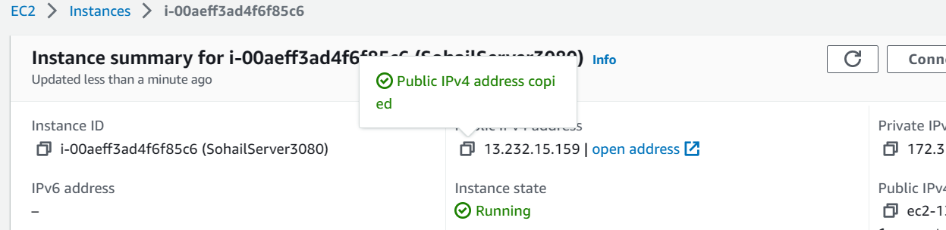

1. Paste the copied IPv4 address to the URL of the browser.[It might take some time.]

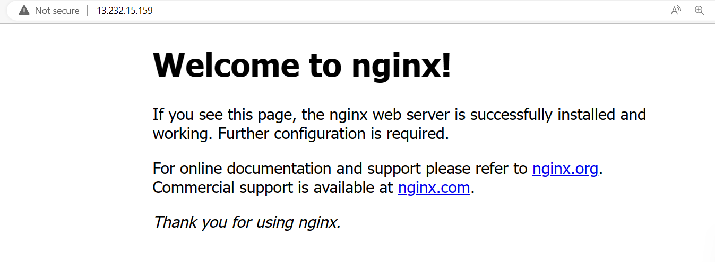

1. Add the Port number to the URL. Here, we have taken 4000 as port number. [It might take some time.]



Hence, the Project was successfully deployed.