ASSIGNMENT 12

**Problem Statement: Deploy and run project in AWS without using port.**

1. Sign in to your AWS account.

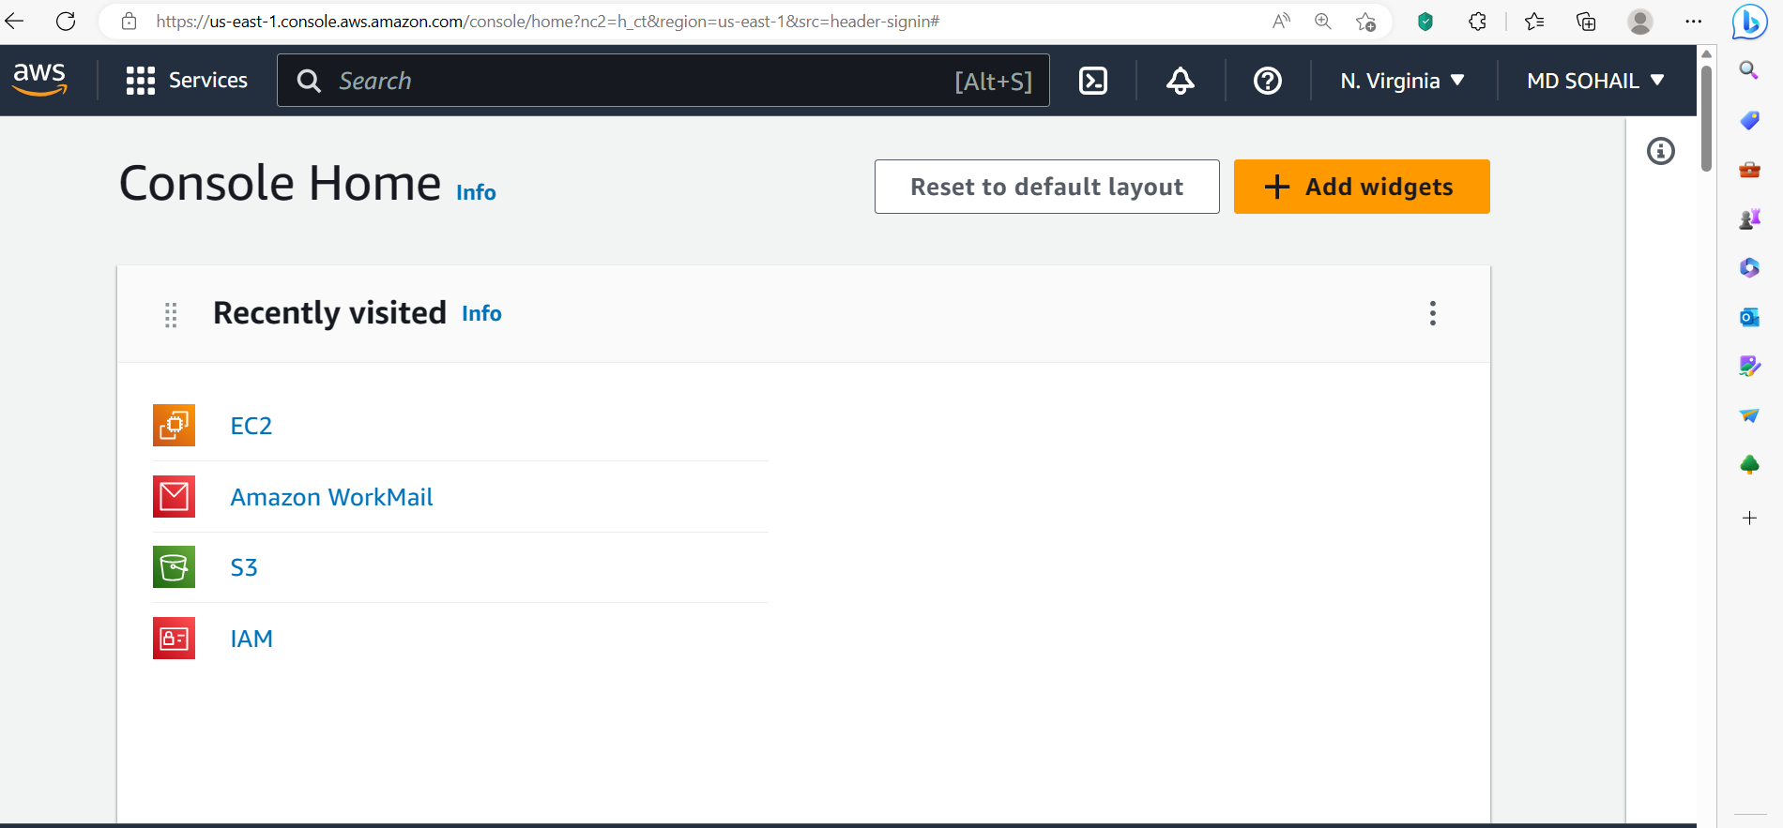

1. Go to EC2 and Click on Launch instance.

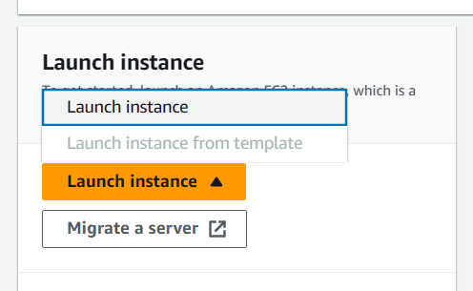

1. Enter a name for the instance.

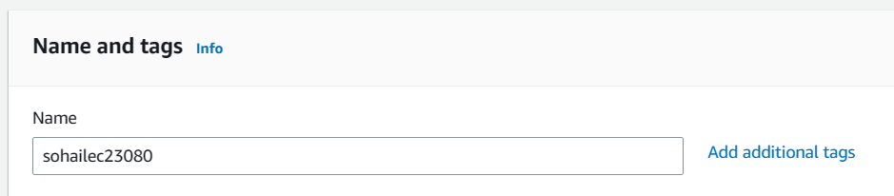

1. Select an OS for your server. [Here we have selected Ubuntu]

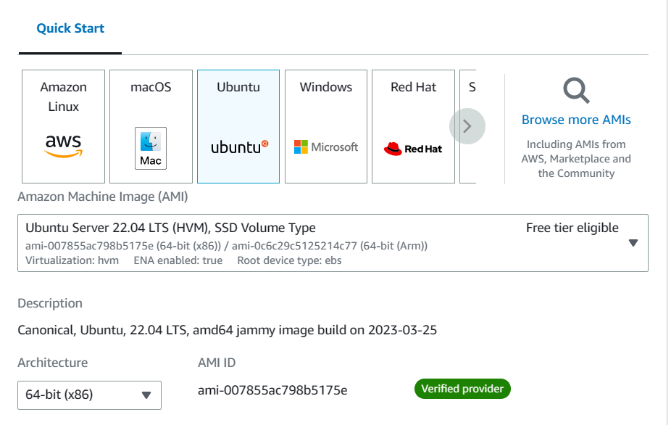

1. Select the instance type as t2.micro

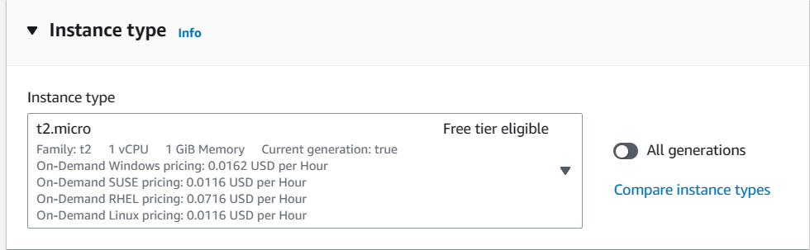

1. Select a key pair if you already have created one otherwise create a new key pair.

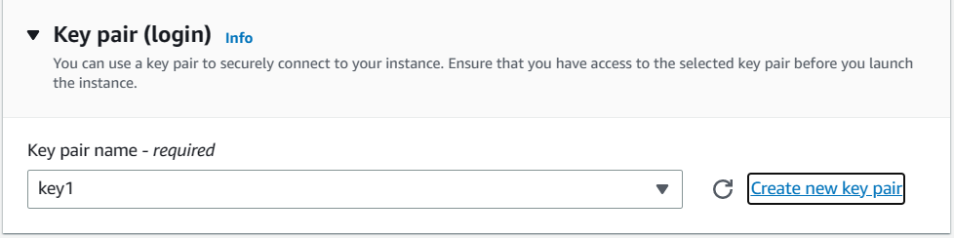

1. In the Network settings, select the existing security group.

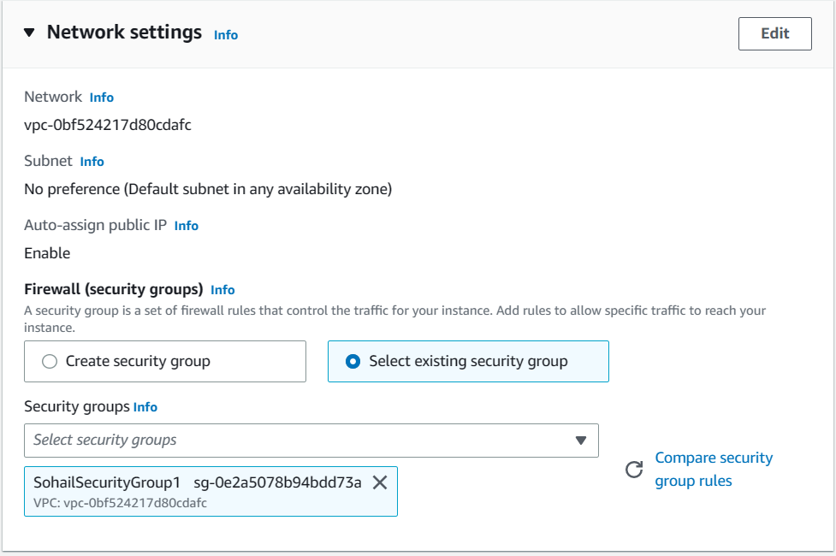

1. In Advanced Details, Enter the following commands in *User data* section-

#!/bin/bash

apt-get update

apt-get install -y nginx

systemctl start nginx

systemctl enable nginx

apt-get install -y git

curl -sL https://deb.nodesource.com/setup_18.x | sudo -E bash -

apt-get install -y nodejs

git clone Repo link

cd Repo name

npm install

node index.js

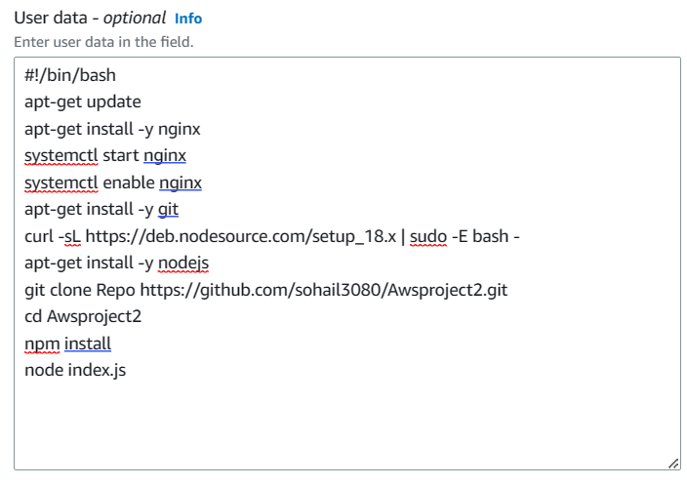

1. Now Click on Launch instance

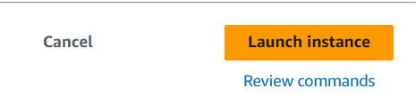

1. As we can see, we have started nginx server and deployed the project successfully.

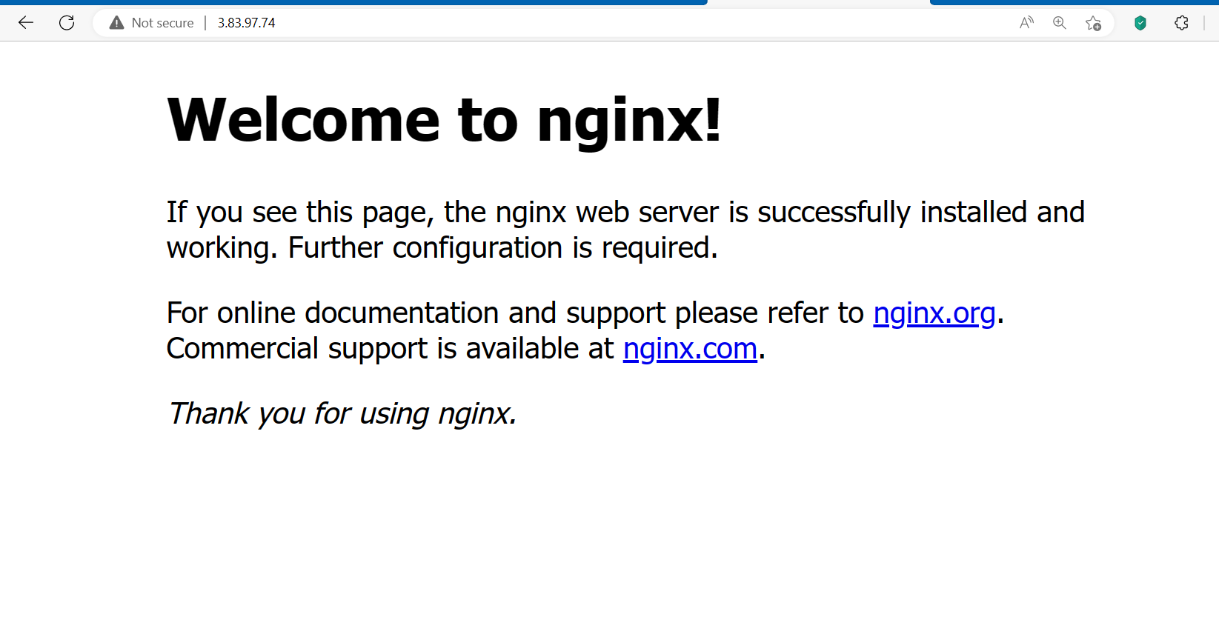

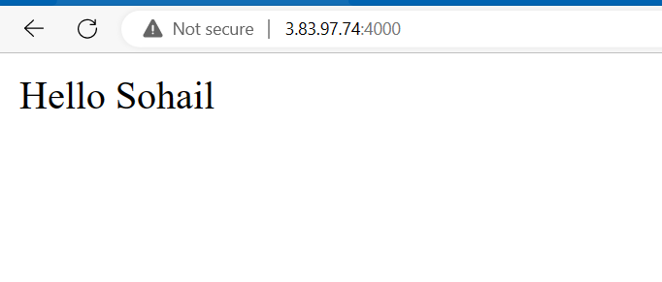

1. Now, Connect the instance using Bitvise SSH Client.

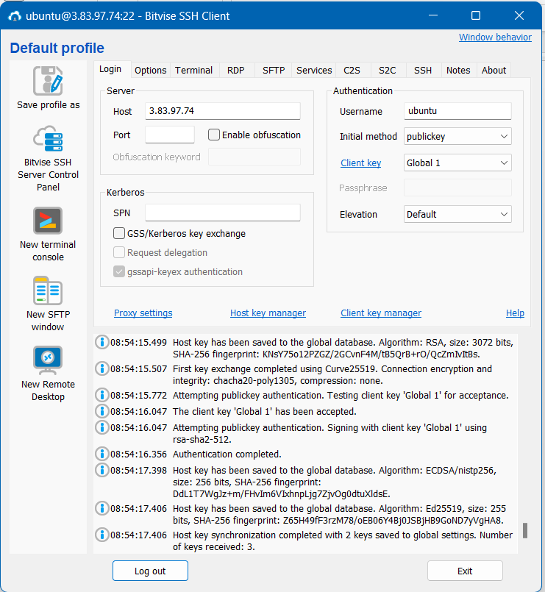

1. In New terminal console,
2. Enter the following commands-

* pwd [*to check the present working directory]*
* cd / *[to go to the root directory]*
* cd /etc/nginx/sites-available/

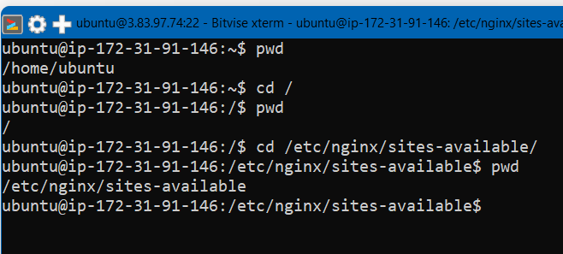

* sudo nano default



1. Now a PHP default code will open.

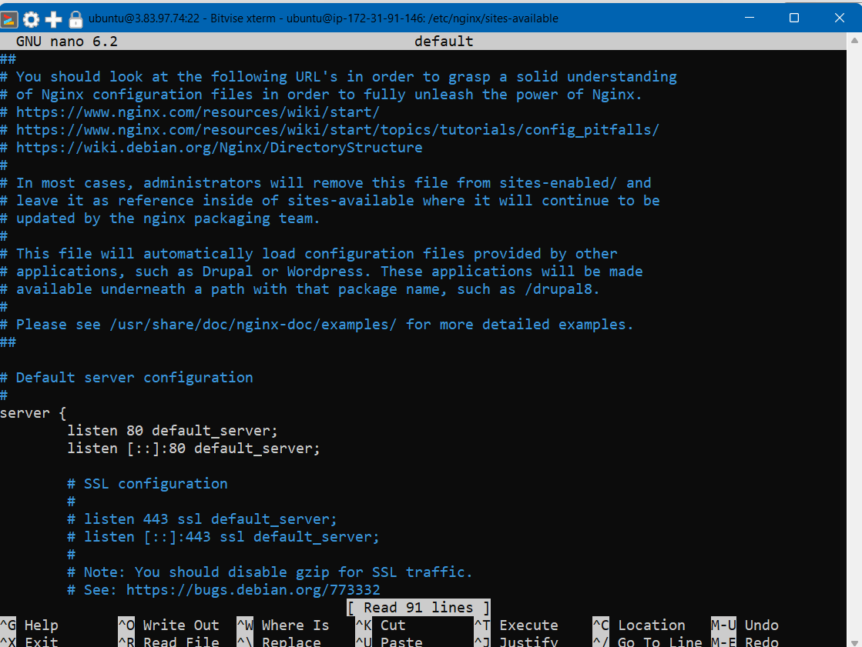

1. Go down until you see the “location” part of the code. Comment the three lines of that as shown in the image below.

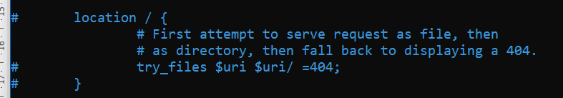

1. Then paste the location code (given below) under the hashed location part.

location / {

proxy_pass http://localhost:4000;

proxy_http_version 1.1;

proxy_set_header Upgrade $http_upgrade;

proxy_set_header Connection 'Upgrade';

proxy_set_header Host $host;

proxy_cache_bypass $http_upgrade;

}

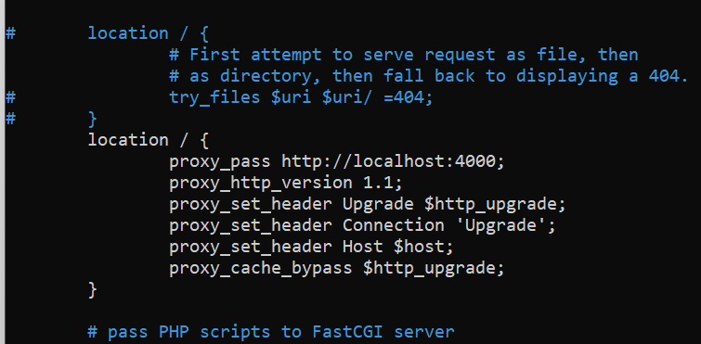

1. Next, Press “***Ctrl+X 🡪 Y 🡪Enter***” respectively to exit and save your changes.

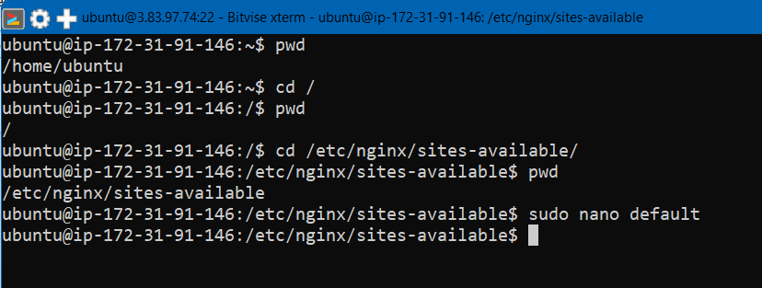

1. Next, Enter the following command:

sudo systemctl restart nginx



1. Now run the Public IPv4 Address in a web browser without using the port number.

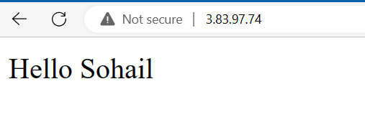

Hence, we have successfully deployed the project without using Port number.