ASSIGNMENT 13

**Problem Statement: Create a Workmail for your organisation.**

1. Sign in to your AWS account.

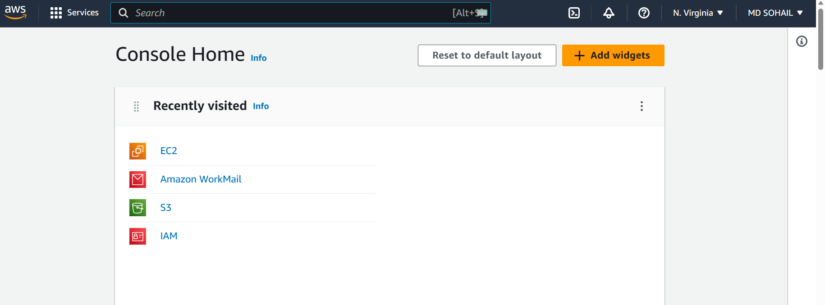

1. Go to Amazon WorkMail [ You can search it in the Search bar or you can open it from the Recent Visits if it is there]. Next, Click on **Create organisation.**

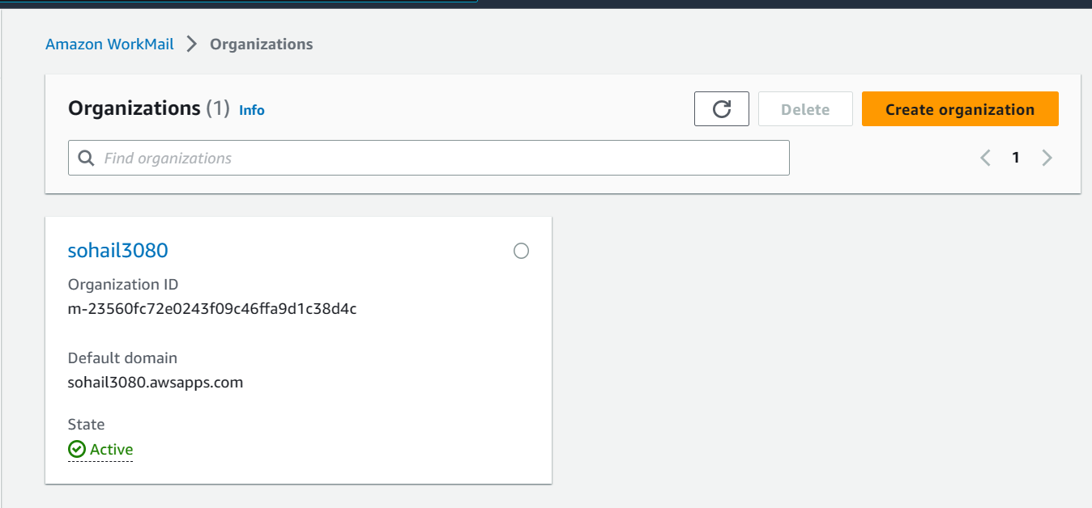

1. Then in the Organization settings select Email domain as ‘Free test domain’ and give any name to the Alias. Then click on ‘Create organization’.

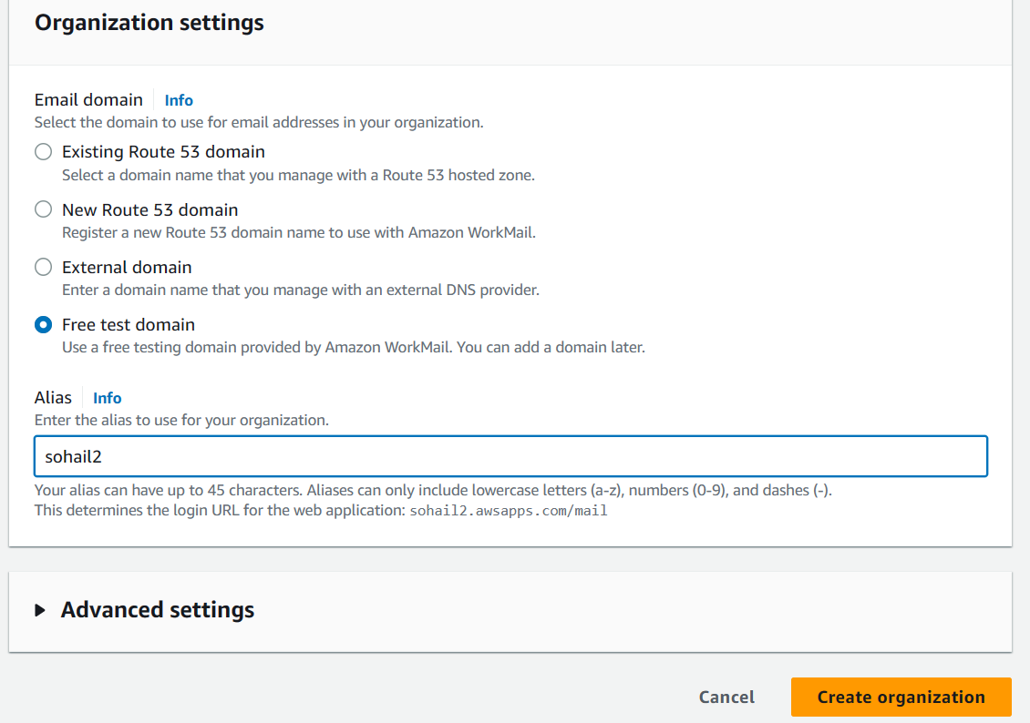

1. Now your organization is created. Then, open your organization by clicking on it.

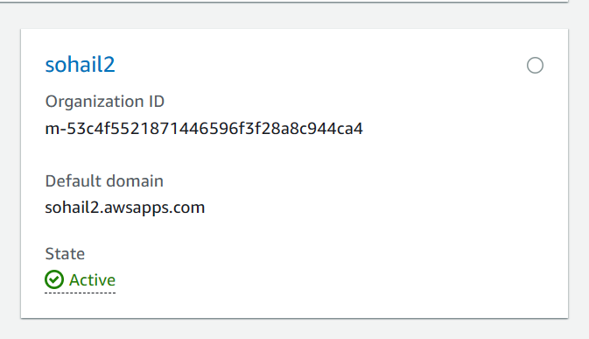

1. Then a window will be opened (shown in the first image below). On the left-hand side you can see a ‘Users’ option. Open it.

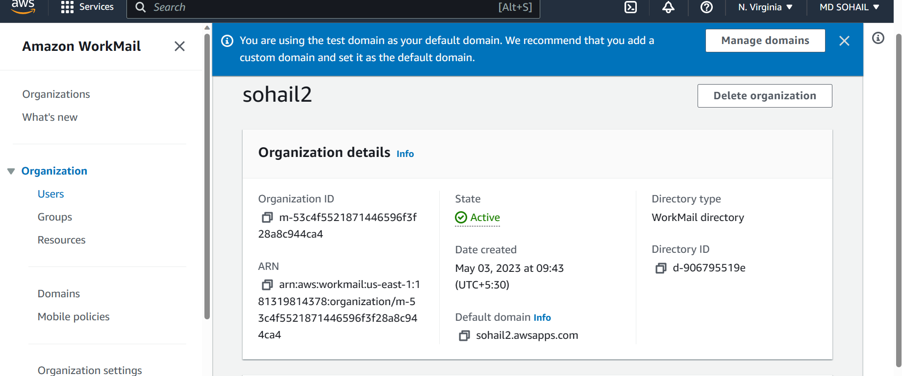

1. Then Click on “Create User”.

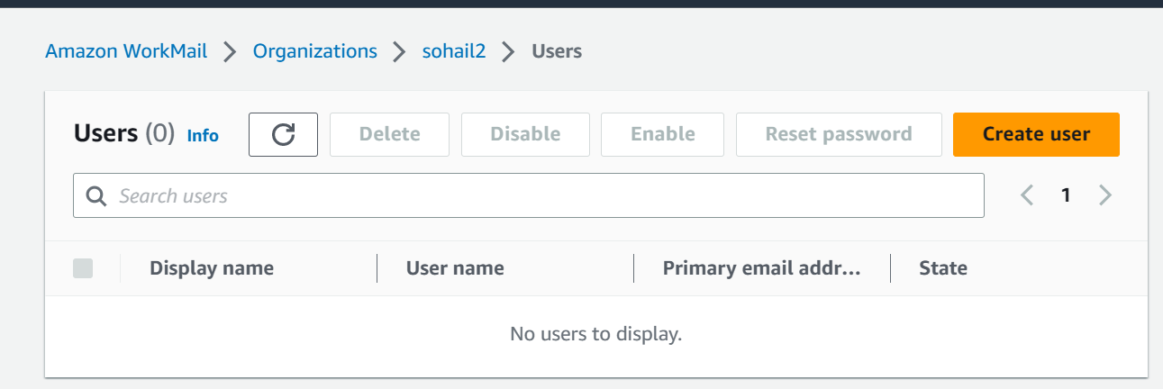

1. Enter proper data to add a user to your Amazon WorkMail Organization (AWO). After filling up the form, click on ‘Create user’.

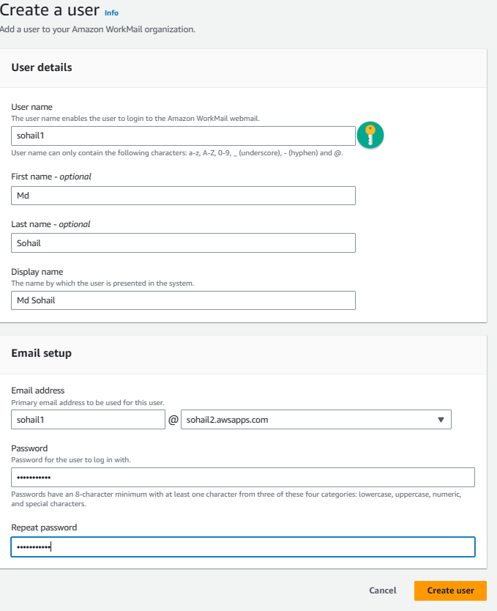

1. Similarly, create another user.

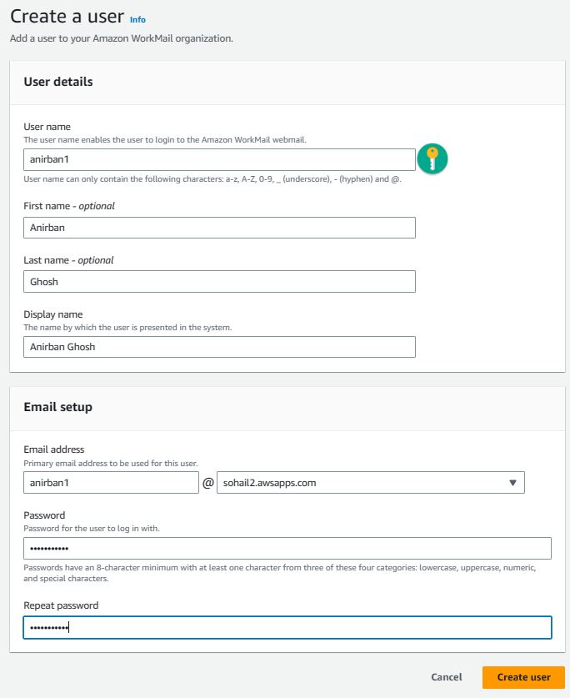

1. So, we have created two users.

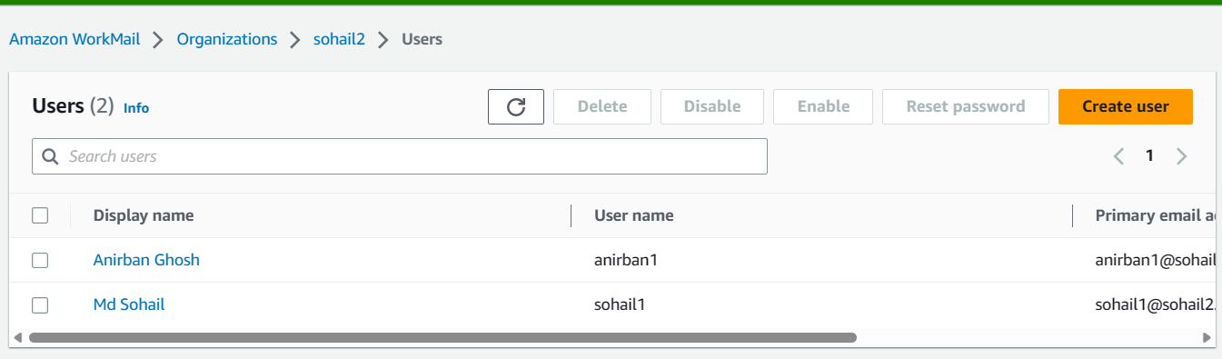

1. Then go to the ‘Organizations’ option on the left sidebar, and click on it. Then click on the organization you created. There, you can see ‘Amazon WorkMail web application’ link and click on it. 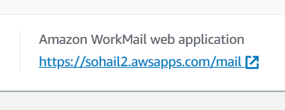
2. Then a sign in webpage will arrive. Sign in with the correct username & password to check whether your WorkMail Organization is working properly or not. [use the username & password of any one user]

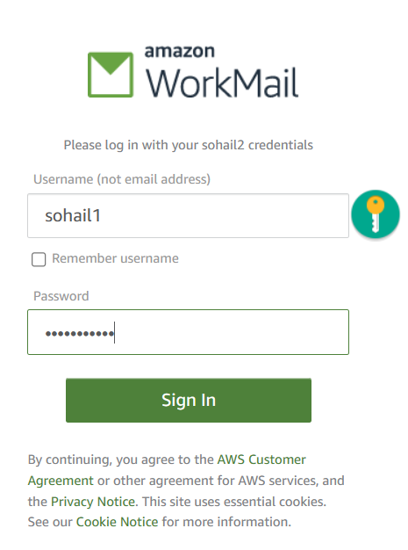

1. You will arrive at the Workmail of the user.

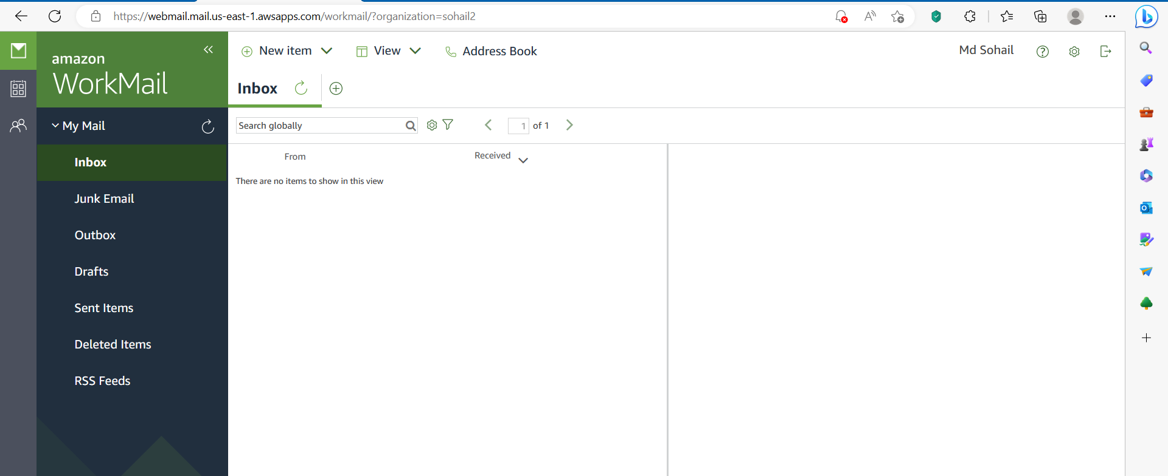

1. Now click on “New item” option in the top. After that, click on “New email”

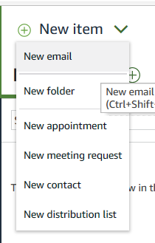

1. Now to send an email to the other user we type that user’s name in the “To” section. Also enter the Subject. Type what you want to write in the message field and click on Send. Then Logout.

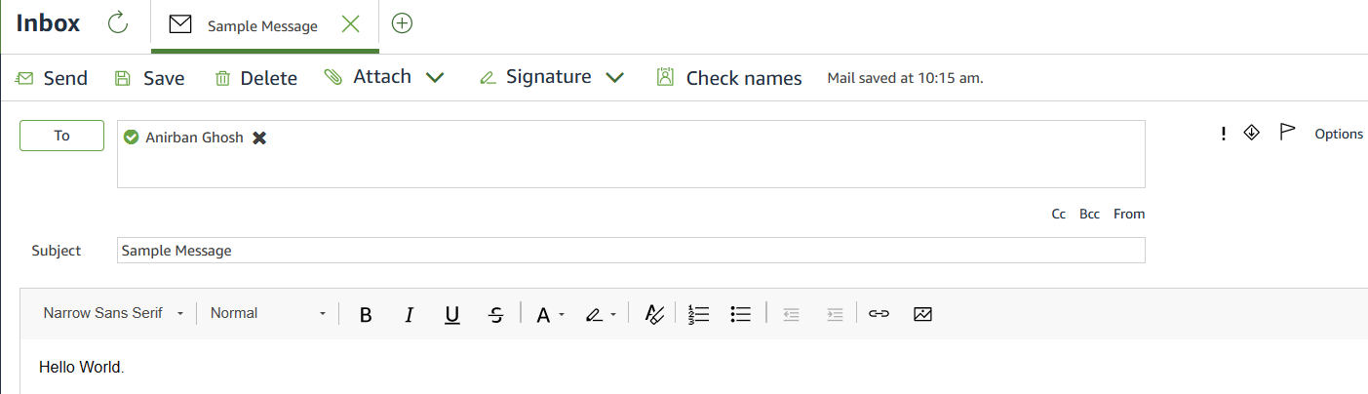

1. Now, again sign in to the other user’s Workmail.

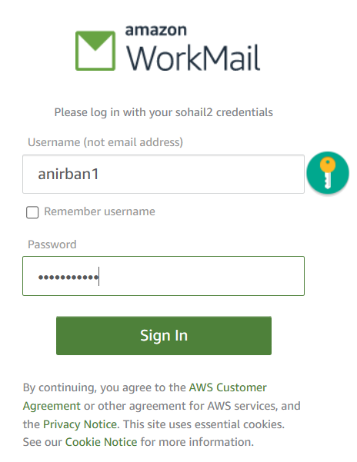

1. Now, you can see that the other user has received the mail.

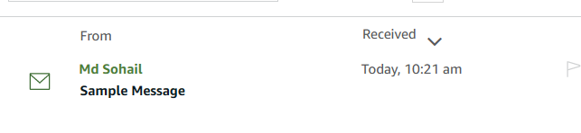

*Hence, the WorkMail is working correctly.*