ASSIGNMENT 14

**Problem Statement: Create an Elastic IP for an instance.**

**Procedure**

1. **Sign in** to your AWS account.

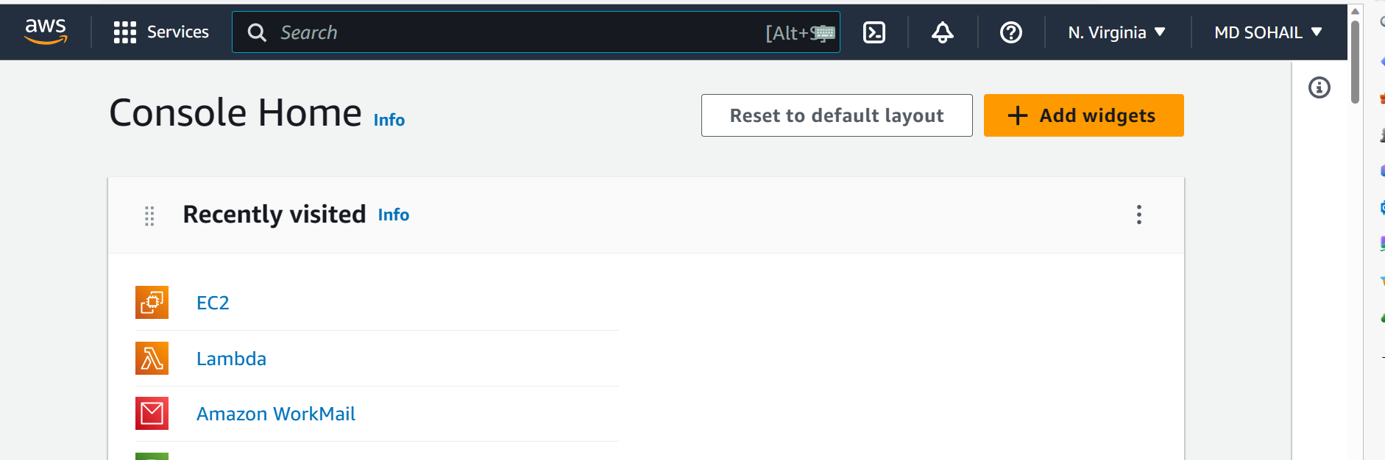

1. Go to EC2 and **create an instance**. [Create using the steps shown in the previous assignments. But there is no need to clone and run the project]

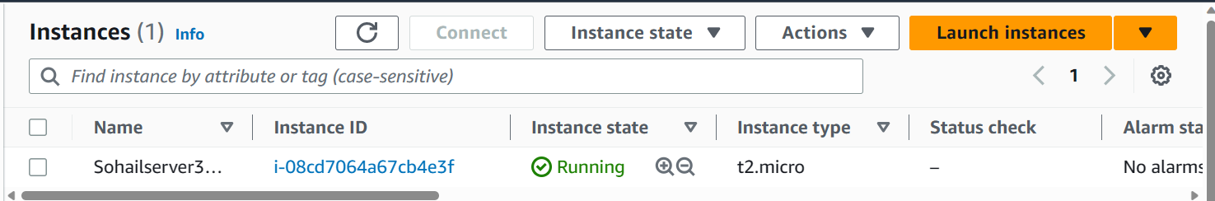

1. Copy the Public IPv4 address of the instance and paste it in a text file to notice its change when the Elastic IP is associated.

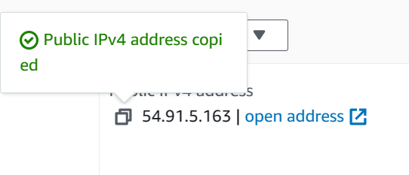



1. Now, go to EC2 dashboard and click on **Elastic IPs**.

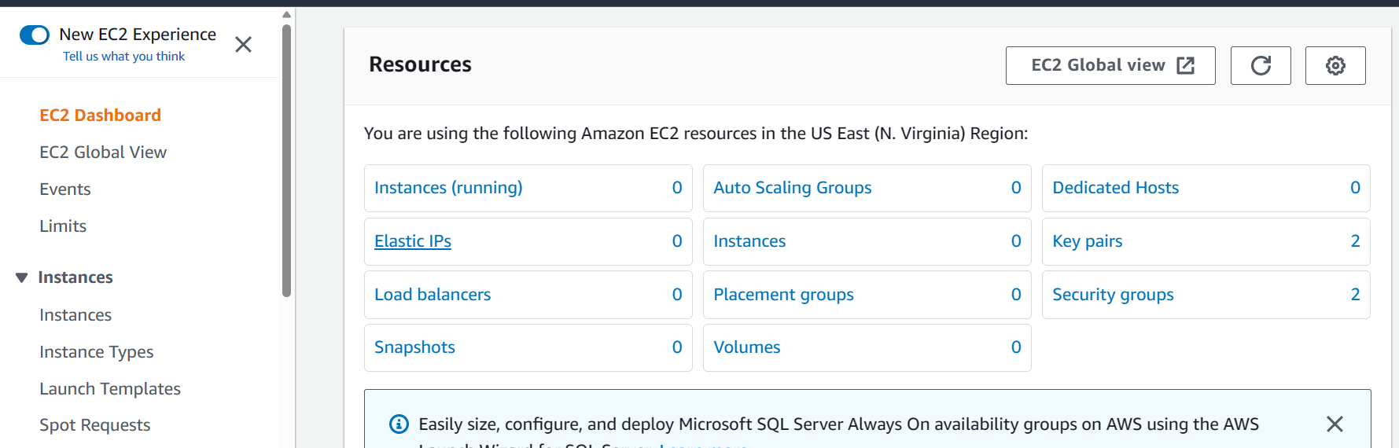

1. Click on **Allocate Elastic IP**.

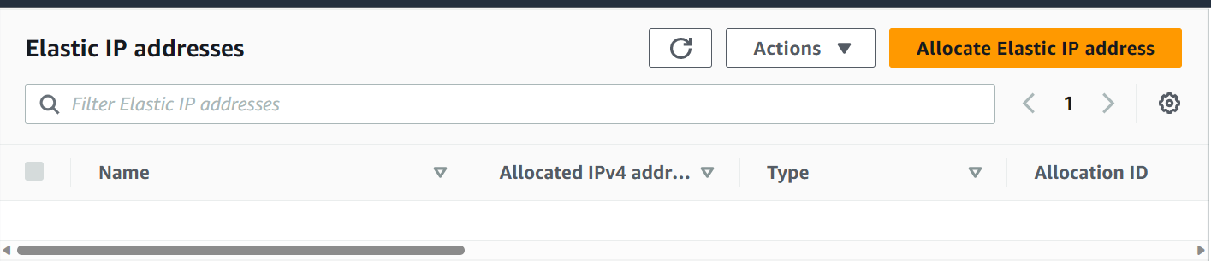

1. Next, click on **Allocate** at the bottom of the page.



1. Now, you can see the **Allocated Elastic IP address**.

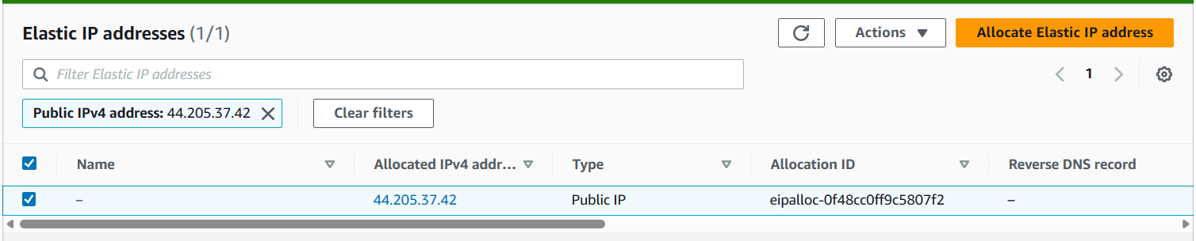

1. Click on the Allocated IPv4 address. Next, click on **Associate Elastic IP address**.

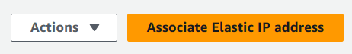

1. Now, in the instance section, choose the **running** instance.

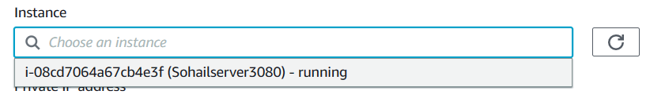

Next, choose the **Private IP address**.

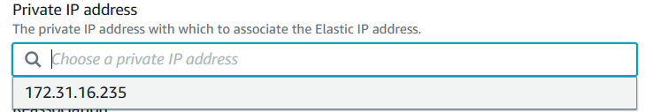

Next, choose whether you want the Elastic IP to be reassociated. [ In my case, I am choosing it to be reassociated.]



At last, click on **Associate**.



1. Now, go to the Instance you created and check its Public IPv4 address. See it has **changed** to Elastic IPv4 address.

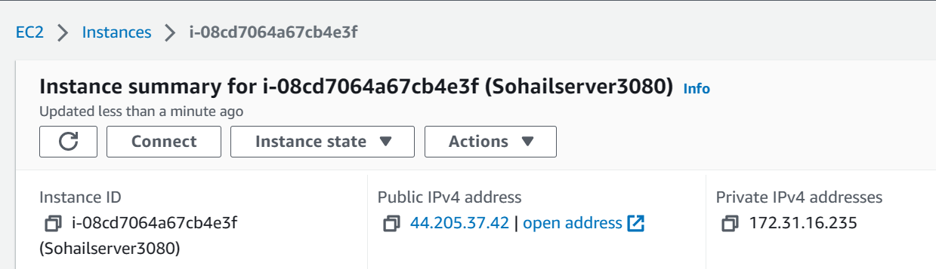

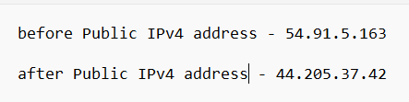

1. To **remove** the Elastic IP, we have to follow the below steps:
2. Go to Elastic Ips
3. Select the Elastic IP and click on **Actions🡪Disassociate Elastic IP address🡪 Disassociate.** [The Elastic IP address will be disassociated from the instance]

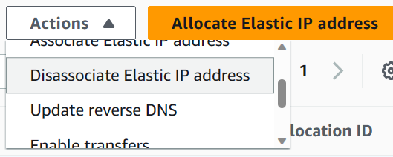

Afterwards, you can see the **Associated instance ID blank**.

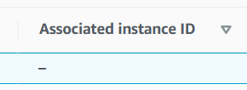

1. Next, select the Elastic IP address and click on **Actions🡪Release Elastic IP addresses🡪Release**

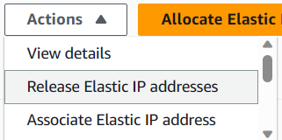

1. You can see that there are no Elastic IP addresses allocated anymore.

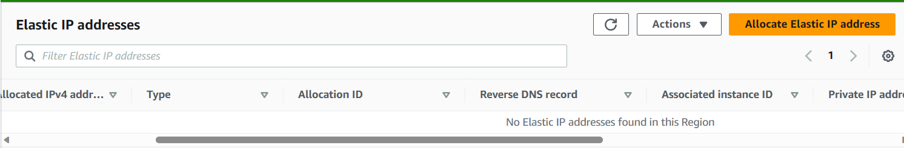

*Hence, we have successfully created, associated and removed the elastic IP.*