ASSIGNMENT 15

**Problem Statement: Create serverless computing service.**

**Procedure**

1. **Sign in** to your AWS account.

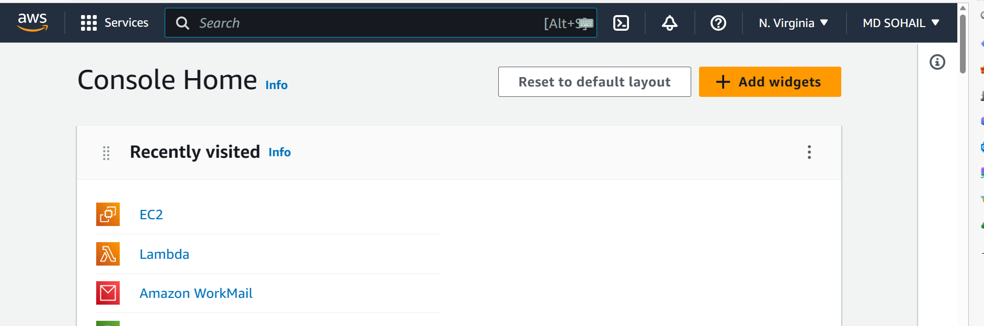

1. Go to **Lambda** and click on **Create a function**.

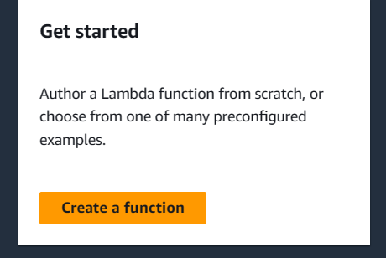

1. Give the Function a **name**.

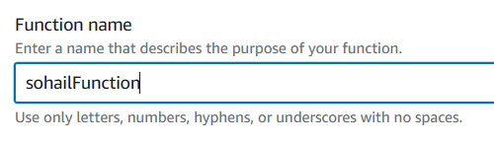

Then, scroll down and click on Create Function.

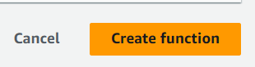

1. Scroll below and go to **Code source** section.

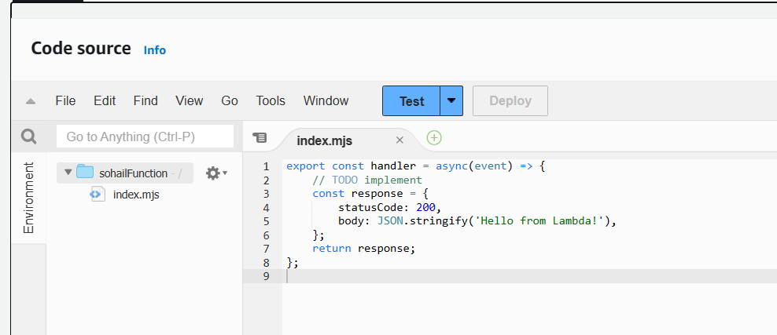

1. **Modify** the code.

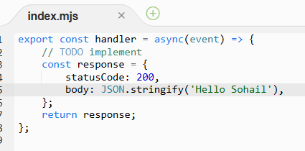

1. **Save** the changes.

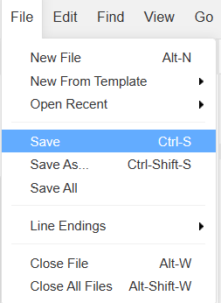

1. Click on **Deploy** to deploy the changes.

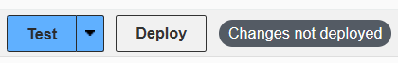

1. Now, Follow the steps: **Configuration🡪Function URL🡪Create function URL**.

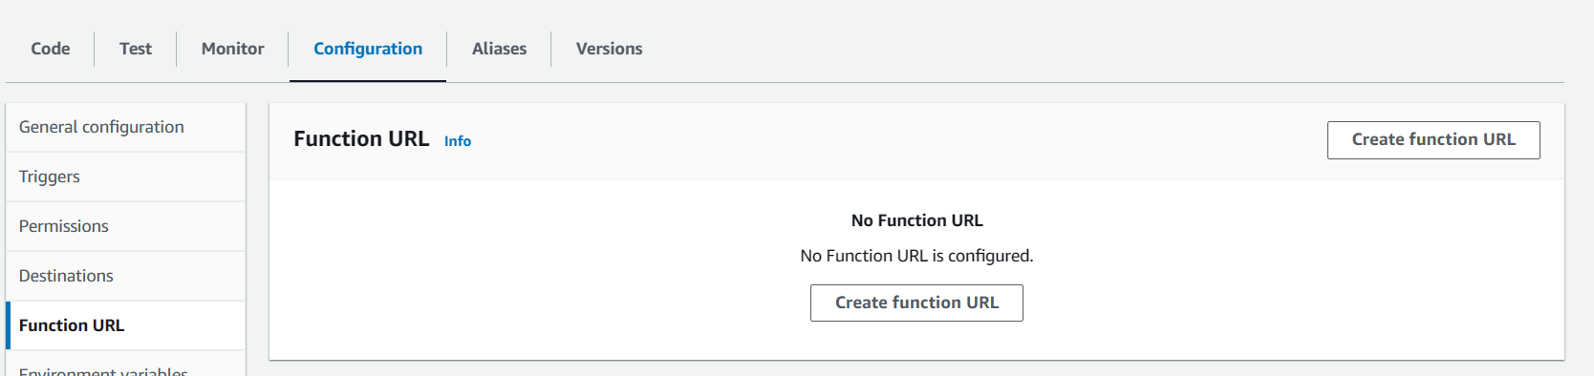

1. Select **NONE**.

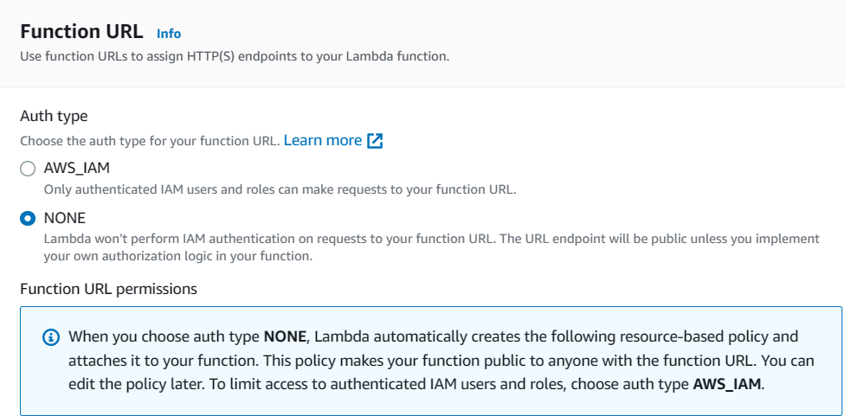

Click on **Save**.



1. Now, copy the **Function URL** and paste it in a browser.

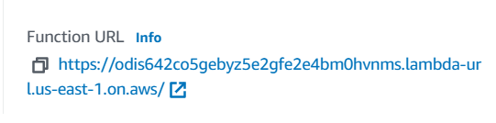

1. You can see that the changes are made.

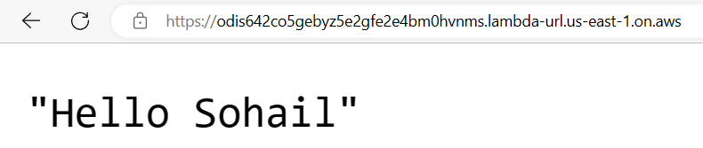

1. Next, to **delete** the function, go to the Functions section.

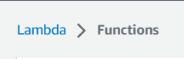

Select the Function and then click on delete.

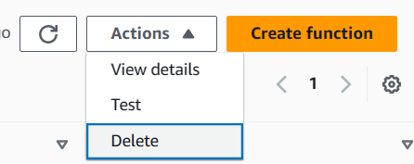

1. Next, type delete and click on **Delete**.

