**ASSIGNMENT 3**

**Problem Statement:** Create IAM resource giving full access of S3(storage).

**Procedure:**

1. Sign in to your console (as root user).
2. On the top side of the page go to the **Search bar** and type “IAM”.
3. Click on the first result showing “IAM”.

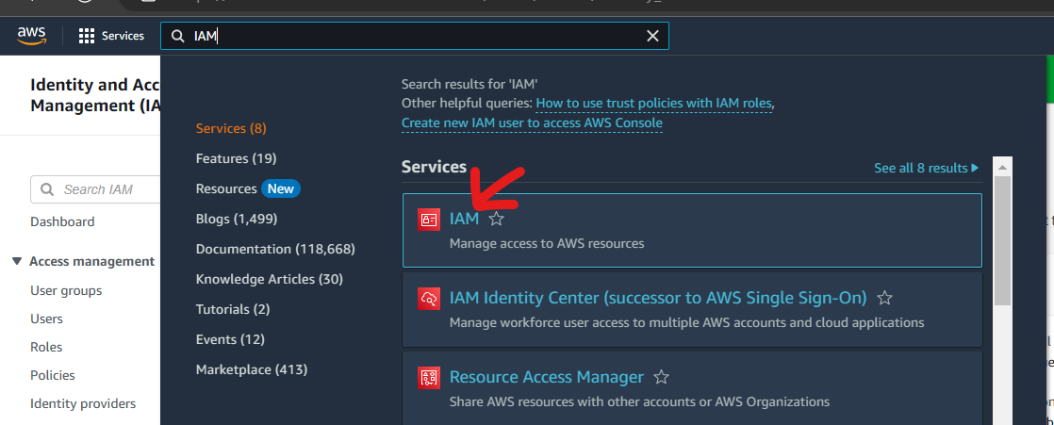

1. We are then redirected to the Identity and Access Management (IAM) dashboard. We then have to select the **Users** option in the left side panel under **Access Management.**
2. Next click on **Add Users** button in the **Users** pag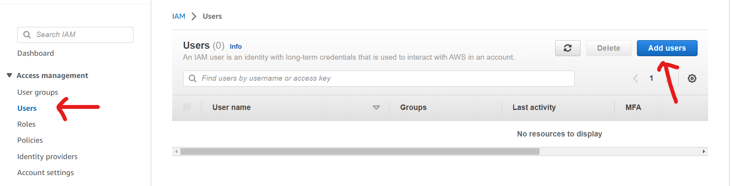
3. After that you have to create a user and specify the details.
   1. Specify the name of the user
   2. **Check** the “Provide user access to the AWS Management Console” box
   3. **Select** the option “I want to create an IAM user”.
   4. Select custom password and enter it.
   5. **Uncheck** the “Users must create a new password at next sign-in” box.
   6. Then click on next

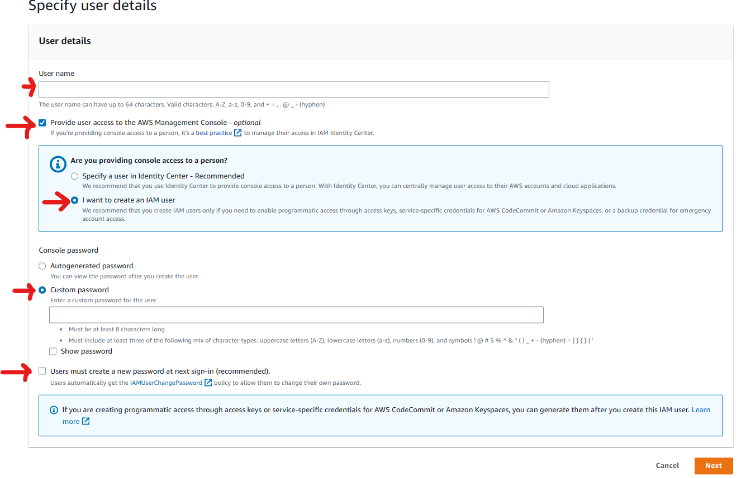

1. Now under **Permissions Options**, select **Add user to Group** option**.**
2. Under **User Groups** click on **Create Group** button.

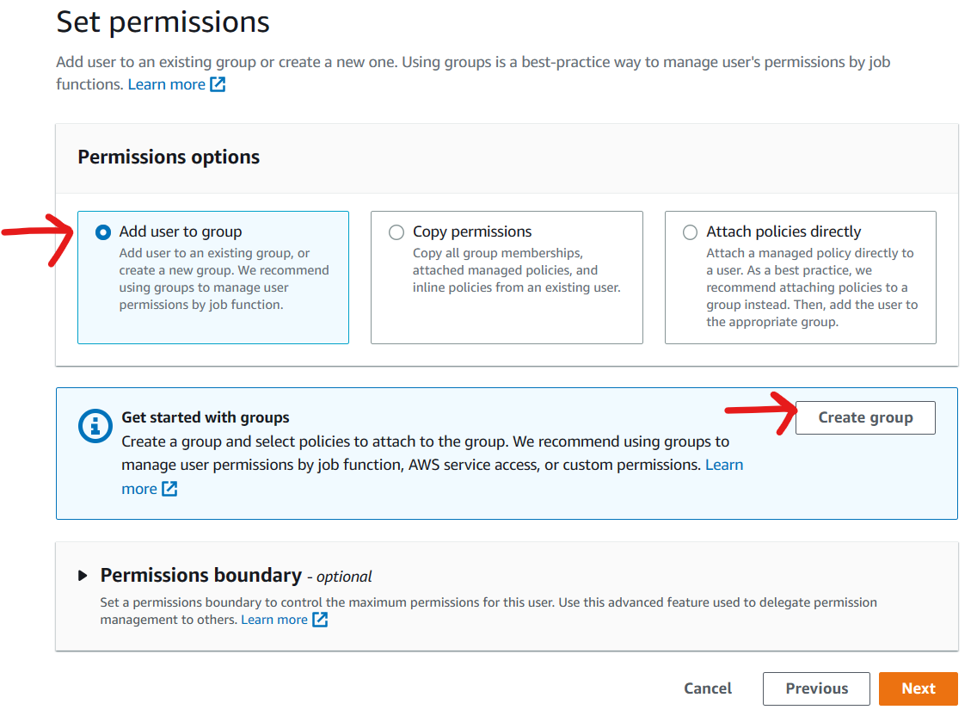

1. A pop-up will appear where you have to specify the new group name and edit the policies/permissions associated with it
   1. Enter the **User Group Name**
   2. Next in the find policies search bar type **S3** as we have to give permission only for S3.
   3. Select the **S3FullAccess** option.
   4. Then click on **Create User Group**

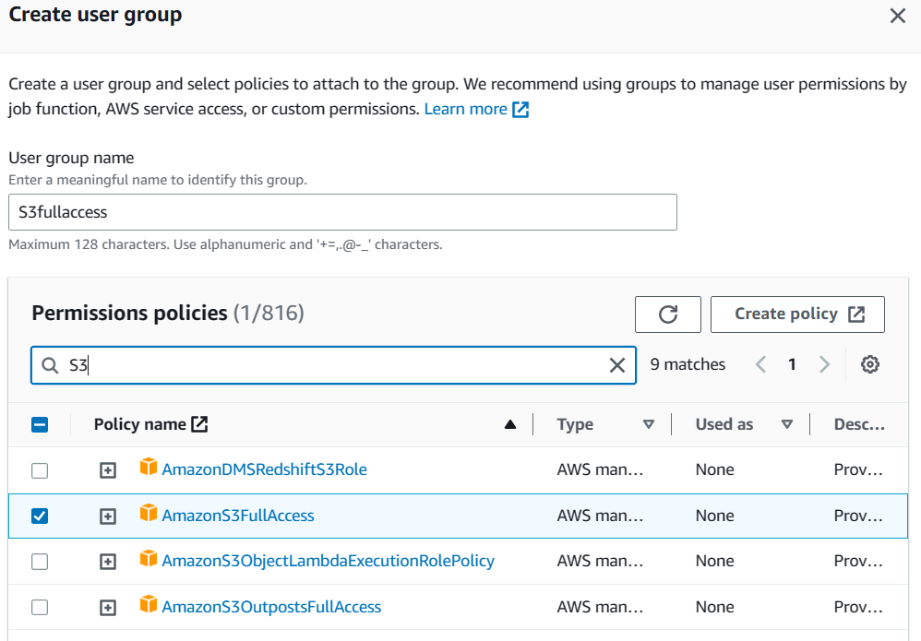

1. Now the pop-up closes and under the **User Groups** section our newly created group is visible in a table format. Select the group.
2. Then click on **Next.**

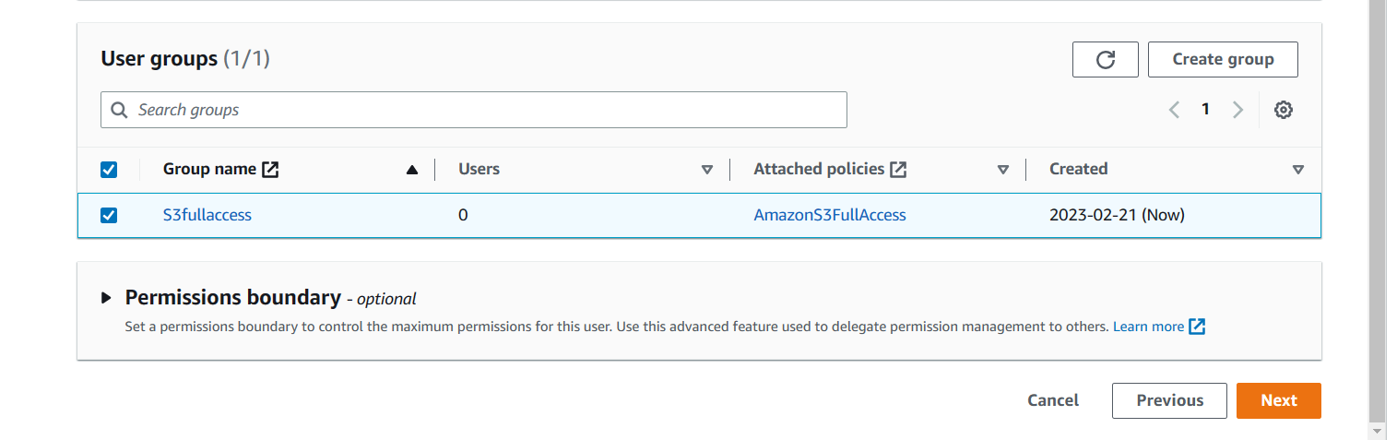

1. We arrive at the **Review and Create** page. After reviewing click on the **Create User** button.

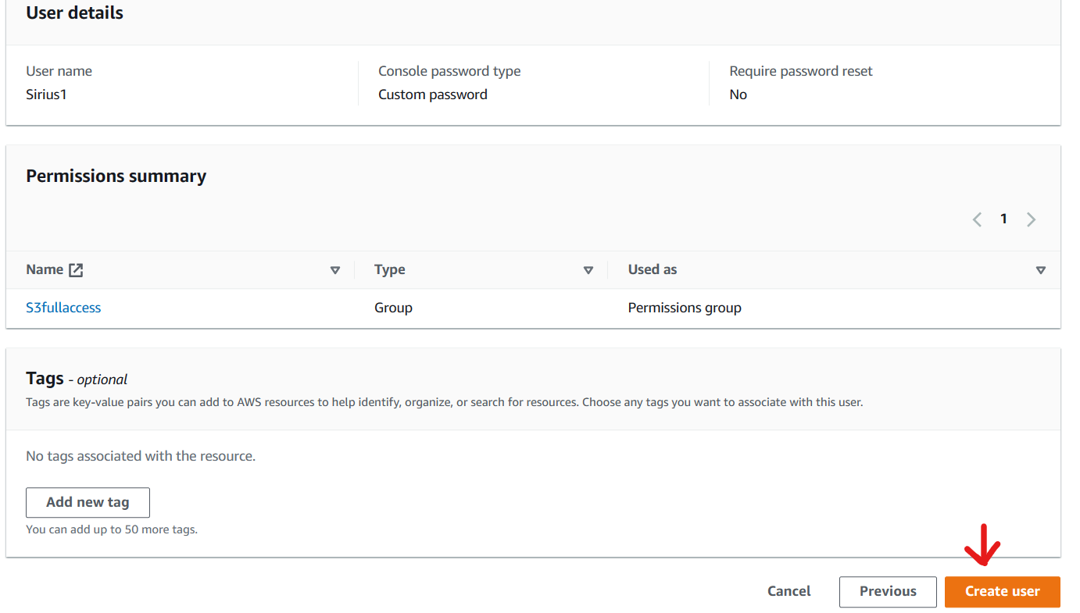

1. Next, we arrive at the **Retrieve Password** page where we can download a **.csv file** or **email the sign-in details of the newly created IAM user**.

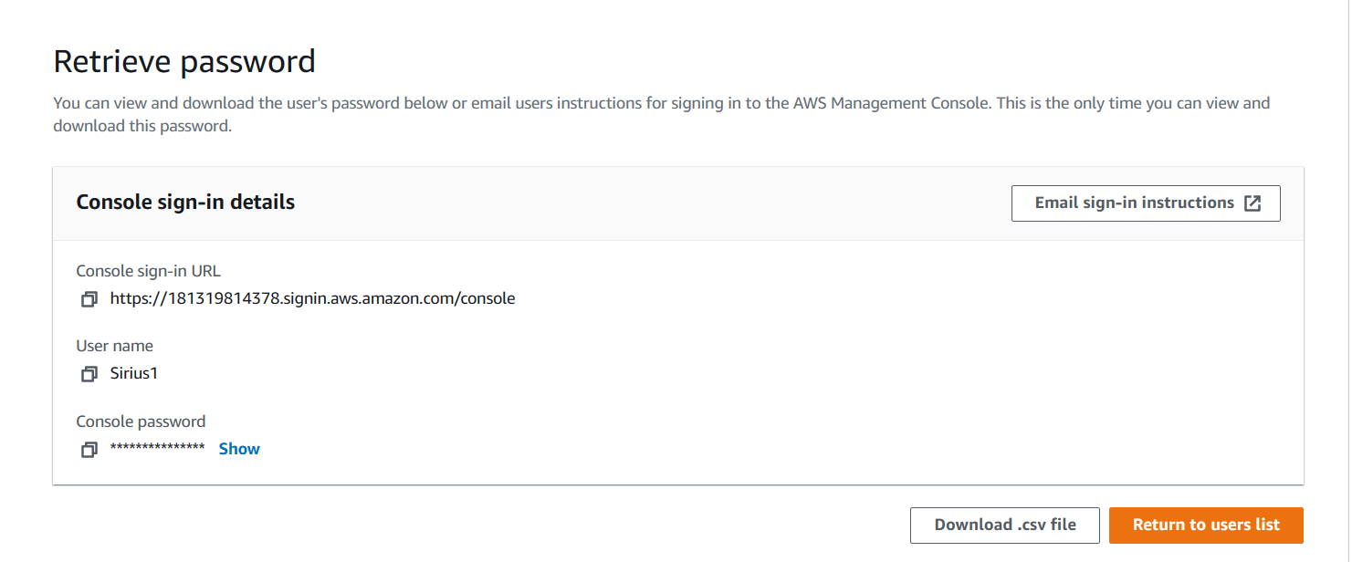

1. After that we can return to users list and see that our new user has been added to the users’ table.

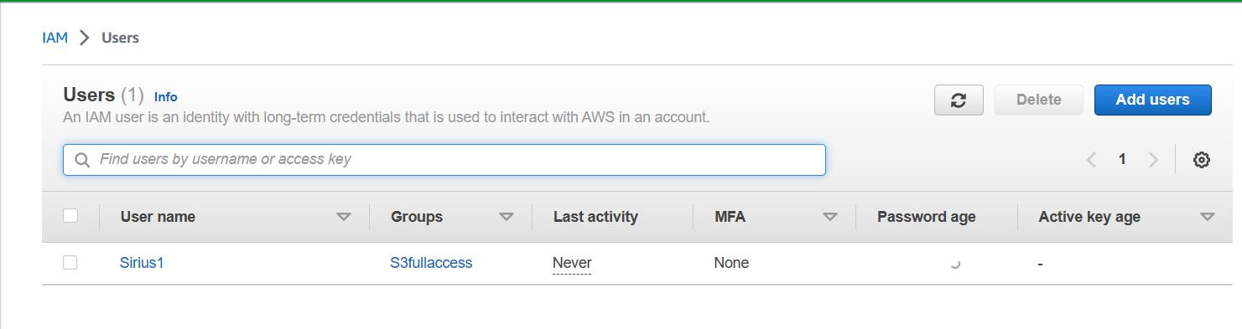

1. Now we logout of our console.
2. Next, we again try to login to the console. But now we select **IAM user login.**
3. Here we have to enter **Account ID** of the root user. We can get that in the drop-down menu after logging in our root user account.

Alternatively, we can use **the link** in our **downloaded .csv file** or our **email** which if used in our **browser** will redirect use to the login page with the Account ID already entered!

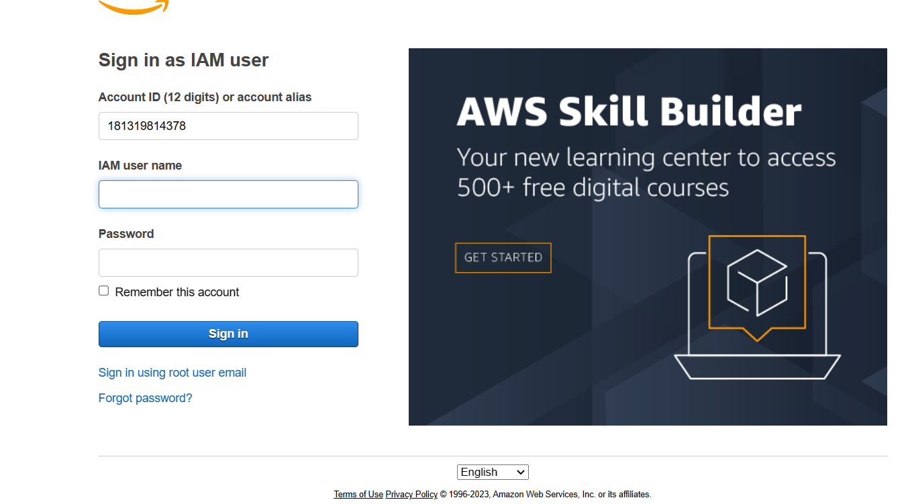

1. Enter the credentials.
2. Note the username in the top right corner. Also, you cannot access your account page as it is controlled only by your root user.



1. Next you can type S3 in the search box and select the first option.

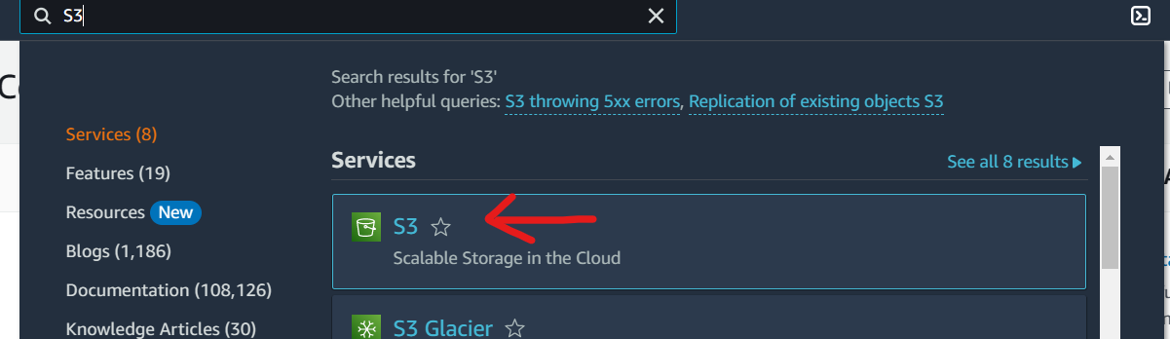

1. Here we get to Create Bucket. Hence we have full access of S3.

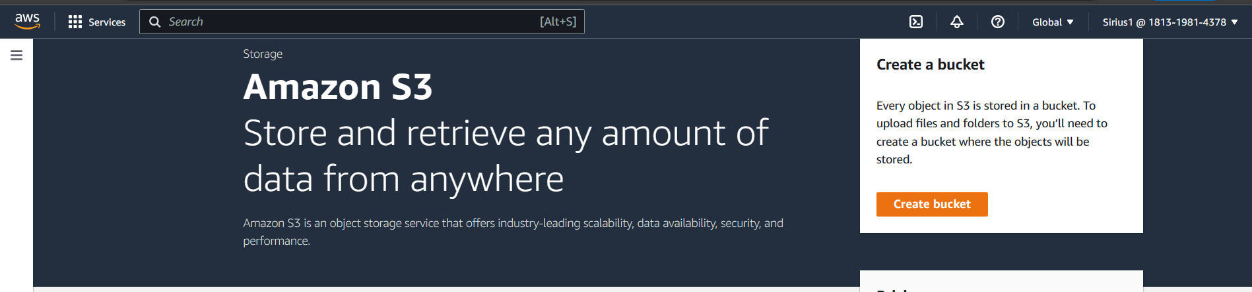

1. Now to check our limits let us search EC2 in search bar. Select the first choice.

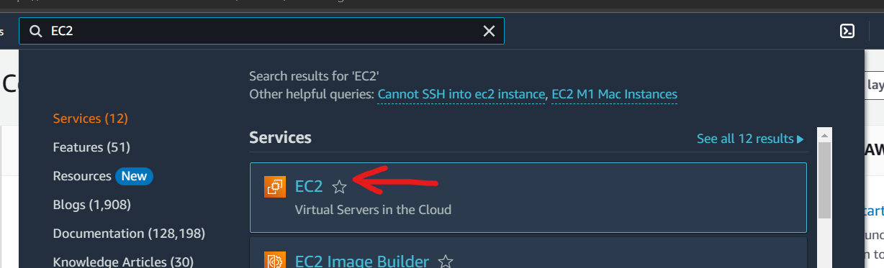

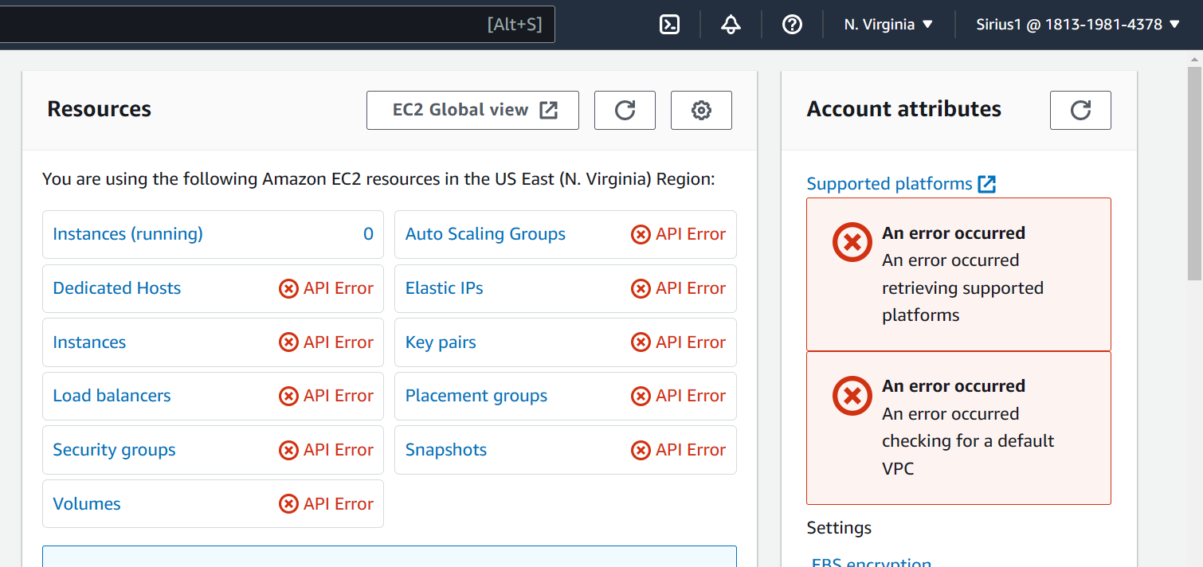

1. Here, we encounter API error. This is proof that we do not have access to EC2. Hence, we have successfully restricted access to our IAM user.
2. Thus, we have successfully created an IAM user and given it only S3 access.
3. Now, we can logout.