ASSIGNMENT 6

***Problem Statement: Upload a static website on S3.***

**🡪**

1. **Sign** **in** to your AWS account as a **root** user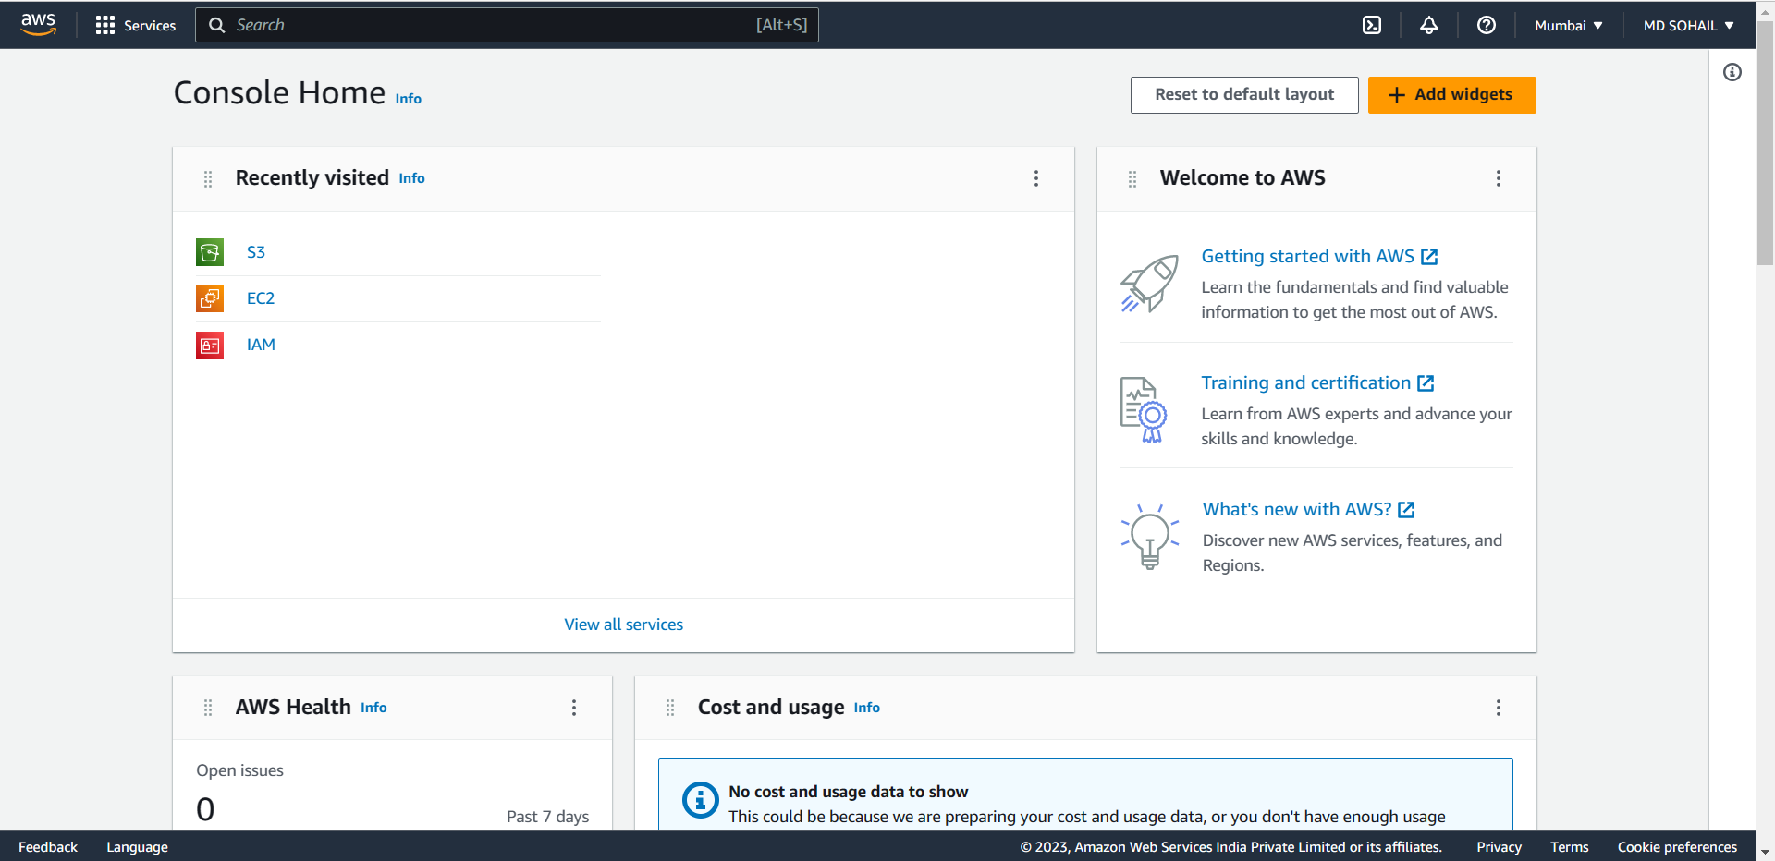
2. Then **Create** a **Public S3 bucket**.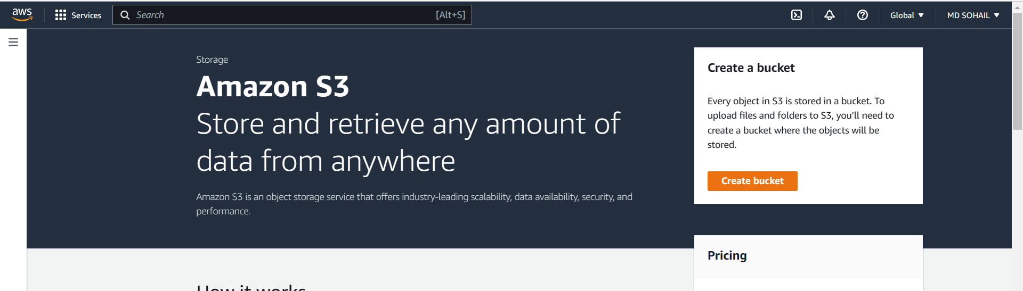

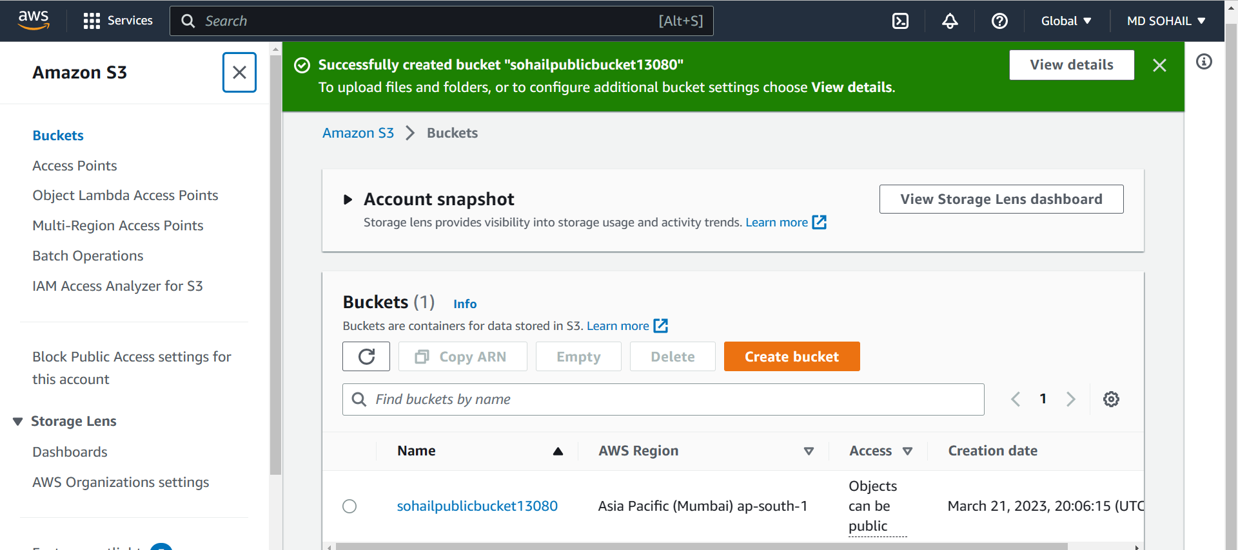

1. Now create two html files anywhere in your computer (preferably in a folder in the Desktop).
   1. The first one is named Home.html
   2. The second one is named next.html

Remember, you can give any name to the files but you have to modify the steps shown further accordingly. We are going to use the given file names to proceed.

The contents of the files are shown in the given screenshots……

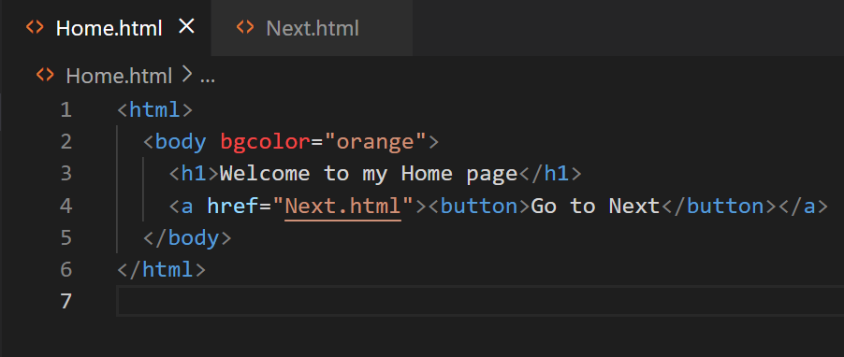

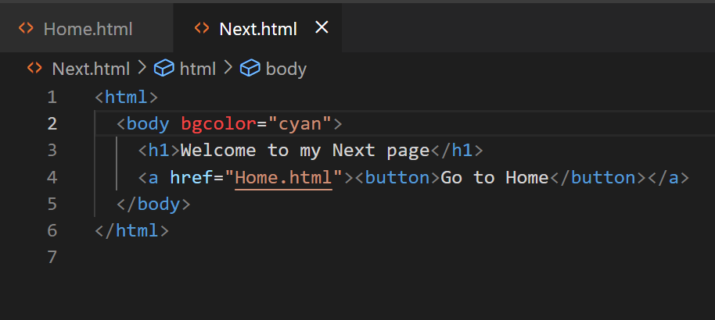

1. Now let us go back to AWS. **Select** the newly created **public bucket.**

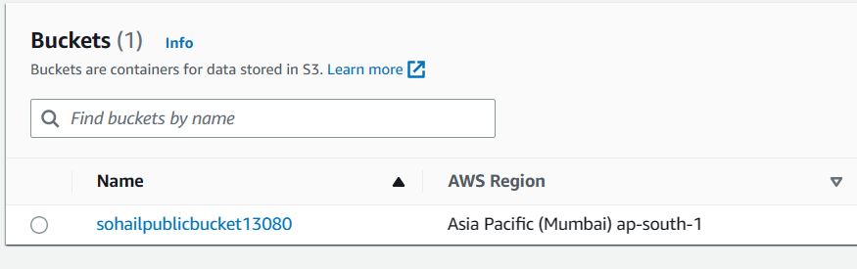

1. Click the **Upload Button.**

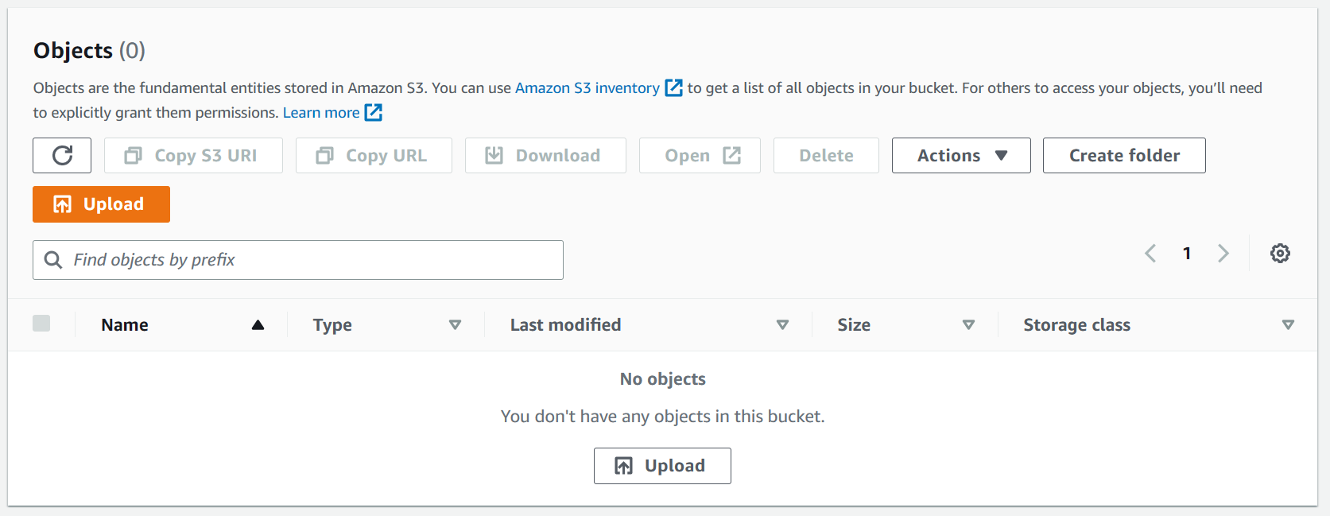

1. Next click on the **Add files** button. Select both the html files and **upload** them by pressing the upload button.

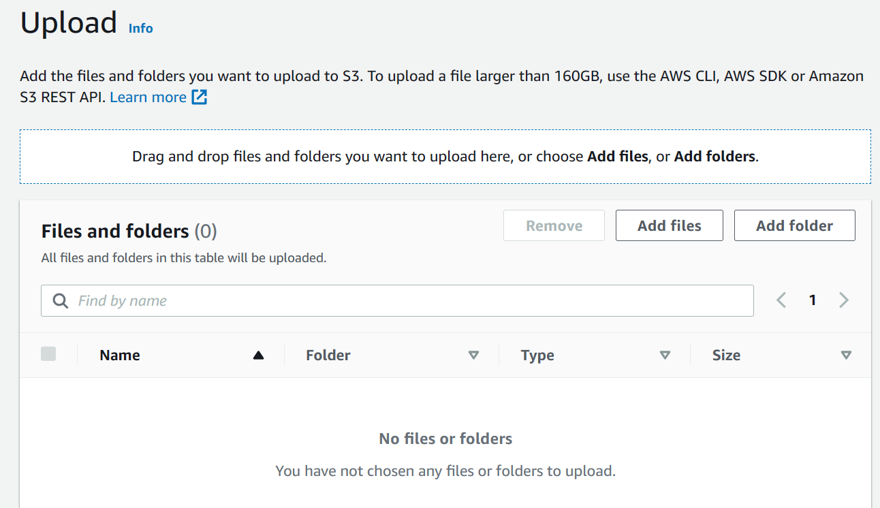

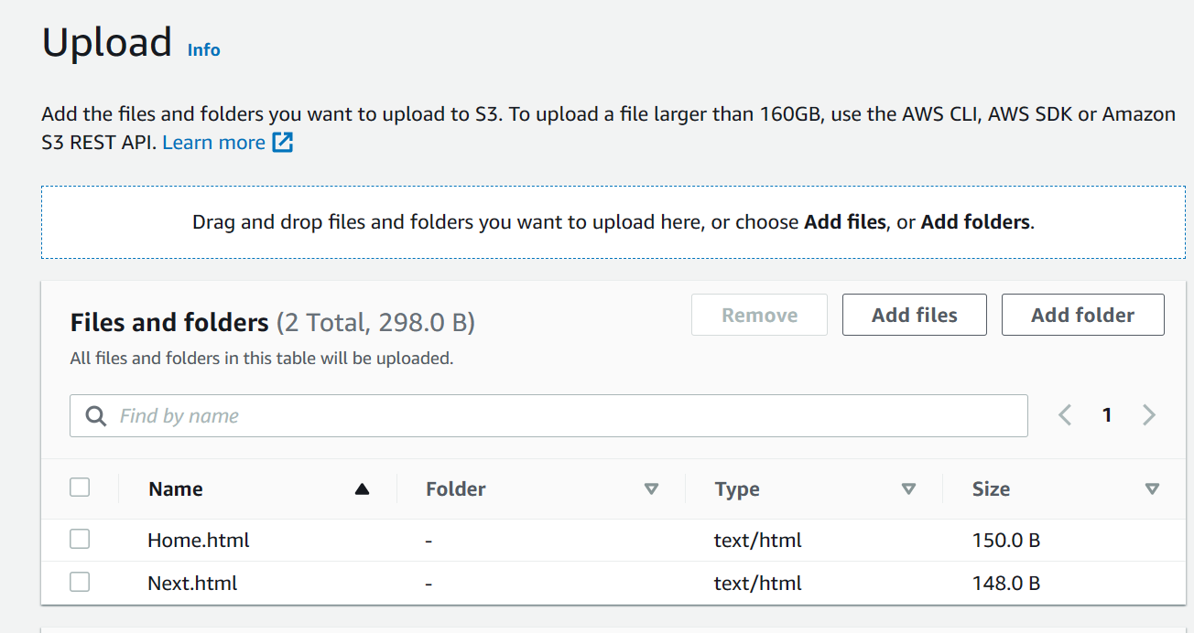

1. Now, after closing the upload status page after all files are updated, select all the files shown in the object table in the public bucket.

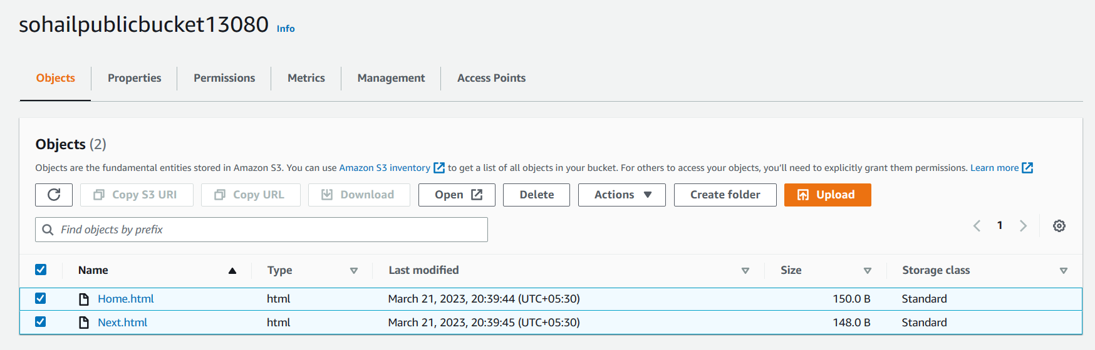

1. Click on the **Actions** button and from the subsequent dropdown menu select **Make public using ACL.**

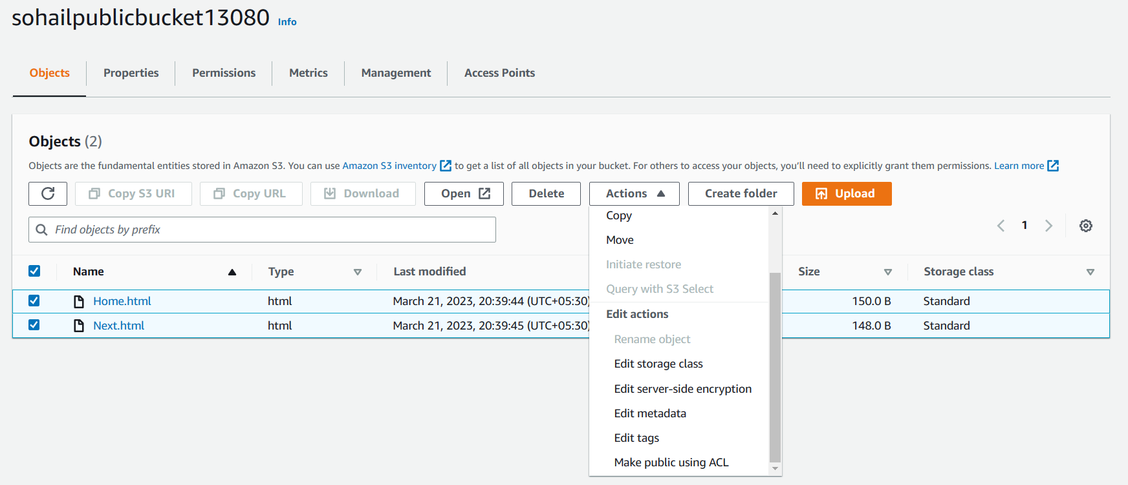

1. Click on **Make public** button to make all the selected files public.

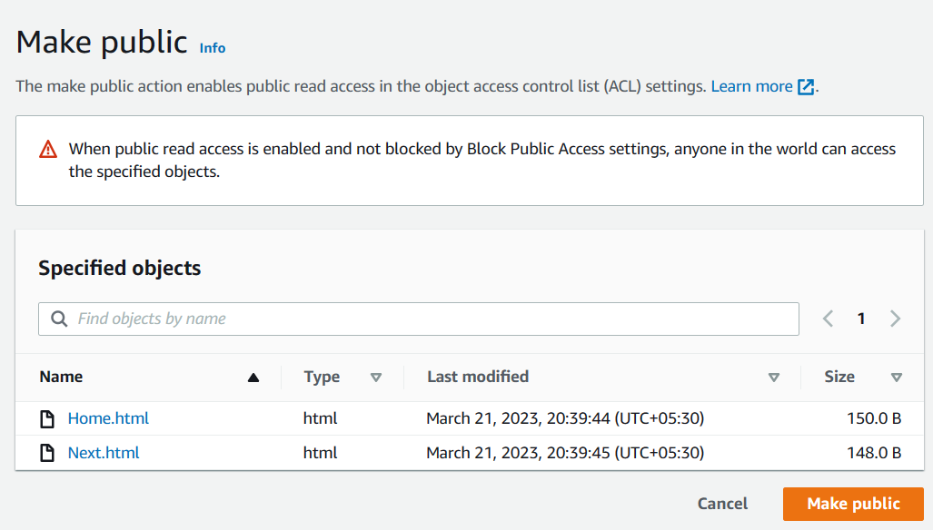

1. Now, we after making public we close the status page and we are redirected to our public bucket page. Now we select the **Properties** tab of the bucket which is located in the right side of the Objects tab.

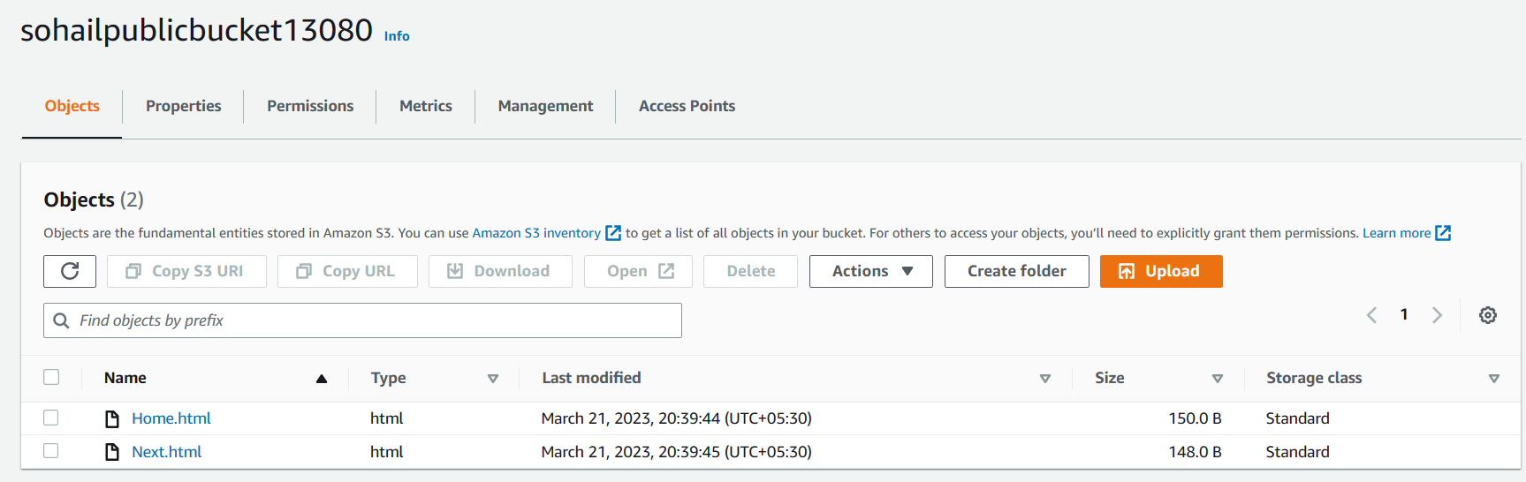

1. After arriving in the Properties tab. Scroll down all the way to the bottom. We will focus only on the Static website hosting section.

By default, it will show disabled.

We have to enable it. In order to do so click on the Edit button on the right- hand side of the section.

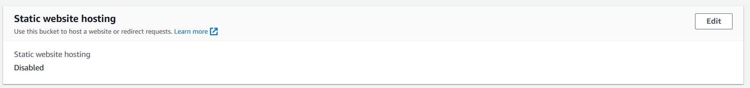

1. Now we will choose the enable option. After choosing it multiple options will appear. Just follow the snapshot provided below and make the same changes.

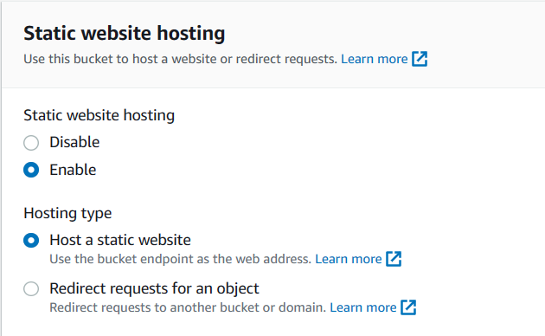

1. Next scroll down. Now we have to mention the html document our link will show. This is the one which anyone can access using the bucket link. In our case we will mention **Home.html** as our index or main html file. You can choose according to your wish and design.

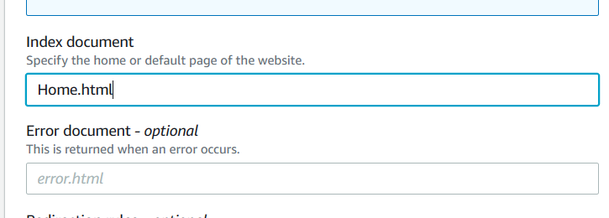

1. Next scroll down and click on **Save changes** button.

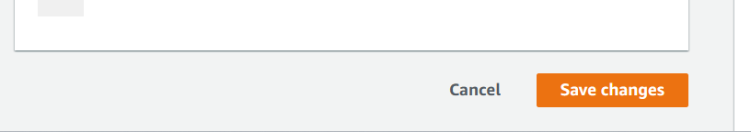

1. Now, you will again arrive in the bucket’s properties tab. Scroll down to the static website hosting area. Now you can see a **link** has arrived.

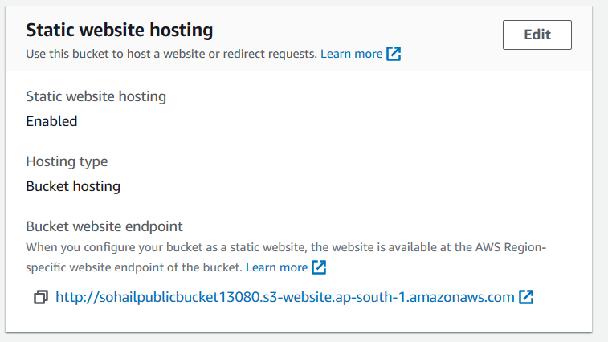

1. Copy the link and paste it in another browser.

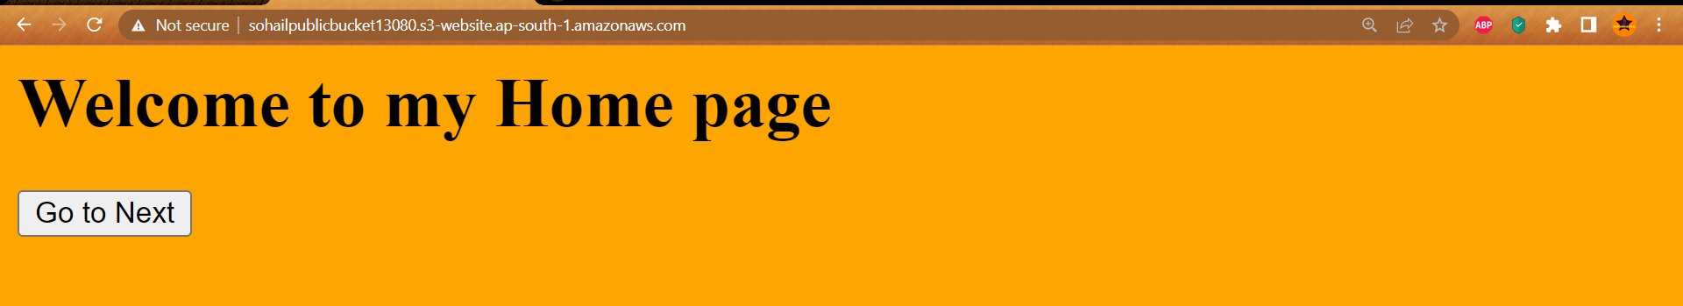

1. We are now viewing the Home.html page. And as scripted, we can click on the

**Go to Next** to arrive at the Next.html page.

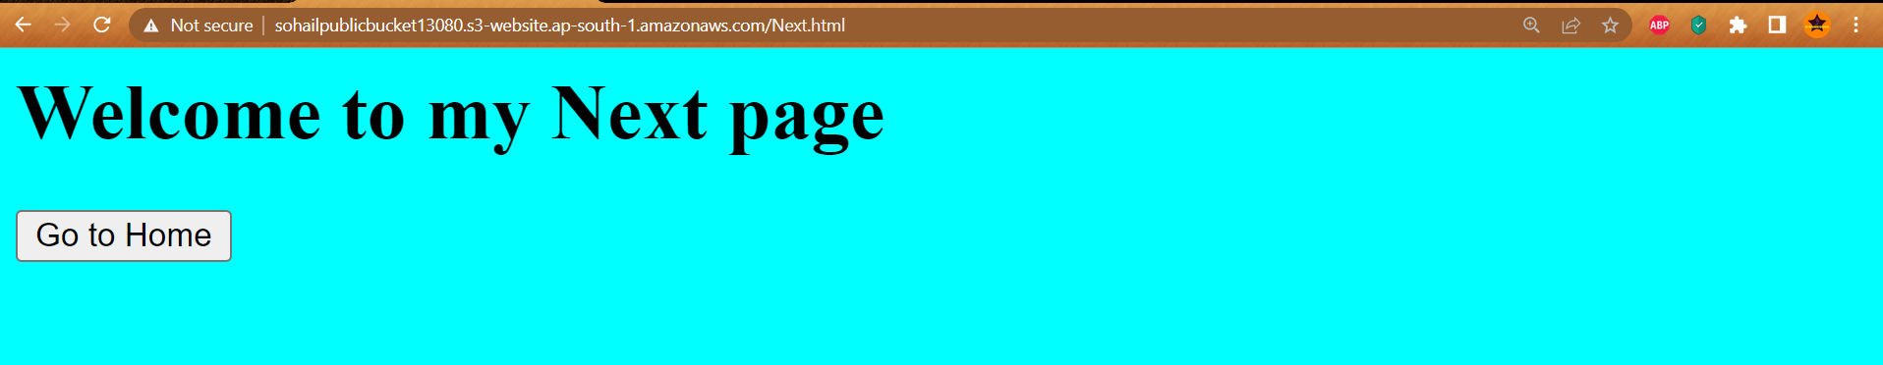

So, we have successfully hosted a static website in amazon S3.