ASSIGNMENT 7

***Problem Statement: Upload a website on EC2.***

1. Create two html file **Home.html** and **Next.html.**

*[Note-We should name the homepage of our website as* ***index.html*** *as nginx takes it as the starting page, but for better understanding in later steps we have taken names randomly]*

2. Open the **Amazon Web Services** home page (aws.amazon.com).

3. Choose **Sign into Console**.

4. Sign in as **Root user** using your email address and password.

5. Go to search and search EC2. Click on **Launch instance**.

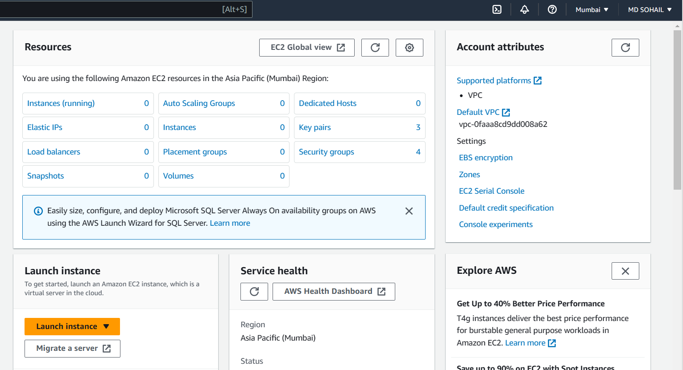

6. In **Launch an instance page** page:

a) Give the instance name in the Name and tags section. Give globally unique name as it is created globally.

b) Select an OS from **Application and OS Images section.**

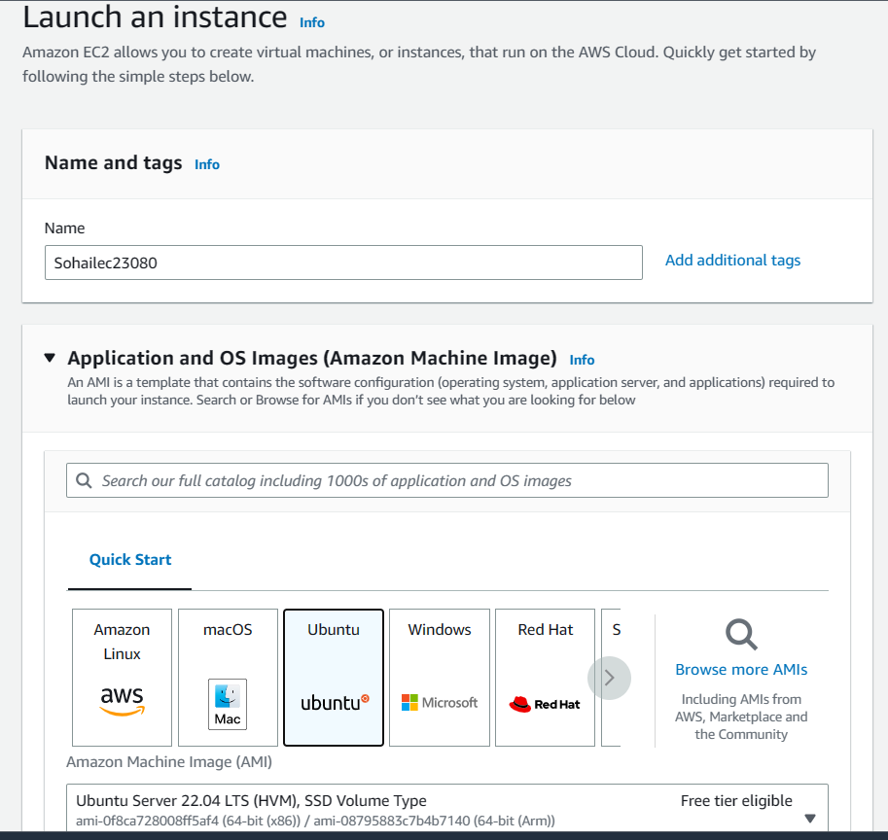

1. Keep the instance type as t2.micro .

d) Then create a new key pair by clicking on **Create new key pair**

->In the create key pair page give it a name and select RSA

in **key pair type** and .pem in **Private key file format** and click on create a new key

pair. It will download the the key pair in your local computer also.

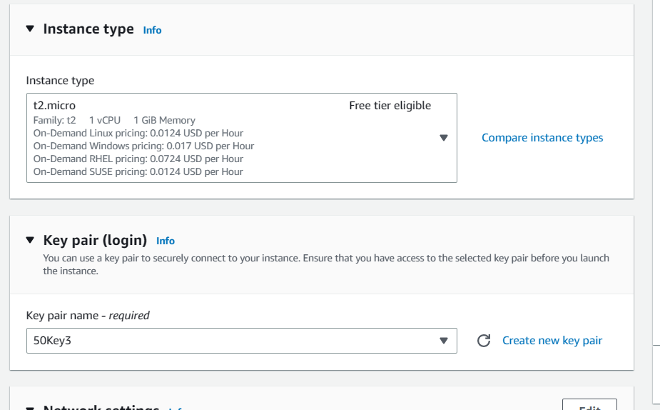

1. In Network settings section Check,

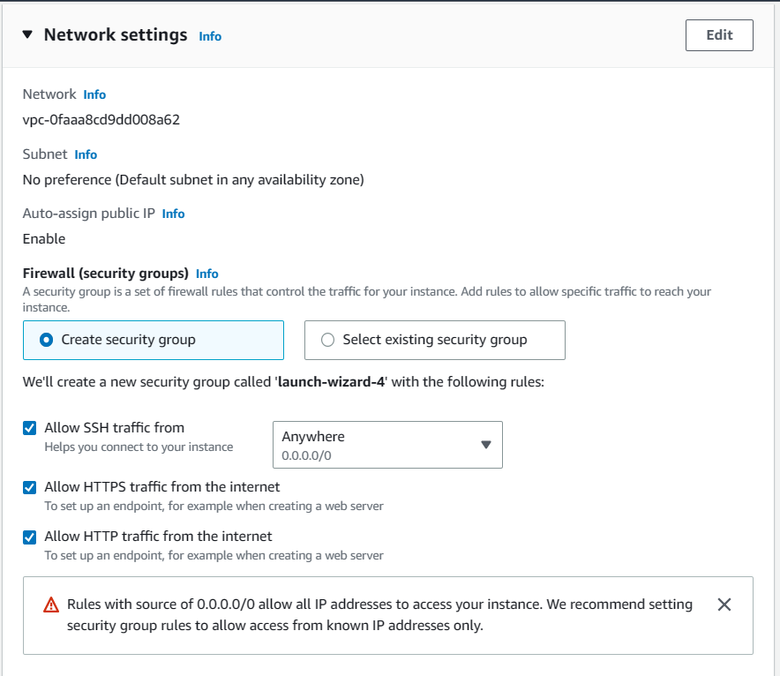

1. Click on **Launch Instance** .

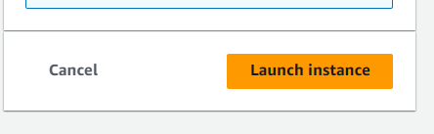

7. Go back to instances page. Select the instances and copy the public ipv4 from the **Details** page.

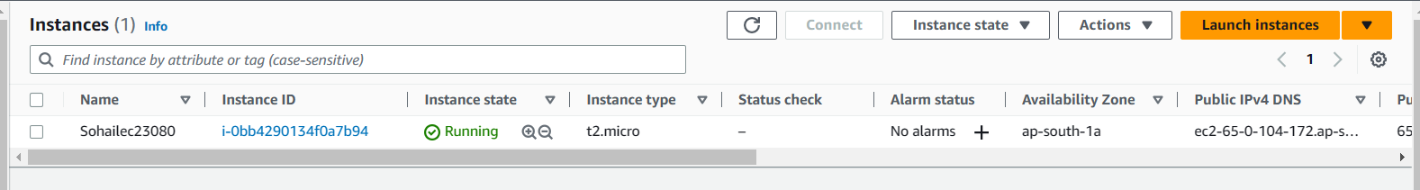

8. Download and install **Bitvise SSH Client**. Open **Bitvise SSH Client.** In **Bitvise SSH Client**

a) Paste the public ipv4 in the host in **Server** section.

b) Keep the Username ubuntu in **Authentication** section as we using ubuntu in EC2 and publickey as **Initial method**.

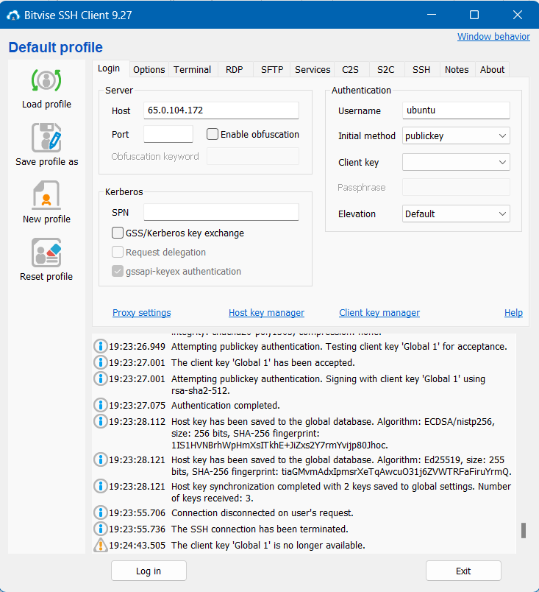

c) Click on client key manager, remove if any key exists, next import your key pair, next close client key manager.

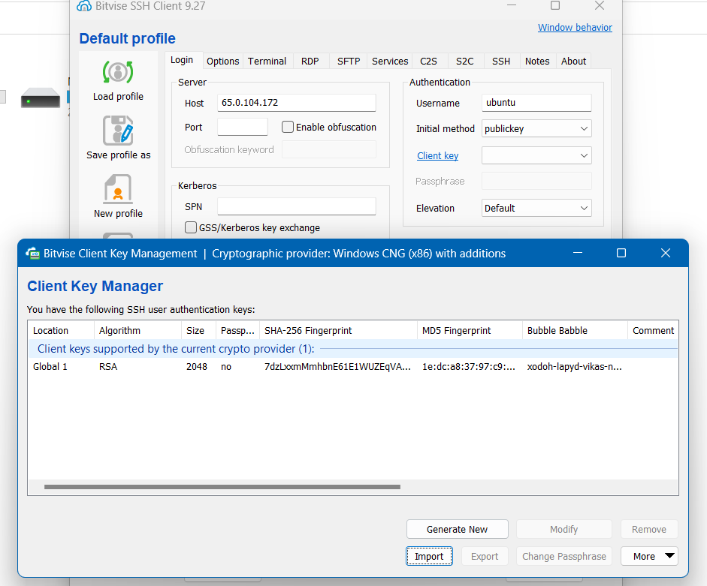

**Next**, Choose the client key that you imported

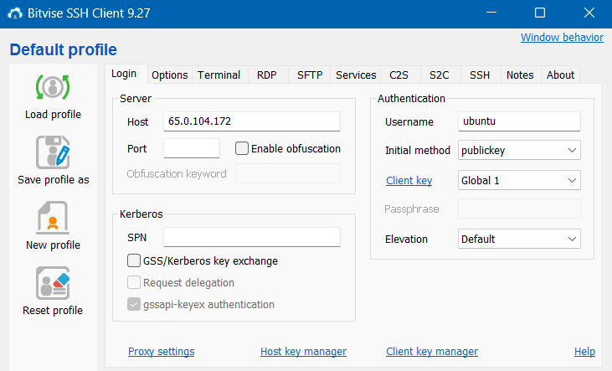

1. Click on login and click on accept and a save.

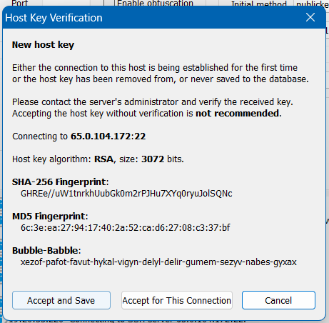

1. Click on **New terminal console** on the left sidebar

In the terminal run command,

a) pwd //To show present working directory

b) sudo apt-get update

c) sudo apt-get upgrade

d) sudo apt-get install nginx

Select ok if any pop up shows up

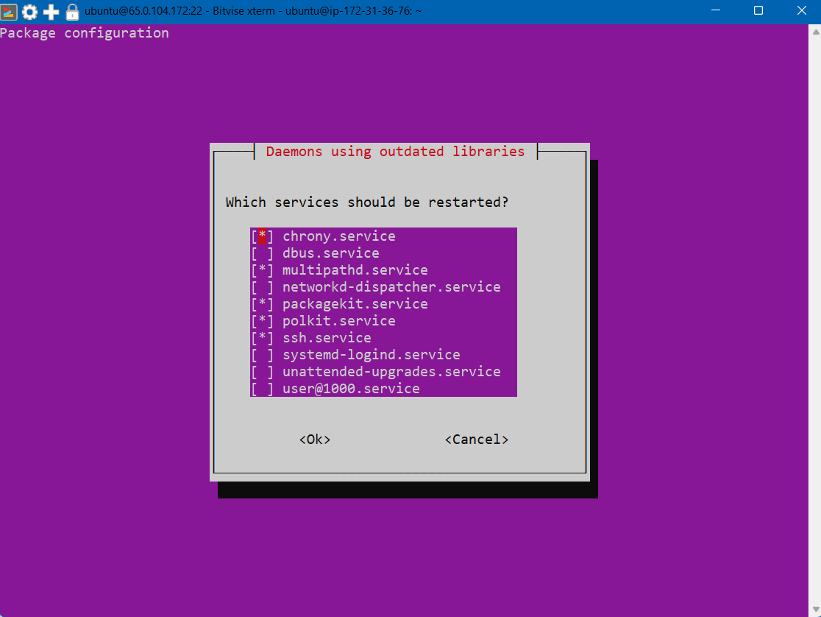

1. . Go back to the **Bitvise SSH Client.** Click on **new SFTP window** in the left side panel. In the SFTP panel in the **Local Files** go to your folder where you kept the **HTML** files.

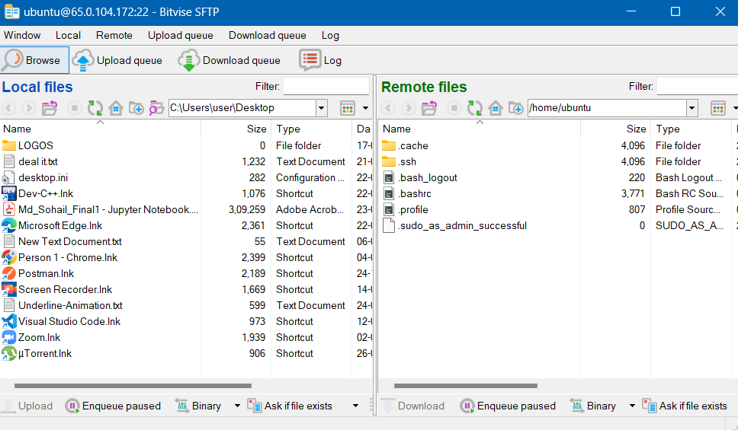

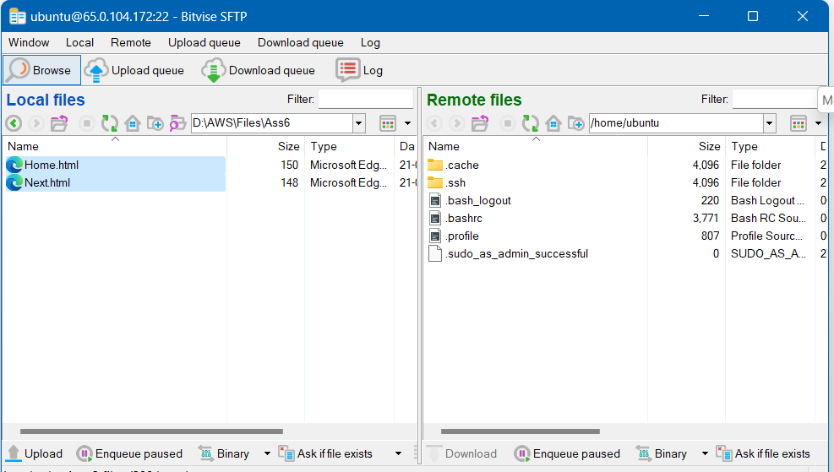

Next, In remote files go to root by clicking on **Up** or using the **path “/”**, then open the **var**, open **www**, open **html** folder.

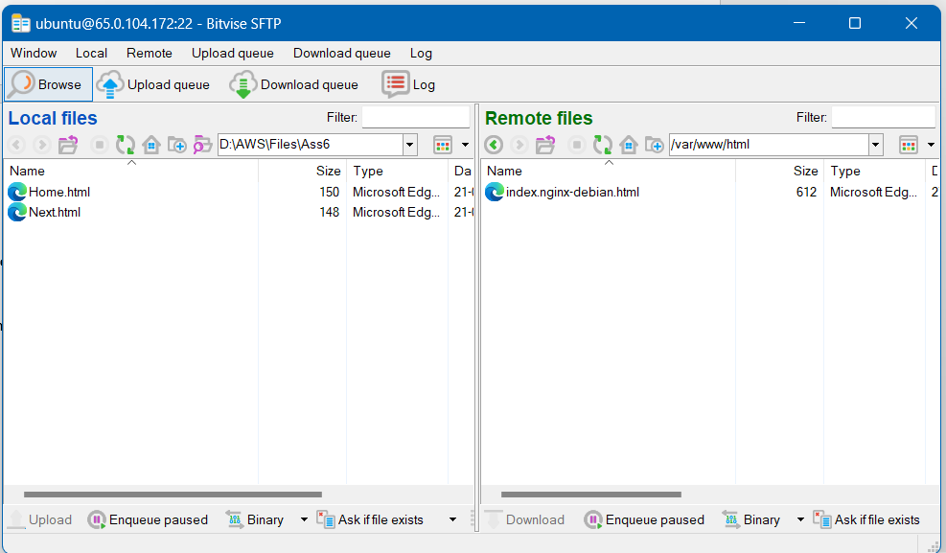

1. Copy the EC2 instance IPv4 and open in a new browser window. You can see the Welcome to “nginx!” page.

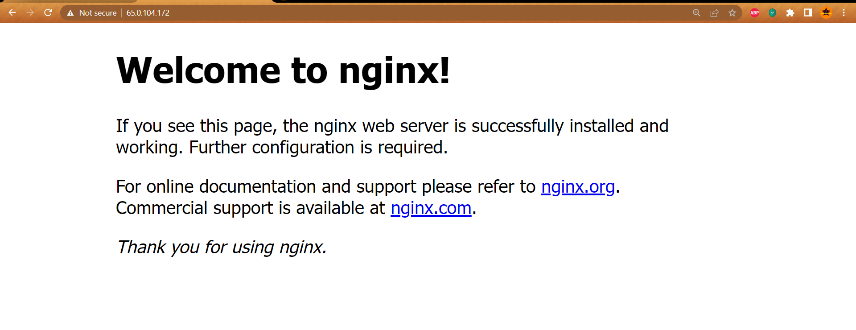

1. Go back to the **terminal console.**

In the terminal console run,

1. nginx -v // To show the version info of the nginx



1. cd / //To go back to the root in the terminal

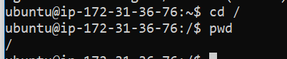

1. cd /var/www //To go to the www folder
2. ls //To show the files

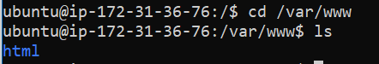

1. sudo chmod 777 html //To give read and write permissions to the HTML folder.

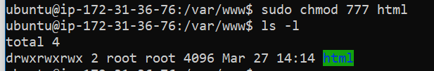

1. Now go to the Bitvise’s SFTP panel and move your file from local files to remote files “/var/www/html”.

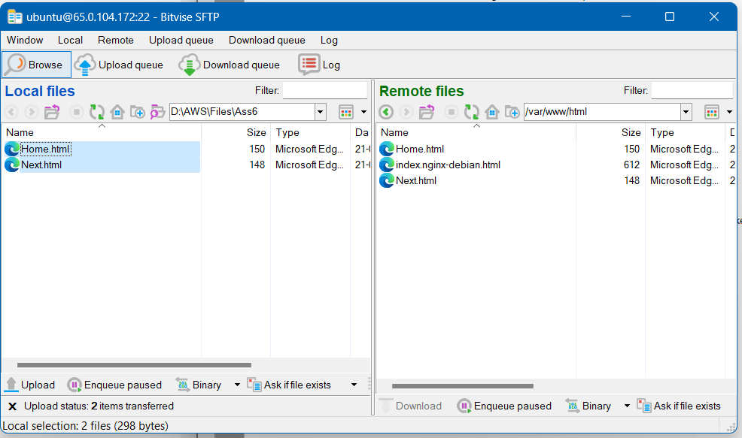

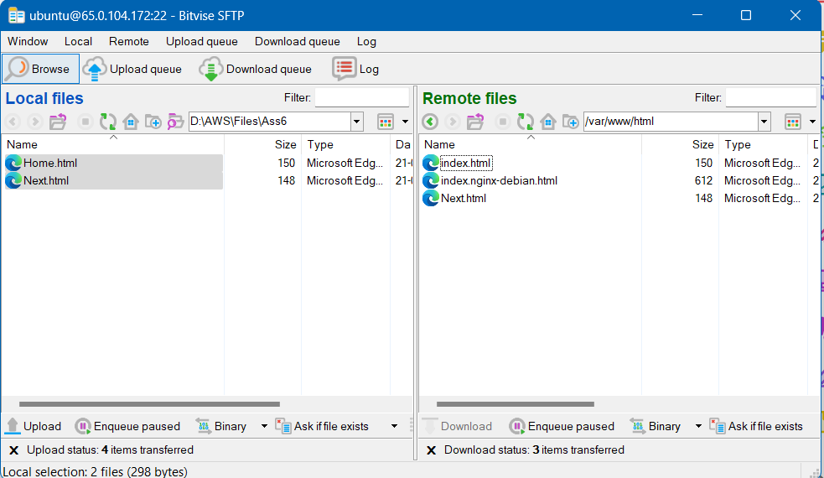

Make sure the home of your webpage is “**index.html**”. If it is not, rename it to **index.html** as nginx takes it as the starting page of the website.

1. Refresh the nginx page your website will be displayed now.

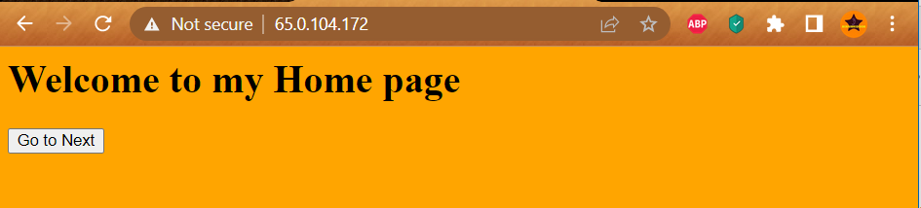

1. Now for **Termination**:
2. Click on instance state On the EC2 Instances page and click on **instance state** then click on terminate instance.

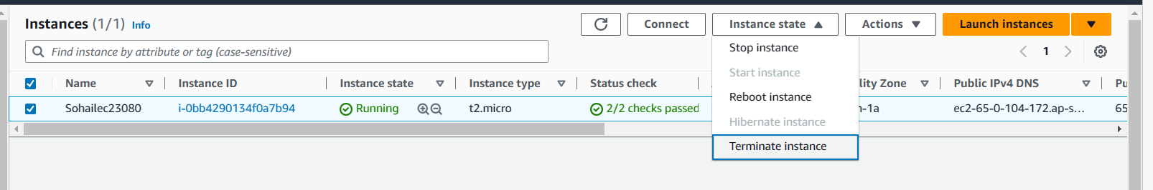

1. Click on **Abort** in Bitvise SSH Client**.**

