ASSIGNMENT 8

***Problem Statement: Deploy a project from local machine to Github and vice versa.***

**CREATE NEW REPOSITORY**

1. Sign in to your Github account.

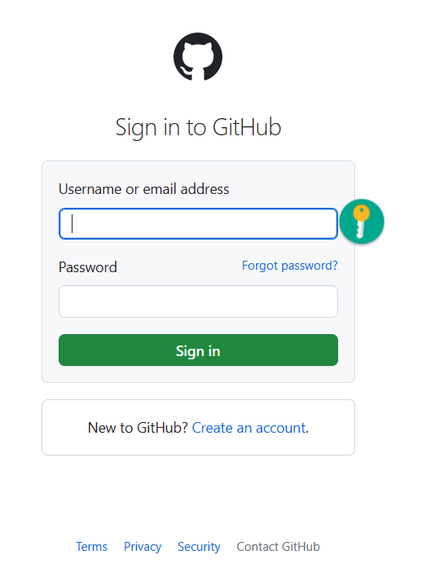

1. Click on the **‘+’** sign in the top right then click on **New repository.**

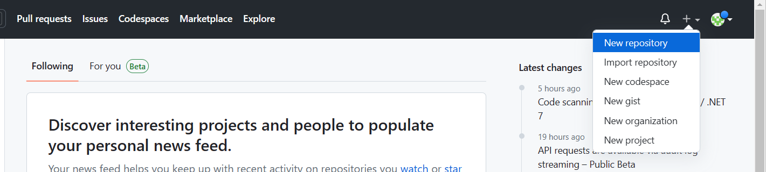

1. Give a **Repository name**. Next, select **Private** and click on **Create repository**.

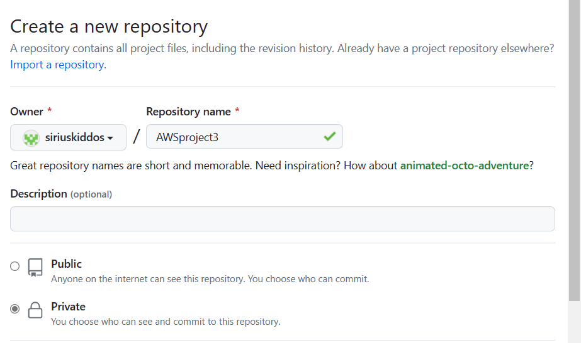



1. Click on your account at the top right, go to **Settings**.

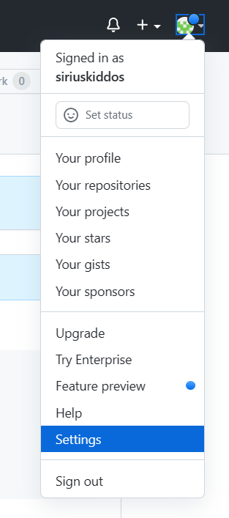

**Then**, go to Developer settings.

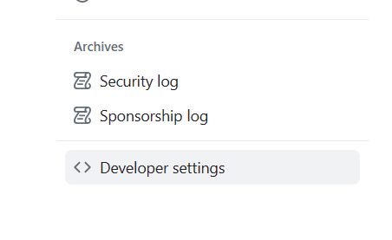

1. Select the drop-down menu of Personal access tokens and click **Tokens (classic).**

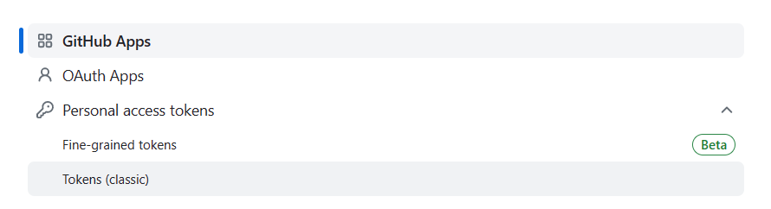

1. Click **Generate new token**, then **Generate new token (classic).**

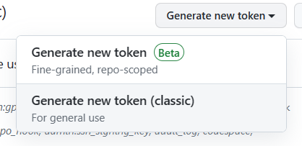

1. Give the Token name, set **Expiration** days as 90 and select all the checkboxes. Click Generate token. Save your token.

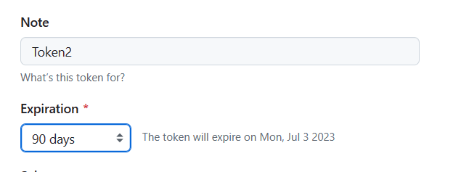

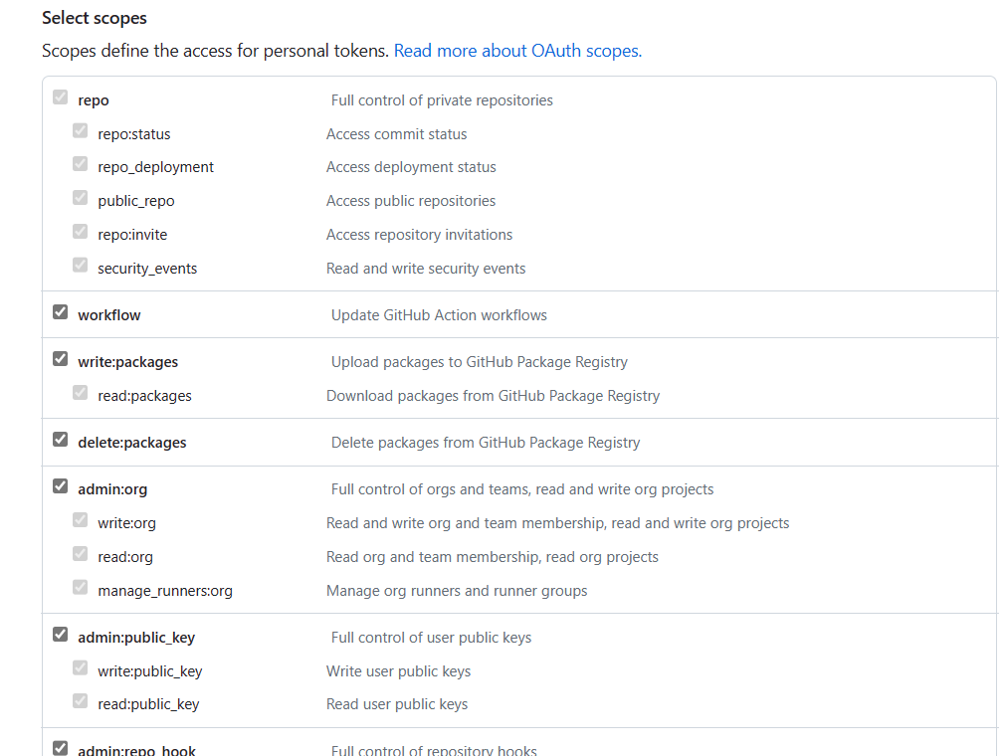

Continue…



1. Go to the newly created repository and then to repository **Settings**. Click **Collaborators**. Then click **Add people** and invite people by searching.



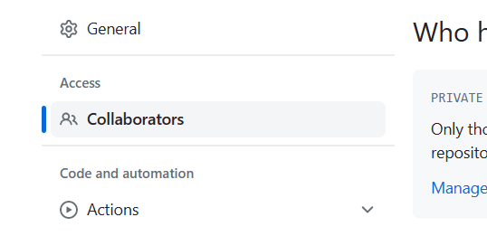



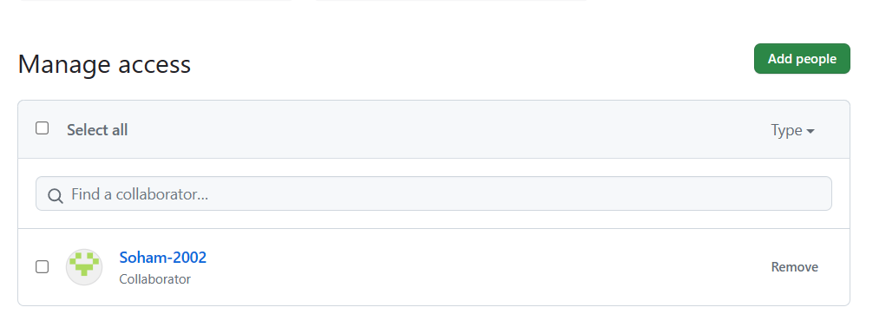

**DEPLOYING A PROJECT FROM LOCAL MACHINE TO GITHUB.**

1. Open the required HTML folder with Git Bash.

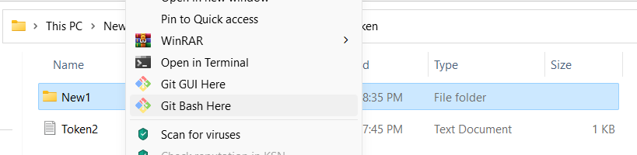

1. Type and execute the following commands one by one.
2. git init

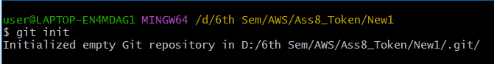

1. ls

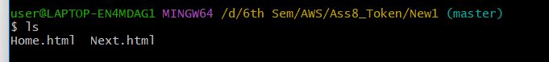

1. git status

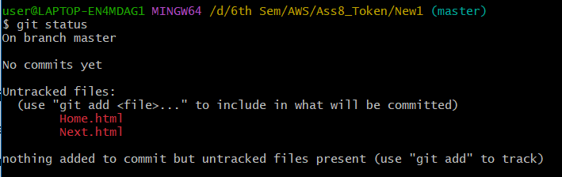

1. git add .
2. git status

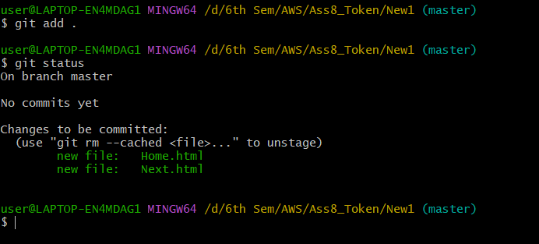

1. git config --global user.email [sohailhaque1234@gmail.com](mailto:sohailhaque1234@gmail.com)



1. git config --global user.name "siriuskiddos"



1. git commit -m “Html files committed”

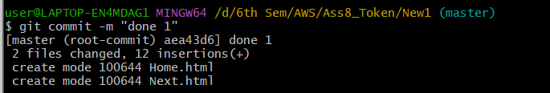

1. git remote add origin https://github.com/siriuskiddos/AWSproject3.git



1. git push -u origin master

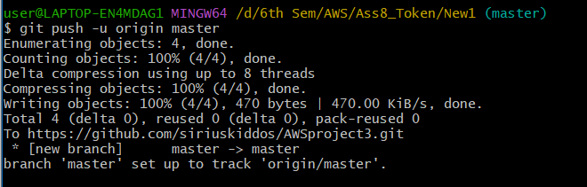

Go to your repository in Github and if it is already open, then refresh.

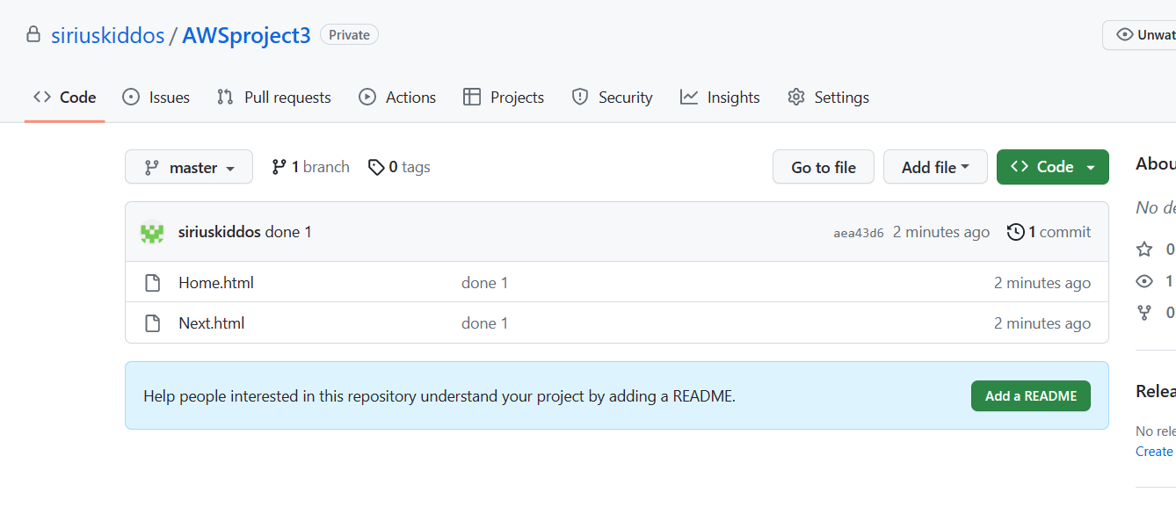

**CLONING A GIVEN REPOSITORY FROM GITHUB TO LOCAL MACHINE AND UPLOADING THAT TO A NEWLY CREATED REPOSITORY**

Cloning from Github to local machine

1. Create new directory and open Gitbash in this folder.



1. Type and execute the following commands
2. git init



1. git clone <https://github.com/sudip7407/New-Repo1.git>

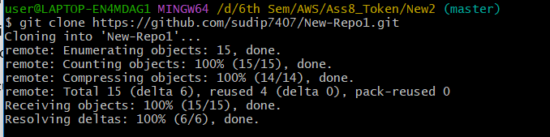

Uploading the cloned project from local machine to my repository

1. Create a new repository in Github
2. Open Gitbash in the cloned folder (remove the already existing .git hidden folder in the folder containing the cloned project.)

Type and execute the following commands

1. git init

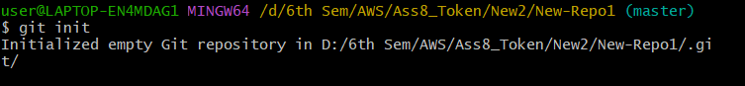

1. git add .



1. git commit -m “Committed”

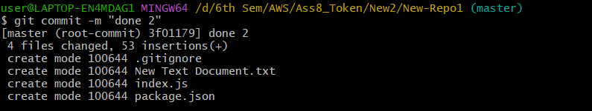

1. git remote add origin <https://github.com/siriuskiddos/AWSproject4.git>



1. git push -u origin master

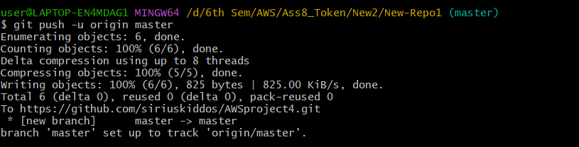

Open the repository and refresh it if it is already opened.

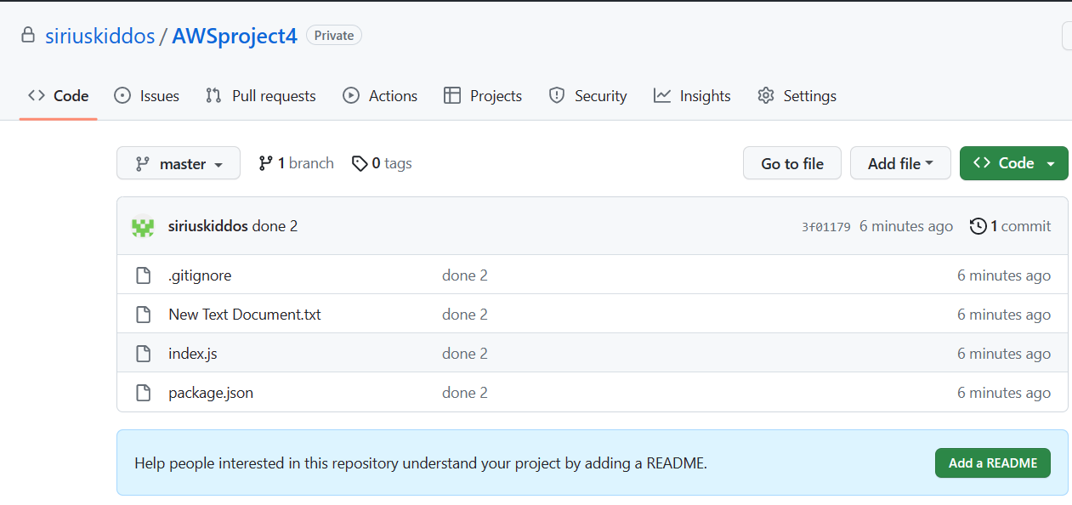

HENCE THE CLONED PROJECT IS SUCCESSFULLY DEPLOYED