ASSIGNMENT 9

***Problem Statement: Deploy a project from Github to EC2.***

1. Sign in to your Github account.

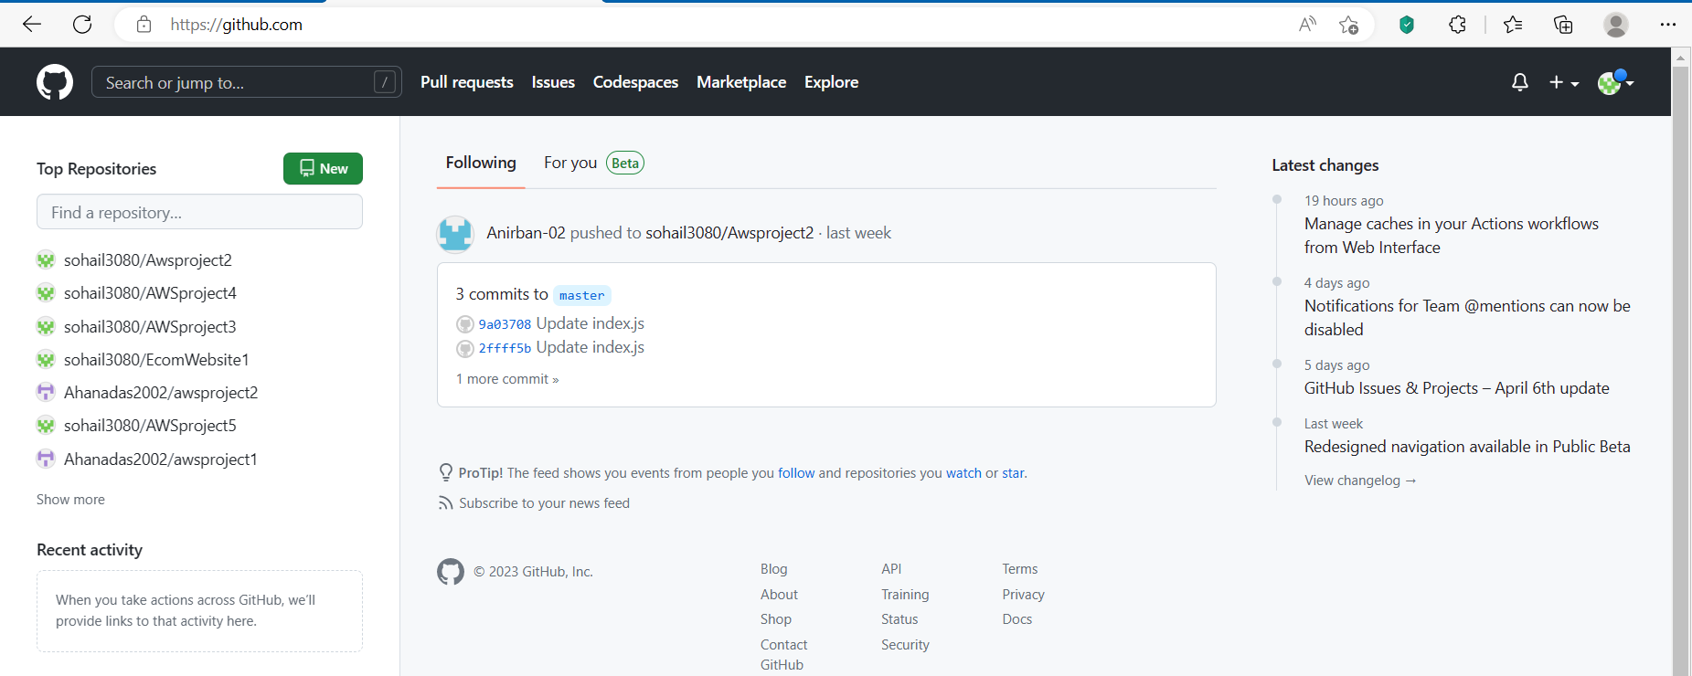

1. Create an EC2 instance in AWS.
2. Sign in to your AWS account and then go to EC2.

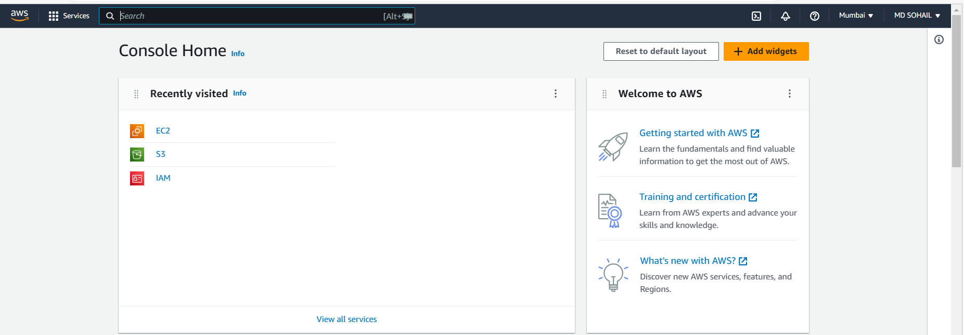

1. Next, Click on ***Launch Instance.***

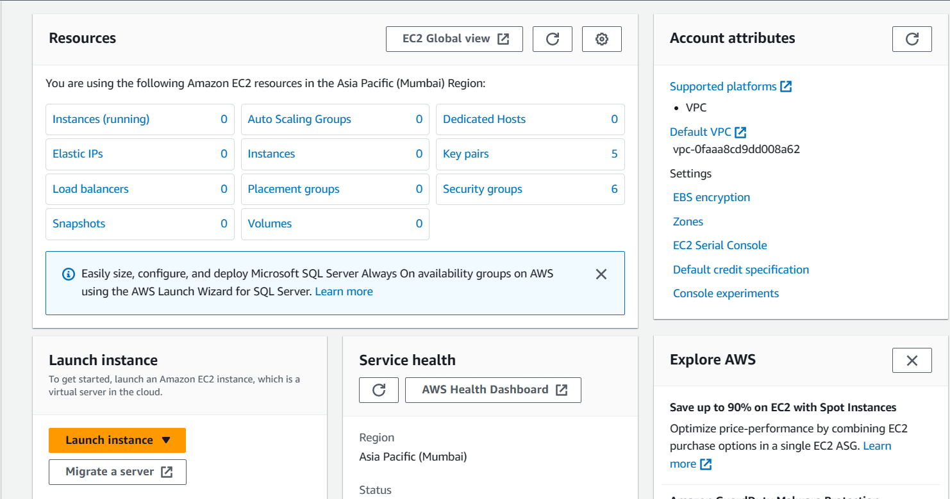

1. Write the instance name. Then, Select an *OS*. Here, we have selected *Ubuntu*.

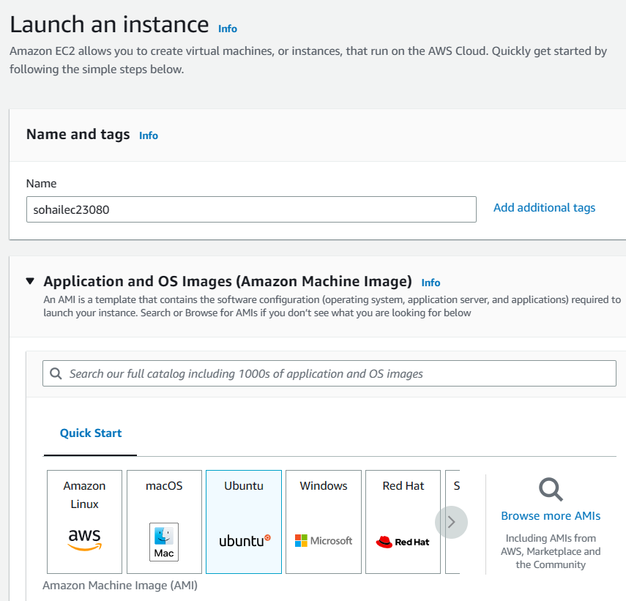

1. We can see the Instance type set here is t2.micro

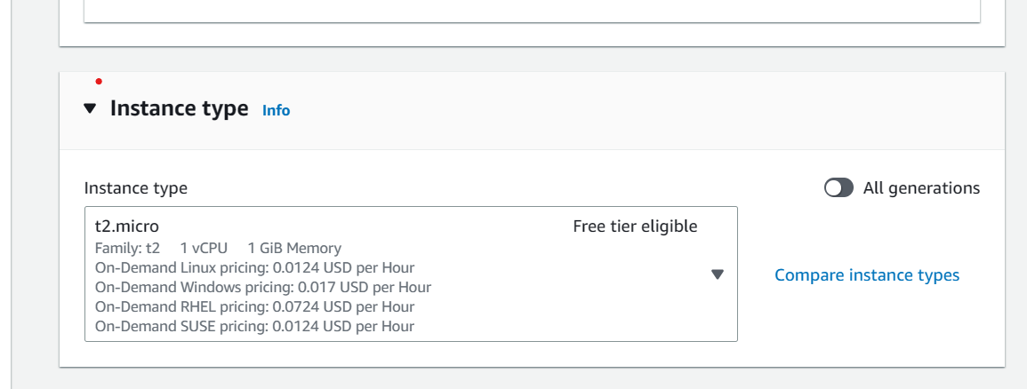

1. We have given a Key pair.

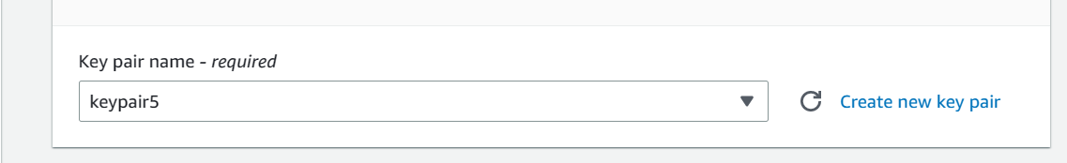

1. Allow the SSH, HTTPS, HTTP traffic from the internet.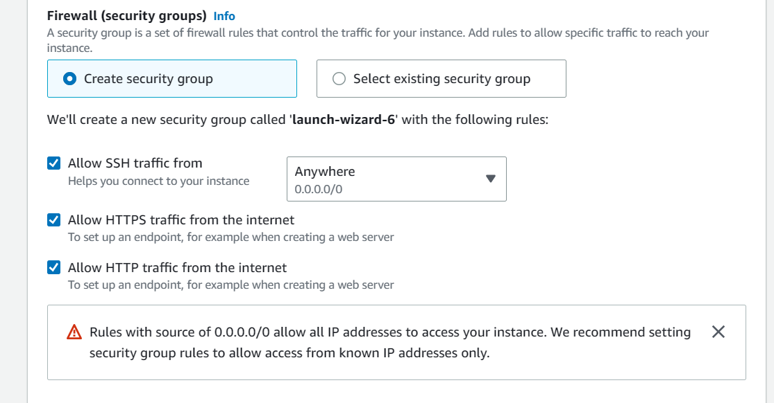
2. Now, Click on ***Launch Instance.***

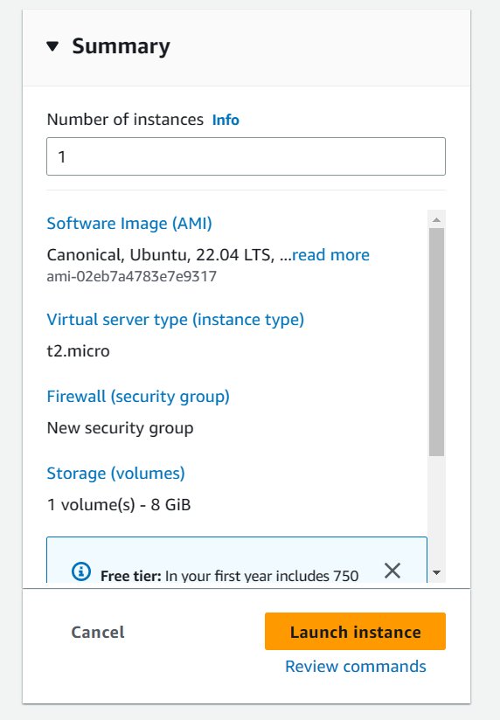

1. Next, copy the *Public IPv4 address*.

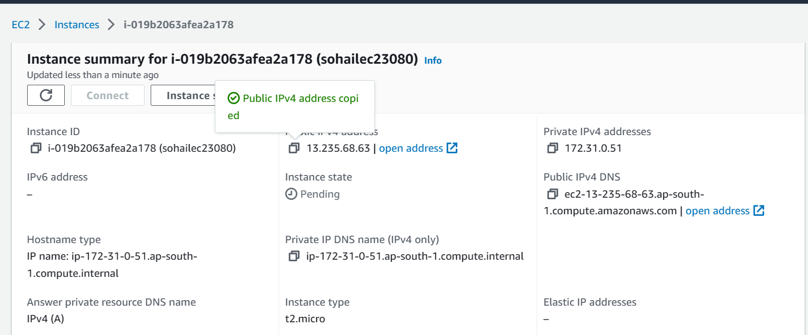

1. Now open Bitvise SSH.
2. Within the Login tab, In the *host* field paste the Public IPv4 address which you have copied earlier. Set the Username as *ubuntu*, Initial method as *public key and* Client key as *Global 1.*

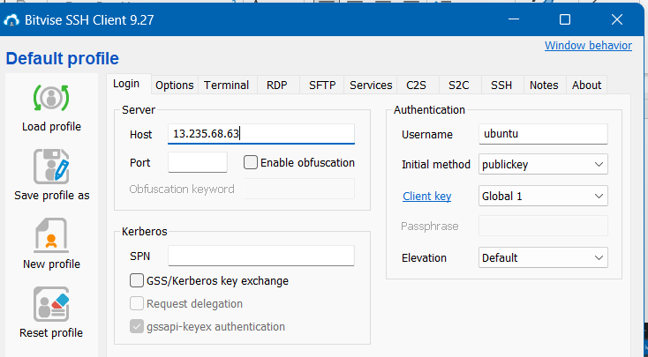

1. Now, Import the key pair.

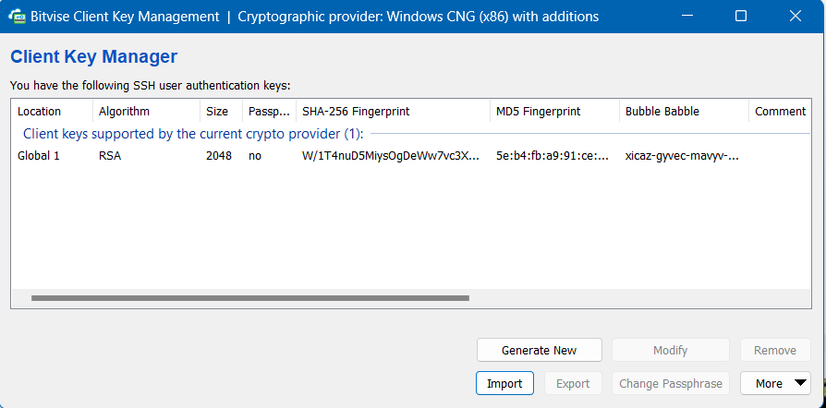

1. Now, Click on **Log in.**

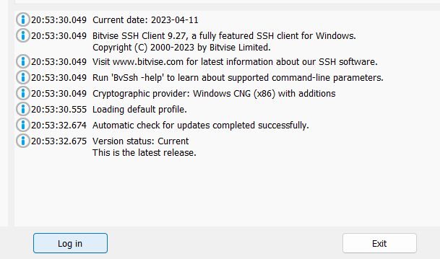

1. Click on *Accept and Save.*

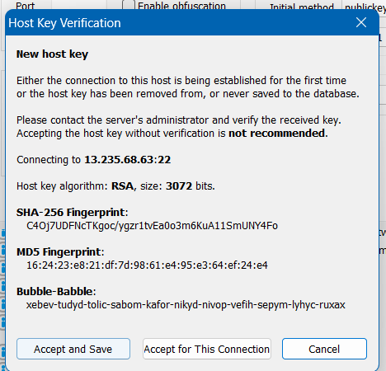

1. Next, Open the **Terminal.**
2. In the *Bitvise SSH Terminal*, Type the following commands in the terminal one by one.
3. pwd



1. sudo apt-get update && sudo apt-get upgrade

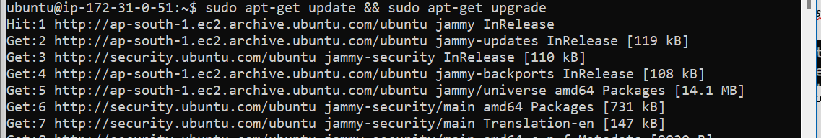

Continuing…

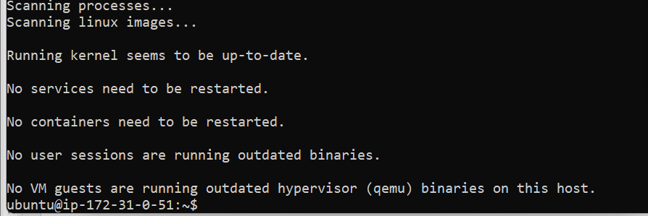

1. sudo apt-get install nginx



Continuing…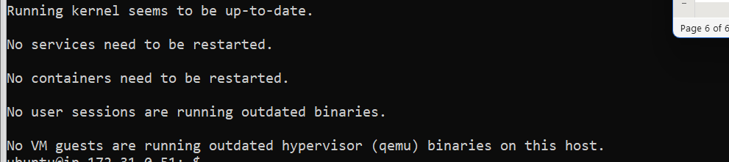

1. nginx -v



1. curl -sL <https://deb.nodesource.com/setup_18.x> | sudo -E bash –

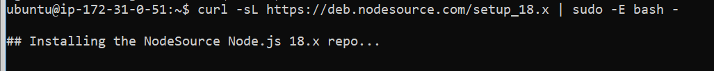

Continuing…

1. sudo apt install nodejs

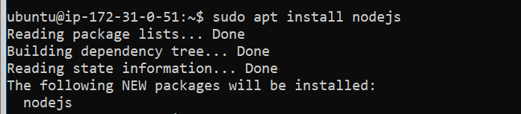

Continuing…

1. node -v



1. Now, copy the HTTPS link of the Github Repository.

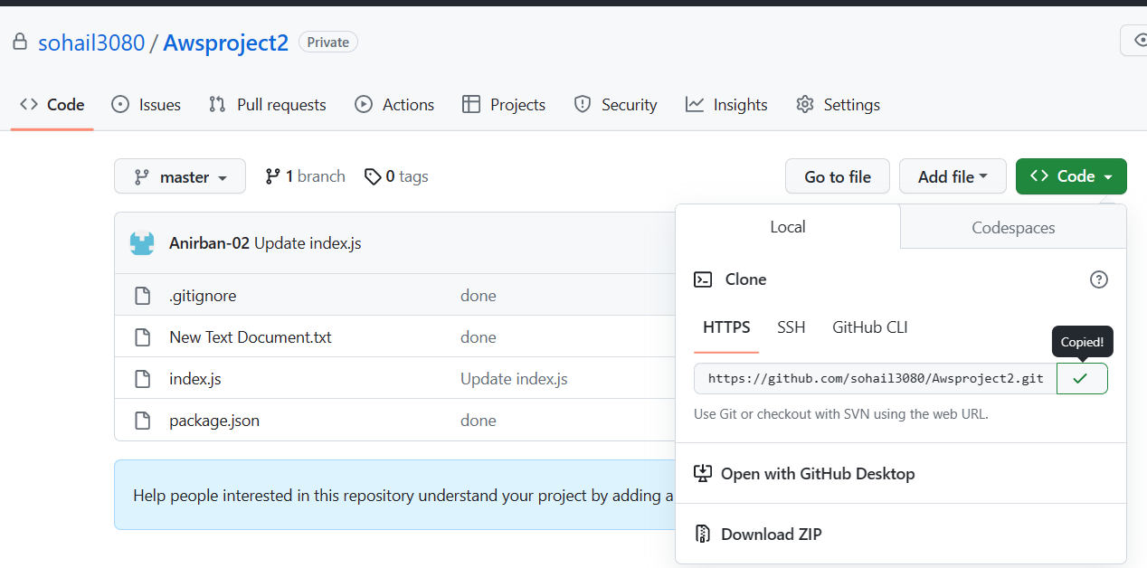

Again, go to Bitvise SSH terminal and type the following command to clone the repository in the EC2 server.

git clone <https://github.com/sohail3080/Awsproject2.git>

Now, give the Username and Password(Token)

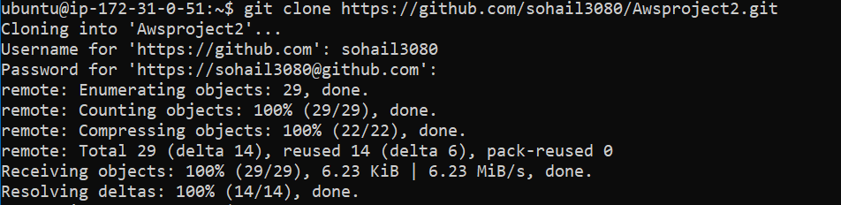

1. dir



1. cd Awsproject2



1. dir



1. npm install

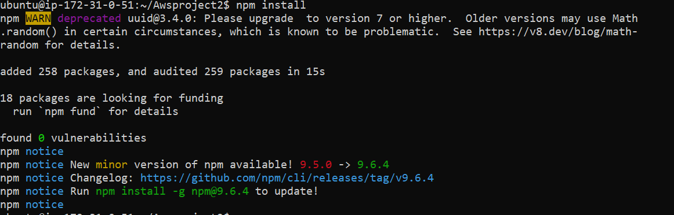

1. node index.js

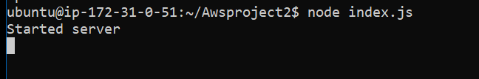

1. Copy the Public IPv4 address and paste it in a browser.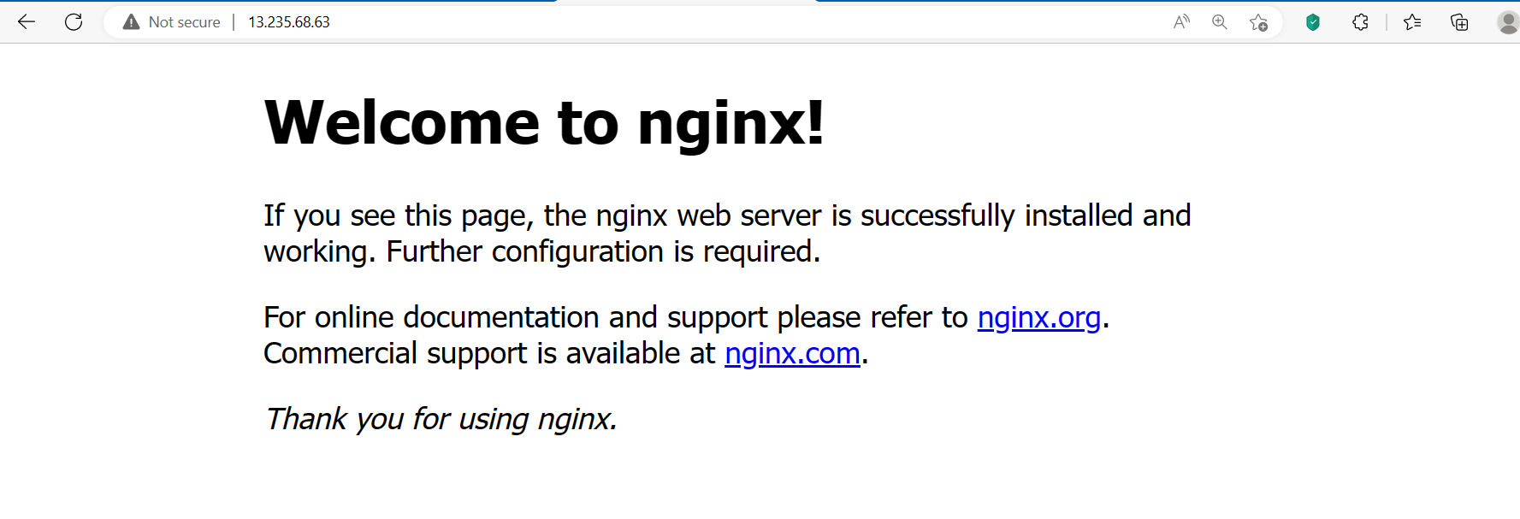
2. We cannot see our website in any port.

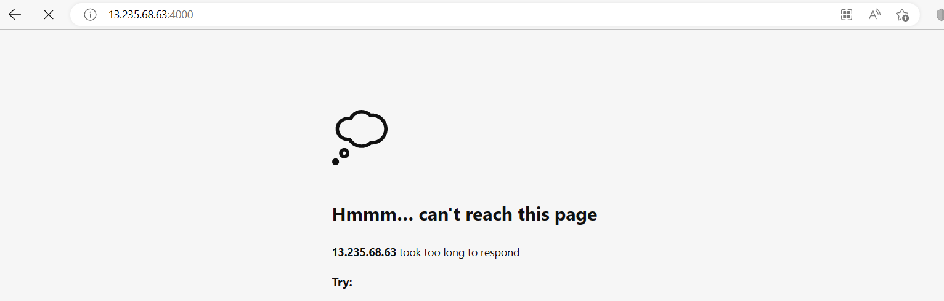

1. Now, to see our website in port 4000, we have to follow the steps.
2. Within the instance you create, got to the Security tab.



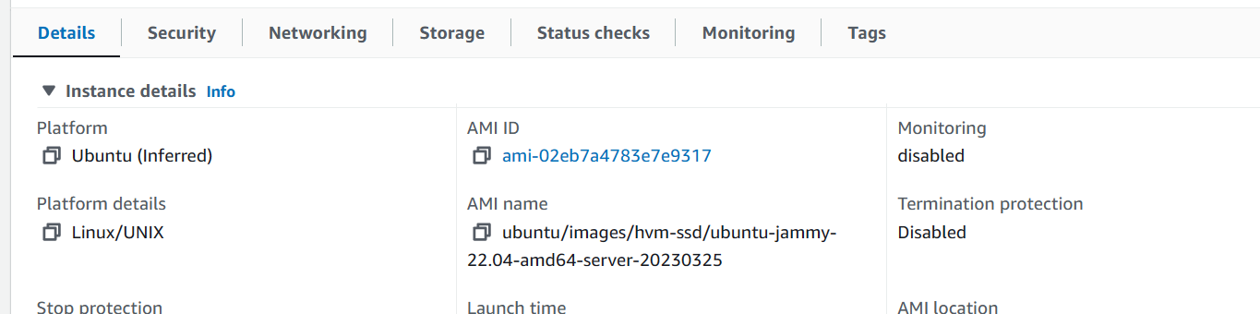

1. Next, Go to the Security groups.

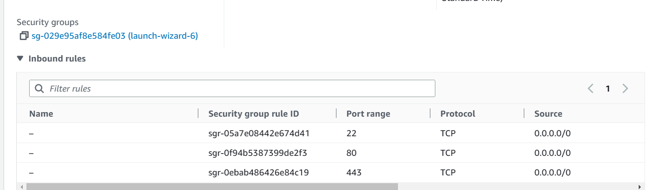

1. Next, Click on Edit inbound rules.

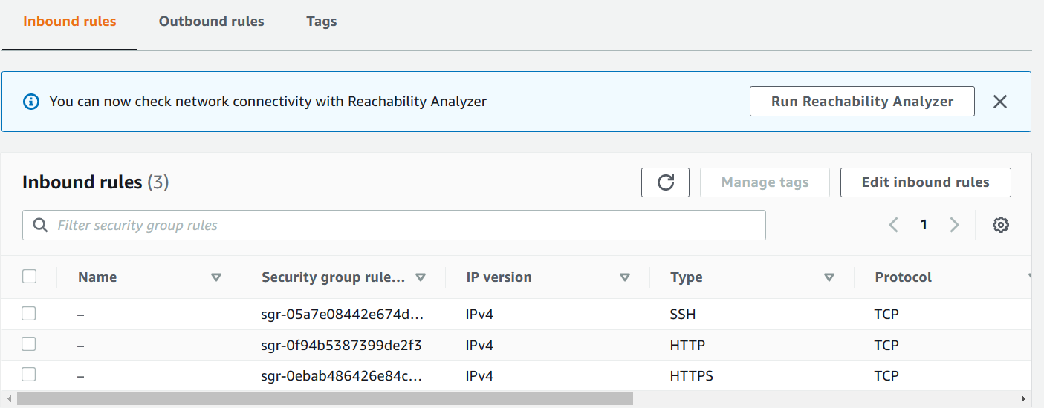

1. Now, add a custom TCP with port 4000 and source 0.0.0.0/0 and Save rules.

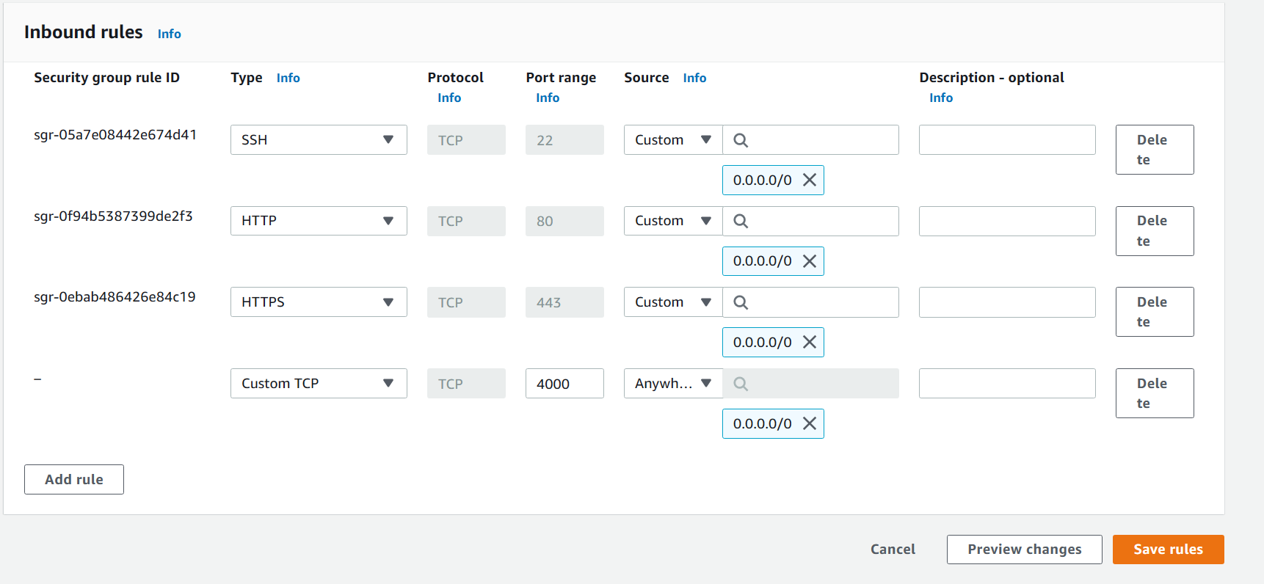

1. We can see that the new rule is added.

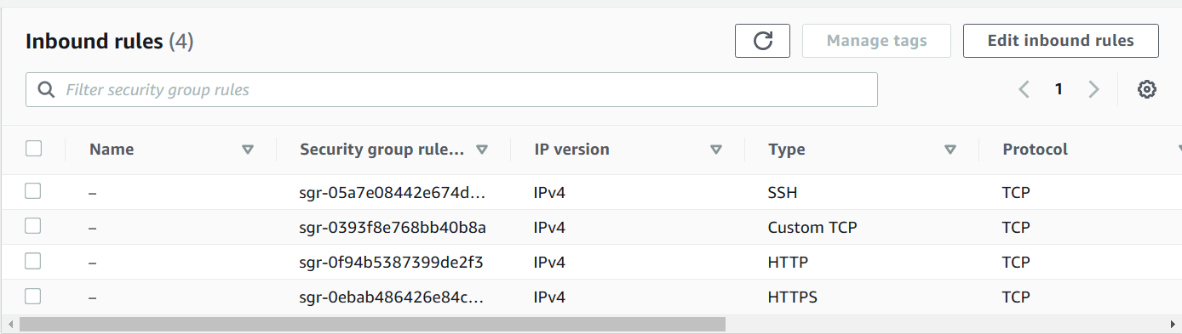

1. Now, add the port number 4000 after the Public IPv4 address you have in the browser URL.



We can see the Text “Hello”. Thus, it is working.

1. Making changes in the webpage.
2. Go to index.js file in your Github Repository. Then, Click on the pen icon.

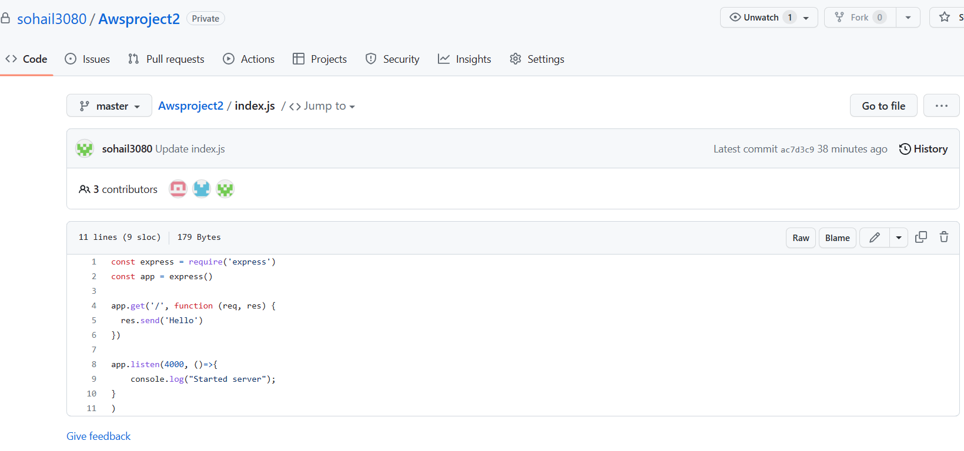

1. Edit the code.

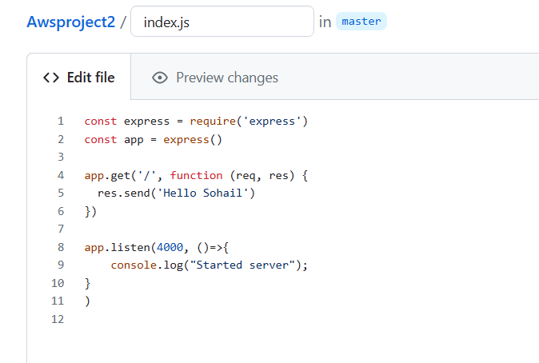

1. Click **Commit changes**.

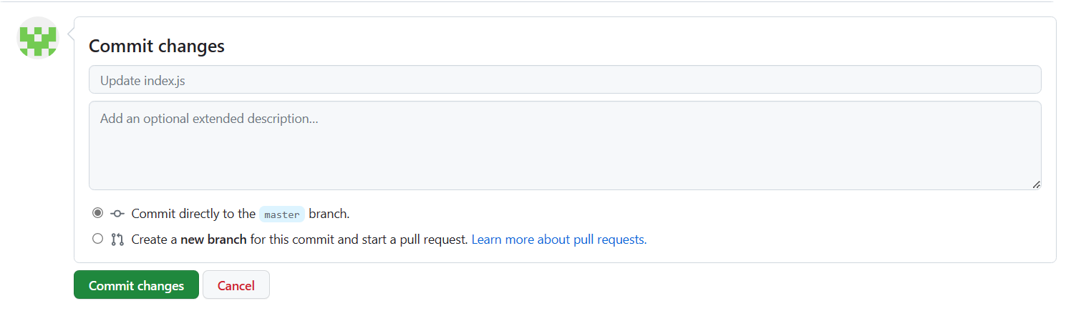

1. Now, go to the Bitvise terminal and run the following commands respectively.

* Stop the server first.

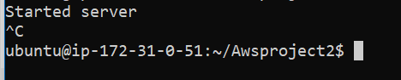

* git pull

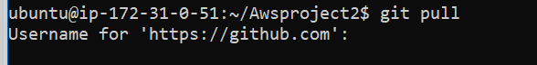

Give *username* and *password*.

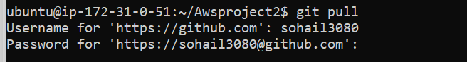

You can see the change is done. i.e. 1 file changed, 1 insertion(+), 1 deletion(-)

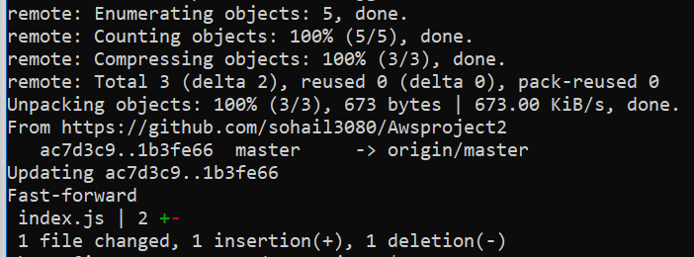

* Start the server again.

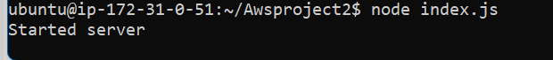

* Refresh the page and we can see the changes.

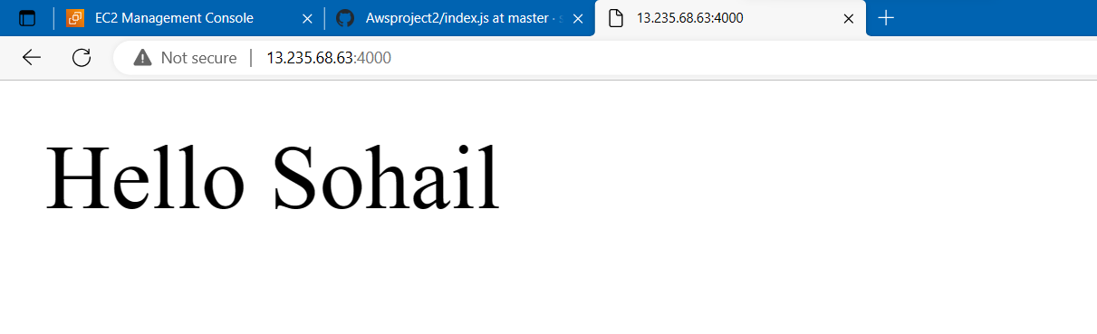

1. Terminate the EC2 server.

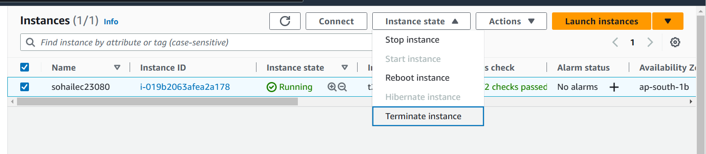

Next, Logout of **Bitvise SSH Client** by clicking *Abort*.