Machine Learning Transformers

1. Imputation
When working with datasets, you may encounter missing values. Imputation is the process of filling or replacing these missing values to maintain data integrity.
✅ Techniques for Imputation:
- Mean Imputation: Replace missing values with the mean of the column (for numerical data).
  - Example: If the age column has missing values, replace them with the average age.
- Median Imputation: Use the median for columns with skewed data (outliers).
- Mode Imputation: For categorical variables, replace missing values with the most frequent value.
- K-Nearest Neighbors (KNN) Imputation: Predict missing values based on the nearest neighbors.
- Forward/Backward Fill: Fill missing values using previous or next observations (time-series data).

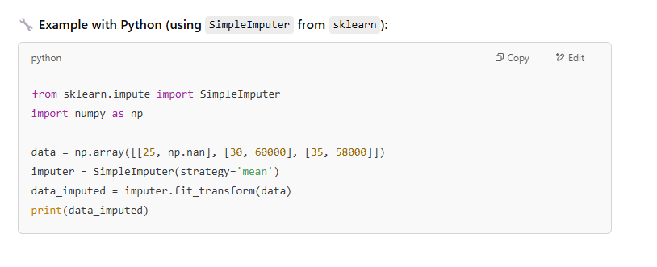
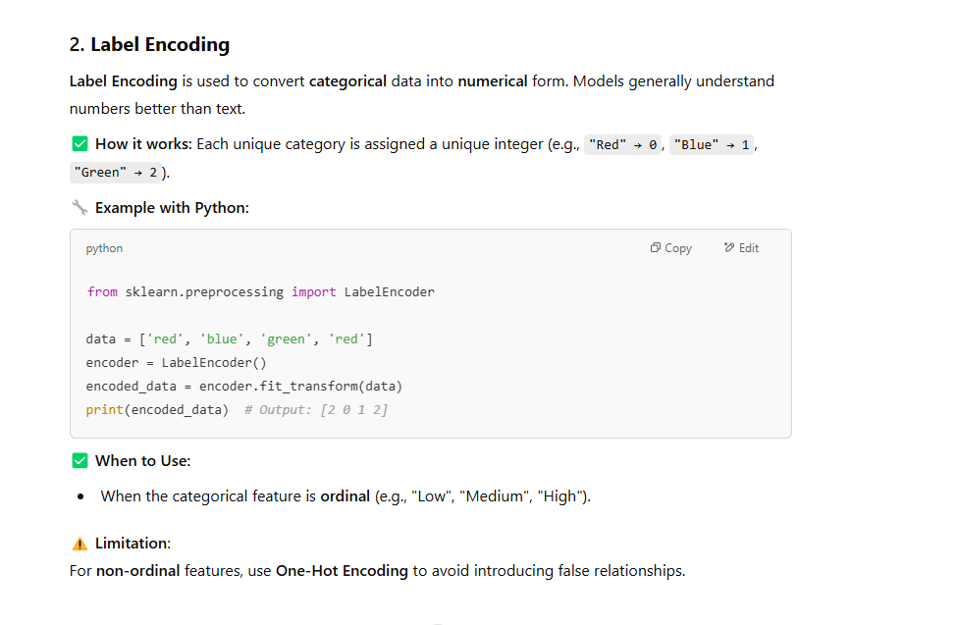

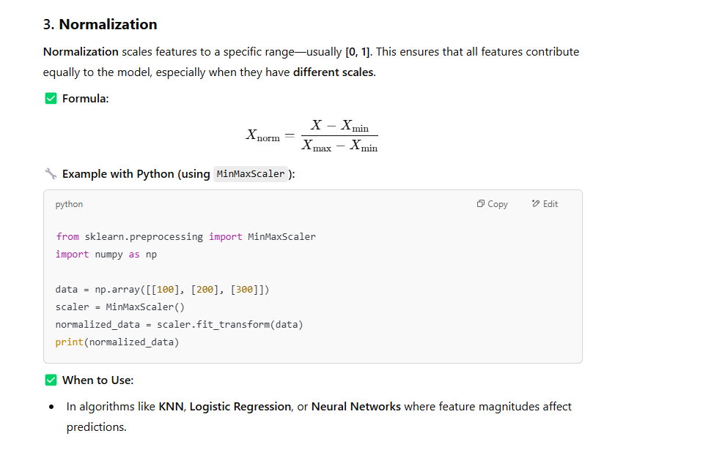
It ranges from 0 to 1

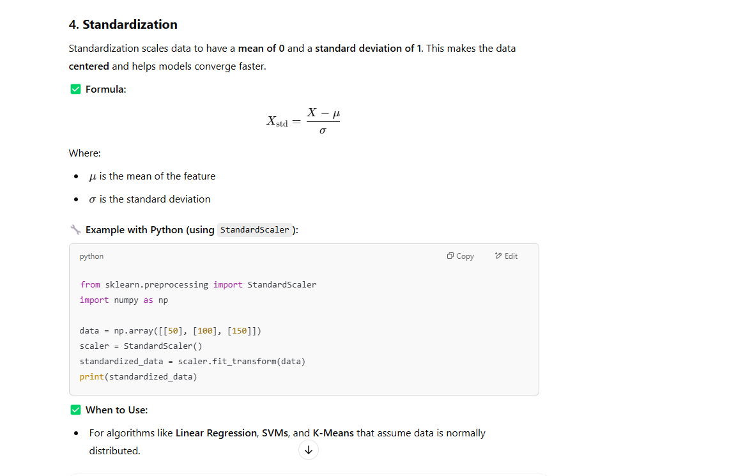
It ranges from -3 to 3
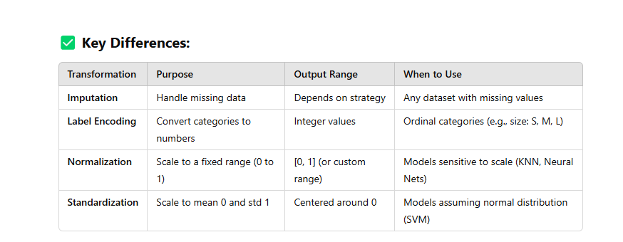

EDA Transformers
