Wednesday, May 06, 2015

703657 PS/2 Web Engineering

Project Design Report

Team : MYLE
Daly Chea
Alexandra Jäger
Carmen Vierthaler

I. Project Model

1.1. Content Model
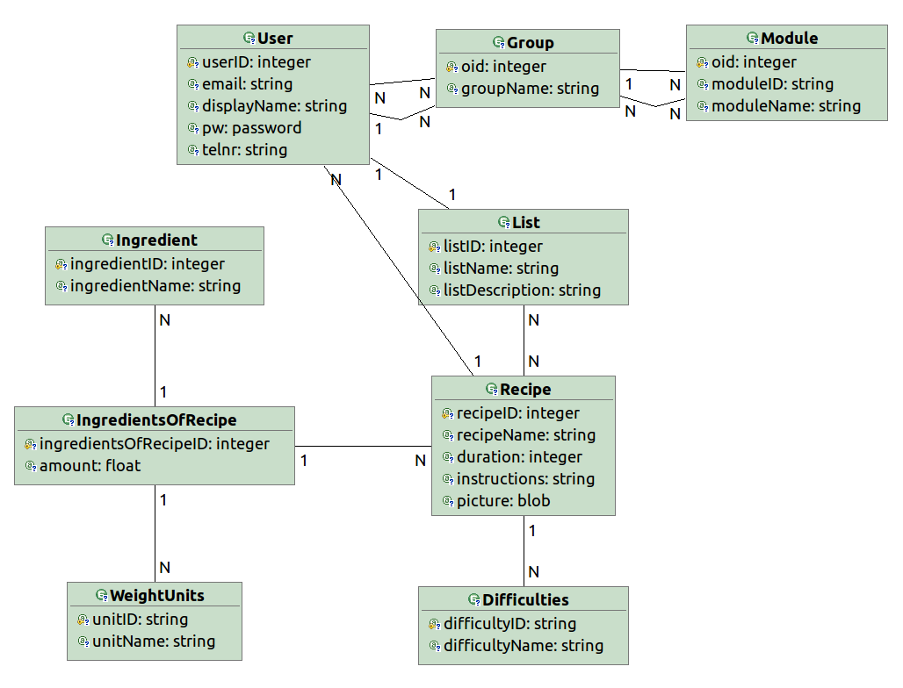

Description:
The recipe is the core element. Each recipe has attributes like name of the recipe and instructions. The difficulty level is predefined and is chosen for a recipe. The ingredients are predefined as well and connected to the recipe. This relation includes the ingredient with necessary amount for the recipe with one of the provided weight units. Additionally each recipe is owned by one user.
The list class is used to store the favorite recipes of a user. Each list is owned by one user and can be linked to several recipes.

Group and Model are mandatory elements of WebRatio in order to provide access control. In order to link a user to the allowed modules which are called site-views, each user is linked to at least one group which is connected to the permitted site-views.

1.2. Hypertext / Navigation Model
Site-view “Guest”

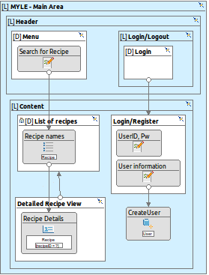

Site-view “Logged-in user”

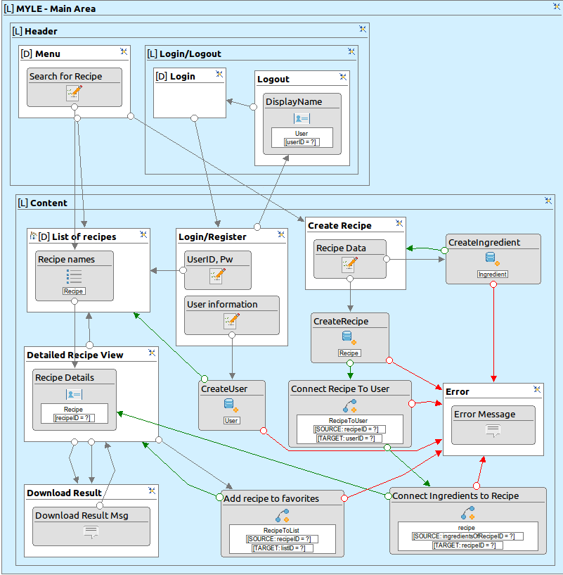

Description:
In WebRatio site-views are used for the presentation model in combination with the navigation model. The site-views are used for access control which is already mentioned in 1.1 Content Model.

The site-view “Guest” is used for visitors of the website and the site-view “Logged-in user” is for user which are registered and logged-in. Guest of the website have limited access to the functions.

Site-view “Guest”:
Guests are able to search for existing recipes and view the recipe details. Furthermore they are able to register a new user and log-in.

Site-view “Logged-in user”: Additionally to the features of the guests “Logged-in user” can download a recipe or add it to their favorite list. These user can get a list of their favorite recipes.
Furthermore they have the ability to create new recipes including the necessary ingredients. The user which created the recipe is the owner of the recipe. If the available ingredients are not suitable new ingredients can be created.

When the user view a random recipe a shopping list with the ingredients and their amounts can be downloaded.
At the end of the session the user can logout.

1.3. Presentation Model
see above in 1.2 Hypertext / Navigation Model
Briefly describe your presentation model

II. Application Architectures

Technologies
At this point, you should be able to choose the most suitable technologies (e.g. framework, libraries, database) for your application. List the technologies here.

Scripting language: PHP 5
Web-application framework Zend 2 (MVC included)
Server and Database: Xampp (mySQL database included, Apache Tomcat)

III. Testing and Usability

Testing Design
Unit testing framework: PHPUnit

The CRUD operations include create, read, update and delete. Currently, in our application, we only plan to support the creation and reading of elements, due to the relatively short time we have to implement our application.

Plan to test a CRUD operation:

1) User: Creation and reading
- check if user is not yet in the database
- if no user with given email address is registered, create a new user with email address, display name, password and telephone number
- check if user was stored correctly by reading the data of the user data from the database

2) Recipe: Creation and reading
check for data which are predefined:
- check if the ingredients used in the recipe are available in the database
- check if weight units and difficulties are available in the database
- check if the creator of the recipe is a registered user
- create a new recipe with name, duration, instructions, difficulty, ingredients for recipe with necessary amounts and weight unit
- check if recipe was stored correctly by reading data of the recipe from the database

