**using** System;  
  
**namespace** arays  
{  
    class Program  
    {  
        **public** static void **Main**(string[] args)  
        {  
          
            Console.**WriteLine**("Hello. Welcome to leasecar.com");  
            // arrays usage  
              
              
            string[] name=**new** string[10];  
            string[] vehicle={"alto","baleno","duster","torrato","swift","innova"};  
            **int**[] leaseamount={2000,3300,1000,3000,4000,4399};  
            string vehicle_name;  
            **int** j=1;  
            **char** option,yn;  
            **do**  
            {  
          
  
                Console.**Write**("\n\nEnter your name to continue: ");  
                  
                name[j]=Console.**ReadLine**();  
                  
                Console.**Write**("\n\nHello "+name[j]);  
                  
                  
                Console.**Write**("\n\nVehicles availble with lease amount are: ");  
                **foreach**(string i **in** vehicle)  
                {  
                    Console.**Write**("\n\n"+i);  
                          
                      
                }  
                  
                  
               Console.**Write**("\n\nWould like to book? (y/n)");  
               yn=Console.**ReadKey**(**true**).KeyChar;  
               **if**(yn.**Equals**('y'))  
               {  
                   Console.**Write**("\n\nEnter vehicle name to book: ");  
                   vehicle_name=Console.**ReadLine**();  
                   **for**(**int** i=0;i<6;i++)  
                   {  
                       **if**(vehicle_name.**Equals**(vehicle[i]))  
                       {  
  
                               Console.**Write**("\n\nSuccessfully booked");  
                               Console.**Write**("\n\nVehicle: "+vehicle[i]);  
                               Console.**Write**("\n\nAmount: "+leaseamount[i]);  
                               vehicle[i]="";  
                               leaseamount[i]=0;  
                                 
                               break;  
                       }  
                       }  
                   }  
                 
               Console.**Write**("\n\n\nWould like to perform the task again?(y/n)");  
               option=Console.**ReadKey**(**true**).KeyChar;  
            }  
            **while**(option.**Equals**('y'));  
            Console.**Write**("\n\nSorry to say Goodbye. See you soon.");  
            Console.**ReadKey**();  
        }  
    }  
}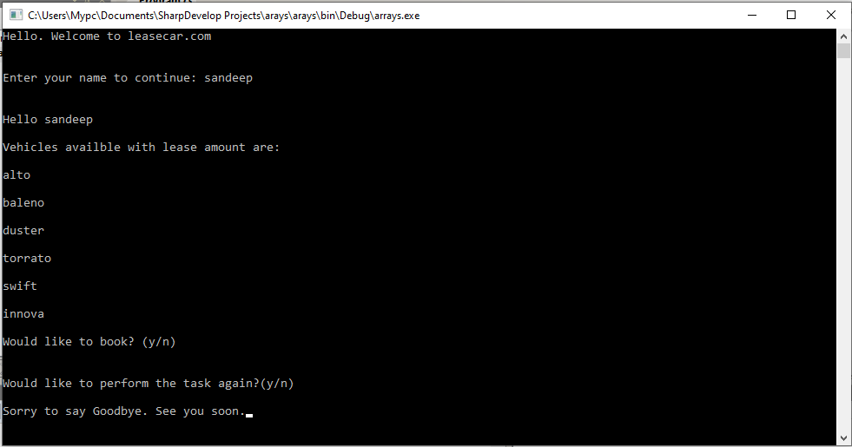

**6.**

**using** System;  
  
**namespace** arrays  
{  
    class Program  
    {  
        static void **Main**(string[] args)  
        {  
            Console.**WriteLine**("Hello World!");  
              
            **char** option;  
            **do**  
            {  
  
                Console.**Write**("\n\n1. Single Dimensional Array\n\n2. Two Dimensional Arrya\n\n3. Jagged Array \n\nChoose your option: ");  
  
                **int** choice = Convert.**ToInt32**(Console.**ReadLine**());  
  
                **switch** (choice)  
                {  
                    **case** 1:  
  
                        Console.**Write**("\n\nStudent information System");  
                        Console.**Write**("\n\nEnter number of students: ");  
                        **int** number = Convert.**ToInt32**(Console.**ReadLine**());  
                        **if** (number > 0)  
                        {  
  
                            string[] Names = **new** string[number];  
                            **int**[] Marks = **new** **int**[5];  
                            string[] Result = **new** string[6];  
                            string[] grade = **new** string[6];  
  
  
  
                            **for** (**int** i = 0; i <number; i++)  
                            {  
                                Console.**Write**("\n\nStudent details of "+i);  
                                Console.**Write**("\n\nStudent Name: ");  
                                Names[i] = Console.**ReadLine**();  
                                Console.**Write**("\n\nTotal Marks: ");  
                                Marks[i] = Convert.**ToInt32**(Console.**ReadLine**());  
                                **if** (Marks[i] >= 0 && Marks[i] <= 500)  
                                {  
                                    **if** (Marks[i] >= 450)  
                                        grade[i] = "Distinction";  
                                    **else**  
                                    **if** (Marks[i] >= 400)  
                                        grade[i] = "First Class";  
                                    **else**  
                                    **if** (Marks[i] >= 350)  
                                        grade[i] = "Second Class";  
                                    **else**  
                                    **if** (Marks[i] >= 300)  
                                        grade[i] = "Third Class";  
                                    **else**  
                                        grade[i] = "Pass";  
                                }  
                                **else**  
                                    Result[i] = "Invalid";  
                           }  
                           Console.**WriteLine**("\n\nStudent Details:");  
                           **for** (**int** i = 0; i <number; i++)  
                           {  
  
                                Console.**WriteLine**((i + 1) + ". " + Names[i] + " - " + Marks[i] + " - Subjects: " + Result[i]+" Grade: "+grade[i]);  
  
                            }  
                        }  
                        **else**  
                        Console.**WriteLine**("\n\nAt least enter 1 student");  
                        Console.**Read**();  
  
                        break;  
  
                    **case** 2:  
  
                        **int**[,] matrix1 = **new** **int**[3,3];  
                        **int**[,] matrix2 = **new** **int**[3,3];  
                        **int**[,] result_add = **new** **int**[3, 3];  
                        **int**[,] result_sub = **new** **int**[3, 3];  
                        **int**[,] result_mult = **new** **int**[3, 3];  
                        **int**[,] result_div = **new** **int**[3, 3];  
  
                        Console.**Write**("\n\nEnter first matrix 3*3 i.e 9 elements\n");  
                        **for** (**int** i = 0; i < 3; i++)  
                        {  
                            **for** (**int** j = 0; j < 3; j++)  
                            {  
                                matrix1[i, j] = Convert.**ToInt32**(Console.**ReadLine**());  
                            }  
                        }  
                        Console.**Write**("\n\nEnter second matrix 3*3 i.e 9 elements\n");  
                        **for** (**int** i = 0; i < 3; i++)  
                        {  
                            **for** (**int** j = 0; j < 3; j++)  
                            {  
                                matrix2[i, j] = Convert.**ToInt32**(Console.**ReadLine**());  
                            }  
                        }  
                        Console.**Write**("\n\nThe first matrix is\n");  
                        **for** (**int** i = 0; i < 3; i++)  
                        {  
                            **for** (**int** j = 0; j < 3; j++)  
                            {  
                                Console.**Write**(" " + matrix1[i, j]);  
                            }  
                            Console.**Write**("\n");  
                        }  
  
  
                        Console.**Write**("\n\nThe second matrix is \n");  
                        **for** (**int** i = 0; i < 3; i++)  
                        {  
                            **for** (**int** j = 0; j < 3; j++)  
                            {  
                                Console.**Write**(" " + matrix2[i, j]);  
                            }  
                            Console.**Write**("\n");  
                        }  
  
  
                        **for** (**int** i = 0; i < 3; i++)  
                        {  
                            **for** (**int** j = 0; j < 3; j++)  
                            {  
                                result_add[i, j] = matrix1[i, j] + matrix2[i, j];  
                                result_sub[i, j] = matrix1[i, j] - matrix2[i, j];  
                                result_mult[i, j] = matrix1[i, j] * matrix2[i, j];  
                                result_div[i, j] = matrix1[i, j] / matrix2[i, j];  
                            }  
                        }  
                          
                        Console.**Write**("\n\nAn Addition\n\n");  
                        **for** (**int** i = 0; i < 3; i++)  
                        {  
                            **for** (**int** j = 0; j < 3; j++)  
                            {  
                                Console.**Write**(" "+result_add[i, j]);  
                            }  
                            Console.**Write**("\n");  
  
                        }  
                        Console.**Write**("\n\nSubstraction\n\n");  
                        **for** (**int** i = 0; i < 3; i++)  
                        {  
                            **for** (**int** j = 0; j < 3; j++)  
                            {  
                                Console.**Write**(" " + result_sub[i, j]);  
                            }  
                            Console.**Write**("\n");  
  
                        }  
                        Console.**Write**("\n\nMultiplication\n\n");  
                        **for** (**int** i = 0; i < 3; i++)  
                        {  
                            **for** (**int** j = 0; j < 3; j++)  
                            {  
                                Console.**Write**(" " + result_mult[i, j]);  
                            }  
                            Console.**Write**("\n");  
  
                        }  
                        Console.**Write**("\n\nDivision\n\n");  
                        **for** (**int** i = 0; i < 3; i++)  
                        {  
                            **for** (**int** j = 0; j < 3; j++)  
                            {  
                                Console.**Write**(" " + result_div[i, j]);  
                            }  
                            Console.**Write**("\n");  
                        }  
                        break;  
                    **case** 3:  
                          
                        **int**[][,] jarray = **new** **int**[2][,]; // 2 is  for two matrix  
  
//                        jarray[0] = new int[3, 3] {{5,4,3},{4,3,4},{2,3,6}}; // first matrix  
  //                      jarray[1] = new int[3, 2] { { 5, 4 }, { 2, 4 }, { 6, 3 } }; // second matrix  
  
                        jarray[0] = **new** **int**[3, 3]; // 3 columns and 3 rows  
                        jarray[1] = **new** **int**[3, 3]; // 3 columns and 3 rows  
  
                        **int**[][,] jarray_result = **new** **int**[4][,]; // 4 matrices for add,sub,mult,div  
                        jarray_result[0] = **new** **int**[3,3]; // 3 colns and 3 rows  
                        jarray_result[1] = **new** **int**[3, 3];  
  
                        jarray_result[2] = **new** **int**[3, 3];  
  
                        jarray_result[3] = **new** **int**[3, 3];  
  
  
  
                        Console.**Write**("\n\nEnter first matrix 3*3 i.e 9 elements\n\n");  
  
                          
                            **for**(**int** j=0;j<3;j++)  
                            {  
                                **for**(**int** k=0;k<3;k++)  
                                {  
                                    jarray[0][j,k] = Convert.**ToInt32**(Console.**ReadLine**());  
                                }  
                            }  
                        Console.**WriteLine**("\n\nEnter second matrix 3*3 i.e 9 elements\n\n");  
                        **for** (**int** j = 0; j < 3; j++)  
                        {  
                            **for** (**int** k = 0; k < 3; k++)  
                            {  
                                jarray[1][j, k] = Convert.**ToInt32**(Console.**ReadLine**());  
                            }  
                        }  
  
                        **for** (**int** i = 0; i < 2; i++)  
                        {  
                            Console.**Write**("\n\nThe matrix "+i+" is\n\n");  
  
                            **for** (**int** j = 0; j < 3; j++)  
                            {  
                                **for** (**int** k = 0; k < 3; k++)  
                                {  
                                    Console.**Write**(" " + jarray[i][j, k]);  
                                }  
                                Console.**WriteLine**("");  
                            }  
                        }  
  
                        **for** (**int** j = 0; j < 3; j++)  
                        {  
                            **for** (**int** k = 0; k < 3; k++)  
                            {  
                                jarray_result[0][j, k] = jarray[0][j, k] + jarray[1][j, k];  
                                jarray_result[1][j, k] = jarray[0][j, k] - jarray[1][j, k];  
  
                                jarray_result[2][j, k] = jarray[0][j, k] * jarray[1][j, k];  
  
                                jarray_result[3][j, k] = jarray[0][j, k] / jarray[1][j, k];  
  
                            }  
                        }  
                        Console.**Write**("\n\nMatrix Addition is\n\n");  
                            **for** (**int** j = 0; j < 3; j++)  
                            {  
                                **for** (**int** k = 0; k < 3; k++)  
                                {  
                                    Console.**Write**(" " + jarray_result[0][j, k]);  
                                }  
                                Console.**WriteLine**("");  
                            }  
                        Console.**Write**("\n\nMatrix substraction is \n\n");  
                        **for** (**int** j = 0; j < 3; j++)  
                        {  
                            **for** (**int** k = 0; k < 3; k++)  
                            {  
                                Console.**Write**(" " + jarray_result[1][j, k]);  
                            }  
                            Console.**WriteLine**("");  
                        }  
                        Console.**Write**("\n\nMatrix multiplication is \n\n");  
                        **for** (**int** j = 0; j < 3; j++)  
                        {  
                            **for** (**int** k = 0; k < 3; k++)  
                            {  
                                Console.**Write**(" " + jarray_result[2][j, k]);  
                            }  
                            Console.**WriteLine**("");  
                        }  
  
  
                        Console.**Write**("\n\nMatrix division is \n\n");  
                        **for** (**int** j = 0; j < 3; j++)  
                        {  
                            **for** (**int** k = 0; k < 3; k++)  
                            {  
                                Console.**Write**(" " + jarray_result[3][j, k]);  
                            }  
                            Console.**WriteLine**("");  
                        }  
                        break;  
                 **default**:  
                            Console.**WriteLine**("\n\nInvalid opttion");  
                            break;  
                    }  
                Console.**Write**("\n\n\nWould like to perform the task again?(y/n)");  
                option = Console.**ReadKey**(**true**).KeyChar;  
            }  
            **while** (option.**Equals**('y'));  
            Console.**Write**("\n\nSorry to say Goodbye. See you soon.");  
            Console.**ReadKey**();  
  
        }  
    }  
}

output:

