Name- Sandeep Reddy

Usn -19MCAR0073

Title-collection [list, queue , array]

List-

**using System;**

**using System.Collections.Generic;**

**using System.Linq;**

**using System.Text;**

**using System.Threading.Tasks;**

**namespace list_generic**

**{**

**class Program**

**{**

**static void Main(string[] args)**

**{**

**//integer types**

**List<int>mynumber = new List<int>();**

**mynumber.Add(11);**

**mynumber.Add(21);**

**mynumber.Add(59);**

**mynumber.Add(38);**

**mynumber.Add(63);**

**foreach (int item in mynumber)**

**{**

**Console.WriteLine(item);**

**}**

**// string types of data**

**List<string> student = new List<string>();**

**student.Add("Sainath");**

**student.Add("Sandeep");**

**student.Add("Suresh");**

**student.Add("Deva");**

**student.Add("Saikiran");**

**foreach(string name in student)**

**{**

**Console.WriteLine(name);**

**}**

**// Console.WriteLine(mynumber.Capacity);**

**Console.ReadLine();**

**}**

**}**

**}**

**Output**

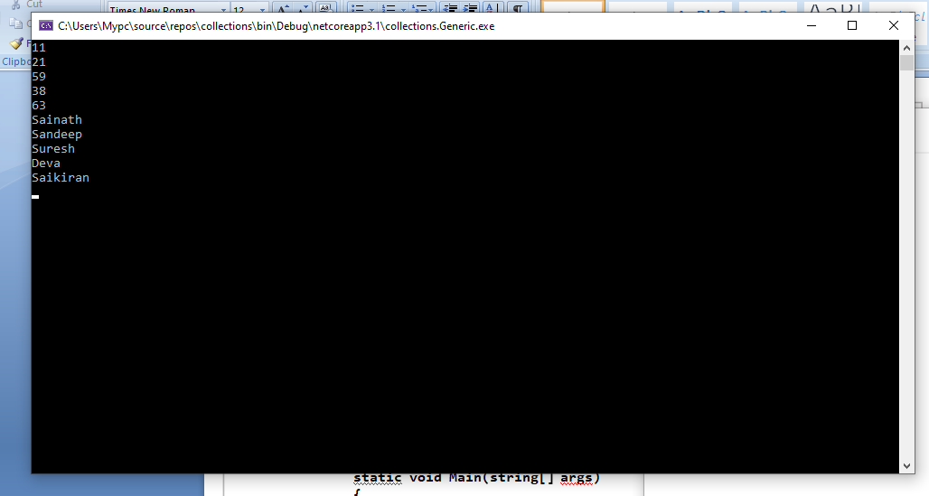

**Queue**

**using System;**

**using System.Collections;**

**using System.Collections.Generic;**

**using System.Linq;**

**using System.Text;**

**using System.Threading.Tasks;**

**namespace myque**

**{**

**class Program**

**{**

**static void Main(string[] args)**

**{**

**Queue my_q = new Queue();**

**{**

**my_q.Enqueue("Sandeep");**

**my_q.Enqueue("Suresh");**

**my_q.Enqueue(100);**

**my_q.Enqueue(true);**

**my_q.Enqueue(5.9);**

**Console.WriteLine("count the element: " +my_q.Count);**

**foreach(object item in my_q)**

**{**

**Console.WriteLine(item);**

**Console.ReadLine();**

**}**

**my_q.Dequeue();**

**Console.WriteLine("--------------");**

**foreach (object item in my_q)**

**{**

**Console.WriteLine(item);**

**Console.ReadLine();**

**}**

**}**

**}**

**}**

**}**

**Output**

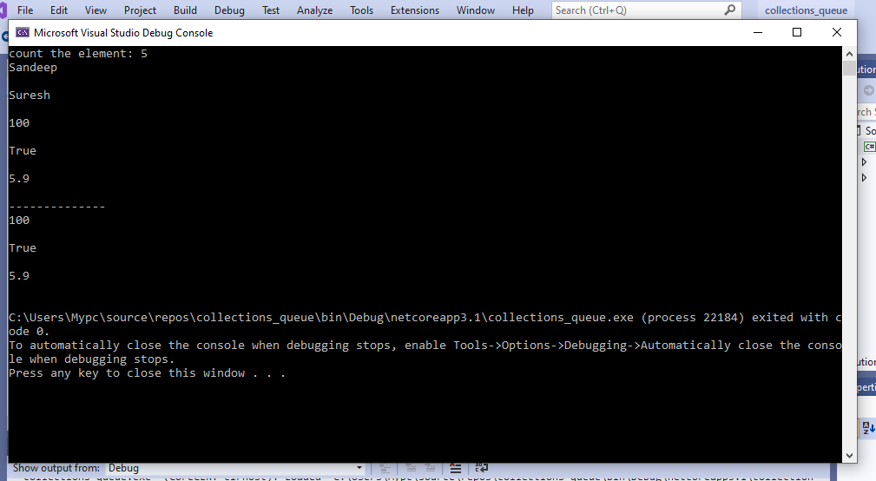

**Array**

**using System;**

**using System.Collections.Generic;**

**using System.Linq;**

**using System.Text;**

**using System.Threading.Tasks;**

**using System.Collections;**

namespace array_c

{

class Program

{

static void Main(string[] args)

{

ArrayList mylist = new ArrayList();

Console.WriteLine(mylist.Capacity);

mylist.Add(10);

Console.WriteLine(mylist.Capacity);

mylist.Add(20);

mylist.Add(30);

mylist.Add(40);

Console.WriteLine(mylist.Capacity);

//if i add the one more numbe

mylist.Add(50);

Console.WriteLine(mylist.Capacity);

foreach (object obj in mylist)

Console.Write(obj + " ");

//inser values

Console.WriteLine();

mylist.Insert(2, 25);

Console.WriteLine(mylist.Capacity);

foreach (object obj in mylist)

Console.Write(obj + " ");

Console.ReadLine();

}

}

}

**Out put**

