**Hazelcast-Installation**

**Prerequisite**

* JDK 1.7+
* Tomcat 7
* Hazelcast 3.6 or above

**Hazelcast**

* Hazelcast is an open source In-Memory Data Grid (IMDG).
* It provides elastically scalable distributed In-Memory computing, widely recognized as the fastest and most scalable approach to application performance.
* Hazelcast is designed to be lightweight and easy to use.
* Hazelcast makes distributed computing simple by offering distributed implementations of many developer friendly interfaces from Java such as Map, Queue, Lock, and JCache.
* Distributed applications can use Hazelcast for distributed caching, synchronization, clustering, processing, pub/sub messaging, etc.
* Hazelcast is implemented in Java and has clients for Java, C/C++, .NET and REST.

**Member Installation Steps**

* Download Hazelcast 3.6 zip from <http://download.hazelcast.com/download.jsp?version=hazelcast-3.6&p=171028013171028013>
* Extract the Hazelcast-3.6.zip file into working directory.
* Following attributes value needs to be modified in Hazelcast.xml which is available under bin directory.
  + - Group 🡺 Cluster group name & password that would be used to enable multi node with same group name
    - management-center 🡺 It should be enabled with mancenter web application link that provides consolidated statistic report includes all clustered members.
    - network – multicast 🡺 It should be enabled to access all clustered members which are available in same network.

**Hazelcast.xml**

|  |
| --- |
| **<**hazelcast xsi:schemaLocation="http://www.hazelcast.com/schema/config hazelcast-config-3.6.xsd"  xmlns="http://www.hazelcast.com/schema/config"  xmlns:xsi="http://www.w3.org/2001/XMLSchema-instance">  <group>  <name>dev</name>  <password>dev-pass</password>  </group>  <management-center enabled="true">http://localhost:8080/mancenter-3.6</management-center>  <network>  <port auto-increment="true" port-count="100">5701</port>  <outbound-ports>  <!--  Allowed port range when connecting to other nodes.  0 or * means use system provided port.  -->  <ports>0</ports>  </outbound-ports>  <join>  <multicast enabled="true">  <multicast-group>224.2.2.3</multicast-group>  <multicast-port>54327</multicast-port>  </multicast>  <tcp-ip enabled="false">  <interface>127.0.0.1</interface>  <member-list>  <member>127.0.0.1</member>  </member-list>  ----  ----  ----- |

**Mancenter**

Mancenter provides dashboard that includes clustered members, caching, maps, queues, topics, partition distribution details and performance statistic report

**Deploy Mancenter**

* Hazelcast provides mancenter.war file which is available under mancenter directory
* Deploy war file in any one application/web server

In web servers like tomcat

Copy mancenter.war file from mancenter directory and paste it into webapp folder of tomcat directory

Start the tomcat server

* Login to mancenter Link : http://<<domain name >>/mancenter

For example: <http://localhost:8080/mancenter-3.6/>

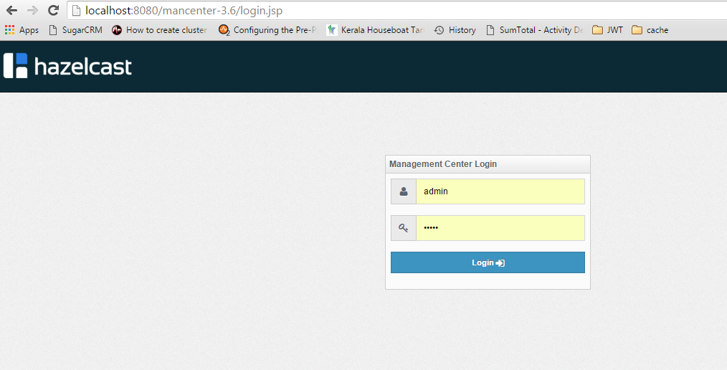

* Default user name & password to login: admin / admin

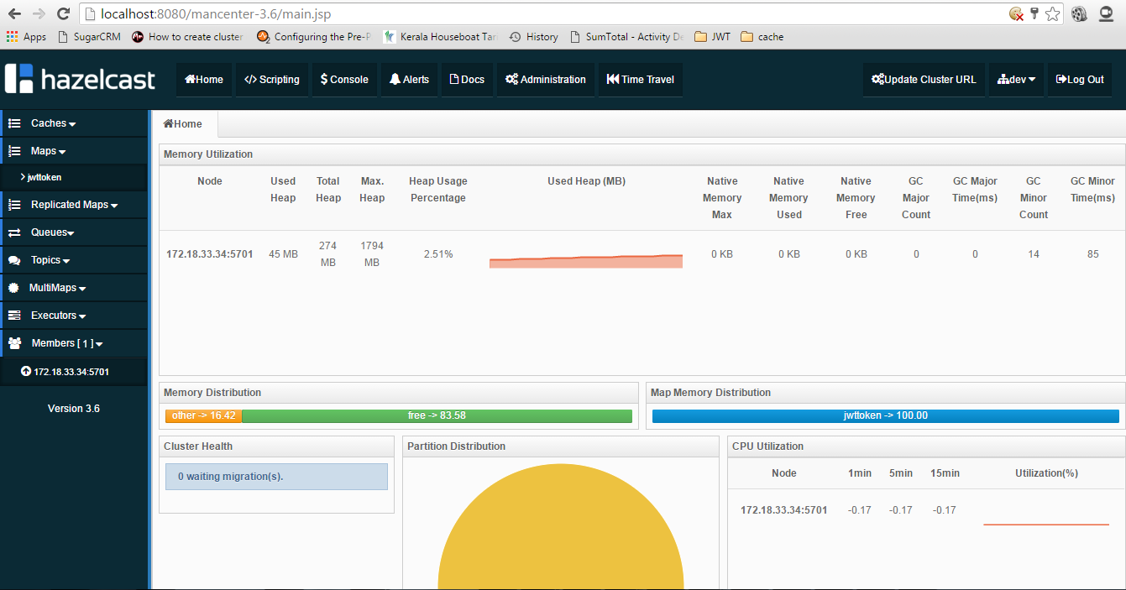

* Run the start.bat to up the Hazelcast server which is present under hazelcast-3.6/bin directory –to connect with the member
* Hazelcast Installed successfully!!!