**Code Coverage-JACOCO-ECLEMMA**

**code coverage** is a measure used to describe the degree to which the source **code** of a program is executed when a particular test suite runs.

**JaCoCo** is a free code coverage library for Java, which has been created by the EclEmma team based on the lessons learned from using and integration existing libraries for many years.

**EclEmma** is a free Java code coverage tool for eclipse

**EclEmma-Installation**

1.Download ,EclEmma from <http://www.eclemma.org/download.html> this site ,and extract into the local system

2.Copy jars form the plugins folder of EclEmma ,and put it into the <eclipse_home>/plugins folder and restart the eclipse

You will see the coverage tool icon in the tool bar .

EclEmma installed successfully!!!

**How to do Code Coverage?**

1.In eclipse workspace,for the particular project have to check whether the junit test case written for the particular class file covers the code .

Right click on the project->coverage as->JUnit Test

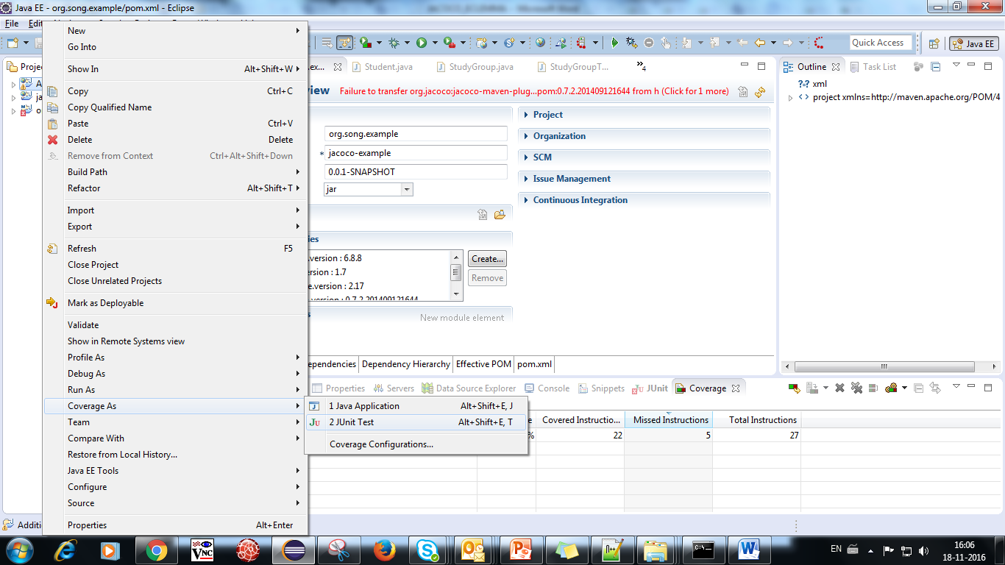

Will give the result as shown



It will show how much the testcase cover the code.

If we see the code

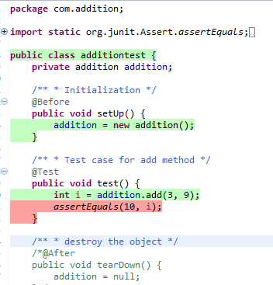

The highlighted in red shows test case doesnot cover the code.

**Exporting Coverage Report:**

**In Eclipse ,Go to ->file->export->java->coverage report**

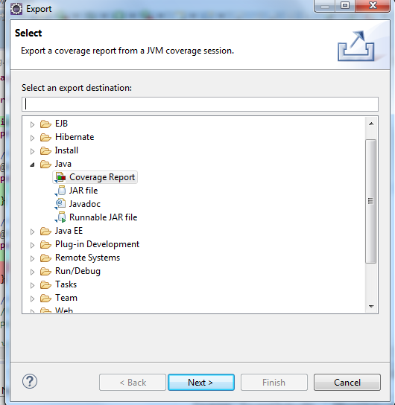

**We can export various kinds of report**

**In html,xml,csv**