**Analyzing with SONAR Runner**

**Prerequisites**

We must have installed the following

* SONAR
* SONAR RUNNER ( client )
* Java 1.5 or Higher

**Installing & Configuring SONAR**

1. Download from the below site (sonar-3.1.1.zip )

<http://www.sonarsource.org/downloads/>

1. Unzip the zip file (sonar-3.1.1.zip) to a folder of your choice (D:\Tools\sonar-3.1.1)
2. Edit the sonar.properties file in the conf folder. (e.g D:\Tools\sonar-3.1.1\conf\sonar.properties)

Uncomment the following lines in the sonar.properties

sonar.jdbc.username: sonar

sonar.jdbc.password: sonar

sonar.web.host: 0.0.0.0

sonar.web.port: 9000

sonar.web.context: /

1. Run StartSonar.bat in the sonar_home/bin/windows-x86-32 folder

Example : D:\Tools\sonar-3.1.1\bin\windows-x86-32>StartSonar.bat

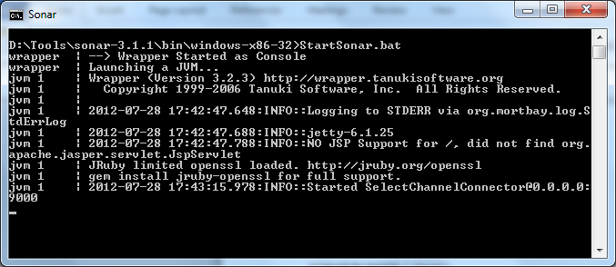

1. Open the browser and type <http://localhost:9000/>

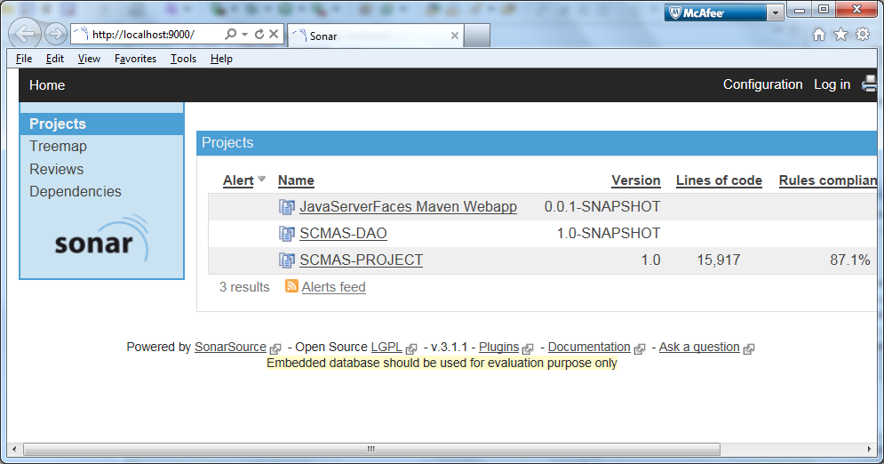

SONAR installation and configuration is complete !!!

**Installing & Configuring SONARRUNNER**

1. Download SONARRUNNER from the below site (sonar-runner1.3.zip )

<http://repository.codehaus.org/org/codehaus/sonar-plugins/sonar-runner/1.3/sonar-runner-1.3.zip>

1. Unzip the zip file (sonar-runner1.3.zip) to a folder of your choice (D:\Tools\sonar-runner-1.3)
2. Update the global settings (database connection, server URL) by editing the file (D:\Tools\sonar-runner-1.3\conf\ sonar-runner.properties )

|  |  |
| --- | --- |
| 1. [?](http://docs.codehaus.org/display/SONAR/Installing+and+Configuring+Sonar+Runner)  |  | | --- | | #----- Default Sonar server  #sonar.host.url=<http://localhost:9000>  #----- PostgreSQL  #sonar.jdbc.url=jdbc:postgresql://localhost/sonar  #sonar.jdbc.driver=org.postgresql.Driver  #----- MySQL  #sonar.jdbc.url=jdbc:mysql://localhost:3306/sonar?useUnicode=true&amp;characterEncoding=utf8  #sonar.jdbc.driver=com.mysql.jdbc.Driver  #----- Oracle  #sonar.jdbc.url=jdbc:oracle:thin:@localhost/XE  #sonar.jdbc.driver=oracle.jdbc.driver.OracleDriver  #----- Global database settings  #sonar.jdbc.username=sonar  #sonar.jdbc.password=sonar  #----- Default directory layout  #sources=src/main/java  #tests=src/test/java  #binaries=target/classes  sonar.sourceEncoding=UTF-8 | |

1. Edit the sonar-runner.properties file in the conf folder. (D:\Tools\sonar-runner-1.3\conf\ sonar-runner.properties)

# -- Project specific configuration ------------

sonar.projectKey=SCMAS:PROJECT

sonar.projectName=SCMAS-PROJECT

sonar.projectVersion=1.0

#----- Default directory layout as shown below

sources=D:\\SMC\\WebContent\\WEB-INF\\classes,D:\\SMC\\src

sonar.sourceEncoding=UTF-8

1. Create a new SONAR_RUNNER_HOME environment variable

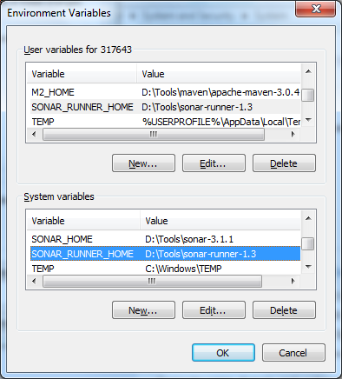

1. Run sonar-runner.bat in the sonar_home/bin/windows-x86-32 folder

Example : D:\Tools\sonar-runner-1.3\bin>sonar-runner.bat

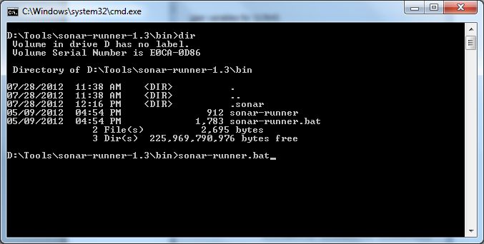

1. Open the browser and type <http://localhost:9000/>

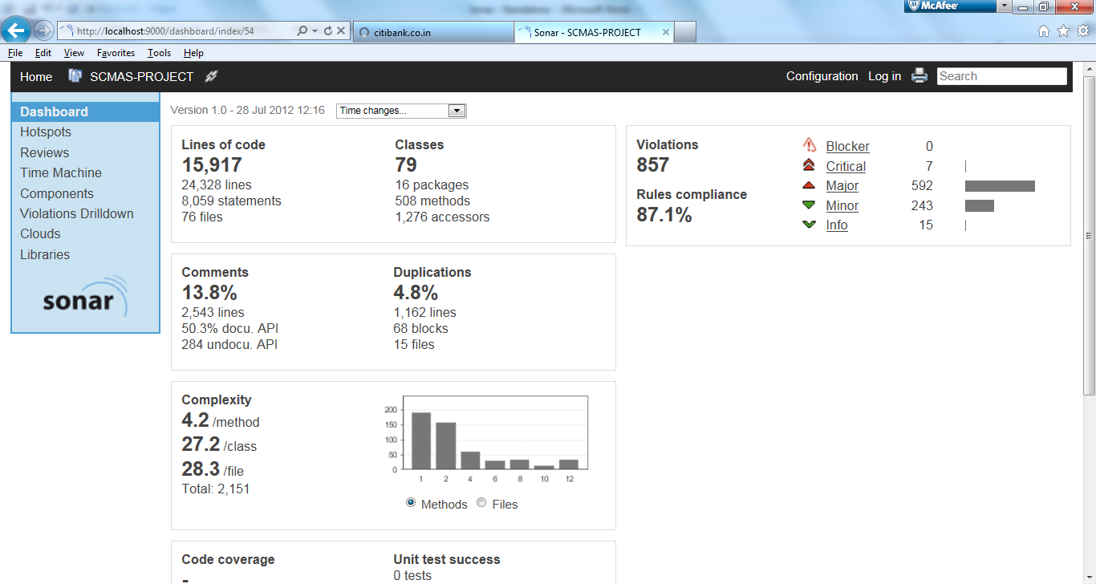

Now we are ready to analyze a project with SONAR RUNNER

**Configuring Plugin**

**Web plugin**

The plugin provides static code analysis of web files within Sonar. Currently **JSP** and **JSF** are supported.

The following metrics are supported:

* sizing (files, lines of code)
* rules compliancy
* complexity
* duplication
* comments

The plugin scans the following files by default: .xhtml, .jspf, .jsp. The file extensions are configurable.

The plugin imports the source code in Sonar, calculates measurements and scans the code for violations, duplications and complexity. The checks are configurable in the Sonar rules repository.

**Installing & Configuring web plugin**

1. Download from the below site (sonar-web-plugin-1.2.jar)

<http://repository.codehaus.org/org/codehaus/sonar-plugins/sonar-web-plugin/1.2/sonar-web-plugin-1.2.jar>

1. Place the jar file (sonar-web-plugin-1.2.jar ) into the directory /extensions/plugins/ ( D:\Tools\sonar-3.1.1\extensions\plugins )
2. Restart the sonar server.
3. Make sure the server started properly. Open the browser and type <http://localhost:9000/>

**Analysis using Maven**

1. Create a maven pom for your project. Set the following properties:

sonar.language: web

sonar.web.sourceDirectory: [folder of the web files]

sonar.dynamicAnalysis: false

Sample pom file

|  |
| --- |
| <?xml version="1.0" encoding="UTF-8"?>  <project xmlns="[http://maven.apache.org/POM/4.0.0"](http://maven.apache.org/POM/4.0.0)  xmlns:xsi="[http://www.w3.org/2001/XMLSchema-instance"](http://www.w3.org/2001/XMLSchema-instance)  xsi:schemaLocation="<http://maven.apache.org/POM/4.0.0> [http://maven.apache.org/xsd/maven-4.0.0.xsd"](http://maven.apache.org/xsd/maven-4.0.0.xsd)>  <modelVersion>4.0.0</modelVersion>  <groupId>my.group.id</groupId>  <artifactId>web</artifactId>  <version>1.0</version>  <name>MyProject :: Web</name>  <properties>  <sonar.language>web</sonar.language>  <sonar.web.sourceDirectory>src/main/webapp</sonar.web.sourceDirectory>  <sonar.dynamicAnalysis>false</sonar.dynamicAnalysis>  </properties>  </project> |

1. For an existing maven project, you might start an analysis by the following command:

**mvn sonar:sonar -Dsonar.language=web -Dsonar.dynamicAnalysis=false -Dsonar.web.sourceDirectory=src/main/webapp**

You may set the property sonar.branch to make sure the web analysis will be reported in sonar under another project name, e.g. -Dsonar.branch=Web.

1. Open the browser and type <http://localhost:9000/>

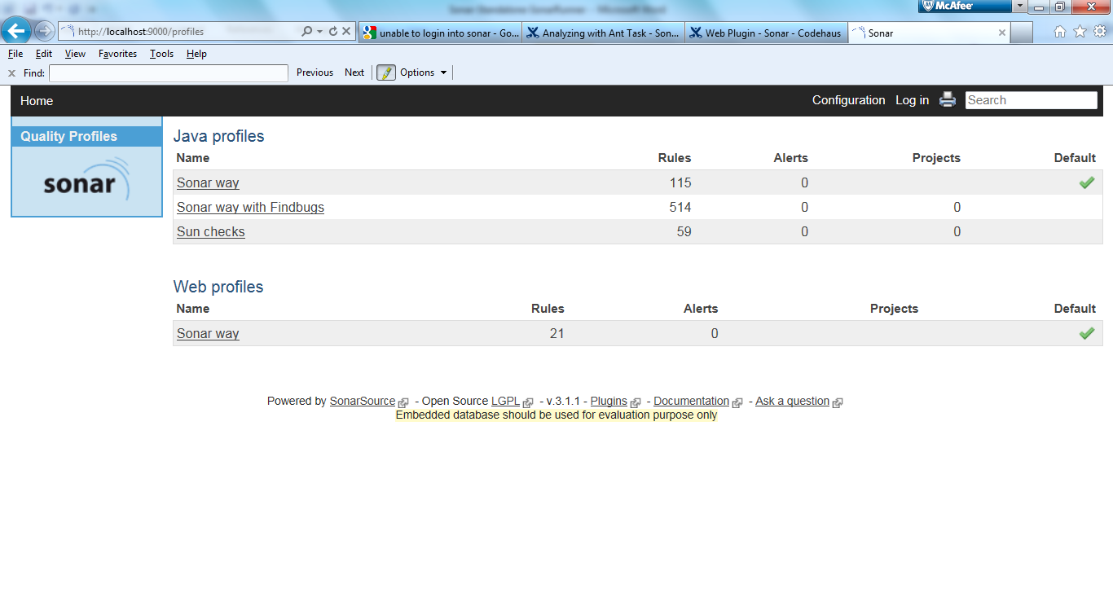

1. Click “configuration” , You will be able to see “Web Profiles” added.
2. Configuration based on extension can be done as mentioned below.

The following properties of the plugin are configurable:

|  |  |
| --- | --- |
| property | default value |
| sonar.web.sourceDirectory |  |
| sonar.web.fileExtensions | xhtml,jspf,jsp |
| sonar.cpd.web.minimumTokens | 70 |

The properties may be set in sonar, the maven pom or the maven commmandline.

Similarly you can configure other plugin available in the website.

<http://docs.codehaus.org/display/SONAR/Plugin+Library>

**Report Generation - PDF**

Sonar PDF plugin allows to generate a report in PDF format that contains the most relevant information showed by Sonar web interface. The report aims to be a deliverable as part of project documentation.

**Note – Can be executed only with the help of Maven. Cannot use SonarRunner**

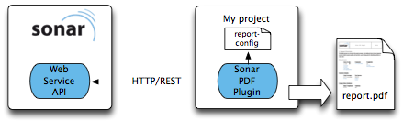

**How to install Sonar PDF Plugin**

Use update center, or alternatively:

* Dowload sonar-pdfreport-plugin-1.3.jar
* Copy to [sonar-dir]/extensions/plugins
* Change the below properties

*sonar.host.url*: sonar server URL (i.e <http://my-host:9000/sonar>)

*sonar.branch (-Dbranch is also supported)*: report on a project branch

*report.type*: select a report type. Values:

*-Dreport.type=executive*

*-Dreport.type=workbook* (default)

*sonar.pdf.username*: username for access WS API

*sonar.pdf.password*: password for the user

If your Sonar server URL is <http://localhost:9000> you don't need to specify *sonar.host.url*.

* Restart Sonar
* **Note :- First analyze your project in sonar.**
* Then run the generate goal (report will be created in the target directory)

mvn org.codehaus.sonar-plugins.pdf-report:maven-pdfreport-plugin:1.3:generate

**Post Job**

Sonar PDF can be used as a plugin of sonar modeling a post-job work. In this way, a PDF report is generated after each analysis in Sonar (mvn sonar:sonar includes the generation of report).

**Administrator Activities**

Login user id as admin and password as admin for changing the settings and also deleting the unwanted project.