**Analyzing with SONAR Runner**

**Prerequisites**

We must have installed the following

* SONAR
* SONAR RUNNER ( client )
* Java 1.5 or Higher

**Installing & Configuring SONAR**

1. Download from the below site (sonar-3.1.1.zip )

<http://www.sonarsource.org/downloads/>

1. Unzip the zip file (sonar-3.1.1.zip) to a folder of your choice (D:\Tools\sonar-3.1.1)
2. Edit the sonar.properties file in the conf folder. (e.g D:\Tools\sonar-3.1.1\conf\sonar.properties)

Uncomment the following lines in the sonar.properties

sonar.jdbc.username: sonar

sonar.jdbc.password: sonar

sonar.web.host: 0.0.0.0

sonar.web.port: 9000

sonar.web.context: /

1. Run StartSonar.bat in the sonar_home/bin/windows-x86-32 folder

Example : D:\Tools\sonar-3.1.1\bin\windows-x86-32>StartSonar.bat

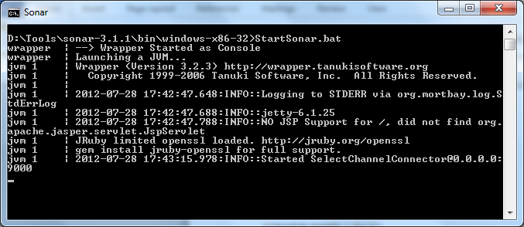

1. Open the browser and type <http://localhost:9000/>

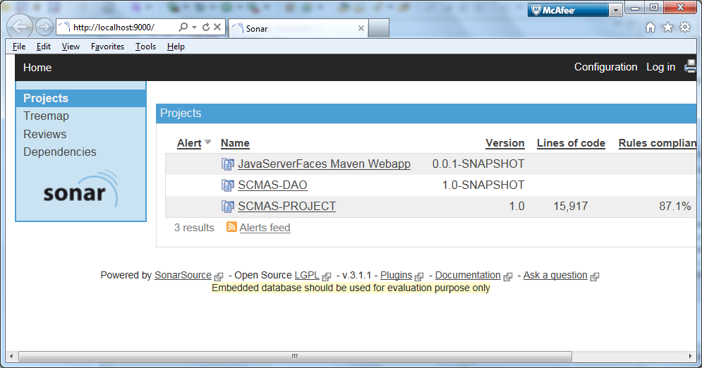

SONAR installation and configuration is complete !!!

**Installing & Configuring SONARRUNNER**

1. Download SONARRUNNER from the below site (sonar-runner1.3.zip )

<http://repository.codehaus.org/org/codehaus/sonar-plugins/sonar-runner/1.3/sonar-runner-1.3.zip>

1. Unzip the zip file (sonar-runner1.3.zip) to a folder of your choice (D:\Tools\sonar-runner-1.3)
2. Update the global settings (database connection, server URL) by editing the file (D:\Tools\sonar-runner-1.3\conf\ sonar-runner.properties )

|  |  |
| --- | --- |
| 1. [?](http://docs.codehaus.org/display/SONAR/Installing+and+Configuring+Sonar+Runner)  |  | | --- | | #----- Default Sonar server  #sonar.host.url=<http://localhost:9000>  #----- PostgreSQL  #sonar.jdbc.url=jdbc:postgresql://localhost/sonar  #sonar.jdbc.driver=org.postgresql.Driver  #----- MySQL  #sonar.jdbc.url=jdbc:mysql://localhost:3306/sonar?useUnicode=true&amp;characterEncoding=utf8  #sonar.jdbc.driver=com.mysql.jdbc.Driver  #----- Oracle  #sonar.jdbc.url=jdbc:oracle:thin:@localhost/XE  #sonar.jdbc.driver=oracle.jdbc.driver.OracleDriver  #----- Global database settings  #sonar.jdbc.username=sonar  #sonar.jdbc.password=sonar  #----- Default directory layout  #sources=src/main/java  #tests=src/test/java  #binaries=target/classes  sonar.sourceEncoding=UTF-8 | |

1. Edit the sonar-runner.properties file in the conf folder. (D:\Tools\sonar-runner-1.3\conf\ sonar-runner.properties)

# -- Project specific configuration ------------

sonar.projectKey=SCMAS:PROJECT

sonar.projectName=SCMAS-PROJECT

sonar.projectVersion=1.0

#----- Default directory layout as shown below

sources=D:\\SMC\\WebContent\\WEB-INF\\classes,D:\\SMC\\src

sonar.sourceEncoding=UTF-8

1. Create a new SONAR_RUNNER_HOME environment variable

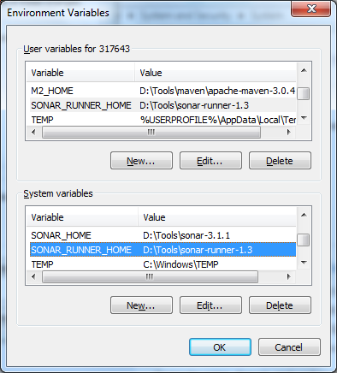

1. Run sonar-runner.bat in the sonar_home/bin/windows-x86-32 folder

Example : D:\Tools\sonar-runner-1.3\bin>sonar-runner.bat

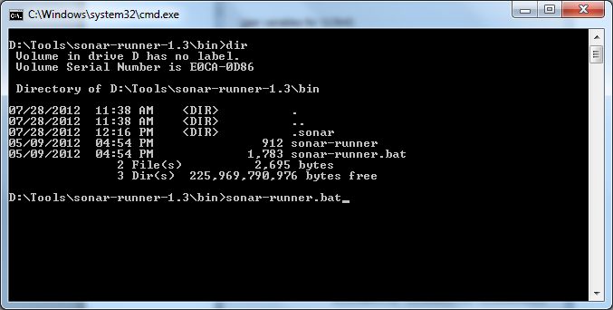

1. Open the browser and type <http://localhost:9000/>

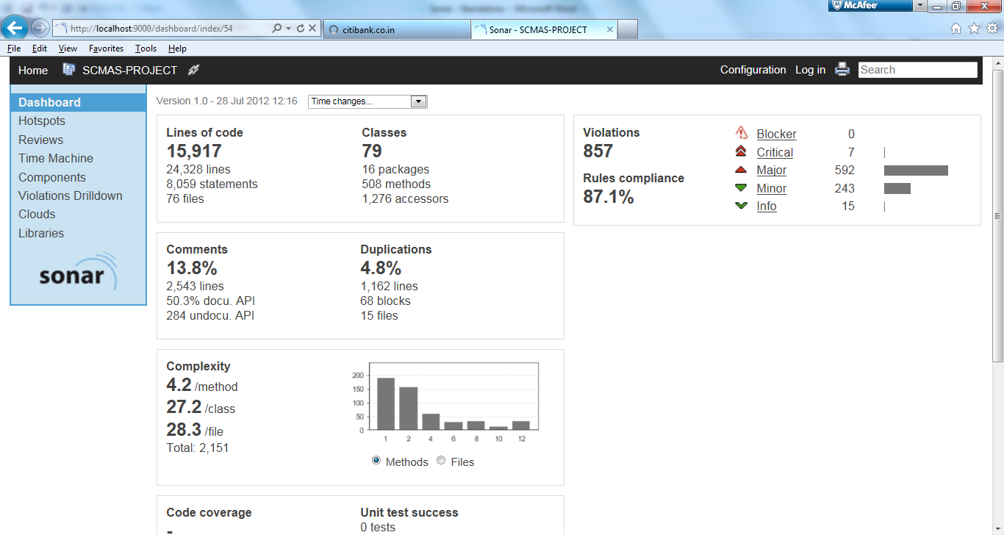

Now we are ready to analyze a project with SONAR RUNNER

**Alternative Way to Run SONNARRUNNER**

1. Instead of editing sonar-runner.properties. Create a properties file under the project directory.

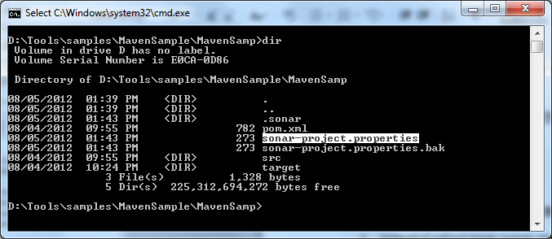

1. Edit the sonar-project.properties file and add the relevant configuration that required for your project.

|  |
| --- |
| # required metadata  sonar.projectKey=MavenSamp  sonar.projectName=MavenSample  sonar.projectVersion=1.0  # path to source directories (required)  #sources=D:\\Tools\\samples\\MavenProject\\src  sources=D:\\Tools\\samples\\MavenSample\\MavenSamp\\src\\main\\java |

1. Execute the sonar-runner.bat from the project folder.

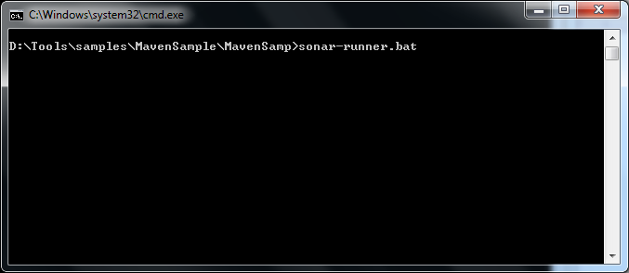

1. Open the browser and type <http://localhost:9000/>

**Administrator Activities**

Login user id as admin and password as admin for changing the settings and also deleting the unwanted project.