**Analyzing with SONAR Cube & SONAR Scanner**

To analyze code, Sonar utilizes some of the most popular and proven tools available in the open source community. These tools pass through source code performing standard checks reviewing errors and possible bugs, each from their own perspective. The nature of the checks range from minor styling ones, for example the detection of unwanted trailing spaces, to more complex ones that easily promote to potential bugs, such as unchecked variables eligible to result in null references. Since version 2.1 Sonar provides its own rules engine too, based on Squid.

Sonar includes the following five analyzers:

1. Squid - http://docs.codehaus.org/display/SONAR/Documentation
2. Checkstyle - http://checkstyle.sourceforge.net/
3. PMD - http://pmd.sourceforge.net/
4. FindBugs - http://findbugs.sourceforge.net/
5. Cobertura - http://cobertura.sourceforge.net/
6. Clover - http://www.atlassian.com/software/clover/

**Installing & Configuring SONAR**

1. Download from the below site (sonar-3.1.1.zip )

<http://www.sonarsource.org/downloads/>

1. Unzip the zip file (sonar-3.1.1.zip) to a folder of your choice (D:\Tools\sonar-3.1.1)
2. Edit the sonar.properties file in the conf folder. (e.g D:\Tools\sonar-3.1.1\conf\sonar.properties)

Uncomment the following lines in the sonar.properties

|  |
| --- |
| *sonar.jdbc.username: sonar*  *sonar.jdbc.password: sonar*  *sonar.web.host: 0.0.0.0*  *sonar.web.port: 9000*  *sonar.web.context: /* |

1. Run StartSonar.bat in the sonar_home/bin/windows-x86-32 folder

Example : D:\Tools\sonar-3.1.1\bin\windows-x86-32>StartSonar.bat

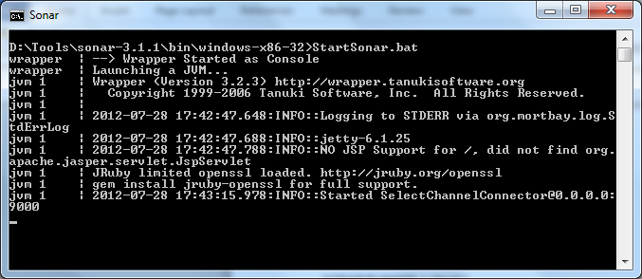

1. Open the browser and type <http://localhost:9000/>

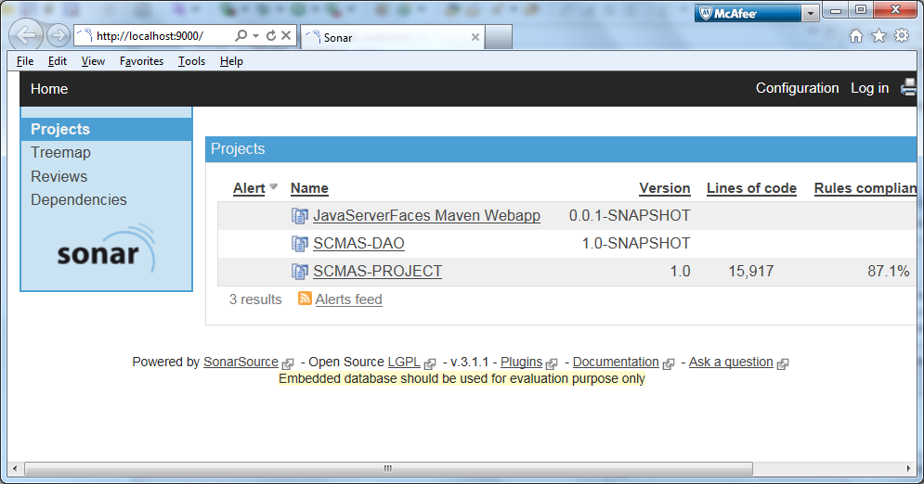

SONAR installation and configuration is complete !!!

**Installing & Configuring SONARRUNNER**

1. Download SONARRUNNER from the below site (sonar-runner1.3.zip )

<http://repository.codehaus.org/org/codehaus/sonar-plugins/sonar-runner/1.3/sonar-runner-1.3.zip>

1. Unzip the zip file (sonar-runner1.3.zip) to a folder of your choice (D:\Tools\sonar-runner-1.3)
2. Update the global settings (database connection, server URL) by editing the file (D:\Tools\sonar-runner-1.3\conf\ sonar-runner.properties )

|  |  |
| --- | --- |
| 1. [?](http://docs.codehaus.org/display/SONAR/Installing+and+Configuring+Sonar+Runner)  |  | | --- | | #----- Default Sonar server  #sonar.host.url=<http://localhost:9000>  #----- PostgreSQL  #sonar.jdbc.url=jdbc:postgresql://localhost/sonar  #sonar.jdbc.driver=org.postgresql.Driver  #----- MySQL  #sonar.jdbc.url=jdbc:mysql://localhost:3306/sonar?useUnicode=true&amp;characterEncoding=utf8  #sonar.jdbc.driver=com.mysql.jdbc.Driver  #----- Oracle  #sonar.jdbc.url=jdbc:oracle:thin:@localhost/XE  #sonar.jdbc.driver=oracle.jdbc.driver.OracleDriver  #----- Global database settings  #sonar.jdbc.username=sonar  #sonar.jdbc.password=sonar  #----- Default directory layout  #sources=src/main/java  #tests=src/test/java  #binaries=target/classes  sonar.sourceEncoding=UTF-8 | |

1. Edit the sonar-runner.properties file in the conf folder. (D:\Tools\sonar-runner-1.3\conf\ sonar-runner.properties)

# -- Project specific configuration ------------

sonar.projectKey=SCMAS:PROJECT

sonar.projectName=SCMAS-PROJECT

sonar.projectVersion=1.0

#----- Default directory layout as shown below

sources=D:\\SMC\\WebContent\\WEB-INF\\classes,D:\\SMC\\src

sonar.sourceEncoding=UTF-8

1. Create a new SONAR_RUNNER_HOME environment variable

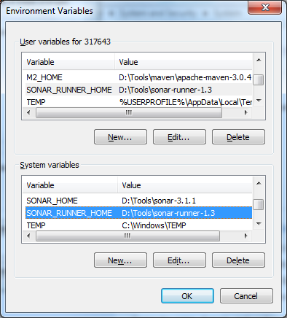

1. Run sonar-runner.bat in the sonar_home/bin/windows-x86-32 folder

Example : D:\Tools\sonar-runner-1.3\bin>sonar-runner.bat

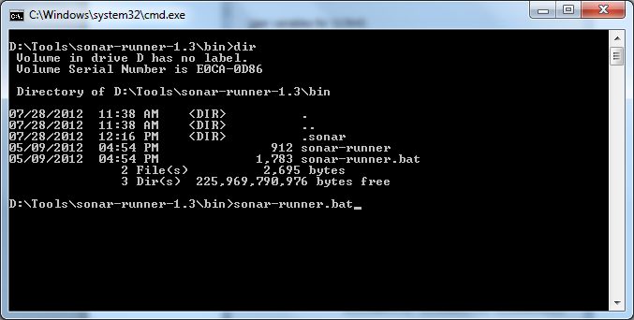

1. Open the browser and type <http://localhost:9000/>

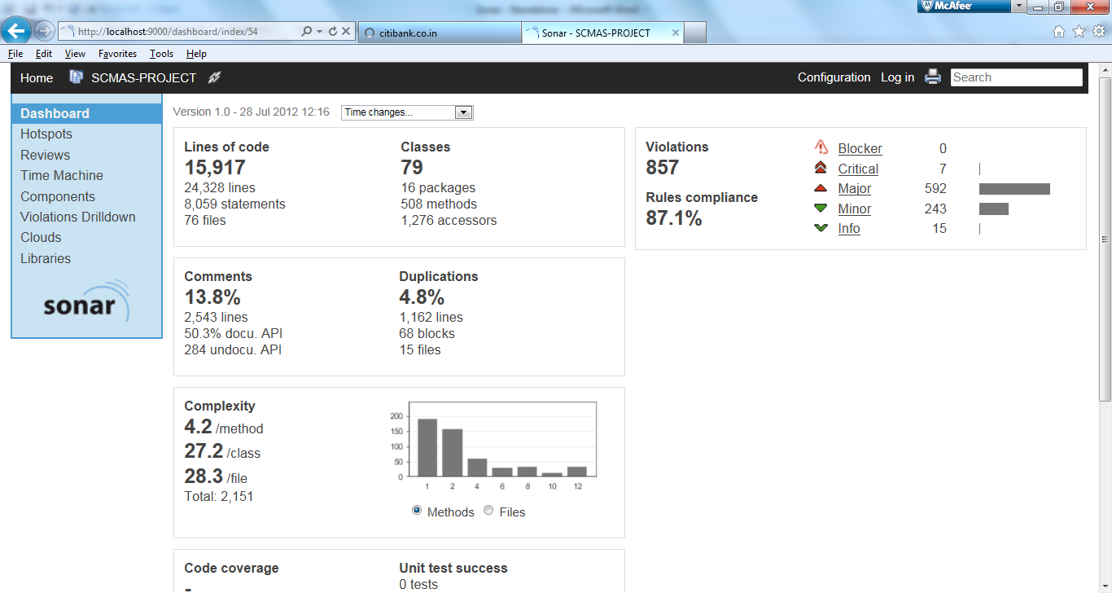

Now we are ready to analyze a project with SONAR RUNNER

**Alternative Way to Run SONNARRUNNER**

1. Instead of editing sonar-runner.properties. Create a properties file under the project directory.

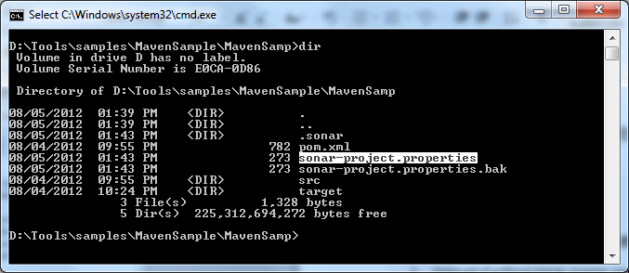

1. Edit the sonar-project.properties file and add the relevant configuration that required for your project.

|  |
| --- |
| # required metadata  sonar.projectKey=MavenSamp  sonar.projectName=MavenSample  sonar.projectVersion=1.0  # path to source directories (required)  #sources=D:\\Tools\\samples\\MavenProject\\src  sources=D:\\Tools\\samples\\MavenSample\\MavenSamp\\src\\main\\java |

1. Execute the sonar-runner.bat from the project folder.

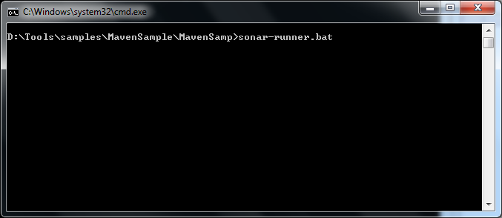

1. Open the browser and type <http://localhost:9000/>

**Administrator Activities**

Login user id as admin and password as admin for changing the settings and also deleting the unwanted project.

<http://docs.sonarqube.org/display/SONARQUBE44/PDF+Plugin>

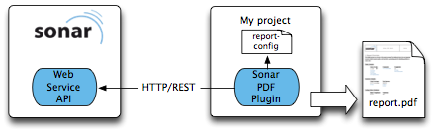

PDF_Generation

**Governance 1.1** – Jul 26, 2016 – SonarQube 5.6 - 5.6.3 (Compatible with LTS)   
Improve PDF report, fix bugs

<http://www.sonarsource.com/products/plugins/governance/>

**References**

<http://docs.sonarqube.org/display/SONAR/Update+Center>

<https://maven-eu.nuxeo.org/nexus/content/repositories/public/org/codehaus/sonar-plugins/>

error-reference

http://stackoverflow.com/questions/27397173/sonarqube-4-5-1-initial-installation-with-oracle-database