**Git GUI**

**Git Installation**

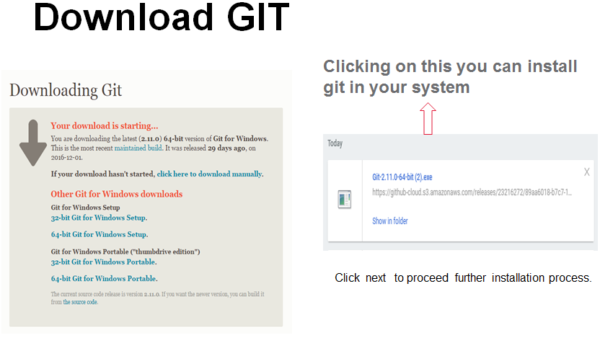

Installation ends with,

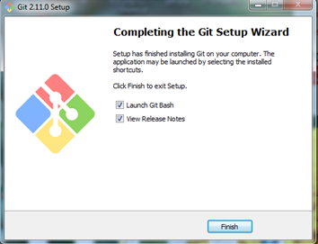

**Creating Master Repository**

1. Creating goto -> windows -> search GIT GUI

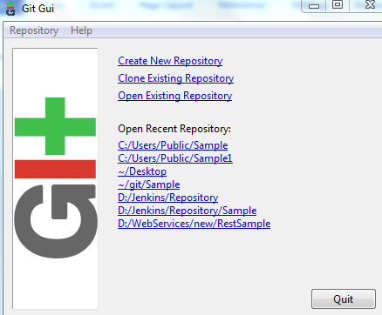

1. Select create new Repository

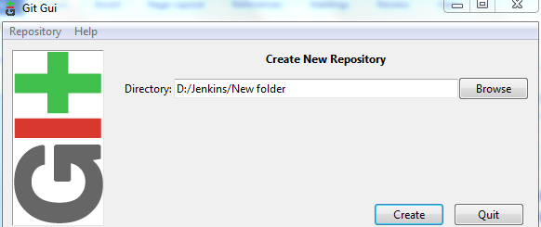

1. It will create new git repository and Git Gui will open for that new repository

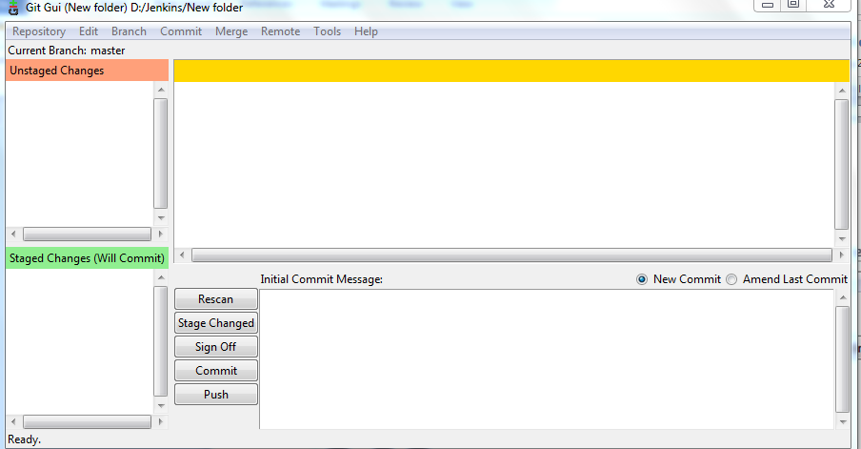

1. Copy the source content to the new repository and save

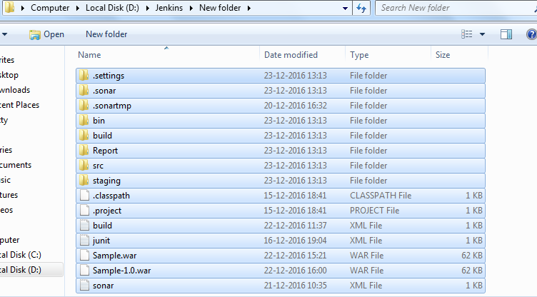

1. Once copied the source to the new repository ..In Git Gui all the source file will appear in the **Unstaged Changes** section

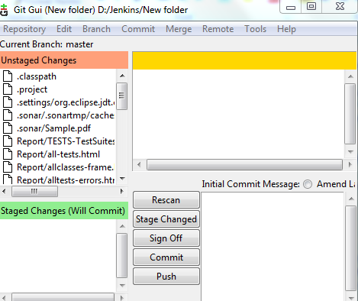

1. We have to click on **Stage Changed** and it comes to **staged changes** after which we have to give command as “**commit**”. code will commit at this point.

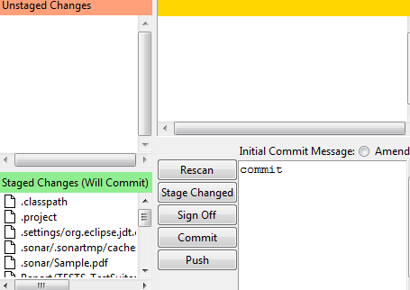

Now master repository is ready with the source!!!

Next step is to clone the repository..

**Clone the repository**

1. In Git Gui , Click on clone existing Repository and give Source location and target directory



1. Specify the source and target location

**Source Location🡪** where the master repository placed

**Target Directory 🡪** where the cloned repository will be placed….it should also be the git repository

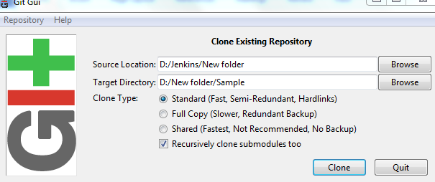

1. Click on **clone.** Now the source code has been cloned and the cloned repository contains all the source code content
2. We have to use the cloned repository URL for modifications.

D:/New folder/Sample

**Note:**

1. **Post Commit**
   1. In the cloned git repository there will be .git file

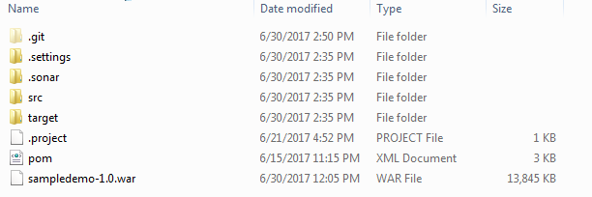

Navigate into .git folder->hooks->

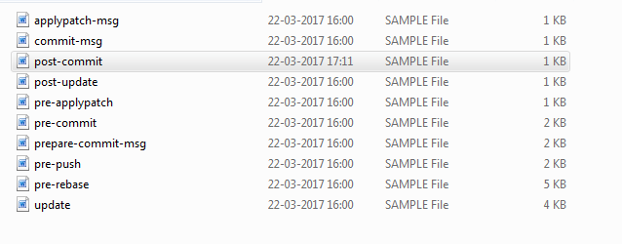

* 1. Create post-commit .sample file and include these lines

#!/bin/sh

curl http://localhost:8086/jenkins/git/notifyCommit?url=file:// D:\Poc's\Jenkins_Maven\Jenkins_Maven-master\Code\PipelineSample-master

which is used to notify the Jenkins url when the code gets committed