Error 1:

while relaunching the image ,the ip will be new ,so it is showing this error

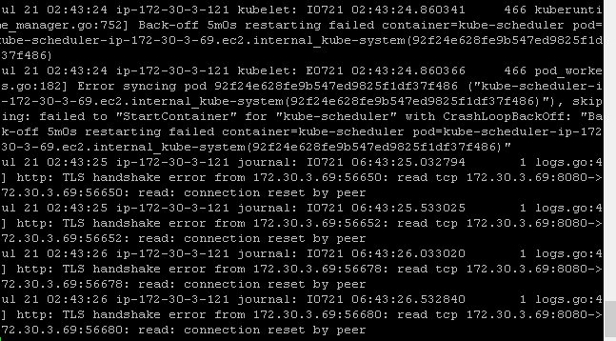

Solution: as it is an image will cause such problem while relaunching the image

Hence I have given reset commands

1. kubeadm reset
2. systemctl daemon-reload

And then

1. kubeadm init --apiserver-advertise-address=172.30.3.69 --apiserver-bind-port=8080 --skip-preflight-checks

Error2: while exposing service it is showing as status pending always

Kubernetes master:

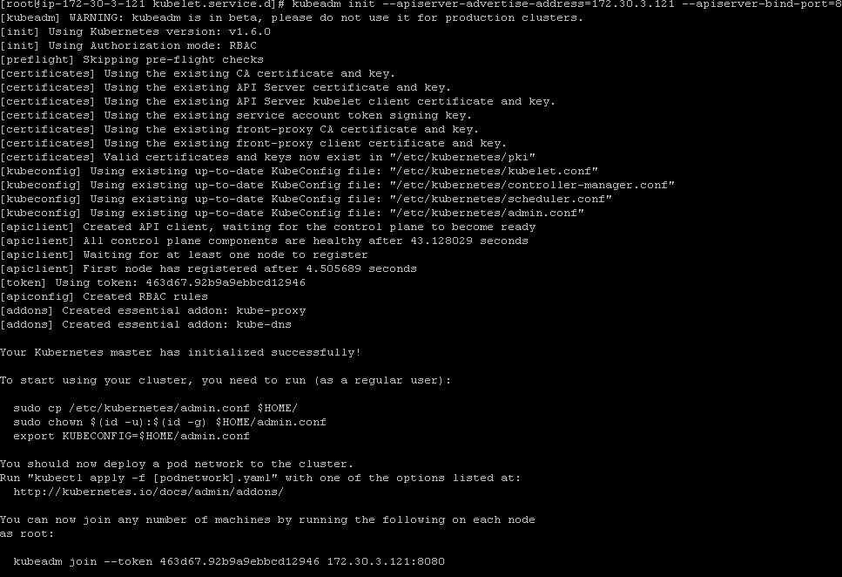

Kubernetes node :

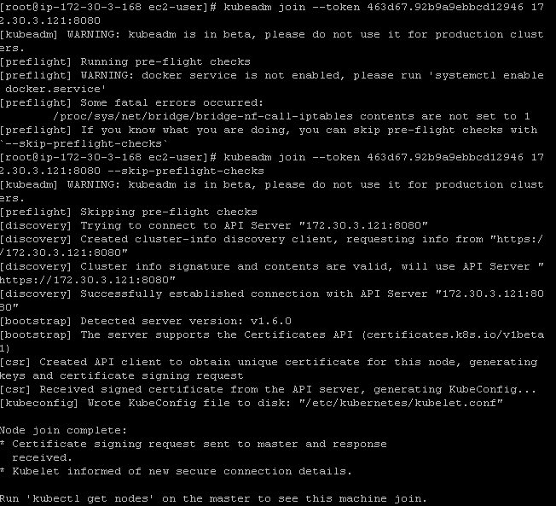

Error in the master while executing “kubectl get nodes”

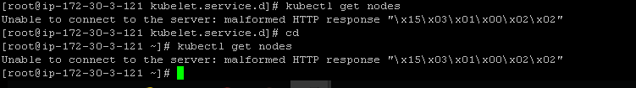

Error log

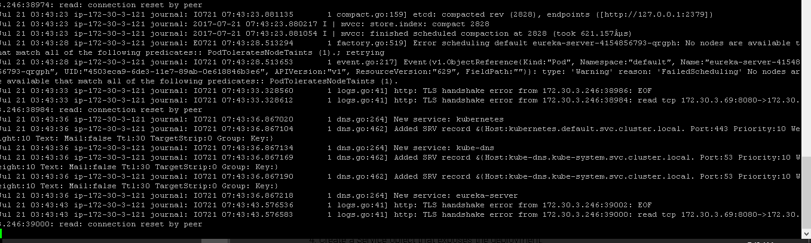



Solution:

Solved by executing following commads in the master node- we have to give permission

1.sudo cp /etc/kubernetes/admin.conf $HOME/

2. sudo chown $(id -u):$(id -g) $HOME/admin.conf

3. export KUBECONFIG=$HOME/admin.conf

Error3 :Ext-IP issue – cannot able to see the external IP



Solution:



Solved- by giving node port

Error4:

Dashboard –issues

After executing the dashboard.yaml cmd

wget https://rawgit.com/kubernetes/dashboard/master/src/deploy/kubernetes-dashboard.yaml kubectl apply -f kubernetes-dashboard.yaml

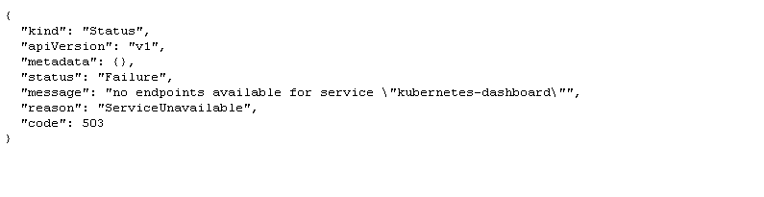

Solution:

Solved by changing version

->vi kubernetes-dashboard.yaml

(make changes in the version as 1.6.2 to 1.6.1)

-> kubectl apply -f kubernetes-dashboard.yaml

Error 5:

