Inheritance

The purpose of inheritance in CSS is to pass down to every descendant a style that was applied to an element. This doesn’t work with every style. What follows is an example of how this works. When you add a color to the <body>, every <p>, <ul>, <ol>, other block elements and its inline elements will change to that color. If you decide to change the color of a <p>, then that paragraph and its inline elements will change to that color. In other words, they inherit the style of the elements above them.

Specificity

The specificity is the measurement of how specific a selector is. The more specific the selector is, the more chances you have to select only one element. The specificity level changes depending on how many attributes an element has. The elements and pseudo elements has 0,0,0,1 points. Which means that if we only use **p** as a selector, the specificity is 0,0,0,1. If we use **li:first-line**, the specificity is 0,0,0,2. Because 1 + 1 = 2. The **class** has 0,0,1,0 points. If we use **p .example** as a selector, the specificity would be of 0,0,1,1. The **id** is more specific than the **class**, because of that the **id** has 0,1,0,0 pints. This is how specificity works. If it still doesn’t make much sense try with this next diagram:

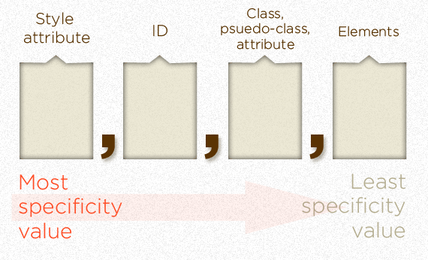

There are more specific attributes beyond the style, but this is just to get the idea of how it works and how we can calculate it. In this diagram we can also see that the class overrides over the elements, the id overrides over the class and elements, the style attribute over the last 3 and so on. And the latest style applied to an element will override the earlier ones.

Source Order

The source order is important because it what will determine which style will be applied to an element that has multiple styles in the CSS. If the element is selected more than once in the CSS and it has the same level of specificity, the latest style that appears on the sheet is the one that will be applied to the element.

Origin Styles

The origin styles can originate from three different places: the user agent / browser, the author (web designer) and the user. The user agent has a default style for the HTML. The author can change this style with CSS. The user can change part of the style if the author gives them the option. The user agent can change the style the author did if they want. The author can prevent this by using a the **!IMPORTANT** attribute on the element he doesn’t want to be changed (better not to do this, can cause trouble). And again, the user can change the style of something if the author gives them the option.

Citation:

Site point. 3 June. 2012.

<http://reference.sitepoint.com/css/cascade>

Coyier, Chris. CSS-Tricks. 2007

CSS-Tricks. 3 June. 2012

<http://css-tricks.com/specifics-on-css-specificity/>

Jonathan Snook, Snook

Snook. 3 June. 2012

<http://snook.ca/archives/html_and_css/understanding_c>