# Machine Learning Engineering Nanodegree

## Proposal

For the capstone project for the Udacity Machine Learning Nanodegree, I have selected the classification of dog images using Convolutional Neural Networks (CNN).

## Domain Background

Image classification is a common Machine Learning task, for this project we will be using different ML techniques and will compare the results obtained from them. I will use different techniques to build an image classifier that will determine the breed of the dog.

Dog breed classification is a well-tested machine learning. For example, the following paper describes building CNN to classify the breed, in order to help lost dogs be returned to their owners.

<https://arxiv.org/pdf/2007.11986.pdf>

## Problem Statement

The purpose of this project is to evaluate different machine learning techniques, and compare them . In order to accomplish this I will use pre trained models, apply Transfer learning techniques and finally create a Convolution Neural Network from scratch.

I will use VGG-16 model pre trained against the ImageNet dataset to build a dog classifier. VGG-16 has been trained with the image-net dataset which consists of over 14 millions images and 1,000 different labeled feature classes which includes 120 dog breeds.

Also I will use pretrained weights of the VGG-16 model and apply Transfer Learning techniques to refine the results, also I will create a CNN from scratch and train it with the Dog dataset.

## Dataset

For this project I will be using the Standford Dog dataset, This dataset consists of 120 different dog breeds with around 150 images per breed for a total of 20,580 images.

From this dataset I will for each different breed of dogs I will select a balanced subset of :

* 1000 images for training
* 8,580 images for testing

Using a total of 20,580 images.

This is a popular dataset for dog breed classification models used in research. And it is also available on Kaggle Playground Prediction Competition https://www.kaggle.com/c/dog-breed-identification

The original data source is found on <http://vision.stanford.edu/aditya86/ImageNetDogs/>

While doing research for the project I realized that the “Stanford Dogs” dataset is available from the tensorflow-datasets package with training/testing split, and I decided to use this instead of manually downloading the data and transforming the data into a format suitable for use with Tensorflow.

Few Sample images from the dataset

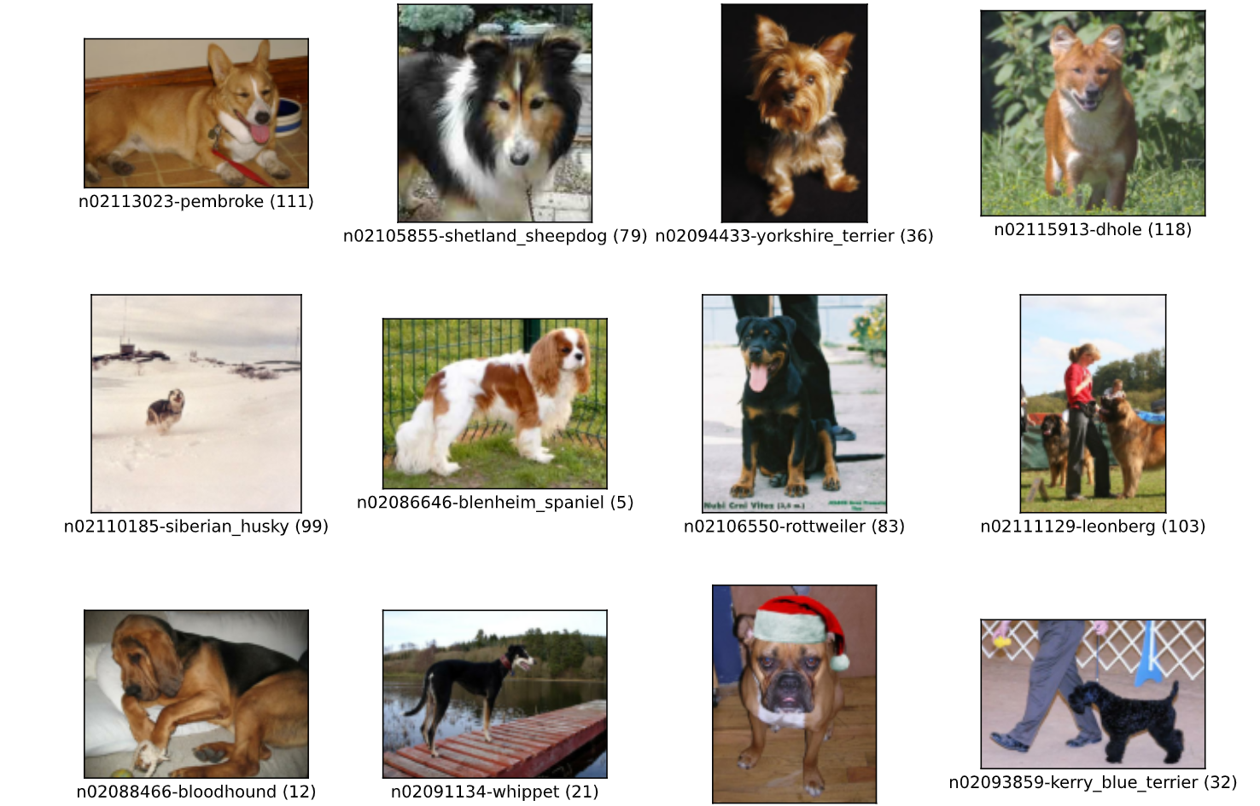

Aditya Khosla, Nityananda Jayadevaprakash, Bangpeng Yao and Li Fei-Fei. ***Novel dataset for Fine-Grained Image Categorization***. First Workshop on Fine-Grained Visual Categorization (FGVC*), IEEE Conference on Computer Vision and Pattern Recognition (CVPR), 2011.*

## Project Design

For this project I decided to use Tensorflow and the Keras API, mainly because I have previous experience using them and they are suitable for this project.

The Keras API includes api to quickly take advantage of pretrained image classification models, as well as implementing Transfer Learning.

In order to accomplish the goals outlined for this project we will build a data pipeline that can perform the preprocessing required for the images. Such has image resizing, and scaling.

The VGG16 model includes a pre processing module that converts the image from RGB to BGR and zero-centers the color channel which is the same as the values used to train against the ImageNet dataset. Also I used a basic data augmentation on the images random horizontal flip, and random rotation of the images when training.

I was able to train the model on my PC with a GTX1650S GPU, with a batch size of 4 (unable to use larger batch sizes due to the low memory on the GPU), even with GPU usage running the entire notebook would take over 18 hours to run (with most of the time spent training the model from scratch).

## Conclusion¶

Using the pretrained model was really easy to use but unfortunately only obtained an accuracy of 39%, Transfer learning was able to get an accuracy of 64% and training was quick. Training the custom model took the longest (about 12 hours for 100 epochs on my setup ) and the model only reached an accuracy of 51% but it looks like there is additional room to improvement.

Additional analysis of what classes the models were able to identify regulary and which classes the models struggled with would be interesting.

Overall it was a very interesting exercise, and I had the opportunity to explore a lot of different image classification options.