**Command for execution**:

Here I have used four different tagsets. So for each tagset there is different command to execute stated below

1. **Penn Tree Bank Tagset:**

It cotains all the tags specified in Penn tree bank

**Command:** python trigram_penn.py hw3_train hw3_heldout

**Screenshot**:

Accuracy for using Penn Tree Bank tag set:

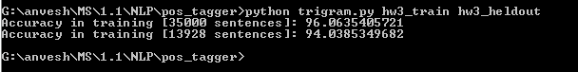

1. **Fine grained Tagset except Noun:**

Here we changed all tags "NN","NNS","NNP",NNPS" to “NOUN”. Except this remaining all tags were kept as it is.

**Command:** python trigram_noun.py hw3_train hw3_heldout

**Screenshot**:

Accuracy for using Fine grained Tagset except Noun:

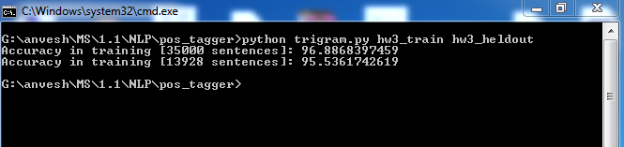

1. **Fine grained Tagset except VERB:**

Here we changed all tags "VB","VBD","VBG","VBN" ,"VBP","VBZ" to “VERB”.Except this remaining all tags were kept as it is.

**Command:** python trigram_verb.py hw3_train hw3_heldout

**Screenshot**:

Accuracy for using Fine grained Tagset except VERB:

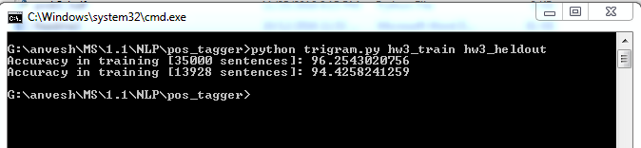

1. **Fine grained Tagset except NOUN,VERB:**

Here we changed all tags "NN","NNS","NNP",NNPS" to “NOUN” & "VB","VBD","VBG","VBN" ,"VBP","VBZ" to “VERB”.Except that remaining all tags were kept as it is.

**Command:** python trigram.py hw3_train hw3_heldout

**Screenshot**:

Accuracy for using Fine grained Tagset except NOUN &VERB:

