IBM Fisher Threshold Summary
Dataset: existing IBM 40,960-shot runs on Marrakesh and Torino. Method: Fisher trace sweep over prefix lengths with threshold estimated at max |d(trace)/dN|.

Key Findings
- Mean threshold is similar across backends: Marrakesh=18272.7, Torino=18409.1.
- Dispersion is high on both backends: Marrakesh std=16374.3, Torino std=16226.2.
- GHZ family consistently lands at high thresholds (~36k), while Hadamard/Layers contains low-threshold modes (~1.5k-3k).
- Result supports regime-dependent threshold families more than a single universal raw-N threshold.

Per-Circuit Thresholds (Marrakesh vs Torino)
Circuit | Qubits | Marrakesh N* | Torino N* | |Delta|
ghz | 5 | 36000 | 36000 | 0
ghz | 10 | 36000 | 36000 | 0
ghz | 20 | 36000 | 36000 | 0
hadamard | 1 | 24000 | 36000 | 12000
hadamard | 5 | 1500 | 1500 | 0
hadamard | 10 | 1500 | 1500 | 0
hadamard | 20 | 1500 | 3000 | 1500
identity | 10 | 36000 | 24000 | 12000
identity | 20 | 24000 | 24000 | 0
layers | 10 | 1500 | 1500 | 0
layers | 20 | 3000 | 3000 | 0

Backend aggregates (from sweep CSV)
backend | mean_threshold | std_threshold | min_threshold | max_threshold
marrakesh | 1.827e+04 | 1.637e+04 | 1500 | 3.6e+04
torino | 1.841e+04 | 1.623e+04 | 1500 | 3.6e+04

Normalized thresholds by regime (mean N*, N*/qubit)
backend | regime_family | mean_n | std_n | mean_n_per_qubit | std_n_per_qubit
marrakesh | GHZ | 3.6e+04 | 0 | 4200 | 2750
marrakesh | HadamardLayers | 5500 | 9083 | 4138 | 9731
marrakesh | Identity | 3e+04 | 8485 | 2400 | 1697
torino | GHZ | 3.6e+04 | 0 | 4200 | 2750
torino | HadamardLayers | 7750 | 1.386e+04 | 6150 | 1.462e+04
torino | Identity | 2.4e+04 | 0 | 1800 | 848.5

Appendix A: Marrakesh sweep report (verbatim)
=== IBM FISHER THRESHOLD SWEEP REPORT ===

detail_csv: results/ibm_fisher_sweep_marrakesh40960.csv
files analyzed: 11

--- Per-file thresholds ---
ibm_marrakesh_ghz_5q_40960shots.txt: threshold~36000 (between 32000-40000)
ibm_marrakesh_ghz_10q_40960shots.txt: threshold~36000 (between 32000-40000)
ibm_marrakesh_ghz_20q_40960shots.txt: threshold~36000 (between 32000-40000)
ibm_marrakesh_hadamard_1q_40960shots.txt: threshold~24000 (between 16000-32000)
ibm_marrakesh_hadamard_5q_40960shots.txt: threshold~1500 (between 1000-2000)
ibm_marrakesh_hadamard_10q_40960shots.txt: threshold~1500 (between 1000-2000)
ibm_marrakesh_hadamard_20q_40960shots.txt: threshold~1500 (between 1000-2000)
ibm_marrakesh_identity_10q_40960shots.txt: threshold~36000 (between 32000-40000)
ibm_marrakesh_identity_20q_40960shots.txt: threshold~24000 (between 16000-32000)
ibm_marrakesh_layers_10q_40960shots.txt: threshold~1500 (between 1000-2000)
ibm_marrakesh_layers_20q_40960shots.txt: threshold~3000 (between 2000-4000)

--- Backend aggregates ---
marrakesh: mean=18272.7, std=16374.3, min=1500, max=36000, n=11

Appendix B: Torino sweep report (verbatim)
=== IBM FISHER THRESHOLD SWEEP REPORT ===

shots_dir: C:\Users\csapl\.gemini\antigravity\scratch\QuantumCircuit\Grammar_Fingerprinting_Archive\Grammar_Fingerprinting_Code_and_Results_v1.0\QuantumCircuit_Grammar_Research_Archive\results\ibm_raw_shots
backend_prefix: ibm_torino
filename_substr: 40960
seed: 42, epochs: 5
lengths: [1000, 2000, 4000, 8000, 16000, 32000, 40000]
files analyzed: 11

--- Per-file thresholds ---
ibm_torino_ghz_5q_40960shots.txt: threshold~36000 (between 32000-40000)
ibm_torino_ghz_10q_40960shots.txt: threshold~36000 (between 32000-40000)
ibm_torino_ghz_20q_40960shots.txt: threshold~36000 (between 32000-40000)
ibm_torino_hadamard_1q_40960shots.txt: threshold~36000 (between 32000-40000)
ibm_torino_hadamard_5q_40960shots.txt: threshold~1500 (between 1000-2000)
ibm_torino_hadamard_10q_40960shots.txt: threshold~1500 (between 1000-2000)
ibm_torino_hadamard_20q_40960shots.txt: threshold~3000 (between 2000-4000)
ibm_torino_identity_10q_40960shots.txt: threshold~24000 (between 16000-32000)
ibm_torino_identity_20q_40960shots.txt: threshold~24000 (between 16000-32000)
ibm_torino_layers_10q_40960shots.txt: threshold~1500 (between 1000-2000)
ibm_torino_layers_20q_40960shots.txt: threshold~3000 (between 2000-4000)

--- Backend aggregates ---
torino: mean=18409.1, std=16226.2, min=1500, max=36000, n=11

Figures
ibm_threshold_compare_bar.png
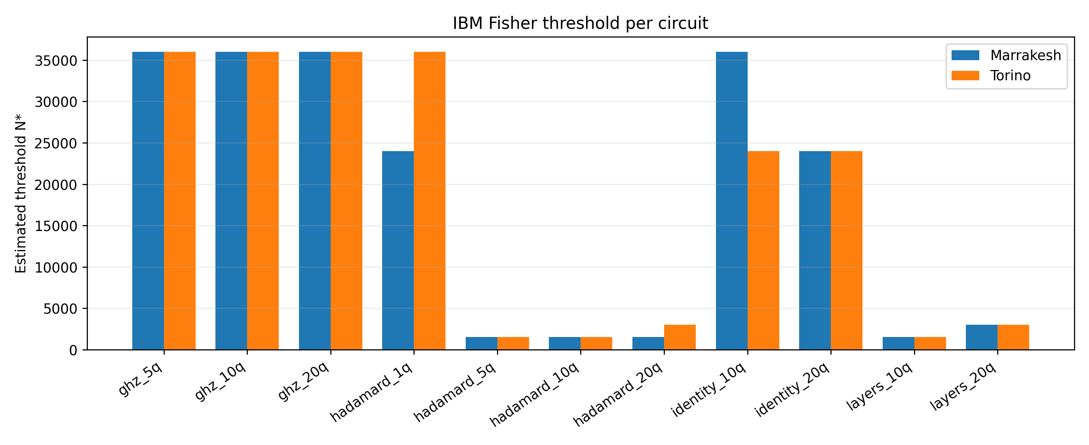
ibm_threshold_regime_boxplot.png
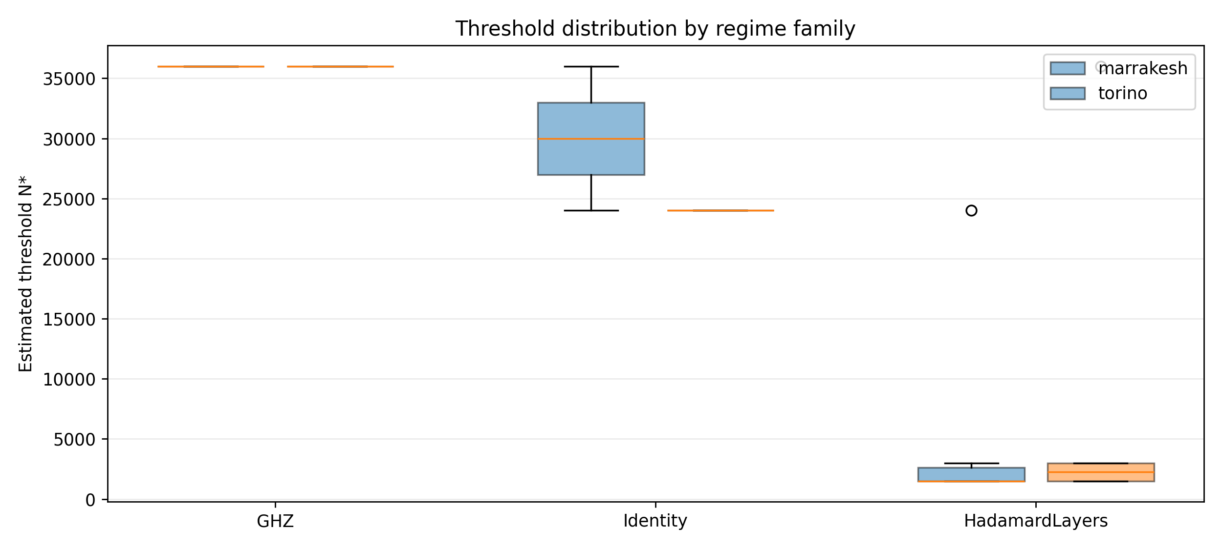
ibm_threshold_regime_nperqubit_boxplot.png
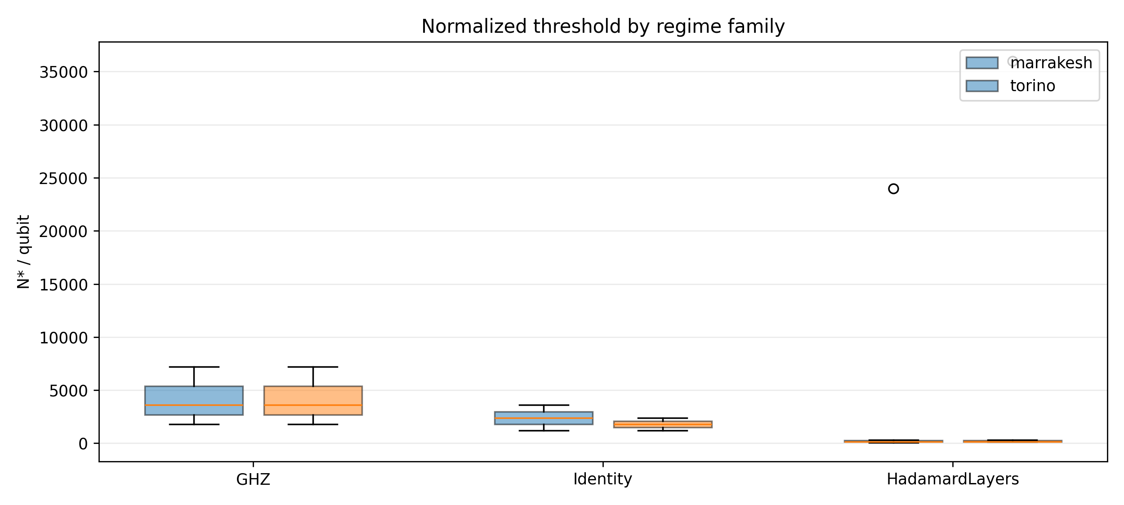
fisher_phase_transition_summary.png
