Additional Features:

Risk assessment is generally done by Likelihood X Impact

This is basic Risk model.

We are looking at COSO Framework for Risk management

1. NiXRisk should be based on Likelihood, Impact, **Vulnerability, Speed of Onset (Velocity)**

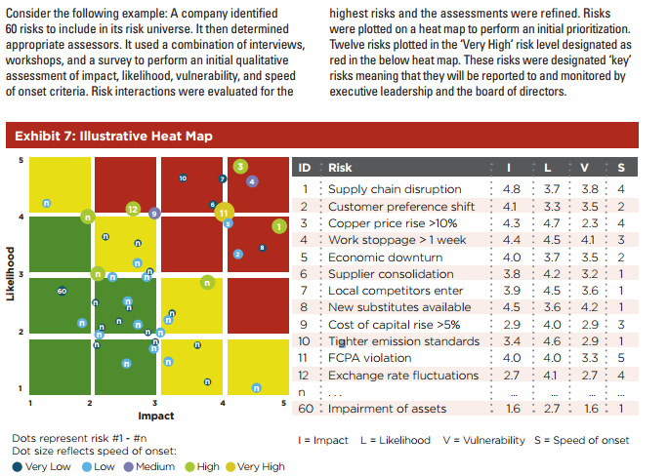

Our Dashboard should have the above Chart – it is called Risk Heat Map – Should be interactive/drill down chart

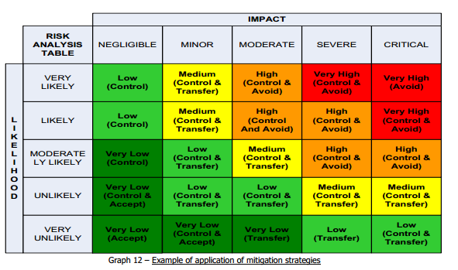

Details about Vulnerability & Velocity given below

* Please note Vulnerability & Velocity should be configurable option
* Likelihood and Impact are non-configurable as they are Risk management basic principle

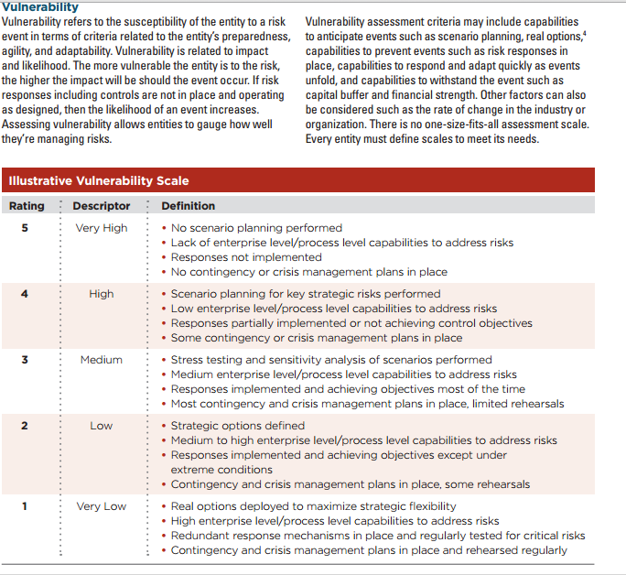

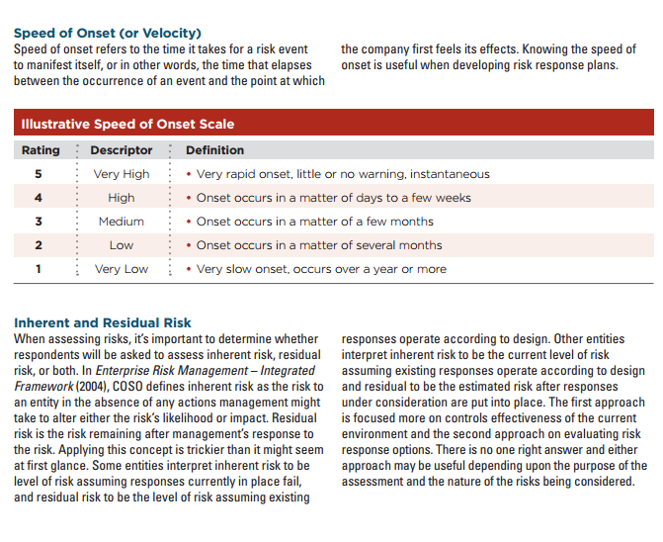

We already have Impact and Likelihood in existing design – But we need to have configuration table which explains the meaning of Ratings

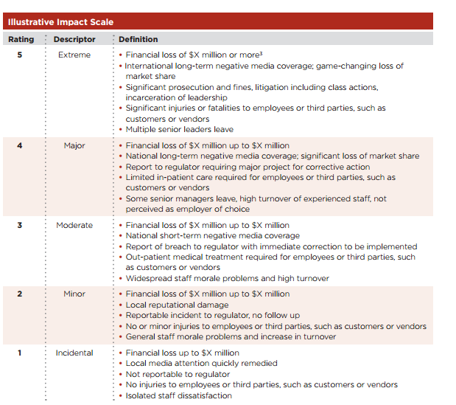

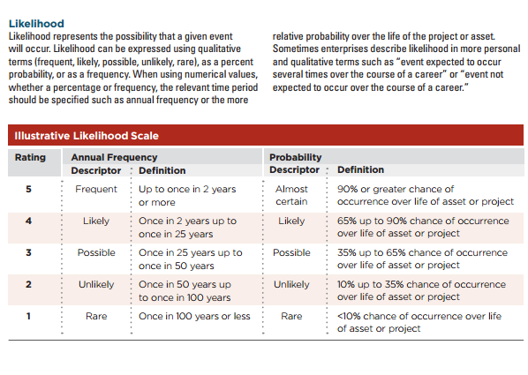

We need 4 configuration area where in we set the definition for scales in Likelihood, Impact, Velocity and Vulnerability

Apart from Risk Heat Map, we need to think about adding MARCI Chart given below. It is a Graph between Vulnerability and Impact

(Dot size represent the velocity size)

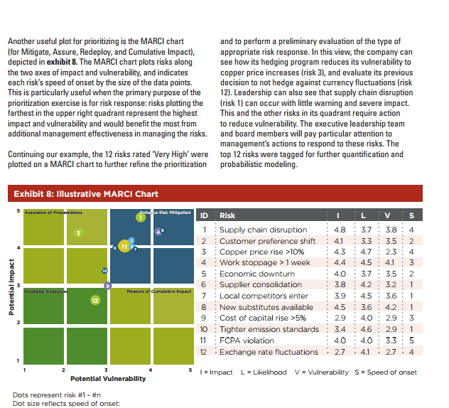

<http://www.protecht.eu/assets/articles/Risk_velocity_April2013.pdf>

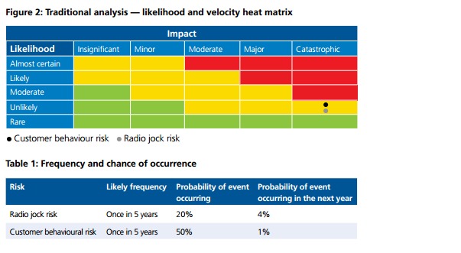

Lets say we conduct Risk for departments in company and want to see which department has more risk

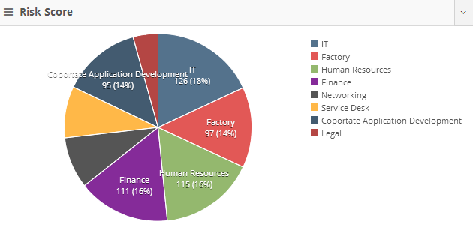

We are going to integrate Asset management into GRC (future plan )

We need show Risk level by Asset / Asset types.

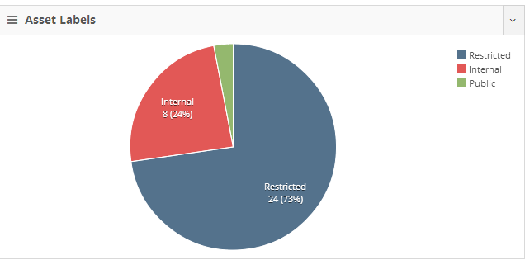

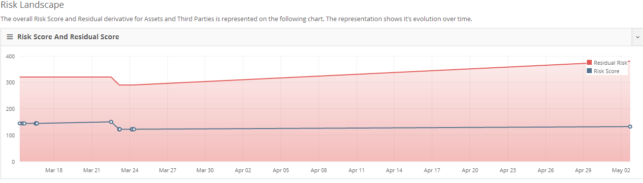

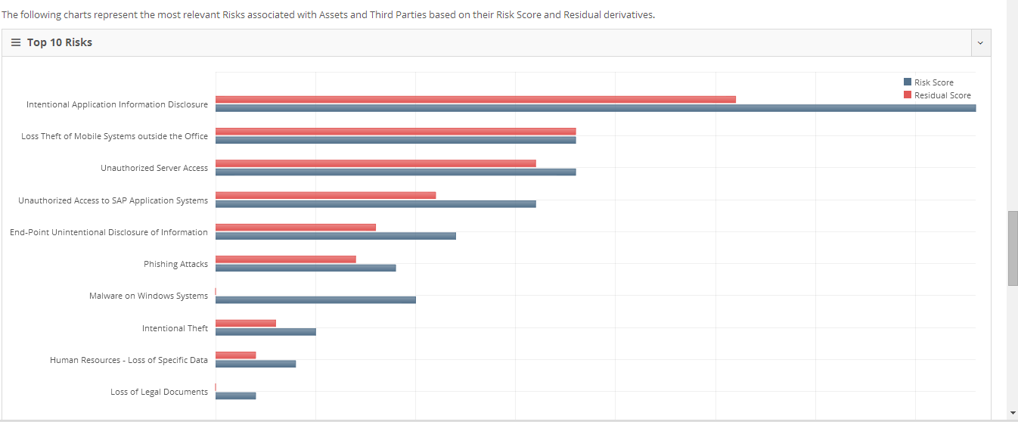

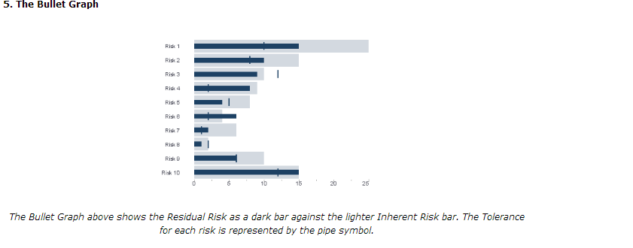

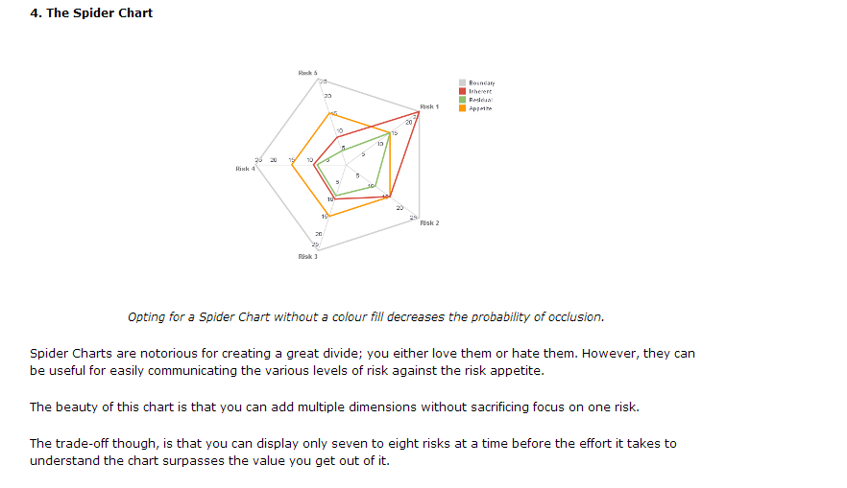

**b)**We are also looking at adding two concepts in Our NixRisk

1. Inherent Risk (Before controls are applied what is the risk level)

2. Residual Risk (After controls are applied what is the risk level - The risk that remains ***after controls*** are taken into account (the net risk or risk after controls).)

Below links explains

<http://community.resolvergrc.com/kb/risk-management/inherent-vs-residual-risk-assessment>

<https://www.fishnetsecurity.com/6labs/blog/inherent-and-residual-risk-how-both-scores-drive-enterprise-risk-decisions>

<http://www.protecht.com.au/resources/articles/five-alternatives-to-the-risk-assessment-matrix>

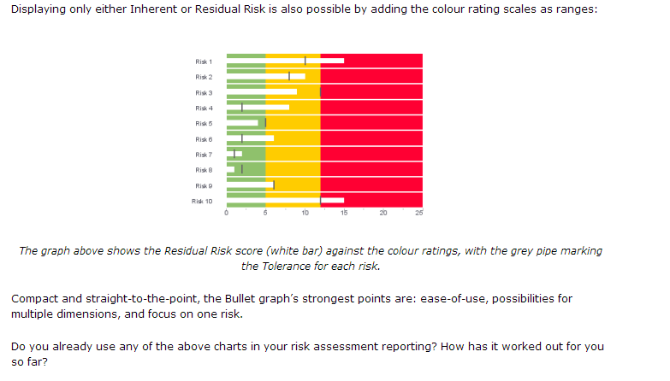

While submitting Risk - Please add a field for Asset related to Risk & Risk Category & Sub category , Department

