PharmaKart
SQL Analysis — Sales & Customer Data
----------------------------------------------------------------------------------------------------------
Part 1 — Get the basic picture:
- How many customers, orders and products are in the database?
TOTAL CUSTOMERS | TOTAL ORDERS | TOTAL PRODUCTS
2253 | 5147 | 79

- How are customers distributed by city/state? Which locations have the most customers?
CITY | TOTAL CUSTOMERS
Bengaluru | 282
Mumbai | 235
Delhi | 220
Hyderabad | 208
Chennai | 137
Pune | 132
…… | ….

STATE | TOTAL CUSTOMERS
Maharashtra | 420
Karnataka | 337
Telangana | 215
Tamil Nadu | 197
Uttar Pradesh | 152
Gujarat | 133
…… | ….

- How many orders are in each order status?
ORDER STATUS | ORDER PERCENTAGE | TOTAL ORDERS PER STATUS
Delivered | 87.97 | 4528
Cancelled | 8.61 | 443
Returned | 2.89 | 149
In Transit | 0.52 | 27

TOTAL ORDER AMOUNT | TOTAL ORDERS PER STATUS
31,83,259.03 | 618.468823

- How does order value differ by platform (Android, iOS and Web)?
ORDER STATUS | TOTAL ORDERS AMOUNT
Android | 19,62,321.34
iOS | 7,00,758.17
Web | 5,20,179.52

- Which acquisition channels have brought the most customers?
ACQUISITION CHANNEL | TOTAL CUSTOMERS
Google Ads | 724
Meta Ads | 456
Organic Search | 411
Referral | 286
Direct | 209
Affiliate | 112
 | 55

Part 2 — What are customers buying?
- Which product categories sell the most units?
CATEGORY | TOTAL UNITS SOLD
Diabetes | 5737
Cardiac | 5737
Gastro | 1582
Vitamins | 1287
Devices | 1150
Skin Care | 1002
Antibiotics | 829
Respiratory | 828
Pain Relief | 719
Thyroid | 235

- Which 10 products have the highest quantity sold?
PRODUCT NAME | TOTAL UNITS SOLD
Pantoprazole 40mg Tablet (Strip of 15) | 750
Metformin 1000mg SR Tablet (Strip of 15) | 680
Glimepiride 1mg Tablet (Strip of 15) | 661
Losartan 50mg Tablet (Strip of 15) | 634
Metoprolol Succinate 50mg ER Tablet (Strip of 15) | 625
Vildagliptin 50mg Tablet (Strip of 15) | 621
Clopidogrel 75mg Tablet (Strip of 15) | 621
Atorvastatin 20mg Tablet (Strip of 15) | 563
Glucometer Test Strips (Pack of 50) | 559
Amlodipine 5mg Tablet (Strip of 15) | 514

- Compare product MRP and selling price. Which products have the largest percentage discount?
PRODUCT NAME | MRP | SELLING PRICE | DISCOUNT PRICE | DISCOUNT PERCENTAGE
Pulse Oximeter | 1,999.00 | 999.50 | 999.50 | 50
Nebulizer Machine | 2,999.00 | 2,099.30 | 899.70 | 30
Digital BP Monitor | 2,499.00 | 1,624.35 | 874.65 | 35
Whey Protein Chocolate (1kg) | 2,499.00 | 1,999.20 | 499.80 | 20
Glucometer Kit with 10 Strips | 1,499.00 | 1,049.30 | 449.70 | 30
Glucometer Test Strips (Pack of 50) | 1,150.00 | 862.50 | 287.50 | 25
Sitagliptin 100mg Tablet (Strip of 15) | 420.00 | 147.00 | 273.00 | 65
Dapagliflozin 10mg Tablet (Strip of 10) | 390.00 | 136.50 | 253.50 | 65
Rosuvastatin 10mg Tablet (Strip of 15) | 250.00 | 87.50 | 162.50 | 65
Biotin Tablet (Bottle of 30) | 499.00 | 374.25 | 124.75 | 25

- Check whether generic and non-generic products show different sales patterns?
PRODUCT TYPE | TOTAL ORDERS | TOTAL UNITS SOLD | TOTAL REVENUE | AVG UNIT PRICE | AVG UNIT PER ITEM
Non-Generic | 3953 | 9127 | 25,17,915.60 | 305.42 | 1.40
Generic | 3544 | 9979 | 6,28,046.20 | 62.30 | 1.70

- Check whether prescription and non-prescription products show different sales patterns ?
PRESCRIPTION TYPE | TOTAL ORDERS | TOTAL UNITS SOLD | TOTAL REVENUE | AVG UNIT PRICE | AVG UNIT PER ITEM
non-prescription | 2995 | 4822 | 14,52,645.15 | 319 | 1.16
prescription | 3658 | 14284 | 16,93,316.65 | 122 | 1.78

Part 3 — Marketing wants to understand coupons
- Which coupon codes are used most often?
COUPON CODE | TOTAL ORDERS | TOTAL REVENUE GENERATED
WELCOME100 | 361 | 3,94,788.95
REFILL15 | 269 | 2,71,318.50
FIRST20 | 218 | 62,881.80
COMEBACK25 | 87 | 73,655.20
SAVE10 | 65 | 79,441.10
MONSOON12 | 42 | 42,888.05
FLAT50 | 30 | 30,120.15
DIWALI30 | 27 | 34,827.25
NEWYEAR150 | 10 | 17,096.70

- Join the coupon information to the orders and compare usage across campaign types
CAMPAIGN TYPE | TOTAL ORDERS | TOTAL CUSTOMERS | TOTAL SALES REVENUE | AVG ORDER VALUE
Acquisition | 566 | 566 | 4,57,670.75 | 311.55
Retention | 201 | 201 | 3,80,879.75 | 300.85
Win-back | 74 | 74 | 73,655.20 | 344.18
Seasonal | 37 | 37 | 42,888.05 | 332.46
Festive | 36 | 36 | 51,923.95 | 393.36

- How much discount has been given through each coupon code?
COUPON CODE | TOTAL DISCOUNT | TOTAL ORDERS
WELCOME100 | 36,100.00 | 361
REFILL15 | 34,843.18 | 269
COMEBACK25 | 15,474.99 | 87
FIRST20 | 12,576.36 | 218
DIWALI30 | 7,402.09 | 27
SAVE10 | 5,660.53 | 65
MONSOON12 | 3,840.52 | 42
FLAT50 | 1,500.00 | 30
NEWYEAR150 | 1,500.00 | 10

- Compare customers who used a coupon with customers who did not. Look at order count and
Spending
ORDER TYPE | TOTAL ORDERS | TOTAL UNITS SOLD | TOTAL REVENUE | AVG ORDER VALUE
Order with Coupon | 1109 | 5198 | 10,07,017.70 | 1,101.66
Order without Coupon | 4038 | 13908 | 21,38,944.10 | 798.37

- Find orders with unusually large coupon discounts and investigate which coupon codes are involved
ORDER ID | CUSTOMER NAME | COUPON CODE | GROSS MRP VALUE | NET SELLING VALUE | TOTAL DISCOUNT AMOUNT | DISCOUNT PERCENTGE
102835 | Aniket Pandey | WELCOME100 | 7,258.00 | 4,744.65 | 2,513.35 | 34.63
104308 | Lakshmi Fernandes | WELCOME100 | 5,009.00 | 2,824.30 | 2,184.70 | 43.62
104170 | Manish Shetty | WELCOME100 | 5,399.00 | 3,318.85 | 2,080.15 | 38.53
101338 | Naveen Bose | WELCOME100 | 4,070.00 | 2,496.10 | 1,573.90 | 38.67
104756 | Mahesh Ansari | COMEBACK25 | 3,889.00 | 2,321.25 | 1,567.75 | 40.31
101615 | Rakesh Rao | WELCOME100 | 3,406.00 | 1,871.70 | 1,534.30 | 45.05
101673 | Mary Jain | WELCOME100 | 3,590.00 | 2,099.50 | 1,490.50 | 41.52
101260 | Anjali Shetty | WELCOME100 | 2,510.00 | 1,028.00 | 1,482.00 | 59.04
100797 | Shruti Kulkarni | WELCOME100 | 3,320.00 | 1,839.00 | 1,481.00 | 44.61
100567 | Vivaan Singh | WELCOME100 | 3,790.00 | 2,310.10 | 1,479.90 | 39.05

Part 4 — Finance found a mismatch
- Using order_items, calculate the item-level amount as quantity × unit_price
ORDER ID | ORDER ITEM ID | PRODUCT ID | QUANTITY | UNIT PRICE | PRODUCT AMOUNT
100001 | 1 | 120 | 2 | 132.00 | 264.00
100002 | 2 | 103 | 3 | 106.25 | 318.75
100002 | 3 | 110 | 2 | 492.80 | 985.60
100002 | 4 | 106 | 1 | 147.00 | 147.00
100002 | 5 | 171 | 1 | 862.50 | 862.50
100002 | 6 | 132 | 1 | 135.00 | 135.00
100003 | 7 | 107 | 2 | 306.00 | 612.00
100003 | 8 | 102 | 3 | 44.10 | 132.30
100003 | 9 | 121 | 1 | 52.00 | 52.00
100003 | 10 | 122 | 1 | 9.00 | 9.00
100003 | 11 | 140 | 3 | 60.00 | 180.00
100003 | 12 | 171 | 1 | 862.50 | 862.50
- Compare the item-level total with the order subtotal for each order
ORDER ID | CUSTOMER ID | ORDER SUBTOTAL | CALC ITEM TOTAL | DIFFERENCE
102335 | 1861 | 656.10 | 44.10 | 612.00
102671 | 2367 | 463.40 | 305.00 | 158.40
104757 | 2132 | 1,298.00 | 1,203.50 | 94.50

- Find orders where the two numbers do not match
ORDER ID | CUSTOMER ID | ORDER SUBTOTAL | CALC ITEM TOTAL | DIFFERENCE
102335 | 1861 | 656.10 | 44.10 | 612.00
102671 | 2367 | 463.40 | 305.00 | 158.40
104757 | 2132 | 1,298.00 | 1,203.50 | 94.50

- Quantify the difference and check whether coupon discounts, delivery fees or other order-level fields help explain it

ORDER ID | CUSTOMER ID | ORDER SUBTOTAL | CALC ITEM TOTAL | DIFFERENCE | Coupon code | Coupon Discount | Delivery Fee
102335 | 1861 | 656.10 | 44.10 | 612.00 |  | 0.00 | 0.00
102671 | 2367 | 463.40 | 305.00 | 158.40 |  | 0.00 | 49.00
104757 | 2132 | 1,298.00 | 1,203.50 | 94.50 |  | 0.00 | 0.00

- Document any assumption you make about which order statuses should be included
ORDER ID | CUSTOMER ID | ORDER STATUS | ORDER SUBTOTAL | CALC ITEM TOTAL | DIFFERENCE
102335 | 1861 | Delivered | 656.10 | 44.10 | 612.00
102671 | 2367 | Delivered | 463.40 | 305.00 | 158.40
104757 | 2132 | Delivered | 1,298.00 | 1,203.50 | 94.50

Part 5 — Delivery check
- Calculate delivery time from order_date to delivery_date where both dates are available.
ORDER ID | CUSTOMER ID | ORDER DATE | DELIVERY DATE | DELIVERY TIME (HR) | DELIVERY TIME DAYS
100001 | 1003 | 02-01-2025 12:28 | 04-01-2025 18:17 | 53.8 | 2
100002 | 1006 | 03-01-2025 19:58 | 04-01-2025 12:54 | 16.92 | 1
100003 | 1011 | 04-01-2025 18:00 | 07-01-2025 12:58 | 66.95 | 3
100004 | 1011 | 05-01-2025 05:48 | 07-01-2025 15:38 | 57.82 | 2
100005 | 1012 | 05-01-2025 11:11 | 07-01-2025 15:44 | 52.53 | 2
100006 | 1016 | 05-01-2025 19:48 | 07-01-2025 17:53 | 46.07 | 2
100007 | 1018 | 06-01-2025 10:54 | 07-01-2025 12:46 | 25.85 | 1
100008 | 1019 | 07-01-2025 09:14 | 08-01-2025 20:35 | 35.33 | 1
100009 | 1020 | 07-01-2025 09:50 | 08-01-2025 09:48 | 23.95 | 1
… | … | … | … | … | …

- Find the average delivery time.
TOTAL DELIVERED ORDERS | AVERAGE DELIVERY DAYS
4677 | 1.80

- Compare delivery time by platform and by location
STATE | CITY | PLATFORM | TOTAL DELIVERED ORDERS | AVERAGE DELIVERY DAYS | AVERAGE DEKIVERY HOURS
Tamil Nadu | Madras | Android | 2 | 1.00 | 21.00
Telangana | Hyderabad | iOS | 2 | 1.00 | 23.00
Telangana | Hyderabad | Web | 1 | 1.00 | 13.00
Karnataka | Bangalore | Web | 5 | 1.00 | 29.20
Maharashtra | Pune | iOS | 2 | 1.00 | 27.00
Karnataka | Bengaluru | Web | 2 | 1.00 | 32.50
Maharashtra | Mumbai | Web | 2 | 1.00 | 26.00
Maharashtra | Bombay | Android | 5 | 1.20 | 33.40
Telangana | Hyderabad | Android | 12 | 1.40 | 32.00
Karnataka | Bangalore | Android | 27 | 1.42 | 33.79
… | … | … | … | … | …

Part 6 — Build one customer report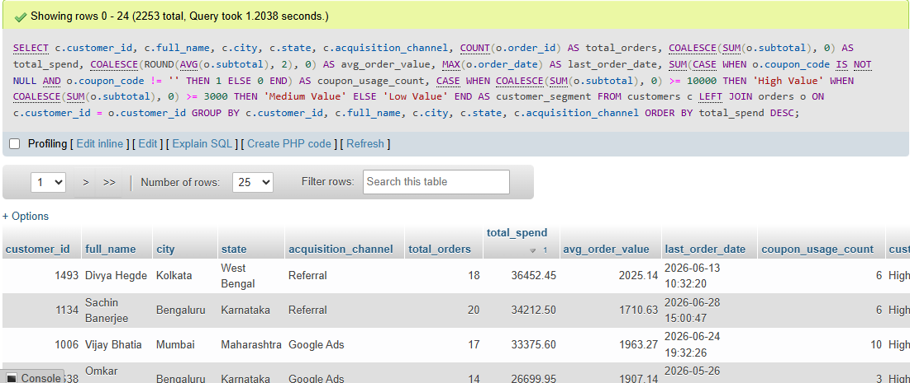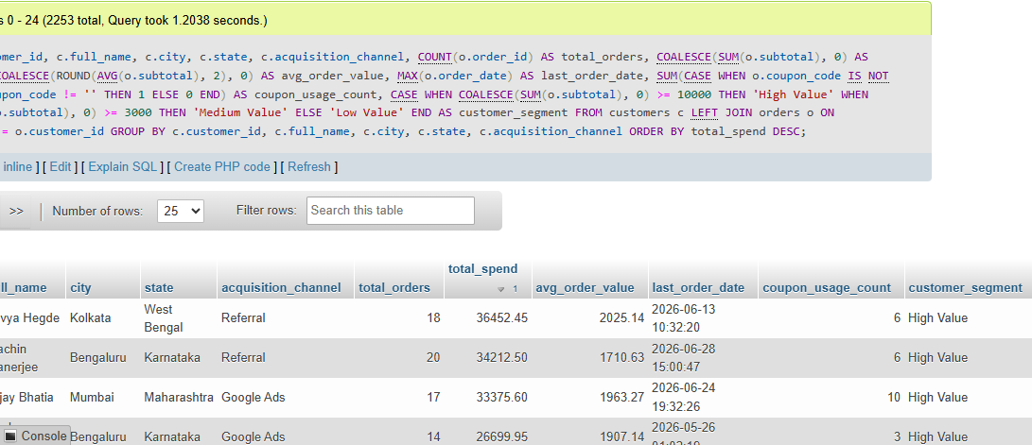

1. Customer Identification & Demographics
- customer_id: The unique identifier for the customer.
- full_name: The customer's name.
- city & state: The geographic location of the customer.
- acquisition_channel: The marketing channel or platform through which the customer was acquired (e.g., social media, direct, referral).

2. Order & Financial Metrics
- total_orders: The total number of orders placed by the customer. (If they have never ordered, this will show 0 due to the LEFT JOIN).
- total_spend: The cumulative monetary sum of all their order subtotals. If they have no orders, COALESCE ensures it displays 0 instead of a blank NULL.
- avg_order_value: The average amount the customer spends per order, rounded to 2 decimal places.
- last_order_date: The date and timestamp of the most recent order they placed, helping you identify active versus dormant accounts.

3. Engagement & Segmentation
- coupon_usage_count: The total count of how many times the customer has successfully applied a coupon code across their orders.
- customer_segment: A dynamic classification label based on their total spend:
  - High Value: Customers with a total spend of 10,000 or more.
  - Medium Value: Customers with a total spend between 3,000 and 9,999.
  - Low Value: Customers with a total spend under 3,000 (or zero spend).

Summary of the Output Structure
- Granularity: Exactly one row per customer.
- Inclusion: Every single customer is listed—even those who have never placed an order (their spend and counts will show as zero).
- Ordering: The final results are sorted in descending order (ORDER BY total_spend DESC), meaning your highest-spending VIP customers appear right at the top of the report.

