 

**SESP and DISA Interoperability**

**Feature Requirements**

**and Specification Document**

**Search and Manage Laboratory Results on the Integration Server**

**Version 1.5**



# Version History

| **Date** | **Version** | **Description** | **Author** |
| --- | --- | --- | --- |
| 16 February 2023 | 1.0 | Creation of the document:  -Merged requirements of NID map, Search results with the new functionality Manage Viral load.  -Updated introduction and annexes accordingly as changed the interface.  -Changed “Estado de resultado” to “Estado de sincronização” | FGH Team |
| 24 April 2023 | 1.1 | -Discontinued Reference ID from search and its results  -Removed “Flagged for review” and “No result” from Cause of not processing  -Added “Invalid result” in Cause of not processing  -Included CD4 in search  -Added permission for Lab technician to reschedule  -Included trim and clear texts on search fields  -*Data de validação* renamed to *Data de autorização* | FGH Team |
| 25 July 2023 | 1.2 | -Added HF name along with the code in search  -Added sample collection date  -Added links on Request ID to e-Lab and NID to open patient dashboard | CSaude Team |
| 5 October 2023 | 1.3 | -Included Informative messages on synchronization progress between local SESP and Integration server.  -Included TBLAM in Search Lab Result: type | CSaude Team |
| 6 November 2023 | 1.4 | -Incorporated CDC comment: Included role-based access requirement | Csaude Team |
| 9 April 2024 | 1.5 | -Included CRAG in Search Lab Result: type | Csaude Team |

Table of Contents

Glossary 3

Concepts 3

1. Introduction 4

1.1. Scope 5

1.2. References 5

2. Requirements Definition 6

2.1 List of Functional Requirements 6

2.2 List of non-functional Requirements 12

3. ANNEXES 13

# Glossary

| **APHL** | Association of Public Health Laboratories |
| --- | --- |
| **DisaLab** | Information Management System for Laboratory (LMIS) used in Mozambiqu*e* |
| **FSR** | Lab Result Request Form in SESP |
| **HF** | Health Facility |
| **Lab** | Laboratory |
| **SESP** | Electronic Patient Tracking System (OpenMRS) |
| **SIS** | HIS (Health Information Systems) team |

# Concepts

* **Request ID** is a code that includes country name, system name (DISA), and barcode which is generated when a FSR is registered in DisaLab/DisaLink. A lab sample will always be associated to a barcode.

# Introduction

Interoperability between DisaLab and SESP allows access to laboratory results in SESP through the automatic electronic transmission of laboratory results from DisaLab to the e-Lab form (Formulário Electrónico de Laboratório) created in SESP, which is time efficient and reduces the workload of manual data entry of the results into the laboratory form of SESP.

Background on how interoperability works can be found in the introduction section of the document SOP_DISA_SESP_Modulo_DISA_HL7app.

In the table below, are listed challenges that occurred during implementation of this interoperability solution. For each challenge there’s a solution described and explanation on what caused the need of a mechanism by which the laboratory team could monitor and manage these results on the integration server.

| **Challenges** | **Solutions** |
| --- | --- |
| Results are sometimes pending on the integration server side, and not sent automatically to the HF SESP as scheduled - mostly due to internet connection issues. | Development of **Search functionality** in the DisaLab Interoperability module of SESP, that allows users to monitor the patients’ laboratory test results using different criteria.  Additionally, development of the **Laboratory Result Management functionality** in the DisaLab Interoperability module of SESP to allow managers to manually perform the following actions on the integration server side:   * map NIDs received from DisaLab to the corresponding NID in SESP or * reallocate the process to another HF (in case of NID not found for example) or * remove lab results |
| There are results that may not have been processed from integration server to SESP (laboratory results created on the integration server, but e-Lab not created in SESP), because of data quality issue with:   * NID (not identified or duplicated in SESP) or * Request ID: a result with same request ID has been already processed or * the result value itself is not valid or blank. |

The purpose of allowing the user to **map NIDs** manually is to create a link between DisaLab NID and corresponding NID in SESP. Data clerks assign DisaLab NIDs to patients that could not be matched using the patient NID in SESP, and so they will then have two potential identifiers: *TARV* *NID* and *Disa NID*. This mapping is performed once for any given patient, and then both systems (DisaLab and SESP) will have the same identifier which ensures that future results are correctly processed. Once the manual mapping is finalized, the synchronization state of this laboratory result will be updated to “Pending” state and will be reprocessed.

In some cases the NID used for the request carries a wrong HF code, which causes a mismatch. If the user determines that the HF code within the NID is incorrect and is able to identify the correct HF code, he/she will be able to **relocate** to the correct HF, thus changing the synchronization status to “Pending” to later be processed at the correct HF.

All results with a “Pending” synchronization state will be processed according to the scheduled job for e-Lab encounter creation in SESP.

### Scope

This document outlines all the requirement definitions for the functionality in the DisaLab Interoperability module in SESP that allows for searching and managing (NID mapping, reallocation, rescheduling and removing) of lab results on the integration server.

### References

1. DISA-SESP Interoperability Business Case: DISA_OpenMRS Interoperability BusinessCase
2. Background of interoperability: SOP_DISA_SESP_Modulo_DISA_HL7app
3. Lab results synchronization (from integration server to SESP) algorithm: SESP_DISA_Interoperability_SyncAlgorithm

# Requirements Definition

### 2.1 List of Functional Requirements

| **Requirement #** | **Category/**  **Functional Area** | **Requirement** |
| --- | --- | --- |
| **DISA_PRL_FR0** | Search Lab Result on Integration server | The system will allow the user to search for lab results on the integration server with the following user choice:   * Type of result/Tipo de resultado **(DISA_PRL_FR1)** * Period: Start date and end date (**DISA_PRL_FR2**) * Request ID/ Identificador da Requisição (**DISA_PRL_FR3**) * Synchronization Status/ Estado da Sincronização (**DISA_PRL_FR4**) * Cause of not processing/ Causa de não processamento (**DISA_PRL_FR5**) * NID (**DISA_PRL_FR6**) * HF/ US (**DISA_PRL_FR7**) |
| **DISA_PRL_FR1** | Search Lab Result: type | The system will allow the user to search for all lab results by selecting one or more type of result   * Viral load (TypeOfResult=HIVVL) * CD4 (TypeOfResult=CD4) * TBLAM(TypeOfResult=TBLAM) * CRAG (TypeOfResult=CRAG)   By default all available options are selected. |
| **DISA_PRL_FR2** | Search Lab Result:  Period | The system will allow the user to search for all lab result records created on the integration server during a specified period:   * Start date: DD/MM/YYYY * End date: DD/MM/YYYY   By default, End date is considered current date if not specified by the user.  The system presents a button (X) to clear text on user click. |
| **DISA_PRL_FR3** | Search Lab Result:  Request ID (Identificador da requisição) | The system will allow the user to search for lab result records by the unique Request ID assigned in DisaLab, with the following format:  MZDISALLLNNNNNNN   * MZ: Two letters for the country. * DISA: Four letters for the laboratory information system. * LLL: 3 letters for the testing laboratory. * NNNNNNN: 7-digit (or more) numeric sequence that identifies the sample.   The system should show the prefix MZDISA for the user to enter the rest of the ID.  Note: If any blank space is introduced by the user, before, in the middle or after the text the system will trim and ignore the blank spaces.  The system presents a button (X) to clear text on user click. |
| **DISA_PRL_FR4** | Search Lab Result:  Synchronization Status (Estado da Sincronização) | The system will allow the user to search for lab result records with the following status:   * Pending * Processed * Not Processed * *All of the above*   *By default Not Processed option is selected.* |
| **DISA_PRL_FR5** | Search Lab Result:  Cause for Not Processing (Causa de Não Processamento) | The system will allow the user to search for lab result records with the following cause (current or historical):   * NID not found in SESP * Invalid Result * Duplicate NID in SESP * Duplicate Request ID * *All of the above* |
| **DISA_PRL_FR6** | Search Lab Result:  NID | The system will allow the user to search for lab result records by the Patient NID, using the following format CCPPDDUSSS/AAAA/NNNNN:   * CC – Country * PP – Province * DD- District * US – Health Facility * SS – Service Code * AAAA – Year * NNNNN – Sequence Number   Note: If any blank space is introduced by the user, before, in the middle or after the text the system will trim and ignore the blank spaces.  The system presents a button (X) to clear text on user click. |
| **DISA_PRL_FR7** | Search Lab Result:  HF | The system will allow the user to search for lab result records by corresponding HF name - code (equals to SISMA code). The source of this select box options are registered in the integration server database table OrgUnit, according to SISMA codes configured in *Administration > Configurations > Disa > Api Sisma Code*. |
| **DISA_PRL_FR8** | Details of Search Patient Lab Results | The system will identify and display a list of all patients with lab results that match the specified criteria (**DISA_PRL_FR1**).  For each patient listed, regardless of search criteria used, the system will show the following details:  *(Original source of the following data is OpenLDR, showing variable names in Integration server)*   * **Requesting HF/US de requisição:** Name of the HF that sent the paper FSR and sample requesting results. (RequestingFacilityName) * **Requesting District/Distrito de Requisição:** Name of the District that sent the paper FSR and sample requesting results. (RequestingDistrictName) * **HF Code/Código da US:** SISMA HF code.(RequestingFacilityCode) * **NID:** Patient ARV NID. (UniqueID) * **Name/Nome:** First and Last Name * **Sex/Sexo:** Patient Sex. (HL7SexCode) * **Age/Idade:** Patient age. (AgeInYears) * **Request ID/Identificador da requisição:** Unique ID assigned to the sample in DisaLab. (RequestID)   For successfully processed results to SESP, Request ID will have a link to e-Lab form associated, and will open in a new tab.   * **Sample collection date/ Data da colheita**: Date when the specimen was collected. (SpecimenDatetime) * **Result authorization Date/Data de autorização:** Date result was authorized/available in OpenLDR. (AuthorisedDateTime) * **Result/Resultado** (FinalResult) * **Type of result/Tipo:** Type of result corresponding on “Resultado” column: HIVVL, CD4, TBLAM, CRAG (TypeOfResult)   *(Original Source of the following data is the Integration server)*   * **Status/Estado:** Status of lab result record on integration server. (SyncStatus) * **Created on Integration server/Criado no Servidor de Integração:** Date lab result was created on the integration server (Created_At). * **Updated on the Integration server/Actualizado no Servidor de Integração:** Date the lab result record was updated on the integration server (marked as processed or not processed) (Updated_At). * **Not Processing Cause/Causa de Não Processamento:** Reason of lab result record not processed: NID not found, Invalid Result, Duplicate NID, Duplicate Request ID. (Not_Processing_Cause).   Action options for user when synchronization to SESP fails under the label**: *Manage Results/Gerir resultados:***  Depending on the processing synchronization status and user authenticated role, the system may show followingAction options to be selected for laboratory results **(DISA_PRL_BR1)**:   * **Reschedule/Reagendar** (**DISA_PRL_FR9**) * **Reallocate/Realocar** (**DISA_PRL_FR10**) * **Void/remover** (**DISA_PRL_FR11**) * **Map NID/ Mapear NID** (**DISA_PRL_FR12**) |
| **DISA_PRL_FR9** | **Manage lab result:**  Reschedule lab result to synchronize to SESP | For the lab result with the Reschedule option selected, the system will update the status of the synchronization from *Not Processed* to *Pending*, thus allowing the same lab result to be processed again when internet connectivity is established at the corresponding SESP HF.  The system shows a success message for the user “Resultado laboratorial reagendado com sucesso.”. |
| **DISA_PRL_FR10** | **Manage lab result:** Reallocate patients to another HF | For the lab result with the Reallocate patient option selected, the system will show:   * A dropdown list with the name of all of the existing provinces in Mozambique > respective districts > respective HF.   and allow the user to select/type one HF from the dropdown.  The system will ask the user to confirm reallocation to the HF selected.  If the user confirms “ok”, for the selected HF the system will update the selected laboratory result on the integration server with the following:   * Requesting Facility Code of the health facility; * Requesting Facility Name of the health facility; * Requesting Facility Province of the health facility; * Requesting Facility District of the health facility; * Laboratory result status set to *Pending*.   The system shows a success message for the user “Resultado laboratorial MZDISALLLLLNNNNNNN realocado para US HF_NAME I (HF_CODE) com sucesso.”  Note: The system will use the MISAU official HF list from SISMA as the basis for the list for provinces and corresponding HFs. |
| **DISA_ PRL_FR11** | **Manage lab result:** Remove | For the lab result with the selected Remove result option, the system will request confirmation for the operation. If the user confirms the operation, the lab result will be voided and no longer be visible to the user.  Note: A voided record in the system will not be permanently deleted in the database. |
| **DISA_PRL_FR12** | **Map DISA NID to SESP** | Once the option to MAP NID is selected, the system will list all patients with a matching given, middle or last name (in the HF SESP) as the selected Laboratory Patient Results name and also allow the user to search manually a Patient (**DISA_FR12.1**) in SESP with the corresponding NID.  The system will allow the user to select a patient from the list and confirm the Mapping (**DISA_FR12.3**) of the NID between DISA and SESP. |
| **DISA_PRL_FR12.1** | **Map DISA NID to SESP:** Search Patient | The system will allow the user to search for the patient by entering the patient name. The system will identify and list the patient(s) that have a match with the name entered, displaying the following details to be selected (**DISA_FR12.2**):   * NID * Full Name * Sex * Age |
| **DISA_FR12.2** | **Map DISA NID to SESP:** Patient Found | The system will list the following information for the user to confirm (**DISA_FR12.3**)   * Integration server (Disa)   + NID - with a link to the corresponding patient dashboard to open in a new tab.   + Name   + Sex   + Age * SESP   + NID   + Name   + Sex   + Age |
| **DISA_FR12.3** | **Map DISA NID to SESP:** Confirm NID Mapping | The user confirms the mapping by selecting the button “Mapear”.  Once confirmed, the system will update the selected laboratory result on the integration server with the following:   * DISA NID with the selected Patient SESP NID * Laboratory result synchronization status to PENDING.   The system will return to the “Disa Interoperabilidade” page and show a message to the user “DISA NID ___ was successfully mapped to SESP NID ___ “.  On the patient details page of SESP, the DISA NID will be visible along with SESP NID. |
| **DISA_FR13** | **Informative messages** | The system will show following messages, related to synchronization process between local SESP and integration server:   1. Always show last synch date/time of last execution “A última sincronização foi concluída em *dd/mm/yyyy* as *hh:mm*h.” 2. When a synchronization is in progress show: “Sincronização está em curso, iniciou em *dd/mm/yyyy* as *hh:mm*h.” 3. Always show the interval configured: “O intervalo de sincronização configurado é ___”.   The system will automatically refresh the messages in order to ensure timely updates for the user. |
| **DISA_FR14** | **User Profiles and Access levels** | User and access management for Disa Interoperability page and respective lab results visualization will be done in SESP, for the following profiles:   * Lab Technician (*Tecnico de Laboratorio*) * Data Manager (*Gestor de Disa Interoperabilidade*)   The manage lab results functionality for these profiles should be configured according to what is described in **DISA_PRL_BR1**. |

2.1 List of Business Rules

| **Business Rule #** | **Category** | **Description** |
| --- | --- | --- |
| **DISA_PRL_BR1** | **Manage Results** | Depending on the synchronization status and user authenticated role, the system will show the specificAction options to be selected on the Manage Results column of Search details.   * **DISA_PRL_BR2** * **DISA_PRL_BR3** * **DISA_PRL_BR4** * **DISA_PRL_BR5** |
| **DISA_PRL_BR2** | **Reschedule/Reagendar** | This option is available in following conditions of lab results:   * Status of synchronization = Not Processed. * Authenticated user role is “Gestor de Disa Interoperabilidade” or “Tecnico de Laboratorio”. |
| **DISA_PRL_BR3** | **Reallocate/Realocar** | This option is available in following conditions of lab results:   * Status of synchronization = Not Processed or Pending. * Authenticated user role is “Gestor de Disa Interoperabilidade” |
| **DISA_PRL_BR4** | **Void/remover** | This option is available in following conditions of lab results:   * Status of synchronization = Not Processed or Pending. * Authenticated user role is “Gestor de Disa Interoperabilidade”. |
| **DISA_PRL_BR5** | **Map NID/ Mapear NID** | This option is available in following conditions of lab results:   * Status of synchronization = Not Processed. * Cause of not processing = NID not found in SESP. * Authenticated user role is “Gestor de Disa Interoperabilidade” or “Tecnico de Laboratorio”. |

### 2.2 List of non-functional Requirements

The HF server running the SESP instance must have internet connection to view integration server data and use the interoperability module.

If this requirement is not fulfilled the system will show a message “Para usar o módulo DISA Interoperabilidade deve estar conectado a internet.” in “Disa Interoperabilidade” page.

# ANNEXES

**Annex 1:** Manage Lab Results Interface

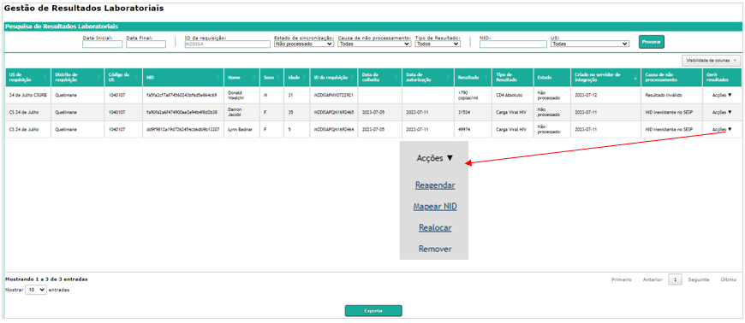

**Annex 2:** Reallocation

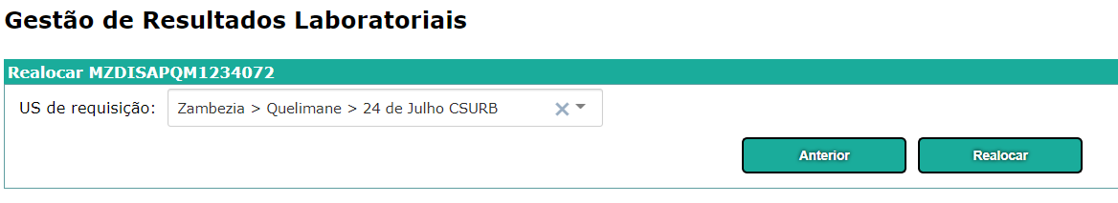

Confirm reallocation

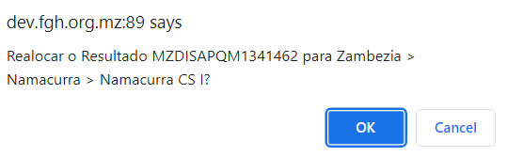

Message on success



**Annex 3:** NID mapping

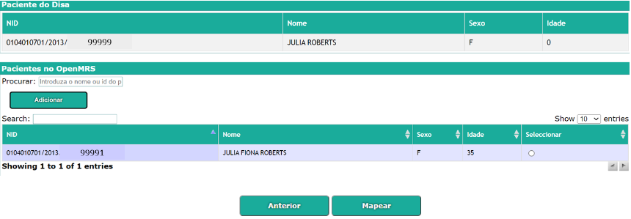

Patient Detail Screen after being Mapped with DISA NID

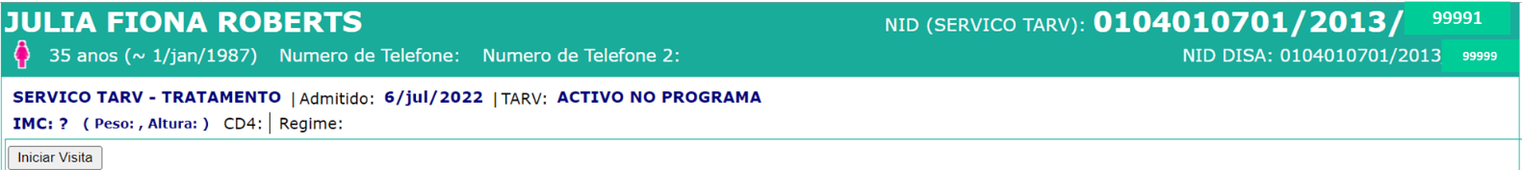

**Annex 4:** Remove lab result

Confirm removal

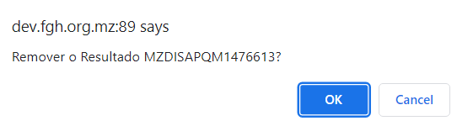

Message on success



**Annex 5:** Reschedule

Message on success

