 

**SESP and DISA Interoperability**

**Feature Requirements**

**and Specification Document**

**Laboratory Results Synchronization Algorithm**

**Version 1.6**



# Version History

| **Data** | **Versão** | **Descrição** | **Autor** |
| --- | --- | --- | --- |
| 31 March 2022 | 0.1 | Document creation | FGH Team |
| 18 April 2022 | 1.0 | Internal review | FGH Team |
| 20 Jun 2022 | 1.1 | Updates:  -Replace all OpenMRS and EPTS references with SESP.  -Replace term staging server with integration server.  -Update algorithm to reflect new consolidated variable in OpenLDR (FinalViralLoadResult).  -Update testing scenarios to reflect new algorithm. | FGH Team |
| 20 Oct 2022 | 1.3 | -Updated the document to include relevant details about the VL synchronization process between the integration server and SESP.  -Altered VL results algorithm to include >10.000.000 as a plausible result, rather than flagging for review. | FGH Team |
| Apr 2023 | 1.4 | -Change of document title from “Viral Load Algorithm” to “Laboratory results synchronization algorithm”  -Removed interoperability diagram, added referencing document  -“Flagged for review” and “FSR sem resultado” was substituted to “Invalid result”  -Changed FSR to e-Lab  -Added CD4 algorithm  -Changed document title from “VL_algorithm” to “SyncAlgorithm”  -Changed variable FinalViralLoadResult to FinalResult  -Added tables of OpenLDR lab result variables  -Updated VL algorithm diagram  -Overall review. | FGH Team |
| 16 Oct 2023 | 1.5 | -Added TBLAM algorithm | CSaude Team |
| 09 Apr 2024 | 1.6 | -Added CRAG algorithm | CSaude Team |

# Table of Contents

**Version History 2**

**Table of Contents 3**

**Concepts 3**

**1. Introduction 4**

1.1. Purpose 4

1.2. Scope 4

1.3. References 4

1.4 General Key Assumptions 4

**2. Viral Load Mapping Requirements 5**

2.1. Key Assumptions 5

2.2. List of Functional Requirements for mapping of VL results 6

2.3. Testing Scenarios 10

**3. CD4 Count Mapping Requirements 11**

3.1. Key Assumptions 12

3.2. List of Functional Requirements for mapping of CD4 Count results 12

**4. TB LAM Mapping Requirements 15**

4.1. Key Assumptions 15

4.2. List of Functional Requirements for mapping of TB LAM results 16

**5.** **CRAG Mapping Requirements****19**

5.1. Key Assumptions 19

5.2. List of Functional Requirements for mapping of CRAG results 20

# Concepts

* **Request ID** is a code that includes country name, system name (DISA), and barcode which is generated when a FSR is registered in Disa. A lab sample will always be associated with a barcode.
* **TypeOfResult** is a variable in the integration server that indicates the code of the type of result received from Disa (OpenLDR): HIVVL, CD4, TBLAM, CRAG, etc.
* **Sync Log** is a table generated by Disa Interoperabilidade module, that registers the following information on creation of e-Lab form: patient id, encounter id, request id, type of result, date created.

# Introduction

Interoperability between DisaLab and SESP allows access to laboratory results in SESP through the automatic electronic transmission of laboratory results from DisaLab to the e-Lab form(Formulário Electrónico de Laboratório) created in SESP, which is time efficient and reduces the workload of manual data entry of the results into the laboratory form of SESP.

Background on how interoperability works can be found in the introduction section of the document SOP_DISA_SESP_Modulo_DISA_HL7app.

The document is structured to have one section per type of lab result to describe requirements for its synchronization process between integration server to SESP.

## Purpose

The purpose of this document is to capture the requirements and specifications for the lab results synchronization algorithm from the integration server (which gets data from OpenLDR - DISA component) to SESP (creation of e-Lab form).

## Scope

This document outlines the requirements to map lab results from Integration Server to SESP.

## References

* Business case: DISA-SESP Interoperability Business Case: DISA_OpenMRS Interoperability BusinessCase_v.1.7
* eLab form in SESP: SESP_eLab_Form Specification and Requirements
* Background of the Interoperability find in introduction section of SOP_DISA_SESP_ModuloDisaInterop_HL7app
* More information on requirements of processing status find in SESP_DISA_Interoperability_SearchManage_Results_Requirements

## 1.4 General Key Assumptions

The key assumptions associated with lab results mapping algorithm are:

* Each result type is associated with a Request ID which is generated for each sample entered in DisaLab.
* The Request ID per TypeOfResult is unique.
* Any duplicated result (Same Request ID for the same TypeOfResult found in Sync logs table) is automatically voided by the system.

# Viral Load Mapping Requirements

In OpenLDR the VL result variables that are mapped to integration server are:

| **Variable in OpenLDR** | | | **Variable in Integration server** |
| --- | --- | --- | --- |
| **Name** | **Type** | **Description** |
| LIMSPanelCode:  HIVVL | varchar | Refers to the code assigned to a test panel within the Laboratory Information Management System (LIMS).  Corresponding code for viral load is HIVVL. | TypeOfResult: HIVVL |
| HIVVL_ViralLoadCAPCTM | varchar | Viral Load Result - quantitative value | FinalResult |
| HIVVL_ViralLoadResult | varchar | Viral Load Result - qualitative value | FinalResult |
| LIMSSpecimenSourceCode | varchar | Specimen Type for VL: DBS, PL, PLC | LIMSSpecimenSourceCode |

Once a patient NID is found in SESP, the system obtains the corresponding Type of Result and FinalResult in the integration server and exports the data to SESP and transforms them into the specific SESP viral load concept, ultimately creating an e-Lab form associated with the identified patient.

## Key Assumptions

The key assumption associated with the VL results mapping algorithm is:

**FinalResult:** Any result aside from a numeric value, "Indetectavel," or "<" (less than operator) or “>” (greater than operator) followed by a numeric value is not valid and will not be entered into SESP (e-Lab will not be created and result status will be set to Not Processed on the integration server).

* All numeric values >=0 will be mapped to the quantitative field, HIV Carga Viral (concept id= 856).
* The remaining values “Indetectavel”, “<” and “>” will be mapped to the qualitative field, HIV Carga Viral Qualitativa (concept_id=1305)

## List of Functional Requirements for mapping of VL results

| **Requirement #** | **Category/**  **Functional Area** | **Requirement** |
| --- | --- | --- |
| **DISA_VLA_FR1** | Identify NID, Request ID and Map VL Results | The system will identify the patient NID with a HIVVL result on the integration server and:   * If there's no duplicated result for the patient in SESP (**DISA_VLA_FR2**) then   + if the result has valid value (**DISA_VLA_FR3**) then * create an e-Lab form (**DISA_VLA_FR4**). |
| **DISA_VLA_FR2** | Verify Request ID for the TypeOfResult | The system will verify if the Request ID for TypeOfResult=HIVVL is unique by verifying in the Sync logs table in SESP.  If a duplicate Request ID for the TypeOfResult is identified:   * No e-Lab form can be created in SESP * The system will automatically void the result * END |
| **DISA_VLA_FR3** | Verify VL results and Transform them into SESP VL concepts | The system will verify the value in the variable FinalResult on the integration server and transform it into SESP viral load concepts as follows:   1. **If FinalResult is Not NULL or Not EMPTY THEN**   - Trim FinalResult;  - If FinalResult contains units text (ignore case) "Copias/ml", "Copies/ml", "cp/ml" remove units;  **1.1 If FinalResult is Numeric THEN**  Valid result on the integration server:  - Concept 856 in SESP (numeric field copies/mL) is equal to FinalResult  - Concept 1305 in SESP (qualitative dropdown) is EMPTY  - The Obscomment field (Valor) associated with Concept 1305 is EMPTY  - SYNCSTATUS = PROCESSED.  END   * 1. **If FinalResult is Not NUMERIC AND**   **is equal to “Indetectavel” (ignore case) THEN**  Valid result on the integration server:  - Concept 856 in SESP (numeric field copies/mL) is EMPTY  - Concept 1305 in SESP (qualitative dropdown) is equal to FinalResult  - The Obscomment field (Valor) associated with Concept 1305 is EMPTY  -SYNCSTATUS = PROCESSED  END   * 1. **Else if starts with “>” followed by number THEN:**   Valid result on the integration server:  - ignore “>”  - Concept 856 in SESP (numeric field copies/mL) is equal to the numeric value after the operator (“>”) in FinalResult  - The Obscomment field (Valor) associated with Concept 1305 is EMPTY  - SYNCSTATUS = PROCESSED  END   * 1. **Else if starts with “<” followed by number THEN:**   Valid result on the integration server:  - Concept 856 in SESP (numeric field copies/mL) is EMPTY  - Concept 1305 in SESP (qualitative dropdown) is equal to “<”  - The Obscomment field (Valor) associated with Concept 1305 is equal to the numeric value after the operator (“<”) in FinalResult .  - SYNCSTATUS = PROCESSED  END   * 1. **Else**   Invalid result on the integration server  SYNCSTATUS = NOT_PROCESSED And  NOT_PROCESSING_CAUSE = Invalid result  END.   1. **Else**   Invalid result on the integration server:  SYNCSTATUS = NOT_PROCESSED And  NOT_PROCESSING_CAUSE = Invalid result  END. |
| **DISA_VLA_FR4** | Create e-Lab form | The system will create an electronic e-Lab form in SESP associated with each patient following the VL results mapping (DISA_VLA_FR3) for VL results. For the remaining variables on the e-Lab, the system will follow the mapping detailed in the following document: SESP_eLab_Form Specification and Requirements. |

Figure 1 below displays the algorithm used during interoperability DISA-SESP for the automatic electronic transmission of HIVVL results from integration server to patients in SESP (**DISA_VLA_FR3**).

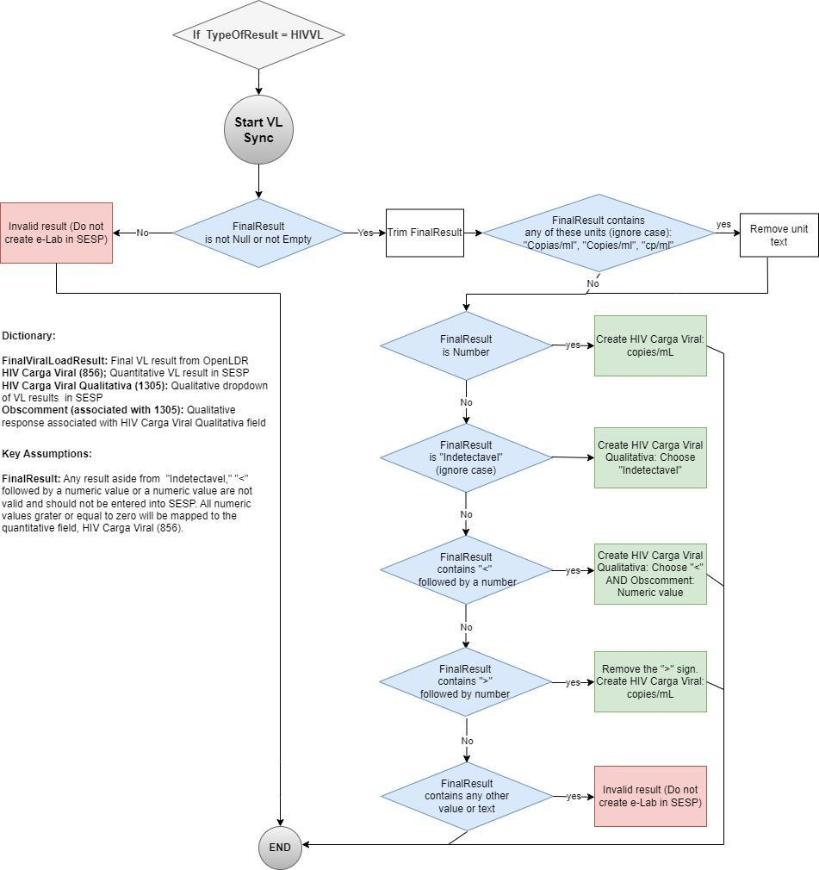

**Figure 1:** Algorithm of mapping VL results from Integration server to SESP

## Testing Scenarios

| **FinalResult**  (Source: Integration server) | **Copies/mL**  **(Concept 856)**  Numeric field  (Source: SESP) | **Qualitative field**  **(Concept 1305)**  Dropdown: (indetectavel OU <)  (Source: SESP) | **Obscomment**  **(Concept 1305)**  Text field  (Source: SESP) | **Notes** |
| --- | --- | --- | --- | --- |
| NUMERIC VALUE | FinalResult | Empty | Empty |  |
| Contains “>” | Insert numeric value from FinalResult. | Empty  (Remove “>”) | Empty |  |
| INDETECTAVEL | Empty | FinalResult | Empty |  |
| Contains “<” | Empty | “<” | Numeric value following the operator in FinalResult (do not include units) |  |
| Null or Empty |  |  |  | Invalid result on integration server and do not create e-Lab in SESP |
| Contains any text aside from “Indetectavel” or “>” or “<” or any numeric value <0 |  |  |  | Invalid result on integration server and do not create e-Lab in SESP |

# CD4 Count Mapping Requirements

CD4 cell count is an indicator of immune function in patients living with HIV and one of the key determinants for the need of opportunistic infection screening and prophylaxis.

In OpenLDR the CD4 result variables that are mapped to integration server are:

| **Variable in OpenLDR** | | | **Variable in Integration server** |
| --- | --- | --- | --- |
| **Name** | **Type** | **Description** |
| LIMSPanelCode:  CD4 | varchar | Refers to the code assigned to a test panel within the Laboratory Information Management System (LIMS).  Corresponding code for CD4 count is CD4. | TypeOfResult:  CD4 |
| CD4FinalResult | Int | Absolute CD4 cell count | FinalResult |
| CD4 Percentage | varchar | CD4 Percentage | Attribute1 |

Once a patient NID is found in SESP, the system obtains the corresponding Type of Result and FinalResult in the integration server and exports the data to SESP and transforms them into the specific SESP CD4 concepts, ultimately creating an e-Lab form associated with the identified patient.

## Key Assumptions

The key assumptions associated with the CD4 results mapping algorithm are:

* Any CD4 absolute result aside from a positive integer including zero value is invalid and cannot be entered into SESP. The system will only create an e-Lab form in SESP for a valid CD4 absolute value.
* Along with Absolute value, CD4 Percentage may exist in OpenLDR. The CD4 percentage value is expected to be numeric (allows decimals) and it will be saved as an attribute of the CD4 result.

## List of Functional Requirements for mapping of CD4 Count results

| **Requirement #** | **Category/**  **Functional Area** | **Requirement** |
| --- | --- | --- |
| DISA_CDA_FR1 | Identify NID, Request ID and Map CD4 Count Results | The system will identify the patient NID with a CD4 result on the integration server and:   * If there's no duplicated result for the patient in SESP (DISA_CDA_FR2) then   + if the result has valid value (DISA_CDA_FR3) then * create an e-Lab form (DISA_CDA_FR4). |
| DISA_CDA_FR2 | Verify Request ID for the TypeOfResult | The system will verify if the Request ID for the TypeOfResult=CD4 is unique by verifying all in the Sync logs table in SESP.  If a duplicate Request ID for the TypeOfResult is identified:   * No e-Lab form can be created in SESP * The system will automatically void the result * END |
| DISA_CDA_FR3 | Verify CD4 results and Transform them into SESP CD4 concepts | The system will verify the value in the variable FinalResult and Attribute1 on the integration server and transform it into SESP CD4 concepts as follows:   1. If FinalResult is Not NULL or Not EMPTY   AND is INTEGER  AND >=0 THEN:  Valid result on the integration server:   * Concept 1695 in SESP (numeric field) is equal to FinalResult; * If Attribute1 is Not Null or Not EMPTY AND is NUMERIC THEN: Concept 730 in SESP (numeric field) is equal to Attribute; * SYNCSTATUS = PROCESSED  1. Else   Invalid result on the integration server:   * RESULT_STATUS = NOT_PROCESSED And * NOT_PROCESSING_CAUSE = Invalid result   END |
| DISA_CDA_FR4 | Create e-Lab form | The system will create an e-Lab form in SESP associated with the patient following the CD4 results mapping (DISA_CDA_FR3). For the remaining variables on the e-Lab, the system will follow the mapping detailed in the following document: SESP_eLab_Form Specification and Requirements. |

Figure 2 below displays the algorithm used during interoperability DISA-SESP for the automatic electronic transmission of CD4 results from integration server to patients in SESP (**DISA_CDA_FR3**).

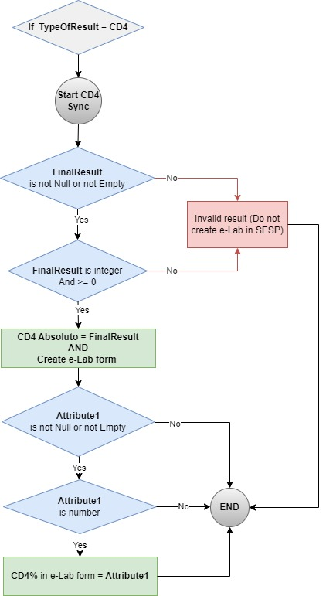

**Figure 2:** Algorithm of mapping CD4 results from Integration server to SESP

# TB LAM Mapping Requirements

Tests based on the detection of mycobacterial lipoarabinomannan (LAM) antigen in urine have emerged as potential point-of-care tests for TB.

If CD4 count is ≤200, then TB LAM is requested for patients who have advanced disease and/or are seriously ill.

| **Variable in OpenLDR** | | | **Variable in Integration server** |
| --- | --- | --- | --- |
| **Name** | **Type** | **Description** |
| LIMSPanelCode: TBLAM | varchar | The TB LAM rapid test provides qualitative results, categorized as either "Positive" or "Negative". Optionally grading can appear for positives. | TypeOfResult:  TBLAM |
| TBLAMFinalResult | varchar | TB LAM final result - qualitative | FinalResult |
| LIMSCodedValue | varchar | Quantitative grading of positive results, usually on a scale from 1 to 4, with higher values indicating a higher concentration of lipoarabinomannan “GRAI”, “GRAII”, “GRIII”, “GRIV”.  For negative presents “N”. | Attribute1 |

Once a patient NID is found in SESP, the system obtains the corresponding Type of Result and FinalResult in the integration server and exports the data to SESP and transforms them into the specific SESP TB LAM concepts, ultimately creating an e-Lab form associated with the identified patient.

## Key Assumptions

* TB LAM generally are presented with CD4 results and may have the same request ID, but different e-Lab forms.

## List of Functional Requirements for mapping of TB LAM results

| **Requirement #** | **Category/**  **Functional Area** | **Requirement** |
| --- | --- | --- |
| DISA_TBLAM_FR1 | Identify NID, Request ID and Map TB LAM Results | The system will identify the patient NID with a TB LAM result on the integration server and:   * If there's no duplicated result for the patient in SESP (DISA_TBLAM_FR2) then   + if the result has a valid value (DISA_TBLAM_FR3) then * create an e-Lab form (DISA_TBLAM_FR4). |
| DISA_TBLAM_FR2 | Verify Request ID for the TypeOfResult | The system will verify if the Request ID for the TypeOfResult=TBLAM is unique by verifying all in the Sync logs table in SESP.  If a duplicate Request ID for the TypeOfResult is identified:   * No e-Lab form can be created in SESP * The system will automatically void the result from integration server * END |
| DISA_TBLAM_FR3 | Verify TBLAM results and Transform them into SESP TBLAM concepts | The system will verify the value in the variable FinalResult and Attribute1 on the integration server and transform it into SESP TB LAM concepts as follows:  If FinalResult is Not NULL or Not EMPTY   1. if contains partial text “Negativ” THEN:  * Valid result on the integration server: * Concept 23951 in SESP is equal to Negativo - Obs 664;   + SYNCSTATUS = PROCESSED   + END  1. if contains partial text “Positiv” THEN:  * Valid result on the integration server:   + Concept 23951 in SESP is equal to Positivo - Obs 703;   + If Attribute1 is Not Null or Not EMPTY AND  1. If EQUALS TO “GRAI” THEN Concept 165185 is equal to Obs 165186 in SESP OR 2. If EQUALS TO “GRAII” THEN Concept 165185 is equal to Obs 165187 in SESP OR 3. If EQUALS TO “GRIII” THEN Concept 165185 is equal to Obs 165188 in SESP OR 4. If EQUALS TO “GRIV” THEN Concept 165185 is equal to Obs 165348 in SESP    * SYNCSTATUS = PROCESSED    * END 5. Else   Invalid result on the integration server:   * RESULT_STATUS = NOT_PROCESSED And * NOT_PROCESSING_CAUSE = Invalid result   END |
| DISA_TBLAM_FR4 | Create e-Lab form | The system will create an e-Lab form in SESP associated with the patient following the TB LAM results mapping (DISA_TBLAM_FR3). For the remaining variables on the e-Lab, the system will follow the mapping detailed in the following document: SESP_eLab_Form Specification and Requirements. |

Figure 3 below displays the algorithm used during interoperability DISA-SESP for the automatic electronic transmission of TB LAM results from integration server to patients in SESP (DISA_TBLAM_FR3).

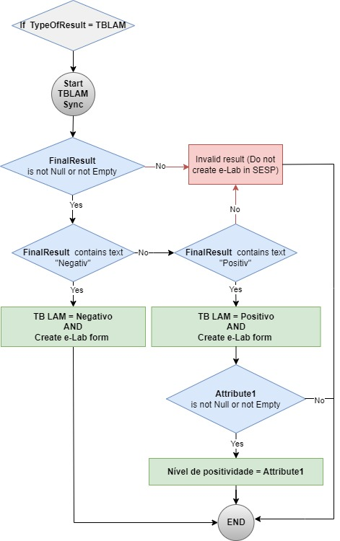

**Figure 3:** Algorithm of mapping TB LAM results from Integration server to SESP

# CRAG Mapping Requirements

The Cryptococcus test is used to diagnose cryptococcal infections, specifically cryptococcosis caused by Cryptococcus neoformans or Cryptococcus gattii. Early detection of cryptococcosis is crucial as it can be a life-threatening infection, especially for people with weakened immune systems.

| **Variable in OpenLDR** | | | **Variable in Integration server** |
| --- | --- | --- | --- |
| **Name** | **Type** | **Description** |
| LIMSPanelCode: CRAG | varchar | The CRAG test provides qualitative results, categorized as either "Positive" or "Negative". | TypeOfResult:  CRAG |
| CryptoFinalResult | varchar | CRAG final result - qualitative | FinalResult |
| LIMSSpecimenSourceCode | varchar | Specimen Type for CRAG: LCR, SER | LIMSSpecimenSourceCode |

Once a patient NID is found in SESP, the system obtains the corresponding Type of Result and FinalResult in the integration server and exports the data to SESP and transforms them into the specific SESP CRAG concepts, ultimately creating an e-Lab form associated with the identified patient.

## Key Assumptions

The key assumption associated with the CRAG results mapping algorithm is:

* Any CRAG result aside from positive or negative value is invalid and cannot be entered into SESP. The system will only create an e-Lab form in SESP for a valid CRAG result value.

## List of Functional Requirements for mapping of CRAG results

| **Requirement #** | **Category/**  **Functional Area** | **Requirement** |
| --- | --- | --- |
| DISA_CRAG_FR1 | Identify NID, Request ID and Map CRAG Results | The system will identify the patient NID with a CRAG result on the integration server and:   * If there's no duplicated result for the patient in SESP (DISA_CRAG_FR2) then   + if the result has a valid value (DISA_CRAG_FR3) then * create an e-Lab form (DISA_CRAG_FR4). |
| DISA_CRAG_FR2 | Verify Request ID for the TypeOfResult | The system will verify if the Request ID for the TypeOfResult=CRAG is unique by verifying all in the Sync logs table in SESP.  If a duplicate Request ID for the TypeOfResult is identified:   * No e-Lab form can be created in SESP * The system will automatically void the result from integration server * END |
| DISA_CRAG_FR3 | Verify CRAG results and Transform them into SESP CRAG concepts | The system will verify the value in the variable FinalResult on the integration server and transform it into SESP CRAG concepts as follows:  If FinalResult is Not NULL or Not EMPTY   1. if contains partial text “Negativ” THEN:  * Valid result on the integration server: * Concept 23952 in SESP is equal to Negativo - Obs 664;   + SYNCSTATUS = PROCESSED   + END  1. if contains partial text “Positiv” THEN:  * Valid result on the integration server:   + Concept 23952 in SESP is equal to Positivo - Obs 703;   + SYNCSTATUS = PROCESSED   + END  1. Else   Invalid result on the integration server:   * RESULT_STATUS = NOT_PROCESSED And * NOT_PROCESSING_CAUSE = Invalid result   END |
| DISA_CRAG_FR4 | Create e-Lab form | The system will create an e-Lab form in SESP associated with the patient following the CRAG results mapping (DISA_CRAG_FR3). For the remaining variables on the e-Lab, the system will follow the mapping detailed in the following document: SESP_eLab_Form Specification and Requirements. |

Figure 4 below displays the algorithm used during interoperability DISA-SESP for the automatic electronic transmission of CRAG results from integration server to patients in SESP (DISA_CRAG_FR3).

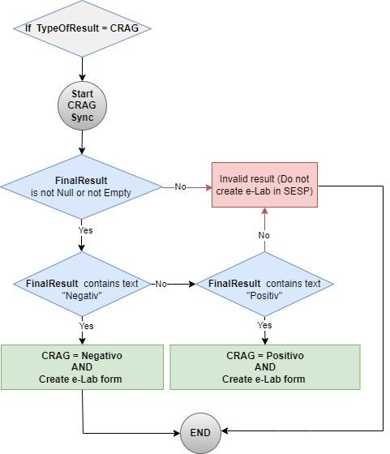

**Figure 4:** Algorithm of mapping CRAG results from Integration server to SESP