Product Requirements Document (PRD)

SalesGenie — AI-Powered Sales Assistant
Document status: Iterative product and technical requirements
Related document: SalesGenie Business Requirements Document (BRD), version 1.0
**Document purpose:** This PRD defines the confirmed product and technical requirements for the current SalesGenie prototype, records decisions and open decisions, and describes how the solution will be validated. It is expected to evolve as implementation, evaluation, user feedback, and technical evidence change.

1. Product Overview
SalesGenie is an AI-powered sales-assistant workflow for Oak & Ember Interiors. It processes inbound customer enquiries, extracts lead details, classifies sales priority, retrieves relevant product catalog context, produces grounded product recommendations, and supports weekly sales insights.
The current prototype includes a selected human-in-the-loop control: recommendation drafts are recorded as Pending for review before a customer email is sent. The reviewer can approve or reject the recommendation email.

2. Confirmed Product Requirements

ID | Product requirement | Status | Source
PR-01 | Process inbound enquiry data and extract structured lead details, including customer name, email, product interest, budget, and urgency when supplied. | Confirmed | Project brief; current prototype.
PR-02 | Classify eligible sales enquiries as Hot, Warm, or Cold. | Confirmed | Project brief; current prototype.
PR-03 | Route Cold leads to a clarification-email path that requests more information and does not recommend products. | Confirmed | Current prototype decision.
PR-04 | Route Hot and Warm leads to catalog retrieval and product recommendation. | Confirmed | Current prototype decision.
PR-05 | Use the product catalog as the source of truth for product IDs, names, prices, availability, and documented features. | Confirmed | Project brief; recommender requirements.
PR-06 | Retrieve catalog context from Pinecone before recommendation generation. | Confirmed | Current prototype decision.
PR-07 | Return one to three eligible product recommendations when products meeting the applicable rules are available. | Confirmed | Project brief; current recommender design.
PR-08 | Exclude recommendations that are out of stock, over budget, unrelated to the request, or unsupported by catalog data. | Confirmed | Project brief; recommender requirements.
PR-09 | Create a customer recommendation draft from the recommendation result. | Confirmed | Current prototype implementation.
PR-10 | Create a Pending approval record before a recommendation email is sent. | Confirmed | Current prototype decision.
PR-11 | Send a customer recommendation email only for an Approved and unsent approval record. | Confirmed | Current prototype decision.
PR-12 | Generate weekly sales insights in a separate scheduled workflow. | Confirmed | Project brief; current prototype.
PR-13 | Record workflow observability/evaluation evidence. | Confirmed | Project brief; current prototype uses Langfuse.

3. Architecture

3.1 Confirmed orchestration approach
The project brief recommends a Sequential Pipeline for standard enquiry processing: ingest, qualify, recommend, and respond. The Weekly Aggregator runs separately on a schedule.
The current prototype implements a tier-based branch after lead qualification:
- Cold leads follow the clarification route.
- Hot and Warm leads follow the RAG retrieval and recommendation route.
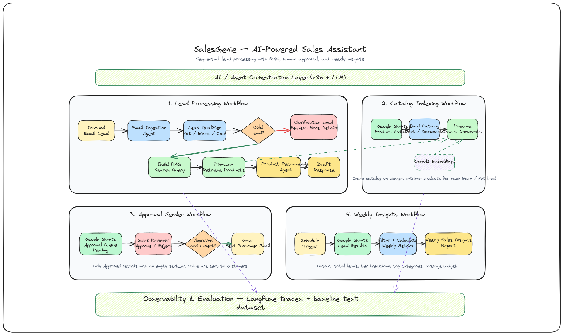

3.2 Confirmed lead-processing architecture

3.3 Confirmed catalog-indexing architecture

3.4 Confirmed approval-sender architecture

3.5 Weekly-insights architecture

3.6 Routing scope requiring decision
The baseline dataset requires separate treatment for product questions and spam. The project brief states that product questions should not be classified Hot/Warm/Cold and spam should not be treated as a lead.
[Decision Required] Confirm whether the final workflow will add a router/message-type step before Lead Qualification to handle:
- sales_inquiry
- vague_inquiry
- product_question
- spam
- support
The current tier-only Cold/Hot/Warm branch does not by itself establish the required treatment for every non-sales message type in the baseline dataset. – The answer is no

4. Technology Choices and Trade-offs
Area | Decision | Alternatives | Reason | Trade-off | Status
Workflow & orchestration | n8n | Zapier, LangFlow | Flexible agent workflows; used in prototype | Requires workflow maintenance | Confirmed
Product catalog | Google Sheets | CSV, CRM | Simple and easy to maintain | Not a production CRM | Confirmed
Retrieval | Pinecone | Qdrant, Weaviate | Managed vector search; easy RAG integration | Third-party dependency and plan limits | Confirmed
LLM | OpenAI | Claude, Gemini | Used in prototype; strong AI capabilities | Model cost and vendor dependency | Confirmed
Embeddings | OpenAI Embeddings | Other embedding models | Compatible with OpenAI-based RAG | Requires consistent model/version for re-indexing | Confirmed
Observability | Langfuse | LangWatch | Provides AI tracing and evaluation | Requires trace-retention and access controls | Confirmed
Email integration | Gmail | Gmail API, other integrations | Used in prototype for email processing | Requires controlled service account/access | Confirmed
Human approval | Google Sheets | CRM/workflow queue | Simple approval workflow for MVP | Manual review limits scalability | Confirmed

5. Ground Truth Approach

5.1 Correct answer and action source

Area | Ground truth / source of truth | Requirement
Product identity | Product catalog | Product ID and product name must match catalog data.
Product price | Product catalog | Recommendation must use catalog price and respect customer budget.
Product availability | Product catalog | Recommendation must use catalog availability and only recommend items recorded as In Stock.
Product features and descriptions | Product catalog | Rationale must use only documented features.
Customer needs | Raw customer enquiry and extracted lead details | Do not invent requirements, budget, quantity, urgency, or deadline.
Lead tier | Lead Qualifier output using the agreed Hot/Warm/Cold rules | Tier must be available for routing.
Weekly metrics | Processed lead records within the selected reporting window | Report must be traceable to actual processed data.
Recommendation-email permission | Approval record | Customer recommendation email may be sent only when Approved and unsent.

5.2 Catalog retrieval and validation
Google Sheets is the editable catalog source in the current prototype. Pinecone is the searchable retrieval representation of catalog product documents. The product recommender must receive the retrieved catalog context and recommend only products present in that context.
Retrieval is not the final eligibility decision. The recommendation process must still validate product availability, budget fit, category relevance, and documented features.

5.3 Handling conflicting information
- If an extracted lead field conflicts with the raw customer enquiry, [Decision Required] confirm precedence in the final workflow. The current Lead Qualifier design states that raw email should take precedence.
- If catalog information conflicts between Google Sheets and Pinecone, Google Sheets is the editable source, and the Pinecone index must be refreshed. [Assumption to Validate] Index refresh ownership and timing.
- If a required catalog value is missing, the system must not invent it. The expected response/action is [TBD].

5.4 Dataset maintenance

Dataset | Current status
Product catalog | Provided as project input; maintained in Google Sheets in current prototype.
Sample inquiry emails | Provided as project input.
Baseline evaluation inputs | Provided as project input.
Processed lead / approval records | Created by current prototype workflows.

6. Agreed Metrics
Only the following measures are explicitly required by the project brief or currently produced by the workflow. Formal targets are not supplied unless stated in the baseline test requirement.

Metric | Definition | Target | Measurement Method | Owner
Total leads | Count of included lead records in reporting window. | [TBD] | Weekly sales metrics output. | [TBD]
Lead-tier breakdown | Count of Hot, Warm, Cold, and unclassified leads. | [TBD] | Weekly sales metrics output. | [TBD]
Top categories | Product-interest categories ranked from processed leads. | [TBD] | Weekly sales metrics output. | [TBD]
Average budget | Average available budget across included lead records. | [TBD] | Weekly sales metrics output. | [TBD]
Catalog grounding | Whether recommended products and claims are supported by catalog data. | Baseline outputs must not invent products not in catalog. | Baseline evaluation and recommendation review. | [TBD]
Budget compliance | Whether recommended product prices comply with the applicable customer budget. | Baseline outputs must meet stated budget constraints. | Baseline evaluation and recommendation validation. | [TBD]
Availability compliance | Whether recommended products are in stock when recommendation rules require it. | Baseline outputs must correctly report availability. | Baseline evaluation and recommendation validation. | [TBD]
Approval control | Whether customer recommendation emails are sent only after approval. | Approved and unsent records only. | Approval queue and email-sender workflow review. | [TBD]

7. Success Metrics and Evaluation Strategy

7.1 Existing evaluation methods

Method | Existing evidence / input | Purpose
Baseline dataset | Eleven supplied inputs, T1 through T11. | Validate lead qualification, grounded recommendations, special cases, and weekly report content.
Workflow observation | n8n node outputs. | Inspect data transformations and workflow routing.
Observability tracing | Langfuse is connected in the current prototype. | Review execution traces and support quality investigation.
Human approval review | Approval queue in current prototype. | Review customer-facing recommendation drafts before sending.

7.2 Required baseline coverage
The baseline dataset requires validation of:
- Standing-desk recommendation under a stated budget.
- Vague enquiry and clarification behavior.
- Bulk chair enquiry with a total budget and urgency.
- Product question classification/routing.
- Competitor mention using catalog-supported differentiators.
- Low-budget edge case.
- Spam identification.
- Conference-table enquiry with business context.
- Minimal vague enquiry.
- Out-of-stock availability query.
- Weekly summary.

7.3 Proposed evaluation methods

Proposed method | Status | Purpose
Automated validation of product IDs, price, availability, and category after recommendation generation. | Proposed in current RAG design; completion status [TBD]. | Prevent unsupported or ineligible recommendations.
Regression execution of baseline dataset after prompt, routing, retrieval, or catalog changes. | Proposed. | Identify changes in behavior over time.
Review of rejected approval records. | Proposed. | Identify recurrent recommendation or draft-quality issues.
Retrieval review: compare retrieved product IDs with recommended product IDs. | Proposed. | Confirm recommendations are grounded in retrieved context.

8. Evaluation Tooling

Tool | Purpose | Status
Langfuse | Trace workflow/agent activity and support evaluation/observability. | Confirmed current prototype decision
n8n execution data | Review node inputs, outputs, and workflow execution. | Confirmed current prototype capability
Supplied baseline input file | Core evaluation dataset. | Confirmed input
Google Sheets lead and approval records | Operational review and weekly aggregation source in current prototype. | Confirmed current prototype decision

Tool selection for automated grading/scoring beyond the above: [Decision Required].

9. Experiment Strategy
No formal experiment plan, baseline measurements, success thresholds, or rollout decision rules have been supplied.

Experiment | Hypothesis | Baseline | Variable | Method | Success Criteria | Measurement | Rollout / decision
RAG retrieval versus full-catalog context | [TBD] | [TBD] | Retrieval approach | [TBD] | [TBD] | [TBD] | [TBD]
Human approval before customer email | [TBD] | [TBD] | Approval control | [TBD] | [TBD] | [TBD] | [TBD]
Lead qualification prompt changes | [TBD] | [TBD] | Prompt/routing rule | [TBD] | [TBD] | [TBD] | [TBD]

10. Security, Privacy, and Governance

10.1 Confirmed requirements and current controls

Area | Confirmed requirement / current control
Authentication | Use OAuth 2.0 or API keys as supported by the external service.  Store credentials securely and prevent exposure in workflows, logs, or responses.
Data source control | Product recommendations must use approved product-catalog information.
Customer-facing action control | Current prototype uses a Pending/Approved/Rejected approval queue before recommendation emails are sent.
Traceability | Evaluation and observability connection is required; current prototype uses Langfuse.
Catalog index content | Current RAG design requires that Pinecone contain catalog product documents, not customer lead details.

10.2 Decisions and requirements to validate

Area | Status / information required
Authorization roles for approval queue | [TBD: who can approve, reject, edit, or view records.]
Customer-data retention | [TBD]
Langfuse trace-data retention and access | [TBD]
Google Sheets access controls | [TBD]
Regulatory/compliance requirements | [TBD: no regulation or policy was supplied.]
Prompt-injection handling | [Decision Required: no agreed control was supplied.]
Secret/API-key storage and rotation | [TBD]

11. Failure Modes and Recovery

11.1 Known failure cases / expected product behavior

Known failure or state | Required or current response | Status
No eligible catalog product is available | Product Recommender returns no_match with no recommendations. | Confirmed current behavior
Lead is Cold | Clarification route requests more information; no product recommendation. | Confirmed current behavior
Approval is Pending or Rejected | Customer recommendation email is not sent. | Confirmed current behavior
Approval is Approved but sent_at is populated | Customer recommendation email is not sent again. | Confirmed current behavior
Catalog product is out of stock | It must not be recommended; availability query must be answered from catalog. | Confirmed requirement
Product is above applicable budget | It must not be recommended. | Confirmed requirement

11.2 Failure scenarios to validate

Failure scenario to validate | Required decision / recovery behavior
Pinecone has no catalog documents or returns no relevant documents | [TBD: error handling, re-index trigger, and operator notification.]
Pinecone index is stale after catalog change | [TBD: refresh process, owner, and timing.]
AI response is malformed or cannot be parsed | [TBD: retry, validation, manual fallback, and alerting behavior.]
Product catalog has missing price or availability | [TBD: record exclusion and remediation process.]
Langfuse, Google Sheets, email, or model provider is unavailable | [TBD: retry, fallback, and operational notification.]
Approval record cannot be updated after email sending | [TBD: duplicate-send prevention and reconciliation approach.]

12. Open Questions and Decisions
- [Decision Required] Will the final workflow implement a router for product questions, spam, and support messages before Lead Qualification?
- [Decision Required] What exact product-recommendation validation is mandatory after the LLM returns an answer?
- [Decision Required] What is the catalog re-indexing trigger, owner, and expected refresh timing?
- [Decision Required] What reviewer role owns Pending approval records and what is the expected handling time?
- [Decision Required] Which fields are permitted in Langfuse traces and Google Sheets approval records?
- [TBD] What final model, model version, model configuration, and token/cost controls apply?
- [TBD] What production CRM, if any, should receive structured lead records?
- [TBD] What is the production deployment, support, and incident-management model?
- [TBD] What is the formal metric target for lead handling, grounding quality, conversion, and productivity outcomes?
- [TBD] What security, privacy, and compliance requirements apply to customer data?

13. BRD ↔ PRD Traceability Matrix

BRD Requirement | PRD Requirement | Technical Capability | Metric | Evaluation Method
Extract lead details from inbound enquiry | PR-01 | Email Ingestion Agent and structured lead output | [TBD] | Baseline inputs; n8n output review
Standardize lead qualification | PR-02 | Lead Qualifier Agent and Hot/Warm/Cold output | Lead-tier breakdown; [TBD] | Baseline T1, T2, T3, T8, T9
Request more information from Cold leads | PR-03 | IF Cold route and clarification email | [TBD] | Baseline T2 and T9
Provide catalog-grounded recommendations | PR-05, PR-06, PR-07, PR-08 | Google Sheets catalog, Pinecone retrieval, Product Recommender, validation | Catalog grounding, budget compliance, availability compliance | Baseline T1, T3, T5, T6, T8, T10; recommendation review
Improve customer-response preparation | PR-09 | Recommendation draft generation | [TBD] | Draft review; human approval review
Prevent unapproved recommendation sending | PR-10, PR-11 | Google Sheets approval queue, Approved-and-Unsent sender workflow | Approval control | Approval workflow test
Produce weekly insights | PR-12 | Separate scheduled Weekly Aggregator | Total leads, tiers, categories, average budget | Baseline T11; reporting-output review
Provide evaluation and observability evidence | PR-13 | Langfuse tracing and n8n execution data | [TBD] | Trace review and baseline evidence
Technical/non-functional requirement | Ground-truth control | Catalog as source of truth; no invented catalog facts | Grounding compliance | Catalog-to-output comparison
Technical/non-functional requirement | Failure handling | [TBD] | [TBD] | Failure-scenario validation

Document Governance
This PRD is iterative. It may change when architecture is validated, test results identify a defect, user feedback is received, catalog/retrieval behavior changes, or technical constraints are discovered. Each changed decision should record its status as Confirmed, Proposed, Decision Required, or TBD.

