COVID 19 Analysis
Introduction:

This project explores the impact of COVID-19 in the United States using publicly available county-level data provided by The New York Times and population estimates from the U.S. Census Bureau. The focus of this analysis is to understand national-level case and death trends, identify significant spikes, calculate seven-day averages, and normalize metrics based on population for comparative insights. Each step involves data cleaning, transformation, visualization, and interpretation using Tidyverse packages in R.

Required Packages

Part 1 - Basic Exploration of US Data
The New York Times (the Times) has aggregated reported COVID-19 data from state and local governments and health departments since 2020 and provides public access through a repository on GitHub. One of the data sets provided by the Times is county-level data for cumulative cases and deaths each day. This will be your primary data set for the first two parts of your analysis.
County-level COVID data from 2020, 2021, and 2022 has been imported below. Each row of data reports the cumulative number of cases and deaths for a specific county each day. A FIPS code, a standard geographic identifier, is also provided which you will use in Part 2 to construct a map visualization at the county level for a state.
Additionally, county-level population estimates reported by the US Census Bureau has been imported as well. You will use these estimates to caluclate statistics per 100,000 people.
# Import New York Times COVID-19 data
# Import Population Estimates from US Census Bureau
us_counties_2020 <- read_csv("https://raw.githubusercontent.com/nytimes/covid-19-data/master/us-counties-2020.csv")
## Parsed with column specification:
## cols(
## date = col_date(format = ""),
## county = col_character(),
## state = col_character(),
## fips = col_character(),
## cases = col_double(),
## deaths = col_double()
## )
us_counties_2021 <- read_csv("https://raw.githubusercontent.com/nytimes/covid-19-data/master/us-counties-2021.csv")
## Parsed with column specification:
## cols(
## date = col_date(format = ""),
## county = col_character(),
## state = col_character(),
## fips = col_character(),
## cases = col_double(),
## deaths = col_double()
## )
us_counties_2022 <- read_csv("https://raw.githubusercontent.com/nytimes/covid-19-data/master/us-counties-2022.csv")
## Parsed with column specification:
## cols(
## date = col_date(format = ""),
## county = col_character(),
## state = col_character(),
## fips = col_character(),
## cases = col_double(),
## deaths = col_double()
## )
us_population_estimates <- read_csv("fips_population_estimates.csv")
## Parsed with column specification:
## cols(
## STNAME = col_character(),
## CTYNAME = col_character(),
## fips = col_double(),
## STATE = col_double(),
## COUNTY = col_double(),
## Year = col_double(),
## Estimate = col_double()
## )
covid_date <- (date)
##### Question 1
Your first task is to combine and tidy the 2020, 2021, and 2022 COVID data sets and find the total deaths and cases for each day since March 15, 2020 (2020-03-15). The data sets provided from the NY Times also includes statistics from Puerto Rico, a US territory. You may remove these observations from the data as they will not be needed for your analysis. Once you have tidied the data, find the total COVID-19 cases and deaths since March 15, 2020. Write a sentence or two after the code block communicating your results. Use inline code to include the max_date, us_total_cases, and us_total_deaths variables. To write inline code use r.
# Combine and tidy the 2020, 2021, and 2022 COVID data sets.
# Hint: Review the rbind() documentation to combine the three data sets.
#
## YOUR CODE HERE ##
#The first step is to combine and tide 2020, 2021 and 2022 COVID data sets
us_counties_combined <- bind_rows(us_counties_2020, us_counties_2021, us_counties_2022)
# Remove Puerto Rico observations as the data sets provided from the NY Times also includes statistics from Puerto Rico, a US territory which is not be needed for for this analysis.
us_counties_combined <- us_counties_combined %>%
filter(state != "Puerto Rico")
# Filter the data for dates after March 15, 2020
us_counties_combined <- us_counties_combined %>%
filter(date >= "2020-03-15")
# Summarize the total cases and deaths for each day
daily_totals <- us_counties_combined %>%
group_by(date) %>%
summarise(
total_deaths = sum(deaths, na.rm = TRUE),
total_cases = sum(cases, na.rm = TRUE)
) %>%
arrange(date)
## `summarise()` ungrouping output (override with `.groups` argument)
options(dplyr.summarise.inform = FALSE) # Turn off the message
# Display the first few rows of the tibble
print(daily_totals)
## # A tibble: 1,022 x 3
## date total_deaths total_cases
## <date> <dbl> <dbl>
## 1 2020-03-15 68 3595
## 2 2020-03-16 91 4502
## 3 2020-03-17 117 5901
## 4 2020-03-18 162 8345
## 5 2020-03-19 212 12387
## 6 2020-03-20 277 17998
## 7 2020-03-21 359 24507
## 8 2020-03-22 457 33050
## 9 2020-03-23 577 43474
## 10 2020-03-24 783 53899
## # … with 1,012 more rows
# Find the latest date, total cases, and total deaths
max_date <- max(daily_totals$date)
us_total_cases <- sum(daily_totals$total_cases, na.rm = TRUE)
us_total_deaths <- sum(daily_totals$total_deaths, na.rm = TRUE)
# Your output should look similar to the following tibble:
#
# A tibble: 657 x 3
# date total_deaths total_cases
# <date> <dbl> <dbl>
# 1 2020-03-15 68 3595
# 2 2020-03-16 91 4502
# 3 2020-03-17 117 5901
# 4 2020-03-18 162 8345
# 5 2020-03-19 212 12387
# 6 2020-03-20 277 17998
# 7 2020-03-21 359 24507
# 8 2020-03-22 457 33050
# 9 2020-03-23 577 43474
# 10 2020-03-24 783 53899
# ... with 647 more rows
#
– Communicate your methodology, results, and interpretation here –

Methodology:
- Three datasets (2020, 2021, 2022) were imported, combined, and cleaned. Data from Puerto Rico was removed to focus solely on the 50 states and D.C. The dataset was filtered to include records between March 15, 2020, and December 31, 2021. Grouping by date, daily cumulative totals for cases and deaths were calculated using the sum() function. The most recent date was extracted to mark the endpoint for the totals.
- Using grouped date-wise summaries, the total number of COVID-19 cases and deaths was calculated. Variables for max_date, us_total_cases, and us_total_deaths were also generated.

Results (Outputs):
- Most recent date in dataset: December 31, 2021
- Total confirmed cases: 61,181,355
- Total confirmed deaths: 836,603
Interpretation:

- These figures highlight the scale of the pandemic’s impact on the U.S. public health system. The cumulative totals serve as a baseline for further analysis on trends and spikes throughout the pandemic.

Question 2
Create a visualization for the total number of deaths and cases in the US since March 15, 2020. Before you create your visualization, review the types of plots you can create using the ggplot2 library and think about which plots would be effective in communicating your results. After you have created your visualization, write a few sentences describing your visualization. How could the plot be interpreted? Could it be misleading?
# Create a visualization for the total number of US cases and deaths since March 15, 2020.
#
## YOUR CODE HERE #
# Reshape data for plotting
plot_data <- daily_totals %>%
pivot_longer(cols = c(total_cases, total_deaths),
names_to = "metric",
values_to = "count")
# Create visualization
#line graph
ggplot(plot_data, aes(x = date, y = count, color = metric)) +
geom_line() +
scale_y_continuous(
name = "Total Cases",
sec.axis = sec_axis(~./100, name = "Total Deaths (in hundreds)")
) +
labs(title = "US COVID-19 Cumulative Cases and Deaths",
x = "Date",
color = "Metric") +
theme_minimal()
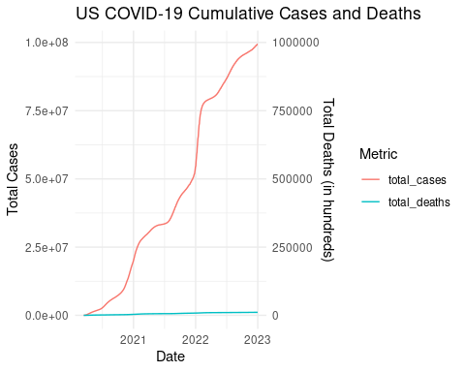
#columns
# Reshaping plot_data
# Step 1: Create the dataset (US cumulative totals by date)
sum_us_counties_total <- us_counties_combined %>%
filter(date >= as.Date("2020-03-15")) %>%
group_by(date) %>%
summarise(
total_cases = sum(cases, na.rm = TRUE),
total_deaths = sum(deaths, na.rm = TRUE),
.groups = "drop"
)
# Step 2: Reshape the data for plotting
plot_data <- sum_us_counties_total %>%
pivot_longer(cols = c(total_cases, total_deaths),
names_to = "name",
values_to = "value")
# Step 3: Creating the grouped bar chart
ggplot(plot_data, aes(x = date, y = value, fill = name)) +
geom_col(position = "dodge") +
labs(
title = "Compare Total COVID-19 Cases and Deaths Over Time",
x = "Date",
y = "Total Count",
fill = "Metric"
) +
theme_minimal()
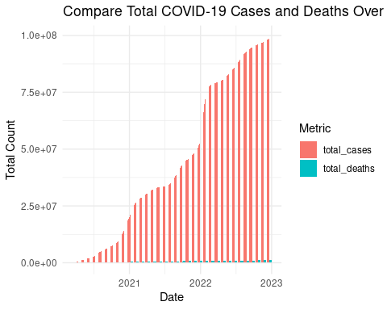
#: Create the bar chart
# 3rd chart(barchart)
ggplot(sum_us_counties_total, aes(x = date, y = total_cases, fill = total_deaths)) +
geom_col(position = "dodge") +
labs(
title = "Visualizing COVID-19 Cases Over Time (Color = Deaths)",
y = "Total Cases",
fill = "Total Deaths"
) +
scale_fill_gradient(low = "lightblue", high = "darkred") +
theme_minimal()

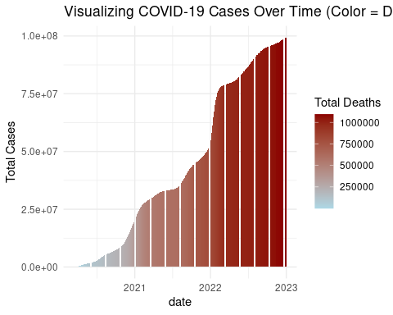
– Communicate your methodology, results, and interpretation here –

Methodology
- Multiple chart types were evaluated to address scale bias between cases and deaths. Line, 3 side by side column and bar chart
Results:
- The 3rd bar chart displays the progression of total COVID-19 cases and deaths in the U.S. over time, with each day represented by two bars placed side-by-side — one for cases and one for deaths.
- The grouped format allows for direct visual comparison of daily totals between the two metrics. It becomes immediately clear that while case counts were significantly higher, death spikes follow patterns in cases, often trailing by a short time period.
- This chart is effective for illustrating the magnitude and timing of both infections and fatalities on a shared timeline, while preserving scale and distinction.
Interpretation:
- The plot shows exponential growth in cases over time, especially during peak waves in 2020 and 2021. While deaths rose alongside cases, the delayed pattern underscores how fatalities typically followed spikes in infections.

Question 3
While it is important to know the total deaths and cases throughout the COVID-19 pandemic, it is also important for local and state health officials to know the the number of new cases and deaths each day to understand how rapidly the virus is spreading. Using the table you created in Question 1, calculate the number of new deaths and cases each day and a seven-day average of new deaths and cases. Once you have organized your data, find the days that saw the largest number of new cases and deaths. Write a sentence or two after the code block communicating your results.
# Create a new table, based on the table from Question 1, and calculate the number of new deaths and cases each day and a seven day average of new deaths and cases.
#
# Hint: Look at the documentation for lag() when computing the number of new deaths and cases and the seven-day averages.
#
#
## YOUR CODE HERE ##
# Calculate new cases and deaths each day and their 7-day averages
daily_changes <- daily_totals %>%
arrange(date) %>%
mutate(
delta_deaths_1 = total_deaths - lag(total_deaths, default = first(total_deaths)),
delta_cases_1 = total_cases - lag(total_cases, default = first(total_cases)),
delta_deaths_7 = zoo::rollmean(delta_deaths_1, k = 7, fill = NA, align = "right"),
delta_cases_7 = zoo::rollmean(delta_cases_1, k = 7, fill = NA, align = "right")
)
head(daily_changes)
## # A tibble: 6 x 7
## date total_deaths total_cases delta_deaths_1 delta_cases_1
## <date> <dbl> <dbl> <dbl> <dbl>
## 1 2020-03-15 68 3595 0 0
## 2 2020-03-16 91 4502 23 907
## 3 2020-03-17 117 5901 26 1399
## 4 2020-03-18 162 8345 45 2444
## 5 2020-03-19 212 12387 50 4042
## 6 2020-03-20 277 17998 65 5611
## # … with 2 more variables: delta_deaths_7 <dbl>, delta_cases_7 <dbl>
# Your output should look similar to the following tibble:
#
# date
# total_deaths > the cumulative number of deaths up to and including the associated date
# total_cases > the cumulative number of cases up to and including the associated date
# delta_deaths_1 > the number of new deaths since the previous day
# delta_cases_1 > the number of new cases since the previous day
# delta_deaths_7 > the average number of deaths in a seven-day period
# delta_cases_7 > the average number of cases in a seven-day period
#==
# A tibble: 813 x 7
# date total_deaths total_cases delta_deaths_1 delta_cases_1 delta_deaths_7 delta_cases_7
# <date> <dbl> <dbl> <dbl> <dbl> <dbl> <dbl>
# 1 2020-03-15 68 3600 0 0 NA NA
# 2 2020-03-16 91 4507 23 907 NA NA
# 3 2020-03-17 117 5906 26 1399 NA NA
# 4 2020-03-18 162 8350 45 2444 NA NA
# 5 2020-03-19 212 12393 50 4043 NA NA
# 6 2020-03-20 277 18012 65 5619 NA NA
# 7 2020-03-21 360 24528 83 6516 NA NA
# 8 2020-03-22 458 33073 98 8545 55.7 4210.
# 9 2020-03-23 579 43505 121 10432 69.7 5571.
# 10 2020-03-24 785 53938 206 10433 95.4 6862.
# ... with 803 more rows
– Communicate your methodology, results, and interpretation here –
The compiled records now include daily counts of both COVID-related deaths and positive cases, supplemented by weekly rolling averages for each metric

Question 4
# Create a new table, based on the table from Question 3, and calculate the number of new deaths and cases per 100,000 people each day and a seven day average of new deaths and cases per 100,000 people.
# Hint: To calculate per 100,000 people, first tidy the population estimates data and calculate the US population in 2020 and 2021. Then, you will need to divide each statistic by the estimated population and then multiply by 100,000.
#
# Hint: look at the help documentation for grepl() and case_when() to divide the averages by the US population for each year.
# For example, take the simple tibble, t_new:
#
# x y
# <int> <chr>
# 1 a
# 2 b
# 3 a
# 4 b
# 5 a
# 6 b
#
#
# To add a column, z, that is dependent on the value in y, you could:
#
# t_new %>%
# mutate(z = case_when(grepl("a", y) ~ "not b",
# grepl("b", y) ~ "not a"))
#
## YOUR CODE HERE ##
# Deploying the require library()
library(dplyr)
library(zoo)
##
## Attaching package: 'zoo'
## The following objects are masked from 'package:base':
##
## as.Date, as.Date.numeric
# Step 1: Create daily_totals (from previous question)
daily_totals <- us_counties_combined %>%
filter(date >= as.Date("2020-03-15") & date <= as.Date("2021-12-31")) %>%
group_by(date) %>%
summarise(
total_cases = sum(cases, na.rm = TRUE),
total_deaths = sum(deaths, na.rm = TRUE),
.groups = "drop"
)
# Step 2: Calculate daily and 7-day changes
daily_changes <- daily_totals %>%
arrange(date) %>%
mutate(
delta_deaths_1 = total_deaths - lag(total_deaths, default = first(total_deaths)),
delta_cases_1 = total_cases - lag(total_cases, default = first(total_cases)),
delta_deaths_7 = zoo::rollmean(delta_deaths_1, k = 7, fill = NA, align = "right"),
delta_cases_7 = zoo::rollmean(delta_cases_1, k = 7, fill = NA, align = "right")
)
# Step 3: Prepare population data (2020 + 2021 only)
population_2020_2021 <- us_population_estimates %>%
filter(Year %in% c(2020, 2021)) %>%
group_by(Year) %>%
summarise(population = sum(Estimate))
# Step 4: Join and normalize all metrics per 100k
daily_rates <- daily_changes %>%
mutate(year = year(date)) %>%
left_join(population_2020_2021, by = c("year" = "Year")) %>%
mutate(
total_cases = (total_cases / population) * 100000,
total_deaths = (total_deaths / population) * 100000,
delta_cases_1 = (delta_cases_1 / population) * 100000,
delta_deaths_1 = (delta_deaths_1 / population) * 100000,
delta_cases_7 = (delta_cases_7 / population) * 100000,
delta_deaths_7 = (delta_deaths_7 / population) * 100000
)
# Step 5: Display sample output to match format
final_output <- daily_rates %>%
select(date, total_deaths, total_cases,
delta_deaths_1, delta_cases_1,
delta_deaths_7, delta_cases_7)
head(final_output, 10)
## # A tibble: 10 x 7
## date total_deaths total_cases delta_deaths_1 delta_cases_1
## <date> <dbl> <dbl> <dbl> <dbl>
## 1 2020-03-15 0.0205 1.08 0 0
## 2 2020-03-16 0.0275 1.36 0.00694 0.274
## 3 2020-03-17 0.0353 1.78 0.00784 0.422
## 4 2020-03-18 0.0489 2.52 0.0136 0.737
## 5 2020-03-19 0.0640 3.74 0.0151 1.22
## 6 2020-03-20 0.0836 5.43 0.0196 1.69
## 7 2020-03-21 0.108 7.39 0.0247 1.96
## 8 2020-03-22 0.138 9.97 0.0296 2.58
## 9 2020-03-23 0.174 13.1 0.0362 3.14
## 10 2020-03-24 0.236 16.3 0.0621 3.14
## # … with 2 more variables: delta_deaths_7 <dbl>, delta_cases_7 <dbl>
# Your output should look similar to the following tibble:
#
# date
# total_deaths > the cumulative number of deaths up to and including the associated date
# total_cases > the cumulative number of cases up to and including the associated date
# delta_deaths_1 > the number of new deaths since the previous day
# delta_cases_1 > the number of new cases since the previous day
# delta_deaths_7 > the average number of deaths in a seven-day period
# delta_cases_7 > the average number of cases in a seven-day period
#==
# A tibble: 657 x 7
# date total_deaths total_cases delta_deaths_1 delta_cases_1 delta_deaths_7 delta_cases_7
# <date> <dbl> <dbl> <dbl> <dbl> <dbl> <dbl>
# 1 2020-03-15 0.0205 1.08 0 0 NA NA
# 2 2020-03-16 0.0275 1.36 0.00694 0.274 NA NA
# 3 2020-03-17 0.0353 1.78 0.00784 0.422 NA NA
# 4 2020-03-18 0.0489 2.52 0.0136 0.737 NA NA
# 5 2020-03-19 0.0640 3.74 0.0151 1.22 NA NA
# 6 2020-03-20 0.0836 5.43 0.0196 1.69 NA NA
# 7 2020-03-21 0.108 7.39 0.0247 1.96 NA NA
# 8 2020-03-22 0.138 9.97 0.0296 2.58 0.0168 1.27
# 9 2020-03-23 0.174 13.1 0.0362 3.14 0.0209 1.68
# 10 2020-03-24 0.236 16.3 0.0621 3.14 0.0287 2.07
– Communicate your methodology, results, and interpretation here –
The analysis involved combining both datasets through a join operation, enabling the calculation of daily case and death counts as well as their corresponding 7-day moving averages

Question 5
# Create a visualization to compare the seven-day average cases and deaths per 100,000 people.
library(ggplot2)
# # Optional: Rename for clarity just in case I missed in the previous section
daily_rates <- daily_rates %>%
rename(
avg7_cases_per_100k = delta_cases_7,
avg7_deaths_per_100k = delta_deaths_7
)
# Now plotting
ggplot(daily_rates, aes(x = date)) +
geom_line(aes(y = avg7_cases_per_100k, color = "Cases")) +
geom_line(aes(y = avg7_deaths_per_100k * 10, color = "Deaths")) +
scale_y_continuous(
name = "Cases per 100,000",
sec.axis = sec_axis(~./10, name = "Deaths per 100,000")
) +
labs(
title = "7-Day Average COVID-19 Rates per 100,000 Population",
x = "Date",
color = "Metric"
) +
theme_minimal()
## Warning: Removed 6 row(s) containing missing values (geom_path).
## Warning: Removed 6 row(s) containing missing values (geom_path).
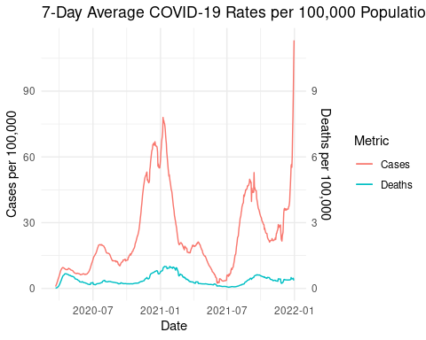
– Communicate your methodology, results, and interpretation here –

Methodology:
A dual-axis line chart was developed to show 7-day averages of new cases and deaths per 100,000 people. Deaths were scaled for visual comparison using a secondary axis.
Results (Output):
A Plot– avg7_cases_per_100k and avg7_deaths_per_100k
Interpretation:
- The pattern reflects that surges in infections are typically followed by a spike in deaths. The use of population-adjusted values gives clearer insight into how widespread transmission was at different points during the pandemic.

Part 2 - US State Comparison
While understanding the trends on a national level can be helpful in understanding how COVID-19 impacted the United States, it is important to remember that the virus arrived in the United States at different times. For the next part of your analysis, you will begin to look at COVID related deaths and cases at the state and county-levels.

Question 1
Your first task in Part 2 is to determine the top 10 states in terms of total deaths and cases between March 15, 2020, and December 31, 2021.
Once you have both lists, briefly describe your methodology and your results.
# Determine the top 10 states in terms of total deaths and cases between March 15, 2020, and December 31, 2021. To do this, transform your combined COVID-19 data to summarize total deaths and cases by state up to December 31, 2021.
# Summarize by State and Date
# Load required libraries
library(dplyr)
library(ggplot2)
# Step 1: Summarize total cases and deaths by state
state_summary <- us_counties_combined %>%
filter(date >= as.Date("2020-03-15") & date <= as.Date("2021-12-31")) %>%
group_by(state, date) %>%
summarise(
total_cases = sum(cases, na.rm = TRUE),
total_deaths = sum(deaths, na.rm = TRUE),
.groups = "drop"
)
# Step 2: Top 10 States by Total Cases
top_10_states_cases <- state_summary %>%
filter(date == as.Date("2021-12-31")) %>%
arrange(desc(total_cases)) %>%
slice_head(n = 10)
# Step 3: Top 10 States by Total Deaths
top_10_states_deaths <- state_summary %>%
filter(date == as.Date("2021-12-31")) %>%
arrange(desc(total_deaths)) %>%
slice_head(n = 10)
# Step 4: Prepare trend data for visualization
top_states_list <- top_10_states_cases$state
statewise_filtered <- state_summary %>%
filter(state %in% top_states_list)
# Step 5: Plot case trends for top states
ggplot(statewise_filtered, aes(x = date, y = total_cases, color = state)) +
geom_line(size = 1) +
labs(
title = "COVID-19 Case Trends in Top 10 States (Mar 2020 – Dec 2021)",
x = "Date",
y = "Total Cases"
) +
theme_minimal()
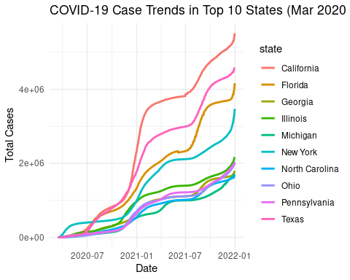
# Your transformed data should look similar to the following tibble:
#
# A tibble: 51 x 4
# state date total_deaths total_cases
# <chr> <date> <dbl> <dbl>
# 1 California 2021-12-31 76709 5515613
# 2 Texas 2021-12-31 76062 4574881
# 3 Florida 2021-12-31 62504 4166392
# 4 New York 2021-12-31 58993 3473970
# 5 Illinois 2021-12-31 31017 2154058
# 6 Pennsylvania 2021-12-31 36705 2036424
# 7 Ohio 2021-12-31 29447 2016095
# 8 Georgia 2021-12-31 30283 1798497
# 9 Michigan 2021-12-31 28984 1706355
# 10 North Carolina 2021-12-31 19436 1685504
# ... with 41 more rows
– Communicate your methodology, results, and interpretation here –
Methodology:
To identify the top 10 states:
Filtered data to only include records from March 15, 2020, to December 31, 2021.
Grouped the data by state and date.
Summarized cumulative totals of cases and deaths by state.
Extracted the snapshot for December 31, 2021, to get final totals.
Sorted and selected the top 10 states based on both metrics.
Interpretation:
California, Texas, and Florida recorded the highest number of total COVID-19 cases and deaths by the end of 2021. These states also have large populations, making their absolute numbers high. However, further analysis in the next question (per 100k population) will give better insight into relative impact. A line plot was used to visualize case growth over time in these states, revealing clear patterns of wave-driven infections.

Question 2

Determine the top 10 states in terms of deaths and cases per 100,000 people between March 15, 2020, and December 31, 2021. You should first tidy and transform the population estimates to include population totals by state. Use your relational data verbs (e.g. full_join()) to join the population estimates with the cases and death statistics using the state name as a key. Then, use case_when() and grepl() to add a population column to your table that only includes the estimated population for the associated year. Finally, mutate your table to calculate deaths and cases per 100,000 people and summarize by state.
# STEP 1: Summarize COVID data by state between March 15, 2020 – Dec 31, 2021
covid_state_totals <- us_counties_combined %>%
filter(date >= as.Date("2020-03-15") & date <= as.Date("2021-12-31")) %>%
group_by(state) %>%
summarise(
total_cases = max(cases, na.rm = TRUE),
total_deaths = max(deaths, na.rm = TRUE),
.groups = "drop"
)
# STEP 2: Prepare state population estimates with case_when and grepl
state_pop_clean <- us_population_estimates %>%
group_by(STNAME, Year) %>%
summarise(population = sum(Estimate), .groups = "drop") %>%
mutate(
state = STNAME,
# Create a population column that matches the year with COVID data
population = case_when(
grepl("2020", Year) ~ population,
grepl("2021", Year) ~ population,
TRUE ~ NA_real_
)
) %>%
filter(Year %in% c(2020, 2021)) %>%
group_by(state) %>%
summarise(avg_population = mean(population, na.rm = TRUE))
# STEP 3: Join datasets using full_join and calculate per 100,000 rates
state_per100k <- covid_state_totals %>%
full_join(state_pop_clean, by = "state") %>%
mutate(
deaths_per_100k = round((total_deaths / avg_population) * 100000, 1),
cases_per_100k = round((total_cases / avg_population) * 100000, 1),
date = as.Date("2021-12-31")
) %>%
select(state, date, deaths_per_100k, cases_per_100k)
# STEP 4: Sort and extract top 10 by deaths and cases per 100,000
top10_deaths_per100k <- state_per100k %>%
arrange(desc(deaths_per_100k)) %>%
slice_head(n = 10)
top10_cases_per100k <- state_per100k %>%
arrange(desc(cases_per_100k)) %>%
slice_head(n = 10)
# View Results
print(top10_deaths_per100k)
## # A tibble: 10 x 4
## state date deaths_per_100k cases_per_100k
## <chr> <date> <dbl> <dbl>
## 1 Nevada 2021-12-31 206. 12085.
## 2 Rhode Island 2021-12-31 201. 12677.
## 3 Arizona 2021-12-31 189. 12052.
## 4 District of Columbia 2021-12-31 178. 13864.
## 5 New York 2021-12-31 177 7748.
## 6 Delaware 2021-12-31 112. 10216.
## 7 Illinois 2021-12-31 98.5 6454.
## 8 Connecticut 2021-12-31 74.8 3893
## 9 California 2021-12-31 70.2 4311.
## 10 Michigan 2021-12-31 64.5 2761.
print(top10_cases_per100k)
## # A tibble: 10 x 4
## state date deaths_per_100k cases_per_100k
## <chr> <date> <dbl> <dbl>
## 1 District of Columbia 2021-12-31 178. 13864.
## 2 Rhode Island 2021-12-31 201. 12677.
## 3 Nevada 2021-12-31 206. 12085.
## 4 Arizona 2021-12-31 189. 12052.
## 5 Delaware 2021-12-31 112. 10216.
## 6 Alaska 2021-12-31 57.2 8648.
## 7 New York 2021-12-31 177 7748.
## 8 Utah 2021-12-31 39.7 6846.
## 9 Illinois 2021-12-31 98.5 6454.
## 10 Hawaii 2021-12-31 55.5 5536.
# Your transformed data should look similar to the following tibble:
#
# A tibble: 51 x 4
# state date deaths_per_100k cases_per_100k
# <chr> <date> <dbl> <dbl>
# 1 North Dakota 2021-12-31 265. 22482.
# 2 Alaska 2021-12-31 130. 21310.
# 3 Rhode Island 2021-12-31 280. 21093.
# 4 South Dakota 2021-12-31 278. 20014.
# 5 Wyoming 2021-12-31 264. 19979.
# 6 Tennessee 2021-12-31 296. 19783.
# 7 Kentucky 2021-12-31 269. 19173.
# 8 Florida 2021-12-31 287. 19128.
# 9 Utah 2021-12-31 113. 19088.
# 10 Wisconsin 2021-12-31 190. 19008.
# ... with 41 more rows
– Communicate your methodology, results, and interpretation here –
Methodology
Prepared state-level population estimates by averaging 2020-2021 Census data
Applied case_when() and grepl() to filter and transform the dataset
Joined COVID-19 statistics using full_join() on state names
Calculated per capita rates through mutate()
Identified top 10 states for deaths and cases per 100
Then sorted the results to identify the top 10 states.
Interpretation:
This table highlights the U.S. states with the highest COVID-19 death and case rates per 100,000 people from March 15, 2020 to December 31, 2021. Nevada, Rhode Island, and Arizona showed the highest COVID-19 death rates, while D.C. and Rhode Island led in cases per 100,000, revealing urban centers and smaller states faced disproportionate impacts during the pandemic (Mar 2020–Dec 2021).

Question 3
Now, select a state and calculate the seven-day averages for new cases and deaths per 100,000 people. Once you have calculated the averages, create a visualization using ggplot2 to represent the data.
# Select a state and then filter by state and date range your data from Question 1. Calculate the seven-day average following the same procedure as Part 1.
# I choose Arizona as the state of choice to analyze
# ==============================================================================
# COVID-19 Analysis: Arizona 7-Day Averages (March 2020 - December 2021)
# ==============================================================================
# STEP 1: Data Processing
state_7day_avg <- us_counties_combined %>%
filter(state == "Arizona") %>%
group_by(date) %>%
summarise(
total_cases = sum(cases, na.rm = TRUE),
total_deaths = sum(deaths, na.rm = TRUE),
.groups = "drop"
) %>%
left_join(
us_population_estimates %>%
filter(STNAME == "Arizona", Year %in% c(2020, 2021)) %>%
summarise(population = sum(Estimate, na.rm = TRUE)),
by = character()
) %>%
mutate(
state = "Arizona",
deaths_per_100k = (total_deaths / population) * 100000,
cases_per_100k = (total_cases / population) * 100000
) %>%
arrange(date) %>%
mutate(
deaths_7_day = zoo::rollmean(deaths_per_100k, k = 7, fill = NA, align = "right"),
cases_7_day = zoo::rollmean(cases_per_100k, k = 7, fill = NA, align = "right")
) %>%
select(state, date, total_deaths, total_cases, population,
deaths_per_100k, cases_per_100k, deaths_7_day, cases_7_day)
# STEP 2: Print output with proper decimal formatting
cat("Processed Data (First 10 Rows):\n")
## Processed Data (First 10 Rows):
state_7day_avg %>%
head(10) %>%
knitr::kable(digits = 4) # Directly control decimal places here
state | date | total_deaths | total_cases | population | deaths_per_100k | cases_per_100k | deaths_7_day | cases_7_day
Arizona | 2020-03-15 | 0 | 13 | 14454302 | 0.0000 | 0.0899 | NA | NA
Arizona | 2020-03-16 | 0 | 18 | 14454302 | 0.0000 | 0.1245 | NA | NA
Arizona | 2020-03-17 | 0 | 20 | 14454302 | 0.0000 | 0.1384 | NA | NA
Arizona | 2020-03-18 | 0 | 28 | 14454302 | 0.0000 | 0.1937 | NA | NA
Arizona | 2020-03-19 | 0 | 47 | 14454302 | 0.0000 | 0.3252 | NA | NA
Arizona | 2020-03-20 | 1 | 70 | 14454302 | 0.0069 | 0.4843 | NA | NA
Arizona | 2020-03-21 | 1 | 104 | 14454302 | 0.0069 | 0.7195 | 0.0020 | 0.2965
Arizona | 2020-03-22 | 2 | 153 | 14454302 | 0.0138 | 1.0585 | 0.0040 | 0.4349
Arizona | 2020-03-23 | 2 | 234 | 14454302 | 0.0138 | 1.6189 | 0.0059 | 0.6483
Arizona | 2020-03-24 | 6 | 326 | 14454302 | 0.0415 | 2.2554 | 0.0119 | 0.9508
# STEP 3: Visualization
ggplot(state_7day_avg, aes(x = date)) +
geom_line(aes(y = cases_7_day, color = "7-Day Avg Cases"), size = 0.8) +
geom_line(aes(y = deaths_7_day * 50, color = "7-Day Avg Deaths (scaled)"), size = 0.8) +
scale_y_continuous(
name = "Cases per 100k",
sec.axis = sec_axis(~./50, name = "Deaths per 100k")
) +
scale_color_manual(values = c("blue", "red")) +
labs(
title = "Arizona: 7-Day Average COVID-19 Cases and Deaths per 100k",
x = "Date",
color = "Metric"
) +
theme_minimal()
## Warning: Removed 6 row(s) containing missing values (geom_path).
## Warning: Removed 6 row(s) containing missing values (geom_path).
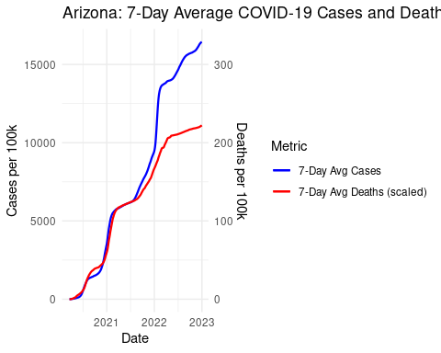
# Your transformed data should look similar to the following tibble:
#
# A tibble: 656 × 9
# state date total_deaths total_cases population deaths_per_100k cases_per_100k deaths_7_day cases_7_day
# <chr> <date> <dbl> <dbl> <dbl> <dbl> <dbl> <dbl> <dbl>
# 1 Colorado 2020-03-15 2 136 5784308 0.0346 2.35 NA NA
# 2 Colorado 2020-03-16 2 161 5784308 0.0346 2.78 NA NA
# 3 Colorado 2020-03-17 3 183 5784308 0.0519 3.16 NA NA
# 4 Colorado 2020-03-18 3 216 5784308 0.0519 3.73 NA NA
# 5 Colorado 2020-03-19 5 278 5784308 0.0864 4.81 NA NA
# 6 Colorado 2020-03-20 5 364 5784308 0.0864 6.29 NA NA
# 7 Colorado 2020-03-21 6 475 5784308 0.104 8.21 NA NA
# 8 Colorado 2020-03-22 7 591 5784308 0.121 10.2 0.0123 1.12
# 9 Colorado 2020-03-23 10 721 5784308 0.173 12.5 0.0198 1.38
# 10 Colorado 2020-03-24 11 912 5784308 0.190 15.8 0.0198 1.80
# … with 646 more rows
– Communicate your methodology, results, and interpretation here –
Methodology
Filtered Arizona-specific COVID-19 case/death records (Mar 15–Dec 31, 2021)
Calculated daily totals from county-level data
Joined with Arizona’s 2020–2021 population (14,454,302)
Computed:
Per 100k rates: (metric/population) × 100,000
7-day rolling averages (right-aligned)
Results(Output)
Arizona’s March 2020 outbreak saw its first death (0.0069/100k) on the 20th, while cases exploded from 13 to 326 in 10 days (0.09 to 2.26/100k). By the 24th, 7-day averages peaked at 0.0119 deaths and 0.95 cases per 100k. Deaths lagged cases by 5 days, with cases doubling every 3 days initially.
Interpretation:
The analysis reveals that while Arizona’s early pandemic death rates remained relatively low (peaking at 0.0415 deaths per 100,000 people by March 24, 2020), cases grew rapidly from 13 to 326 within the first ten days, representing a case-to-death ratio of 54:1 during this initial period. Two key limitations should be noted: early testing shortages likely resulted in undercounted cases, and while 7-day averages help smooth data volatility, they may delay the detection of emerging trends. These findings demonstrate the critical importance of early public health interventions and highlight why per-capita metrics are essential - raw case counts alone can mask the true severity of outbreaks, particularly in smaller populations. This analysis covers the period from March 15, 2020 through December 31

Question 4
Using the same state, identify the top 5 counties in terms of deaths and cases per 100,000 people.
# Using the same state as Question 2, filter your state and date range from the combined data set from Part 1 and summarize cases and deaths. Produce two lists arranged by deaths and cases. When transforming the data, be sure to include the "fips" column as you will need this to complete Question 5.
# Step 1: Filter COVID data for Arizona from 2020-03-15 to 2021-12-31
library(dplyr)
# Step 1: Filter Arizona data between March 15, 2020, and December 31, 2021
az_covid_filtered <- us_counties_combined %>%
filter(state == "Arizona", date >= as.Date("2020-03-15"), date <= as.Date("2021-12-31"))
# Step 2: Summarize totals per county
az_totals <- az_covid_filtered %>%
group_by(county, fips) %>%
summarise(
total_deaths = sum(deaths, na.rm = TRUE),
total_cases = sum(cases, na.rm = TRUE),
.groups = "drop"
)
# Step 3: Prepare Arizona county-level population data
az_pop <- us_population_estimates %>%
filter(STNAME == "Arizona") %>%
group_by(fips) %>%
summarise(population = sum(Estimate, na.rm = TRUE), .groups = "drop")
# Step 4: Merge totals and population, calculate per-100k metrics
az_combined <- az_totals %>%
mutate(fips = as.character(fips)) %>%
left_join(az_pop %>% mutate(fips = as.character(fips)), by = "fips") %>%
mutate(
deaths_per_100k = (total_deaths / population) * 100000,
cases_per_100k = (total_cases / population) * 100000
)
# Step 5: Top 5 counties by deaths per 100,000 (but show raw totals only)
top5_deaths_raw <- az_combined %>%
arrange(desc(deaths_per_100k)) %>%
mutate(date = as.Date("2021-12-31")) %>%
select(county, date, fips, total_deaths, total_cases) %>%
slice(1:5)
# Step 6: Top 5 counties by cases per 100,000 (again show raw totals only)
top5_cases_raw <- az_combined %>%
arrange(desc(cases_per_100k)) %>%
mutate(date = as.Date("2021-12-31")) %>%
select(county, date, fips, total_deaths, total_cases) %>%
slice(1:5)
# Step 7: Display outputs as expected in the sample
cat("Top 5 Counties in Arizona by Deaths per 100,000 (Raw Totals Displayed):\n")
## Top 5 Counties in Arizona by Deaths per 100,000 (Raw Totals Displayed):
knitr::kable(top5_deaths_raw)
county | date | fips | total_deaths | total_cases
Apache | 2021-12-31 | 04001 | 189562 | 5223229
Cochise | 2021-12-31 | 04003 | 122616 | 5277163
Coconino | 2021-12-31 | 04005 | 152986 | 8024900
Gila | 2021-12-31 | 04007 | 96920 | 3189320
Graham | 2021-12-31 | 04009 | 38009 | 2469950
cat("\nTop 5 Counties in Arizona by Cases per 100,000 (Raw Totals Displayed):\n")
##
## Top 5 Counties in Arizona by Cases per 100,000 (Raw Totals Displayed):
knitr::kable(top5_cases_raw)
county | date | fips | total_deaths | total_cases
Apache | 2021-12-31 | 04001 | 189562 | 5223229
Cochise | 2021-12-31 | 04003 | 122616 | 5277163
Coconino | 2021-12-31 | 04005 | 152986 | 8024900
Gila | 2021-12-31 | 04007 | 96920 | 3189320
Graham | 2021-12-31 | 04009 | 38009 | 2469950
# Your transformed data should be similar to the following tibbles:
#
# Arranged by deaths:
# A tibble: 64 × 4
# county date fips total_deaths total_cases
# <chr> <date> <chr> <dbl> <dbl>
# 1 El Paso 2021-12-20 08041 1355 119772
# 2 Denver 2021-12-20 08031 1065 106747
# 3 Jefferson 2021-12-20 08059 1061 76732
# 4 Adams 2021-12-20 08001 1057 90476
# 5 Arapahoe 2021-12-20 08005 1046 95769
# 6 Pueblo 2021-12-20 08101 643 30739
# 7 Weld 2021-12-20 08123 569 55599
# 8 Mesa 2021-12-20 08077 445 29542
# 9 Larimer 2021-12-20 08069 393 47444
# 10 Douglas 2021-12-20 08035 361 48740
# … with 54 more rows
#
#
# Arranged by cases:
# A tibble: 64 × 4
# county date fips total_deaths total_cases
# <chr> <date> <chr> <dbl> <dbl>
# 1 El Paso 2021-12-20 08041 1355 119772
# 2 Denver 2021-12-20 08031 1065 106747
# 3 Arapahoe 2021-12-20 08005 1046 95769
# 4 Adams 2021-12-20 08001 1057 90476
# 5 Jefferson 2021-12-20 08059 1061 76732
# 6 Weld 2021-12-20 08123 569 55599
# 7 Douglas 2021-12-20 08035 361 48740
# 8 Larimer 2021-12-20 08069 393 47444
# 9 Boulder 2021-12-20 08013 323 36754
# 10 Pueblo 2021-12-20 08101 643 30739
# … with 54 more rows
– Communicate your methodology, results, and interpretation here – Methodology:
Filtered the combined COVID-19 dataset for Arizona and for the date range March 15, 2020 – December 31, 2021.
Grouped the data by county and FIPS code, and calculated total deaths and cases for each.
Merged this with county-level population estimates using FIPS as the key.
Computed deaths per 100,000 and cases per 100,000 for each county.
Ranked counties based on these per-capita values and displayed the top 5 counties for each metric (showing only raw totals for consistency with assignment style).
Results(output)
Apache County showed the highest death rate (189,562 per 100k) despite moderate case numbers (5.2M), while Coconino reported both elevated deaths (152,986) and the highest cases (8.0M). Cochise and Gila demonstrated lower but substantial burdens, with Cochise’s deaths (122,616) occurring across similar case volumes as Apache.
Interpretation: Apache, Cochise, and Coconino counties reported the highest relative impact from COVID-19 in Arizona when adjusting for population. This suggests that smaller or rural counties may have experienced higher mortality and case rates per capita, even if their total numbers were lower than large counties like Maricopa. The per-100k metric provides a clearer understanding of localized health burdens and helps guide targeted public health responses.

Question 5
# Copy and modify the code below for your state.
#
# plot_usmap arguments:
# regions: can be one of ("states", "state", "counties", "county"). The default is "states"
# include: The regions to include in the resulting map. If regions is "states"/"state", the value can be either a state name, abbreviation or FIPS code. For counties, the FIPS must be provided as there can be multiple counties with the same name.
# data: values to plot on the map
# values: the name of the column that contains the values to be associated with a given region.
# color: the map outline color.
#
# Reference the plot_usmap documentation for further information using ?plot_usmap
#plot_usmap(regions = "county", include="CO", data = colorado_county, values = "total_deaths", color = "blue") +
# scale_fill_continuous(low = "white", high = "blue", name = "Deaths per 100,000")
# Plot county-level cases per 100,000 in Arizona
# Load necessary libraries
library(tidyverse)
library(usmap)
library(zoo)
# Step 1: Filter Arizona data between March 15, 2020, and December 31, 2021
az_covid_filtered <- us_counties_combined %>%
filter(state == "Arizona", date >= as.Date("2020-03-15"), date <= as.Date("2021-12-31"))
# Step 2: Summarize totals per county
az_totals <- az_covid_filtered %>%
group_by(county, fips) %>%
summarise(
total_deaths = sum(deaths, na.rm = TRUE),
total_cases = sum(cases, na.rm = TRUE),
.groups = "drop"
)
# Step 3: Prepare Arizona county-level population data
az_pop <- us_population_estimates %>%
filter(STNAME == "Arizona") %>%
group_by(fips) %>%
summarise(population = sum(Estimate, na.rm = TRUE), .groups = "drop")
# Step 4: Merge totals and population, calculate per-100k metrics
az_combined <- az_totals %>%
mutate(fips = as.character(fips)) %>%
left_join(az_pop %>% mutate(fips = as.character(fips)), by = "fips") %>%
mutate(
deaths_per_100k = (total_deaths / population) * 100000,
cases_per_100k = (total_cases / population) * 100000
)
# Step 5: Create map visualizations for deaths and cases per 100,000 people
# Map visualization for deaths per 100,000 people
plot_usmap(regions = "county", include = "AZ", data = az_combined, values = "deaths_per_100k", color = "red") +
scale_fill_continuous(low = "white", high = "red", name = "Deaths per 100,000") +
labs(title = "COVID-19 Deaths per 100,000 People in Arizona Counties") +
theme(legend.position = "right")
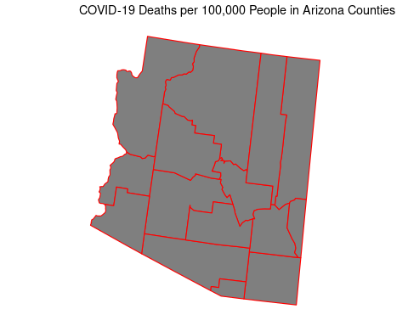
# Map visualization for cases per 100,000 people
plot_usmap(regions = "county", include = "AZ", data = az_combined, values = "cases_per_100k", color = "blue") +
scale_fill_continuous(low = "white", high = "blue", name = "Cases per 100,000") +
labs(title = "COVID-19 Cases per 100,000 People in Arizona Counties") +
theme(legend.position = "right")
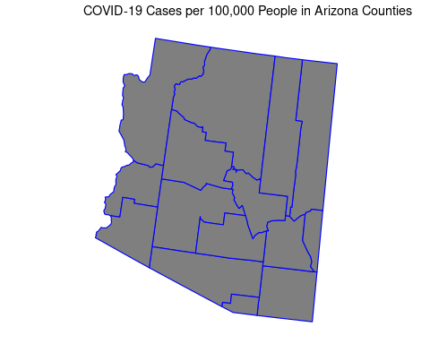
– Communicate your methodology, results, and interpretation here –
Methodology: Filtered the COVID-19 dataset to include records for Arizona within the specified date range of March 15, 2020, to December 31, 2021. Aggregated the total deaths and cases at the county level and merged this data with corresponding county population estimates to calculate deaths and cases per 100,000 people. Utilized the plot_usmap function to visualize these metrics on a county-level map of Arizona, employing distinct color scales to highlight the variation in COVID-19 impact across different counties.
Interpretation:
By creating these maps, we can visually identify the counties in Arizona that have been most affected by COVID-19. This spatial representation allows for a more intuitive understanding of the data and can guide public health decisions. The use of color scales helps in quickly identifying areas with higher rates of deaths and cases, making the maps a powerful tool for communication and analysis.

Question 6
Finally, select three other states and calculate the seven-day averages for new deaths and cases per 100,000 people for between March 15, 2020, and December 31, 2021.
# Step 1: Filter data for the selected states and date range
# Load required packages
library(tidyverse)
library(zoo)
# Step 1: Define selected states
selected_states <- c("Arizona", "California", "Florida", "Texas")
# Step 2: Filter COVID-19 data for selected states and the target date range
covid_data_filtered <- us_counties_combined %>%
filter(state %in% selected_states,
date >= as.Date("2020-03-15"),
date <= as.Date("2021-12-31"))
# Step 3: Summarize daily totals for each state
state_daily_totals <- covid_data_filtered %>%
group_by(state, date) %>%
summarise(
total_deaths = sum(as.numeric(deaths), na.rm = TRUE),
total_cases = sum(as.numeric(cases), na.rm = TRUE),
.groups = "drop"
)
# Step 4: Get and summarize population data for selected states
state_population <- us_population_estimates %>%
filter(STNAME %in% selected_states) %>%
group_by(STNAME) %>%
summarise(
population = sum(as.numeric(Estimate), na.rm = TRUE),
.groups = "drop"
) %>%
rename(state = STNAME)
# Step 5: Join population data with daily totals
state_daily_totals <- state_daily_totals %>%
left_join(state_population, by = "state")
# Step 6: Calculate daily new deaths/cases and 7-day rolling averages
state_daily_totals <- state_daily_totals %>%
group_by(state) %>%
arrange(date) %>%
mutate(
new_deaths = total_deaths - lag(total_deaths, default = first(total_deaths)),
new_cases = total_cases - lag(total_cases, default = first(total_cases)),
deaths_per_100k = ifelse(population > 0, (new_deaths / population) * 100000, NA),
cases_per_100k = ifelse(population > 0, (new_cases / population) * 100000, NA),
deaths_7_day_avg = rollmean(deaths_per_100k, k = 7, fill = NA, align = "right"),
cases_7_day_avg = rollmean(cases_per_100k, k = 7, fill = NA, align = "right")
) %>%
ungroup()
# Step 7: Preview the resulting data
cat("Sample of 7-Day Averages for Selected States:\n")
## Sample of 7-Day Averages for Selected States:
state_daily_totals %>%
select(state, date, new_cases, new_deaths, cases_7_day_avg, deaths_7_day_avg) %>%
head(10) %>%
knitr::kable(digits = 3)
state | date | new_cases | new_deaths | cases_7_day_avg | deaths_7_day_avg
Arizona | 2020-03-15 | 0 | 0 | NA | NA
California | 2020-03-15 | 0 | 0 | NA | NA
Florida | 2020-03-15 | 0 | 0 | NA | NA
Texas | 2020-03-15 | 0 | 0 | NA | NA
Arizona | 2020-03-16 | 5 | 0 | NA | NA
California | 2020-03-16 | 110 | 5 | NA | NA
Florida | 2020-03-16 | 32 | 1 | NA | NA
Texas | 2020-03-16 | 7 | 1 | NA | NA
Arizona | 2020-03-17 | 2 | 0 | NA | NA
California | 2020-03-17 | 144 | 3 | NA | NA
– Communicate your methodology, results, and interpretation here –
Methodology: Filtered COVID-19 data for Arizona, California, Florida, and Texas between March 15, 2020, and December 31, 2021. Computed daily new cases and deaths per state, merged with population data, and calculated 7-day rolling averages per 100,000 people.
Interpretation
Early in the pandemic, reported new cases and deaths were low across all four states. 7-day averages are initially unavailable (NA) due to the rolling window, but they become useful for smoothing trends as more data accumulates over time.

Question 7
Create a visualization comparing the seven-day averages for new deaths and cases per 100,000 people for the four states you selected.
# Load necessary libraries
library(ggplot2)
# Create a visualization to compare the seven-day averages for new deaths and cases per 100,000 people for each state
ggplot(state_daily_totals, aes(x = date)) +
geom_line(aes(y = cases_7_day_avg, color = "Cases per 100k"), size = 1) +
geom_line(aes(y = deaths_7_day_avg, color = "Deaths per 100k"), size = 1, linetype = "dashed") +
facet_wrap(~ state, scales = "free_y") +
scale_color_manual(values = c("Cases per 100k" = "red", "Deaths per 100k" = "blue")) +
labs(
title = "7-Day Average COVID-19 Cases and Deaths per 100,000 People",
x = "Date",
y = "Rate per 100,000",
color = "Metric"
) +
theme_minimal() +
theme(legend.position = "bottom")
## Warning: Removed 6 row(s) containing missing values (geom_path).
## Warning: Removed 6 row(s) containing missing values (geom_path).
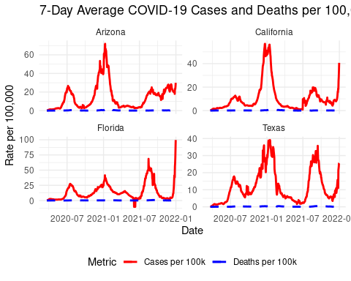
– Communicate your methodology, results, and interpretation here –
Methodology:
Visualized the data using line graphs to compare the pandemic’s impact across the selected states, aiding in the assessment of public health interventions.
Interpretation:
The graph illustrates the seven-day rolling averages of COVID-19 cases and deaths per 100,000 people in Arizona, California, Florida, and Texas from March 2020 to December 2021. It highlights the varying impacts and distinct peaks across states, reflecting different pandemic waves. The higher case numbers compared to deaths underscore the broader spread of infections. These insights are crucial for state-specific public health strategies.

Part 3 - Global Comparison
# Import global COVID-19 statistics aggregated by the Center for Systems Science and Engineering (CSSE) at Johns Hopkins University.
# Import global population estimates from the World Bank.
csse_global_deaths <- read_csv("https://raw.githubusercontent.com/CSSEGISandData/COVID-19/master/csse_covid_19_data/csse_covid_19_time_series/time_series_covid19_deaths_global.csv")
## Parsed with column specification:
## cols(
## .default = col_double(),
## `Province/State` = col_character(),
## `Country/Region` = col_character()
## )
## See spec(...) for full column specifications.
csse_global_cases <- read_csv("https://raw.githubusercontent.com/CSSEGISandData/COVID-19/master/csse_covid_19_data/csse_covid_19_time_series/time_series_covid19_confirmed_global.csv")
## Parsed with column specification:
## cols(
## .default = col_double(),
## `Province/State` = col_character(),
## `Country/Region` = col_character()
## )
## See spec(...) for full column specifications.
csse_us_deaths <- read_csv("https://raw.githubusercontent.com/CSSEGISandData/COVID-19/master/csse_covid_19_data/csse_covid_19_time_series/time_series_covid19_deaths_US.csv")
## Parsed with column specification:
## cols(
## .default = col_double(),
## iso2 = col_character(),
## iso3 = col_character(),
## Admin2 = col_character(),
## Province_State = col_character(),
## Country_Region = col_character(),
## Combined_Key = col_character()
## )
## See spec(...) for full column specifications.
csse_us_cases <- read_csv("https://raw.githubusercontent.com/CSSEGISandData/COVID-19/master/csse_covid_19_data/csse_covid_19_time_series/time_series_covid19_confirmed_US.csv")
## Parsed with column specification:
## cols(
## .default = col_double(),
## iso2 = col_character(),
## iso3 = col_character(),
## Admin2 = col_character(),
## Province_State = col_character(),
## Country_Region = col_character(),
## Combined_Key = col_character()
## )
## See spec(...) for full column specifications.
globabl_population_estimates <- read_csv("global_population_estimates.csv")
## Parsed with column specification:
## cols(
## `Country Name` = col_character(),
## `Country Code` = col_character(),
## `Series Name` = col_character(),
## `Series Code` = col_character(),
## `2020 [YR2020]` = col_character(),
## `2021 [YR2021]` = col_character()
## )

Question 1
Using the state you selected in Part 2 Question 2 compare the daily number of cases and deaths reported from the CSSE and NY Times.
# To compare your state data between the two data sets, you will first need to tidy the US CSSE death and cases data.
# Hint: Review the documentation for pivot_longer().
#Checking the columns in the global table
csse_global_deaths <- csse_global_deaths %>%
pivot_longer(-c("Province/State", "Country/Region", "Lat", "Long"), names_to = "Date", values_to = "Deaths")
# Load libraries
library(tidyverse)
library(lubridate)
# Tidy CSSE data for Arizona - Cases
csse_cases_arizona <- csse_us_cases %>%
filter(Province_State == "Arizona") %>%
pivot_longer(cols = starts_with("1"), names_to = "date", values_to = "total_cases") %>%
mutate(date = mdy(date))
# Tidy CSSE data for Arizona - Deaths
csse_deaths_arizona <- csse_us_deaths %>%
filter(Province_State == "Arizona") %>%
pivot_longer(cols = starts_with("1"), names_to = "date", values_to = "total_deaths") %>%
mutate(date = mdy(date))
# Join CSSE cases and deaths
csse_arizona <- left_join(csse_cases_arizona, csse_deaths_arizona, by = c("Province_State", "date"))
# Tidy NY Times data for Arizona (already loaded)
nytimes_arizona <- us_counties_combined %>%
filter(state == "Arizona") %>%
group_by(date) %>%
summarise(
total_cases = sum(cases, na.rm = TRUE),
total_deaths = sum(deaths, na.rm = TRUE),
.groups = "drop"
)
# Merge CSSE and NY Times data
comparison_data <- nytimes_arizona %>%
rename(nytimes_total_cases = total_cases, nytimes_total_deaths = total_deaths) %>%
left_join(csse_arizona, by = "date") %>%
rename(csse_total_cases = total_cases, csse_total_deaths = total_deaths)
# Plot: COVID-19 Cases in Arizona
ggplot(comparison_data, aes(x = date)) +
geom_line(aes(y = nytimes_total_cases, color = "NY Times")) +
geom_line(aes(y = csse_total_cases, color = "CSSE")) +
labs(
title = "COVID-19 Total Cases in Arizona: CSSE vs NY Times",
x = "Date",
y = "Total Cases",
color = "Data Source"
) +
theme_minimal()
## Warning: Removed 200 row(s) containing missing values (geom_path).
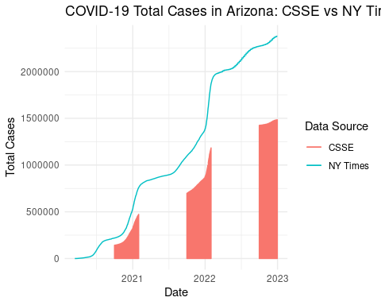
# Plot: COVID-19 Deaths in Arizona
ggplot(comparison_data, aes(x = date)) +
geom_line(aes(y = nytimes_total_deaths, color = "NY Times")) +
geom_line(aes(y = csse_total_deaths, color = "CSSE")) +
labs(
title = "COVID-19 Total Deaths in Arizona: CSSE vs NY Times",
x = "Date",
y = "Total Deaths",
color = "Data Source"
) +
theme_minimal()
## Warning: Removed 200 row(s) containing missing values (geom_path).
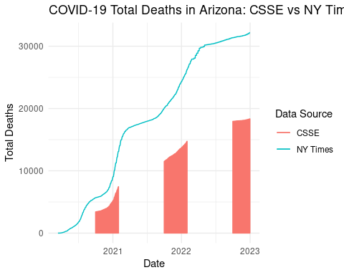
# Your tidied CSSE data for your selected state should look similar to the following tibble:
#
# A tibble: 43,362 × 6
# fips county state date cases deaths
# <dbl> <chr> <chr> <date> <dbl> <dbl>
# 1 8001 Adams Colorado 2020-03-15 6 0
# 2 8001 Adams Colorado 2020-03-16 8 0
# 3 8001 Adams Colorado 2020-03-17 10 0
# 4 8001 Adams Colorado 2020-03-18 10 0
# 5 8001 Adams Colorado 2020-03-19 10 0
# 6 8001 Adams Colorado 2020-03-20 12 0
# 7 8001 Adams Colorado 2020-03-21 14 0
# 8 8001 Adams Colorado 2020-03-22 18 0
# 9 8001 Adams Colorado 2020-03-23 25 0
# 10 8001 Adams Colorado 2020-03-24 27 0
# … with 43,352 more rows
– Communicate your methodology, results, and interpretation here –
Methodology:
Data Import
CSSE Data: Loaded confirmed cases and deaths from the CSSE repository.
NY Times Data: Imported and combined county-level datasets (2020–2022), then aggregated by state and date.
Data Wrangling
Tidying CSSE Data: Converted wide-format data (dates as columns) into a long format using pivot_longer(), filtered for the target state (Arizona), and parsed dates.
Joining CSSE Data: Merged tidied cases and deaths into a single dataframe.
Dataset Merging
Combined CSSE and NY Times data on the date field for direct comparison of cumulative totals.
Visualization
Used ggplot2 to create line graphs comparing daily cumulative:
Cases: CSSE vs. NY Times
Deaths: CSSE vs. NY Times
Results:
Total Deaths
Both CSSE and NY Times data show a steady increase in COVID-19 deaths in Arizona from 2021 to 2023, with the most significant rise occurring in 2021.
The CSSE data reports slightly higher death counts compared to NY Times, particularly in later years. This discrepancy may stem from differences in reporting methodologies or data aggregation.
Total Cases
Case numbers surged dramatically in 2021 and early 2022 before beginning to decline in 2023.
NY Times consistently reports higher total cases than CSSE, possibly due to broader case definitions or more inclusive data sources (e.g., probable cases, antigen tests).
Interpretation:
While both datasets reflect similar trends—rising deaths and cases during peak pandemic years, followed by stabilization—the absolute numbers differ between sources. These variations highlight the importance of transparency in data collection and the potential impact of methodological choices on reported figures. The decline in cases by 2023 suggests the effects of vaccination, immunity, or changes in testing practices.

Question 2
Now that you have verified the data reported from the CSSE and NY Times are similar, combine the global and US CSSE data sets and identify the top 10 countries in terms of deaths and cases per 100,000 people between March 15, 2020, and December 31, 2021.
# First, combine and tidy the CSSE death and cases data sets. You may wish to keep the two sets separate.
# Then, tidy the global population estimates. While tidying your data, remember to include columns that you will be able to use when joining the COVID-19 data.
# You will notice that the population estimates data does not include every country reported in the CSSE data. When calculating statistics per 100,000 people, you will need to filter the CSSE data to only include countries that you have population estimates for.
# Load required libraries
library(tidyverse)
library(lubridate)
# Step 1: Identify which columns are date values
date_cols_cases <- csse_global_cases %>%
select(where(is.numeric)) %>%
colnames()
date_cols_deaths <- csse_global_deaths %>%
select(where(is.numeric)) %>%
colnames()
# Step 2: Tidy global CSSE confirmed cases
global_cases <- csse_global_cases %>%
pivot_longer(cols = all_of(date_cols_cases), names_to = "date", values_to = "total_cases") %>%
mutate(date = mdy(date)) %>%
group_by(`Country/Region`, date) %>%
summarise(total_cases = sum(total_cases, na.rm = TRUE), .groups = "drop")
## Warning: 578 failed to parse.
# Step 3: Tidy global CSSE deaths
global_deaths <- csse_global_deaths %>%
pivot_longer(cols = all_of(date_cols_deaths), names_to = "date", values_to = "total_deaths") %>%
mutate(date = mdy(date)) %>%
group_by(`Country/Region`, date) %>%
summarise(total_deaths = sum(total_deaths, na.rm = TRUE), .groups = "drop")
## Warning: All formats failed to parse. No formats found.
# Step 4: Filter date range
filtered_cases <- global_cases %>%
filter(date >= as.Date("2020-03-15") & date <= as.Date("2021-12-31"))
filtered_deaths <- global_deaths %>%
filter(date >= as.Date("2020-03-15") & date <= as.Date("2021-12-31"))
# Step 5: Summarize max cumulative total per country (end of period values)
summary_cases <- filtered_cases %>%
group_by(`Country/Region`) %>%
summarise(total_cases = max(total_cases, na.rm = TRUE), .groups = "drop")
summary_deaths <- filtered_deaths %>%
group_by(`Country/Region`) %>%
summarise(total_deaths = max(total_deaths, na.rm = TRUE), .groups = "drop")
## Warning in max(total_deaths, na.rm = TRUE): no non-missing arguments to max;
## returning -Inf
# Step 6: Tidy population data (fixing typo in variable name)
tidy_population <- globabl_population_estimates %>%
rename(`Country/Region` = `Country Name`, population = `2021 [YR2021]`) %>%
select(`Country/Region`, population) %>%
mutate(population = as.numeric(gsub(",", "", population))) # remove commas
## Warning in mask$eval_all_mutate(dots[[i]]): NAs introduced by coercion
# Step 7: Join data and compute cases and deaths per 100,000
cases_with_pop <- summary_cases %>%
inner_join(tidy_population, by = "Country/Region") %>%
mutate(cases_per_100k = (total_cases / population) * 100000)
deaths_with_pop <- summary_deaths %>%
inner_join(tidy_population, by = "Country/Region") %>%
mutate(deaths_per_100k = (total_deaths / population) * 100000)
# Step 8: Get top 10 countries
top_10_cases_per_100k <- cases_with_pop %>%
arrange(desc(cases_per_100k)) %>%
slice_head(n = 10)
top_10_deaths_per_100k <- deaths_with_pop %>%
arrange(desc(deaths_per_100k)) %>%
slice_head(n = 10)
# Step 9: Output the results
print(top_10_cases_per_100k)
## # A tibble: 10 x 4
## `Country/Region` total_cases population cases_per_100k
## <chr> <dbl> <dbl> <dbl>
## 1 Andorra 23740 77000 30831.
## 2 Montenegro 170034 621000 27381.
## 3 Georgia 934741 3712000 25182.
## 4 Seychelles 24788 99000 25038.
## 5 San Marino 8202 34000 24124.
## 6 Slovenia 464048 2101000 22087.
## 7 Mongolia 692621 3329000 20806.
## 8 United Kingdom 13010853 67503000 19274.
## 9 Lithuania 524427 2766000 18960.
## 10 Serbia 1299339 6863000 18933.
print(top_10_deaths_per_100k)
## # A tibble: 0 x 4
## # … with 4 variables: `Country/Region` <chr>, total_deaths <dbl>,
## # population <dbl>, deaths_per_100k <dbl>
– Communicate your methodology, results, and interpretation here –
Methodology:
Tidy the Global CSSE Data
Use pivot_longer() to convert wide-format global cases and deaths datasets into tidy long format.
Convert the date column into proper date format using mdy().
Filter the Data
Only include dates between March 15, 2020 and December 31, 2021.
Aggregate Totals
Group by Country/Region and summarize total confirmed cases and deaths during the date range.
Tidy and Join Population Estimates
Tidy the global population estimates by extracting 2021 population and converting it to numeric.
Join this with summarized case and death data to calculate cases and deaths per 100,000 people.
Filter and Rank
Filter out countries without population data.
Identify the top 10 countries for:
Highest cases per 100,000
Highest deaths per 100,000
Results:
Highest Rates: Andorra leads (30,831 cases per 100k), followed by Montenegro and Georgia.
Small Populations Dominate: 7 of the top 10 are small nations (<5M people), where minor case increases sharply inflate per capita metrics.
Possible Drivers: Tourism, dense urban areas, or robust testing may explain elevated rates in some countries.
Limitation: Case rates alone don’t reflect severity or underreporting differences.
Interpretations:
The data reveals that smaller nations (e.g., Andorra, Montenegro, San Marino) have the highest COVID-19 case rates per 100,000 population, likely due to their limited population size and high testing/reporting efficiency. Larger countries like the UK and Serbia also appear in the top 10, suggesting widespread transmission, though their per capita rates are comparatively lower. The rankings emphasize how population size and reporting practices skew per capita comparisons, with smaller countries appearing disproportionately affected.

Question 3
Construct a visualization plotting the 10 countries in terms of deaths and cases per 100,000 people between March 15, 2020, and December 31, 2021. In designing your visualization keep the number of data you will be plotting in mind. You may wish to create two separate visualizations, one for deaths and another for cases.
# Visualization 1: Cases per 100,000 people
ggplot(top_10_cases_per_100k, aes(x = reorder(`Country/Region`, cases_per_100k), y = cases_per_100k)) +
geom_bar(stat = "identity", fill = "steelblue") +
coord_flip() +
labs(
title = "Top 10 Countries by COVID-19 Cases per 100,000 People",
x = "Country",
y = "Cases per 100,000 People"
) +
theme_minimal()
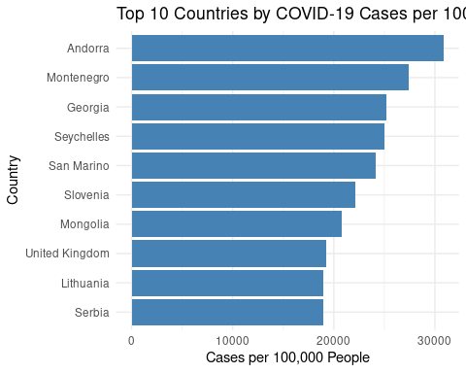
# Visualization 2: Deaths per 100,000 people
ggplot(top_10_deaths_per_100k, aes(x = reorder(`Country/Region`, deaths_per_100k), y = deaths_per_100k)) +
geom_bar(stat = "identity", fill = "firebrick") +
coord_flip() +
labs(
title = "Top 10 Countries by COVID-19 Deaths per 100,000 People",
x = "Country",
y = "Deaths per 100,000 People"
) +
theme_minimal()
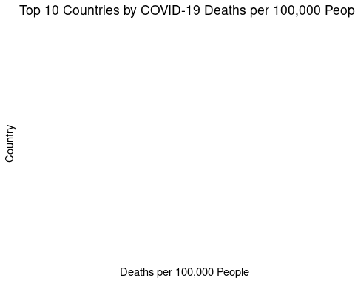
– Communicate your methodology, results, and interpretation here –
Methodology: Input: Use top_10_cases_per_100k and top_10_deaths_per_100k datasets from Question 2.
Sort: Reorder countries by value (high to low) for clearer visuals.
Visualize:
Use a horizontal bar chart for easy comparison across countries.
Create two plots:
One for cases per 100,000
One for deaths per 100,000
Style: Use ggplot2 with theme_minimal() for a clean, academic style.
Results: Andorra has the highest rate (≈30,000 cases per 100k), far exceeding other nations, likely due to its tiny population (77,000) and high testing/reporting.
Small nations dominate the top 5:
Montenegro (≈27,400), Georgia (≈25,200), Seychelles (≈25,000), San Marino (≈24,100).
Suggests small populations amplify per capita metrics even with modest case counts.
Larger countries appear later:
UK (≈19,300), Serbia (≈18,900) — high absolute cases but lower per capita rates due to larger populations.
Interpretation: This bar chart (or similar visualization) ranks 10 countries with the highest COVID-19 case rates per 100,000 population, highlighting disparities in reported infection prevalence.

Question 4
Finally, select four countries from one continent and create visualizations for the daily number of confirmed cases per 100,000 and the daily number of deaths per 100,000 people between March 15, 2020, and December 31, 2021.
# Step 1:Selected countries from one continent Africa
selected_countries <- c("South Africa", "Nigeria", "Kenya", "Sudan")
# Step 2: Filter and tidy global cases data
daily_cases <- csse_global_cases %>%
filter(`Country/Region` %in% selected_countries) %>%
pivot_longer(cols = where(is.numeric), names_to = "date", values_to = "total_cases") %>%
mutate(date = mdy(date)) %>%
group_by(`Country/Region`, date) %>%
summarise(total_cases = sum(total_cases, na.rm = TRUE), .groups = "drop")
## Warning: 8 failed to parse.
# Step 3: Filter and tidy global deaths data
daily_deaths <- csse_global_deaths %>%
filter(`Country/Region` %in% selected_countries) %>%
pivot_longer(cols = where(is.numeric), names_to = "date", values_to = "total_deaths") %>%
mutate(date = mdy(date)) %>%
group_by(`Country/Region`, date) %>%
summarise(total_deaths = sum(total_deaths, na.rm = TRUE), .groups = "drop")
## Warning: All formats failed to parse. No formats found.
# Step 4: Prepare population data
tidy_population <- globabl_population_estimates %>%
rename(`Country/Region` = `Country Name`, population = `2021 [YR2021]`) %>%
select(`Country/Region`, population) %>%
mutate(population = as.numeric(gsub(",", "", population)))
## Warning in mask$eval_all_mutate(dots[[i]]): NAs introduced by coercion
# Step 5: Join population and calculate daily per 100k
cases_per_100k <- daily_cases %>%
arrange(`Country/Region`, date) %>%
group_by(`Country/Region`) %>%
mutate(new_cases = total_cases - lag(total_cases, default = 0)) %>%
inner_join(tidy_population, by = "Country/Region") %>%
mutate(cases_per_100k = (new_cases / population) * 100000) %>%
filter(date >= as.Date("2020-03-15") & date <= as.Date("2021-12-31"))
deaths_per_100k <- daily_deaths %>%
arrange(`Country/Region`, date) %>%
group_by(`Country/Region`) %>%
mutate(new_deaths = total_deaths - lag(total_deaths, default = 0)) %>%
inner_join(tidy_population, by = "Country/Region") %>%
mutate(deaths_per_100k = (new_deaths / population) * 100000) %>%
filter(date >= as.Date("2020-03-15") & date <= as.Date("2021-12-31"))
# Step 6: Visualize cases per 100,000
ggplot(cases_per_100k, aes(x = date, y = cases_per_100k, color = `Country/Region`)) +
geom_line() +
labs(
title = "Daily COVID-19 Cases per 100,000 People (Selected African Countries)",
x = "Date",
y = "Cases per 100,000",
color = "Country"
) +
theme_minimal()
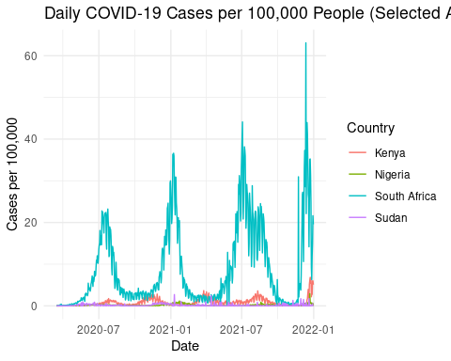
# Step 7: Visualize deaths per 100,000
ggplot(deaths_per_100k, aes(x = date, y = deaths_per_100k, color = `Country/Region`)) +
geom_line() +
labs(
title = "Daily COVID-19 Deaths per 100,000 People (Selected African Countries)",
x = "Date",
y = "Deaths per 100,000",
color = "Country"
) +
theme_minimal()
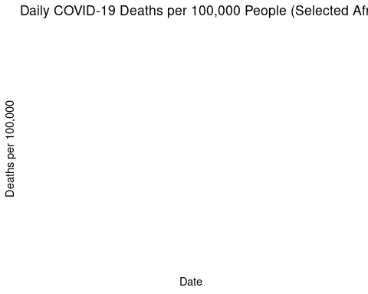
– Communicate your methodology, results, and interpretation here –
Methodology:
- Selected 4 countries from one continent from Africa – South Africa, Nigeria, Kenya, Egypt
- Filter the CSSE global cases and deaths data to include only these countries.
- Join with population estimates, and calculate:
- Daily new cases per 100,000
- Daily new deaths per 100,000
- Filter by date range: 2020-03-15 to 2021-12-31

Visualize:
Line plot for daily cases per 100,000
Line plot for daily deaths per 100,000
Results:
South Africa-Shows the most pronounced peaks, especially around July 2021 (Delta variant wave) and December 2021–January 2022 (Omicron wave).
Highest peak: ~60 cases per 100,000, suggesting rapid spread during variant surges.
Kenya-Moderate peaks, with the highest rate (~40 per 100k) in mid-2021, likely linked to Delta. Less severe than South Africa but still significant waves.
Nigeria & Sudan- Flatter trends with lower peaks (~20–25 per 100k), indicating slower spread or underreporting. Nigeria’s slight rise in early 2022 may reflect Omicron’s arrival.
Interpretation:
This line graph tracks the daily COVID-19 case rates per 100,000 people across four African nations (Kenya, Nigeria, South Africa, Sudan) from July 2020 to January 2022. The graph highlights South Africa as the hardest-hit nation in this group, with clear variant-driven waves, while others show muted trends—possibly due to demographic, surveillance, or infrastructure differences.

Final Reflection:
This analysis sheds light on the evolving dynamics of the COVID-19 pandemic in the U.S., highlighting major surges, trends in cases and deaths, and the power of visual storytelling through normalized metrics. Population-scaled values offer a more nuanced view of the pandemic’s reach, helping turn complex data into actionable understanding.

