Location and Directions
For those using GPS navigation device, please use this address: 200 Chapel Rd. Birdsboro, PA 19508. Visit the camp at www.hpcamp.org/ Office hours: M-F, 8:00am - 4:30pm Phone: (610) 286-5942 ext.153 - Fax: (610) 286-4821. If you cannot reach the camp office, please call (484) 467-6221. Email: office@hpcamp.org

The following organizations are represented at N-Counter. Here is contact information.

  Jon Maroni  Assistant Director of Admission  One Willard Avenue  Houghton NY 14744  Phone: 585.567.9500 x9372  www.houghton.edu |   Liberty University  Training Champions for Christ since 1971  Kandice Cruice  National Recruitment Coordinator  Resident Enrollment  Phone: (434) 592-5909 |  |   Zachary Mahon  Recruiter  200 Manor Avenue  Langhorne, PA 19047  Phone: 215.702.4234  www.cairn.edu
  Chris Studley  Director  Northern Frontier Camp  North River, NY  Office Phone 215-493-2995  Email: chris@northernfrontier.org  www.northernfrontier.org |   Steve Niphakis  717-318-4654  omf.org/us |  |   Chris Hendrickson  PO Box 204  Liberty Corner NJ 07938  Phone: 908-991-3219  www.coregapyear.org
 |   Chief Mark Curran  Camp Director  Wardensville, WV  www.camphemlock.org |  |   Dave Stiansen, Director  Haycock Camp, Kintnersville, PA  Office Phone: 610-346-7155  www.haycock.org/our-progs/ram
  Corporate Sponsor, in Morgantown, PA |  | 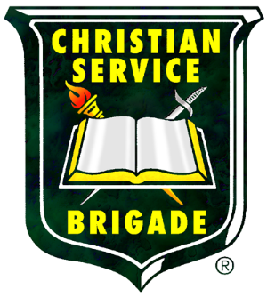  Phone: 800-815-5573 / 716-526-0026  office@csbministries.org  www.csbministries.org




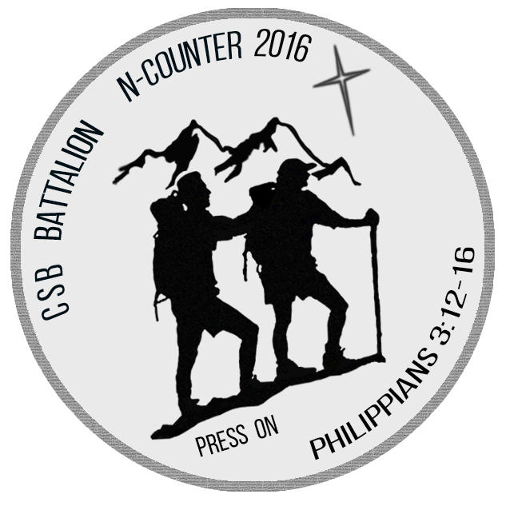

Friday April 29 – Sunday May 1, 2016

High Point Camp
200 Chapel Road
Birdsboro, Pennsylvania

www.csbncounter.org

The purpose of N-Counter is to glorify God through fellowship, discipleship, and the experience of CSB Battalion across regions.

N-Counter Schedule
Friday 6:00 Check-in begins
9:00 Regional Camp Fires (locations to be announced)
10:30 Break and return to unit sites
11:00 Quiet in the Camp
Saturday Wake up and Breakfast at assigned times
7:45 am Line Up and Call to Worship
8:15 Activities begin, Team leaders have schedules
12:45 Lunch at assigned areas, with teams
1:30 Activities resume; Follow the team schedule
6:00 Team leaders pick up Bible study at Chapel
6:00 Dinner begins for Adults, Leaders and Alumni
Teams do Bible study; then dinner at assigned time
7:00 Brigade Leaders and Alumni meeting at Chapel
7:30 Evening colors: observed by quiet in the camp
8:00 Line Up by Battalion, proceed to evening meeting
11:00 Quiet in Camp

Sunday 6:30 Reveille and Wake Up, Battalion uniforms to be worn
Breakfast at assigned time with Battalion unit
9:00 Line Up with morning colors; group photo
9:20 Sunday Morning Service at Worship Center
11:00 Benediction and Watch Word
11:10-12:00 Check Out

An individual permission/medical form for all attendees, properly filled out for each youth and adult, is required at Check-In. A signature is required by a parent or guardian of every minor.

All Battalion units will stay overnight in tent sites or in cabins as
pre-arranged. A wash house, with running water, sinks, showers and toilets, is located not far from these sites, as are portable toilets.

What to Bring - Personal Gear

Each participant should bring the following items:
- Backpack, duffel or other minimal luggage
- Rain protection for extended time in the rain
- Extra shoes (waterproofing is suggested)
- Sleeping bag or blankets, and pillow
- Warm outerwear, jacket, sweat shirt, hat
- Two changes of clothes
- Battalion unit’s uniform shirt
- Sunscreen or sunblock
- Personal items (towel, soap, toothbrush, comb, etc.)
- Flashlight or similar, with batteries
- Water bottle for personal use
- Bible and Trails book, pen or pencil

Do not bring
- Chain saws, Pets, Fireworks
- Radio, TV, music players or similar
- Alcohol, tobacco or controlled substances
- Personal firearms, ammunition, bows, arrows, slingshots
- Electricity generators
- Cooking materials (all meals are provided)

N-Counter Camp policies
- Vehicles can only be driven through camp for the unloading and loading of luggage. Please park all vehicles, as directed by the N-Counter Staff, to remain parked for the duration of the event.
- No one can use the lake unless a camp life guard is on duty. Any persons on the lake must wear a life vest.
- Guests will leave the facilities as they found them. Damages to rooms and equipment will be deducted from the group’s security deposit.
- Quiet in camp hours will be followed strictly by all Battalions & guests
- The use of cigarettes/tobacco products, alcohol, and illegal narcotics, fireworks, and personal firearms are prohibited. The entire camp is a smoke free environment.

