**Project Report: An Advanced Aeroplane Chess**

**Introduction**

Aeroplane chess is a modern Chinese chess game based on a kind of British chess. Like other chess game, aeroplane chess have been transplanted to computer platform, and we can find many versions of aeroplane chess game online. However, traditional aeroplane chess seems to lose its attraction among teenagers due to the restricted game mode. In this project, our group created an advanced aeroplane chess game. It can not only perform the function of traditional aeroplane chess, but also add new features to make the game totally different. Additionally, this game supports LAN battle, which means friends can play this game online. We hope by introducing this project, our generation can recall the happiness we had once upon a time.

Here is our group members’ name and contribution list:

(Group members are not changed since the submission of project proposal.)

117010243 Tang Wentian

117010099 Huang Tianjian

117010366 Zeng Lewei

117010289 Wu Runzhong

117010155 Lin Siyi

(Job distribution is slightly changed since the submission of project proposal.)

|  |  |
| --- | --- |
| Member | Job |
| Tang Wentian | Scene: start scene, main scene, end scene  Main interface (Normal mode): dice |
| Huang Tianjian | AI design: all parts  Liaison |
| Zeng Lewei | Scene: main scene  Main interface (Normal mode): dice, planes, event dispatch  AI interface: all parts |
| Wu Runzhong | Scene: end scene  Main interface (Normal mode): dice, planes, win judge  Main interface (Advanced mode): all parts |
| Lin Siyi | LAN system: all parts |
| Testing is done by all members.  LAN system is not completed. Other functions have achieved expected results. | |

**Description of the game**

When you enter the beginning interface of this game, you can start a game, read the help, or exit the game. After you start a game, you can change the game mode (online/offline mode, traditional/advanced mode), numbers and type of players.

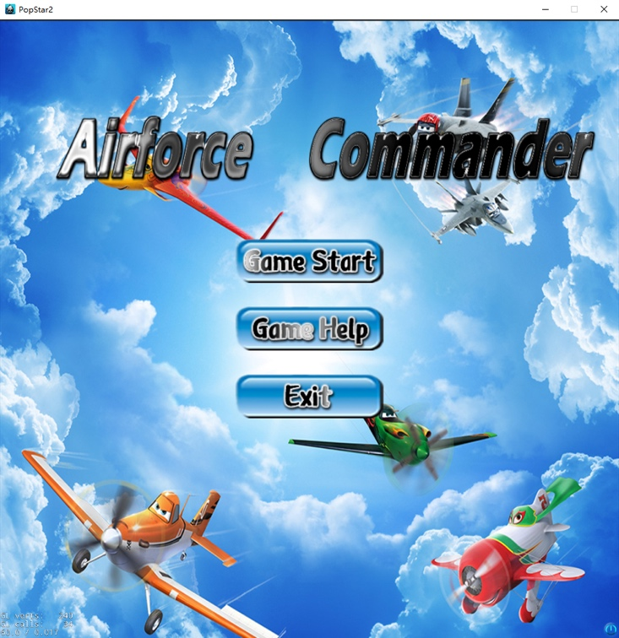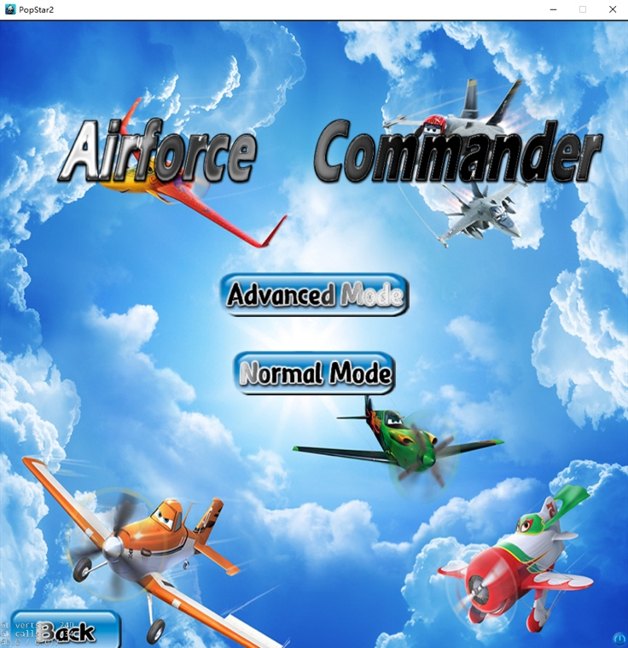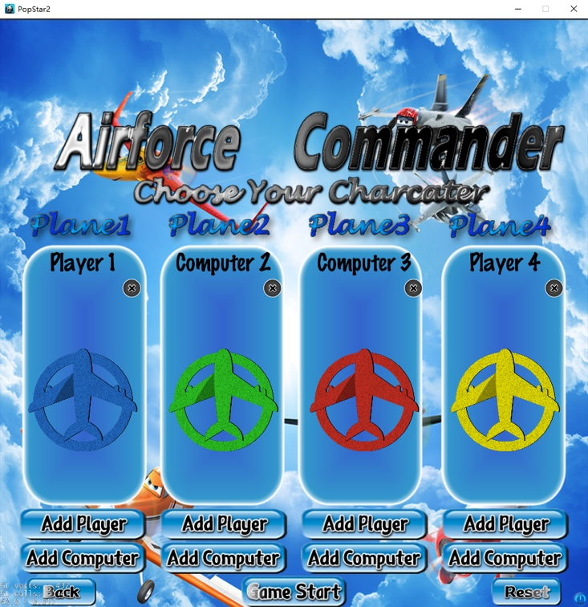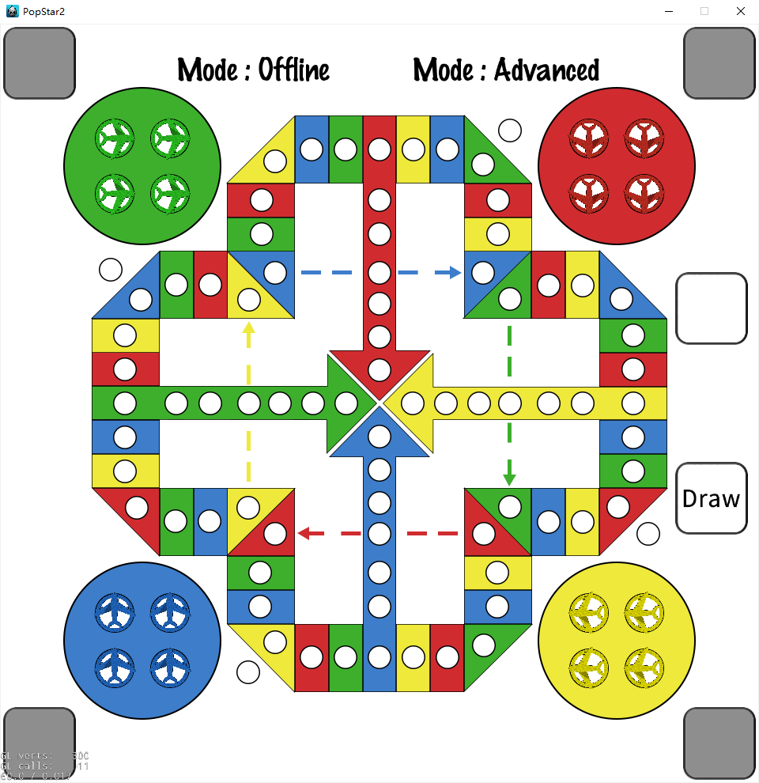

Game mode:

There are two game modes: traditional mode and advanced mode. Traditional mode is not different from the most common aeroplane chess game. Roll the dice and move the chesses according to the roll point. Let all of your four planes finish the game before other players to win. As for the advanced mode, we add an ability card system to the game, which allow players to use certain ability cards to hinder enemies or buff their own chess to win the game. The mechanism of ability card system is as follows:

1. When a player rolls the dice to 1 or 6, the player gets a chance to draw an ability card instead of moving a chess. One player can only possess at most 1 card at a time. If the player draws a card when having a card already, the original card will be replaced by the new card.
2. One ability card can only be used once, and one player can only use ability card once in one turn. When the player chooses to use ability card, then he or she cannot roll the dice or move chesses anymore.
3. There are four kinds of ability cards, and each of them can be drawn with equal possibility. They are:

* Attack: assign this ability to one OWN chess. Enemy chess less than 5 steps far from this chess will be crashed (send back to airport) unless they are protected.
* Defense: assign this ability to ANY chess. This chess will not be attacked or be interfered (but still can be rammed) in 5 rounds. If a chess has already been interfered, this card will have no effect.
* Interfere: assign this ability to ANY chess. The chess cannot move/attack/defense in 4 rounds.
* Eliminate: assign this ability to ANY chess. The buff/debuff state (defensed/interfered) of the chess will be eliminated.

**Game Framework**

There are three main components in this project, which are main interface (normal mode & advanced mode), AI player (AI core & AI interface) and LAN system.

* **Main interface (Normal mode)**

The basic part of the game.

**Start scene**

Start_Scene inherits the Scene class in cocos2d.h. It is the start interface of the game. It obtains the value of argument from the selection and operation of the user. And it can be divided into five parts: Main Menu, Help Menu, Online/Offline Selection Interface, Advance/Normal Mode Selection Interface and Player/Computer Selection Interface.

In the initialization of this scene, all the components of the five parts are created. However, only the components of main menu are showed while others are “hidden” by setScale(0).

1. Main Menu:

Create one sprite named bg with file “start.png” and set it as the background picture of the main menu. Then let three options appear: game start, game help and exit.

Game start: “Turn to” the online/offline selection interface. “Turn to” means let all the components of previous interface disappear temporarily by setScale(0), then let the components of next interface appear;

Game help: “Turn to” the help menu interface.

Exit: Exit the game by calling function end();

1. Help Menu

This interface includes four options with four corresponding “content” Sprite: Introduction, Normal mode rules, Advance mode rules, Credits.

Four options control the appearance of four contents by using the function helpmenu to set the value of variables help_choose, then function update() monitors the value of variables and let the corresponding content appear.

Meanwhile, there is another option “back”. It will turn back to the Main Menu interface and reset all the variables in the Start_Scene by functionrefresh1(). And this option will appear in all interfaces in Start_Scene except for Main Menu interface. It will not be talked about again in the introduction of other interfaces.

1. Online/Offline Selection Interface

This interface includes two options: Online_mode and Offline_mode. Online_mode will turn to the online part. Offline_mode will turn to the Advance/Normal Mode Selection Interface and set bool variable online false by function refresh2_1.

1. Advance/Normal Mode Selection Interface

This interface includes two options: Normal_mode and Advance_mode. Advance_mode will set the bool variable advance_mode to true while Normal_mode will set it to false. Both of them will turn to the Player/Computer Selection Interface by function refresh3.

1. Player/Computer Selection Interface.

Let the Sprite named choose_bg created with file “choose_bg.png” appear, set it as the background of this interface.

There are five kinds of options: Add_Player/Add_Computer options, reset options, cancel options and start option.

Add_Player/Add_Computer options: Add players or computers by setting the elements in a four-element integer array player to 1 or -1. The function update() monitors the value of the integer array and shows the player’s choice in corresponding columns by labels and Sprites.

Reset option: Set the integer array player to {0,0,0,0}. Once an element of player is 0, the corresponding column will clear the label and Sprite in it.

Cancel options: Set the corresponding element in the integer array player to 0.

Start option: It only appears when two or more than two players are initialized. It will create a new scene HelloWorldScene, transmit bool variable online, advance_mode and integer array player to it and then turn the scene to it by calling replaceScene().

**HelloWorldScene**

HelloWorldScene is the scene of the main game interface, inheriting the Scene class in cocos2d.h. All the events and objects of the main game interface are initialized by init().

The initialization includes:

1. Create the background Sprite with file “background.png”.
2. Initialize the planes according to the integer array players, set the position and other data of all Planes class objects.
3. Initialize the dice.
4. Create and initialize the Win_Judge class object.
5. Create and initialize the Card_Generator class object.
6. Create and initialize the AI_player class object.
7. Show the Online/Offline mode and Advance/Normal mode by labels according to the bool variables is_advance_mode and online.

**Planes**

A new mechanism called EventDispatch should be introduced first. EventDispatch is a mechanism for responding to user events. Event listeners encapsulate your event processing code, event dispatcher notifies listeners of user events, and event objects contain information about the event. Custom event is a kind of event, which is the main method we used in transmitting data between different sprites class. This is because of the running mechanism of Cocos2d-x: All the sprites in the game scene are initialed in the HelloWorld::init() and HelloWorld::setPlane(). To set and use EventDispatch, three steps are needed:

1. Create an EventCustom object, and dispatch it with a unique name.
2. If needed, set user data of custom event into the EventCustom.
3. Set an event listener in the initial function of target sprite, and sign it to the eventDispatcher.
4. The listener will monitor the event. When triggered, it will call the response function.

The structure of using EventDispatch is like a stack. And then the details in planes class can be introduced.

The Planes class inherits the Sprite class in cocos2d.h. Else, it has some data fields to define its color, id, status, buff, position, enter point *(the point of entering outer runway)*, turn point *(the point of entering final runway)*, the start and end point of dotted line, initial direction of planes, coordinate in the airport and take-off point, the plane has jumped or not and the plane can be touched or not.

In the initial function of Planes (init()), all the listeners are signed to eventDispatcher. The create function will call initial function, and set the parameters of the plane.

onTouchBegan is the response function of touchListener. When a plane is clicked, this function will be called. A plane can be clicked for movement or as a card receiver. For movement, it will first tell other planes that it is being clicked (dispatch event plane_click). According to the buff and status of plane, different actions will be created and plane will do the action. After each move, the plane will tell dice and other planes that the movement of plane has ended (dispatch event plane_end), tell other planes the position of itself in order to judge collision happened or not (dispatch event plane_position), and tell all the planes to summit the status in order to check whether the player has won or not (dispatch event win_check, further talked in win judge part). As a card receiver, this part will be talked in advanced mode part.

When rollPTListener hears the roll number from dice, it will call the response function setRollPoint. This function will set the roll number of planes, helping the plane to create actions and calculate position.

When planeClickListener hears the click event from other planes, it will call the response function setTouchable. It will set the parameter can_touch of the plane to false, avoiding the plane being clicked during other planes’ action. This is to ensure that only one plane will be click between two roll event.

When roundListener hears the dice roll event, it will call the response function submit_status. This function will submit the status of plane, in order to help the dice to determine the 4 planes of the player are all unmovable or not.

Function setCard, resetCard, round_decrease and machinegun_attack_judge are designed for advance mode, and will be talked in advanced mode part.

When planePositionListener hears the position of other plane, it will call the reponse function ram_judge. It will compare the position information of two planes. If they have different color and same position, going_down function will be called in order to create crash animation and refresh status of the crashed plane. To set the texture of the crashed plane to default, set_texture_to_default function will be called.

Function get_chess, AIMove and AIUseCard are designed for the interface of AI, and will be talked in AI interface part.

**Dice**

This defines the Dice class, which is used to display the dice, create random roll point and control the round of the game. It is better than setting an individual round controller because the only way we can use to transmit data is through the event dispatcher.

Similar to the Planes class, it inherits the Sprite class in order to be added to the main game scene. The init() function sets the position of dice and adds all the needed event listeners to the event dispatcher. The create function initiates the initial parameters of dice, including the number of players and computers.

When the dice is clicked, the touchListener will get the event and call the response function onTouchBegan. If the player is not a computer, it will do these things. First, it will call getrandom() to set a random number as the roll point and set the texture of the dice. Then, it will dispatch three events:

1, eventClick, in order to tell planes with the corresponding color that they can be moved;

2, eventRollPT, in order to pass the roll point to the planes;

3, eventRoundG, in order to pass the real-time color to card generator and planes. This is for two purposes: the planes will return their status, helping the dice to decide whether to skip the round or not, and if the card generator is clicked, it will create a card and send the card to corresponding card slot based on the color.

Then, if the roll number does not equal 6, the round will be changed. If the round is changed, it will tell the planes by eventRoundChange. This is to help the planes calculating the round left of their buff/debuff state. If none of the current four planes can move, it will jump to the next player directly. eventRoundS is used to tell the card slot that which slot will be activated. If the player is a computer, it will directly call the AICall() function, which will be talked in the AI interface part.

setTouchable and setTouchableFalse are used to set the parameter can_touch of the dice, avoiding the dice being clicked during planes’ action. setStatusArray is the function used to decide whether to skip the round or not, which has been talk before. skipTurn is the callback function to skip a player if that player uses a card.

Functions AISkipTurn(), AICall(), AIPass, AINoMove(), AIDraw(), AIUseCard, AIMove, AIDiceAnimation() are used in the AI interface. They will be talked in the AI interface part.

**Win judge**

Though win_judge class inherits the Sprite class in cocos2d.h, it does not act like a sprite. It is added to the scene HelloWorldScene for every game but its position is outside the program window and its size is scaled to 0 (invisible).

For the planes, when the listener winCheckListener hears the event win_check from a plane with the same color, they will tell the win_judge whether their status is “finished” (dispatch event finish_status).

For the win_judge, listener finishStatusListener hears the event finish_status and calls function setFinishStatusArray to store the information about whether the status of the planes is “finished”. If all four planes of a player have finished the game, the win judge will create a new End_Scene and tell End_Scene which player has won the game by setting its variable winner_color. After that, the win judge will turn the scene to it by calling replaceScene().

**End scene**

End_Scene is the end scene of the game, inheriting the Scene class in cocos2d.h. It contains three parts: background, options and result label.

The background is a sprite which is same as the background of Start_Scene.

There are three options:

1. Restart option: restart the game according to integer array players transmitted from HelloWorldScene.
2. Back_to_title option: turn back to the Start_Scene.
3. Exit option: exit the game by calling function end().

The result label shows the winner of the game in the center according to the variable winner_color.

* **Main interface (Advanced mode)**

The difference between normal mode and advanced mode is that ability card system is introduced in advanced mode.

**Planes (Advanced mode extension)**

The Planes class has four data fields for advanced mode: card, round_left_of_card *(information about the card which is going to be used)*, buff, round_left *(information about the buff/debuff state of the plane)*.

In normal mode, parameter card and buff are always “none”, and parameter round_left_of_card and round_left are always 0. In advanced mode, when slotListener hears that a card in the card slot is clicked (corresponding to event slot_click, further talked in card slot part), then function setCard will be called. It will change parameter card to the name of the card temporarily, and change parameter round_left_of_card to the duration of the card temporarily.

If the parameter card is not “none”, then when the plane is clicked, it will be considered as a card receiver since all four kinds of card need a target plane. The function body which can move the plane will not be executed.

If the plane is selected as the target of card “Attack”, it will tell other planes its attack range (dispatch event machinegun_attack) if the parameter buff of the plane is not “stopaction”. When listener machinegunAttackListener hears the event machinegun_attack, it will call function machinegun_attack_judge. This function determines whether the plane should be crashed. If the plane is in the attack range of the attacker and has a different color with the attacker and its buff is not “protection”, going_down function will be called in order to create crash animation and refresh status of the crashed plane. To set the texture of the crashed plane to default, set_texture_to_default function will be called.

If the plane is selected as the target of card “Defense”, the parameter buff of the plane will be checked. If the parameter buff is “stopaction”, no change will be made. If the parameter buff is not “stopaction”, the parameter buff will be set to “protection” and the parameter round_left_of_card will be copied to the parameter round_left. The texture of the plane will also be changed.

If the plane is selected as the target of card “Interfere”, the parameter buff of the plane will be checked. If the parameter buff is “protection”, no change will be made. If the parameter buff is not “protection”, the parameter buff will be set to “stopaction” and the parameter round_left_of_card will be copied to the parameter round_left. The texture of the plane will also be changed. When a player tries to move a plane whose parameter buff is “stopaction”, the plane will not advance but event plane_click and plane_end will still be dispatched.

If the plane is selected as the target of card “Eliminate”, the buff/debuff state of the plane will be cleared. The parameter buff is reset to “none” and the parameter round_left is reset to 0. To set the texture of the crashed plane to default, set_texture_to_default function will be called.

No matter what kind of card is used on the plane, the plane will tell all planes and the dice that a card is used (dispatch event use_card).

When cardListener hears the event use_card, it will call function resetCard. It resets parameter card to “none” and resets parameter round_left_of_card to 0.

When roundChangeListener hears the event round_change, it will call function round_decrease. Every time when this function is called, it decreases the parameter round_left by 1 if it is not 0, and changes the parameter buff to “none” if the parameter round_left is 0.

**Dice (Advanced mode extension)**

When the dice is rolled, it will distribute two events to tell the card generator whose turn it is and whether the card generator should be enabled (further talked in card generator part).

Since using a card consumes an action chance (including rolling the dice), if a player uses a card, then he or she cannot roll the dice and the next player’s turn will start. If cardListener hears that a card is used (corresponding to event use_card), it will call function skipTurn to end the current player’s turn and to start the next player’s turn.

When a player’s turn ends and the next player’s turn starts, the dice will distribute event round_change to the planes and they will calculate the number of rounds left for their buff/debuff state.

**Card generator**

The Card_Generator class inherits the Sprite class in cocos2d.h. It has two data fields: round *(int type, indicating who rolled the dice just now)* and can_touch *(bool type, indicating whether the player can draw a card)*. In the game, it looks like a button with a word “Draw” on it.

In the initial function of Card_Generator (init()), all the listeners are signed to eventDispatcher. The create() function will call initial function, and set the parameters of the card generator.

When roundListener hears the player who rolled the dice just now, it will call function setRound to change the parameter round to the integer representing the color of the player.

When rollPTListener hears the roll number from dice, it will call the response function setTouchable. This function checks whether the roll point is 1 or 6. If the roll point is 1 or 6, the parameter can_touch will be changed to true. Otherwise, can_touch will be changed to false.

onTouchBegan is the response function of touchListener. The body of the function will be executed if and only if the parameter can_touch is true. This function generates a random integer representing an ability card (uses function randomInteger extracted from Stanford C++ Libraries) and tells that integer to card slot corresponding to the current player (dispatch event generator_click). After that, event eventPlaneClick and eventWinCheck are dispatched, since drawing a card consumes a chance to move a chess. After the card generator is clicked, the parameter can_touch will be set back to false.

Since drawing a card consumes a chance to move a chess, a player cannot draw a card if he or she moves a chess. If planeClickListener hears that a plane is moved (corresponding to event plane_click), it will call function setTouchableFalse to set the parameter can_touch to false.

Function AIDraw is designed for the interface of AI, and will be talked in AI interface part.

**Card slot**

The Card_Slot class inherits the Sprite class in cocos2d.h. It has some data fields: color *(int type, indicating who the card slot belongs to)*, player_type *(int type, indicating the type of a player)*, card_num *(int type, indicating the kind of the card in the slot)*, player_count *(int type, indicating the number of players)*, can_touch *(bool type, indicating whether the player can use a card)*.

In the initial function of Card_Slot (init()), all the listeners are signed to eventDispatcher. The create() function will call initial function, and set the parameters of the card slot.

When generatorClickListener hears that the card generator is clicked (event generator_click) by the owner of the card slot, it will call function setCard to change the parameter card_num to the integer representing the card generated and to change the texture of the card slot.

When roundListener hears that a new turn begins, it will call the response function setTouchable. This function checks whether it is the turn of the owner of the card slot. If it is, the parameter can_touch will be changed to true. Otherwise, can_touch will be changed to false.

onTouchBegan is the response function of touchListener. The body of the function will be executed if and only if the parameter can_touch is true and the card slot is not empty. This function tells all planes the effect of the card stored in the card slot (dispatch event slot_click) and then deletes the card in the card slot.

Since using a card consumes an action chance (including rolling the dice), a player cannot use a card if he or she rolls the dice. If rollPTListener hears that the dice is clicked (corresponding to event roll_point), it will call function setTouchableFalse to set the parameter can_touch to false.

Function passCard and AIUseCard are designed for the interface of AI, and will be talked in AI interface part.

* **AI core**

The inspiration for this AI core comes from a design of Chinese chess AI. This aeroplane chess AI consists of three basic classes: the move generator (movegenerator.h / movegenerator.cpp), the evaluator (evaluator.h / evaluator.cpp) and the search engine (searchengine.h / searchengine.cpp). Move generator is a class which can generate and store all possible moves according to the current game state. Evaluator is a class which can evaluate the value of a specific move; the larger the value, the better the move. Search engine is the main class for this AI core; it combines initialized move generator and evaluator object in order to simulate a real player’s action. In addition, the AI core contains a define.h in order to store some common data structures and macros for the above three classes. Detailed implementation are as follows:

**define.h**

This head file defines some necessary data structures and macros for the AI. For example, the representation of chess ID, chess colors, chessboard coordinates and etc. They are configured as some macros for the convenience of programming.

There are three important data structures: CHESS, CHESSMOVE, and COORDINATE. CHESS is a structure containing the ID (representing the chess uniquely), the color, the coordinate, buff state and buff round left of a chess. CHESSMOVE is a structure containing the ID of the chess being manipulated, the roll point and the information about ability card using. COORDINATE is a structure containing two integers representing the region and the location respectively. The reason for using this coordinate representation is that the chessboard of aeroplane chess is not full-covered. Some points on the two-dimensional plane is out of the chessboard, and chess will have different behavior in different region of the chessboard. Therefore, I did not choose two-dimensional coordinate in the convenience of computation.

**Move generator**

When creating a move generator, the constructor will set off mode (deciding what roll point can take off), set the game mode (traditional mode or advanced mode), and set random seed. Setting random seed when initializing will let the dice roll result different every time.

The core function for move generator is createPossibleMove(). This method generates currently possible move according to current chessboard, roll point, the color of the player and ability card the player have. Each possible move is constructed into a CHESSMOVE structure and is stored into the moveCount array.

**Evaluator**

Evaluator only have one function evaluate(). The main logic for evaluating is to compare the chessboard before and after a certain move. If the new chessboard results in a favorable situation, the value will be higher. If the new chessboard confronts a bad situation, the value will be lower.

Because of the mechanism of aeroplane chess, the evaluation process is basically a simulation of human player’s thinking mode. First, the evaluator counts benefits of a move. Benefits include bonus from using ability card efficiently, crashing enemy chess, moving own chess ahead, etc. Then the evaluator counts damages of a move. Damages include the threat from enemies and punishment from overlapping. The final value is counted by benefits subtracting damages.

**Search engine**

This is the main part of AI. When initializing, the search engine must point to a move generator object and an evaluator object in order to function. The play() method will let the AI change chessboard intelligently. This method simulates player behavior like this:

1. Copy the chessboard into cur_Chessboard which is inside the search engine instance;

2. Roll the dice. Then create move with createPossibleMove().

3. If there is only one move, it must be "not possible to move" case. Then do not do any movement. If there is more than one possible move, search a good move and make move with three methods, searchAGoodMove(), makeMove(), useAbility().

4. If game is not over and roll point is six, continue until the third time roll. Else, player end its turn.

5. Copy the modified chessboard in place to the original one.

searchAGoodMove() will evaluate all possible move and choose the move with the maximum value. makeMove() and useAbility()will modify chessboard according to the move AI choose.

* **AI interface**

This is the interface for game in order to dock to AI core. It coordinates different components of the game, and transmits data between main interface and AI core.

**Before AI interface**

This part starts from the Dice::onTouchBegan. When the dice was being click, it will determine the current player is AI or not. If not, it will do as talked before. Else, it will call Dice::AICall function. The dice becomes untouchable, and it will call all the card slots (eventGetCard) and planes (eventGetChess) in order to provide essential data for AI player. It will also pass

The card slots receive it by getCardListener, and call the response function Card_Slot::passCard. According to the color of current player, it will pass the corresponding card number to AI interface (eventReceiveCard). And the planes receive it by getChessListener, and call the response function Planes::get_chess. It will convert the information of itself to the format that AI interface need, and pass to the Dice(eventChessPass). The dice will listen it with chessboardListener, calling response function AIPass to combine all the chesses into a chessboard and pass it to the AI_interface (event_receive_chessboard) with roll point (event_receive_point). Now it’s the time for AI_interface.

**AI interface**

The AI_interface defines an AI_player class, which inherits Node class and searchEngine class. First, chessboardListener, pointListener and cardListener will catch the information from dice and card slot with response functions saveChessboard, savePoint and saveCard. After saving them, AIPlay function will use the method in AI core part and calculate the best move. According to the best move created by search engine, there are four situations: don’t move the plane, move the plane, draw card or use card. This matches four different EventCustoms that will be passed: eventAINoMove, eventAIMove, eventAIDraw and eventAIUseCard.

**After AI interface**

Dice will receive the four EventCustoms first, because except for using card, dice need to display the roll animation. Now enumerate the four situations.

1. Don’t move the plane: AINoMoveListener will call response function AINoMove, which only display the animation and set the dice touchable.
2. Move the plane: AIMoveListener will call response function AIMove. It displays roll animation, passes the target plane’s information to Planes class (eventAIMove2Plane). AIMoveListener in Planes class will call response function AIMove. If the information of plane is match, it will make the planes move.
3. Draw card: AIDrawListener will call response function AIDraw. It displays roll animation, and call the card generator (eventAIDraw2Generator). AIDrawListener in Card_Generator class will call response function AIDraw, which is almost the same as the OnTouchBegan function.
4. Use card: AIUseCardListener will call response function AIUseCard. It will pass the information to card slot (eventAIMove2Slot). AIUseCardListener in Card_Generator class will call response function AIUseCard, which is almost the same as the OnTouchBegan function.

In Dice class there is an AISkipTurn function, which is similar to the SkipTurn function and used for AI using card.

* **LAN system**

The construction of LAN system is a failure. However, the difficulties we have encountered and the solutions we have discovered are treasurable for us. Additionally, reasons accounting for this failure are valuable and priceless, too.

**Problems encountered & Solutions**

1. Database Design

The general idea on database designing was implementing a register-and-login system. Only when the registration was validated by my checking system could a player login successfully and play games. To simplify the validation, previously I decided to restrict two register fields “Student’s Name” as accounts and “Student’s ID” as passwords. If a student registers, it reads a file containing pairings of students’ names and the responding IDs and verifies it. However, my request for the file was rejected. After that I realized that it could be substituted by regular expression testing on certain students’ ID formats.

1. Multithread

The idea of using multithread was when your server’s listen socket is set in a SYN_RECV blocked state, once a client does not response SYN+(ACK+1) to server, then your server socket will be blocked in this state and all work will terminate. I created a nested-socket for my server, one was for an overall global listening thread which sent heart-beat packages and invoked the clients sending socket, and the other one was for the read/write IO within clients’ read/write socket. If I want to break the connection between one client because of exploiting, I can kill one thread including the read/write IO with it instead of killing outer clients. If the outer thread gets lame or dropped, we can refer to the error logger for further reasoning.

1. Asyn IO & Co-routine

During the process I found a book *Linux Multithreading Server of High Performance using C++ Muduo Library* that invoked my idea. Large scales of throughput among web services cannot be handled with multiple piling of threads, and I need to manipulate one non-blocked asynchronous thread driving one file descriptor for one event. In order not to lose control of various asynchronous threads, co-routine was built to provide await functions for threads to submit their resources and guaranteed message-pipes’ safety on fibers when ported to different platforms. Because co-routines were ill-performing when the protocol was CPU-bound, I modified and used Muduo’s Library Channel::ReadEventCallback to compensate this situation.

**Reasons of failure**

1. Opinions Bifurcation on core business

The main reason for my failure is that I misunderstood the core business. It took much time on database designing, but it turned out to be useless. I realized that every round will be flushed, so everything will be reset. The register-and-login system was useful but posed little use, since no validation will be taken on players. And it was effort-consuming on server development. The library Boost::asio has long, harassing function names and they are hard to memorize. Compared with official servers, gaming servers have shared-cored businesses that synchronized states, which consist of serialization on game structures to message streams, channelization through an encapsulated structure MessageType, and deserialization to update states. I misunderstood our purposes, which accounts for my failure.

1. Shortage of experience on network programming

As a layman to network programming, I made a tardy progress dealing with sockets. What’s worse, I was in lack of the overview of socket programming and PC games development. I neglected differences between “Official Server Development” and “Gaming System Implementations”. The trickiest part was not Asyn or Coroutine, but the design of gaming protocol and how to serialize the structure of a human player’s plane and an AI’s plane. This task was not that difficult but complex and heavy-loaded, but I ran out of my time to learn new things and to make a difference. It was a common sense for experienced developers to build MessageType and gaming protocol, but for a layman it dawned on me just too late.

**Reference**

Guo Zijian. (2009). Chinese chess online game system.

“random.h” and “random.cpp” from Stanford C++ Libraries. Retrieved from https://stanford.edu/~stepp/cppdoc/

GitHub

Cocos 2d-x documents. Retrieved from https://docs.cocos2d-x.org/cocos2d-x/en/