### Software Engineering- CSC 4350 Spring 2017

An encryption and decryption system for message communication

**ADEPT**

**A**mani Konduru

Benjamin Garber (**D**aniel)

**E**dward Bull

**P**aul David Utesch

**T**eam

**2/20/2017**

Table of Contents

Title Page 1

I. Horizontal Prototype 2

II. Requirements Traceability Matrix (RTM) 2

III. Use cases and Interaction Diagrams 4

IV. Function Point Cost Analysis 13

V. Database 13

VII. Gantt Chart 15

VIII. Glossary 16

IX. Rational for Use cases 18

# Horizontal Prototype

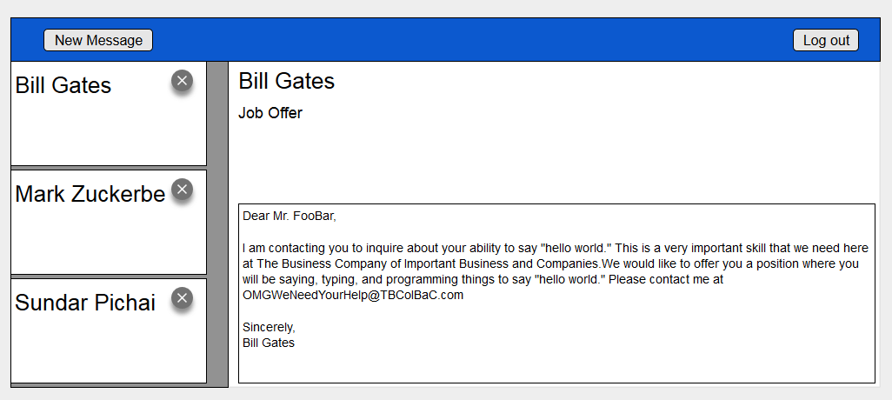

# Requirements Traceability Matrix (RTM)

|  |  |  |  |  |  |
| --- | --- | --- | --- | --- | --- |
| **Entry**  **#** | **System Specification text** | **Type** | **Build** | **Use Case Name** | **Category** |
| 1 | The Adept Mail Server shall store user e-mails in a database. | SW | 1 | Send Email, Edit Emails | Server |
| 2 | The Adept Mail Server shall move user e-mails between user-designated mailboxes upon an authenticated request from that user. | SW | 2 | Edit Folders | Server |
| 3 | The Adept Mail Server shall delete user-designated e-mails from its database upon an authenticated request from that user. | SW | 2 | Delete Emails | Server |
| 4 | The Adept Mail Server shall serve user data when authenticated requests are received from the Adept Mail Client via a minimally compliant IMAP protocol. | SW | 1 | Serve Updates | Server |
| 5 | The Adept Mail Server shall send user emails from other Adept Mail Servers upon an authenticated request from that user via a minimally compliant SMTP protocol. | SW | 2 | Send Email, Send External Email | Server |
| 6 | The Adept Mail Server shall receive user emails from other Adept Mail Servers via a minimally compliant SMTP protocol. | SW | 2 | Receive Email | Server |
| 7 | The Adept Mail Server shall encrypt all incoming and outgoing connections using the TLS 1.2 standard. | SW | 1 | Receive Email, Send External Email, Serve Updates, Edit Emails, Edit Folders, Authenticate | Server |
| 8 | The Adept Mail Server shall support multiple concurrent connections. |  | 1 | Receive Email, Serve Updates, Edit Emails, Edit folders | Server |
| 9 | The Adept Mail Client shall request user email data from the Adept Mail Server via a minimally compliant IMAP protocol. | SW | 1 | Request Update | Client |
| 10 | The Adept Mail Client shall store user email data locally in a local database. | SW | 1 | Request Update | Client |
| 11 | The Adept Mail Client shall send user emails to the Adept Mail Server via a minimally compliant SMTP protocol. | SW | 1 | Send Email | Client |
| 12 | The Adept Mail Client shall provide a graphical user interface to allow users to generate requests and view their emails. | SW | 2 | Authenticate, view Email, Manage Emails, Manage Folders | Client |
| 13 | The Adept Mail Client shall require local authentication from any user before executing local requests. | SW | 1 | Authenticate | Client |
| 14 | The Adept Mail Client shall provide remote authentication to the Adept Mail Server prior to executing any requests. | SW | 1 | Manage Emails, Manage Folders | Client |
| 15 | The Adept Mail Client shall locally encrypt and decrypt the subject and body of every email it sends and receives, respectively, using symmetric-key block encryption based on a user provided password. | SW | 2 | Request Update | Client |

# Use cases and Interaction Diagrams

3.1. Use Case Diagram

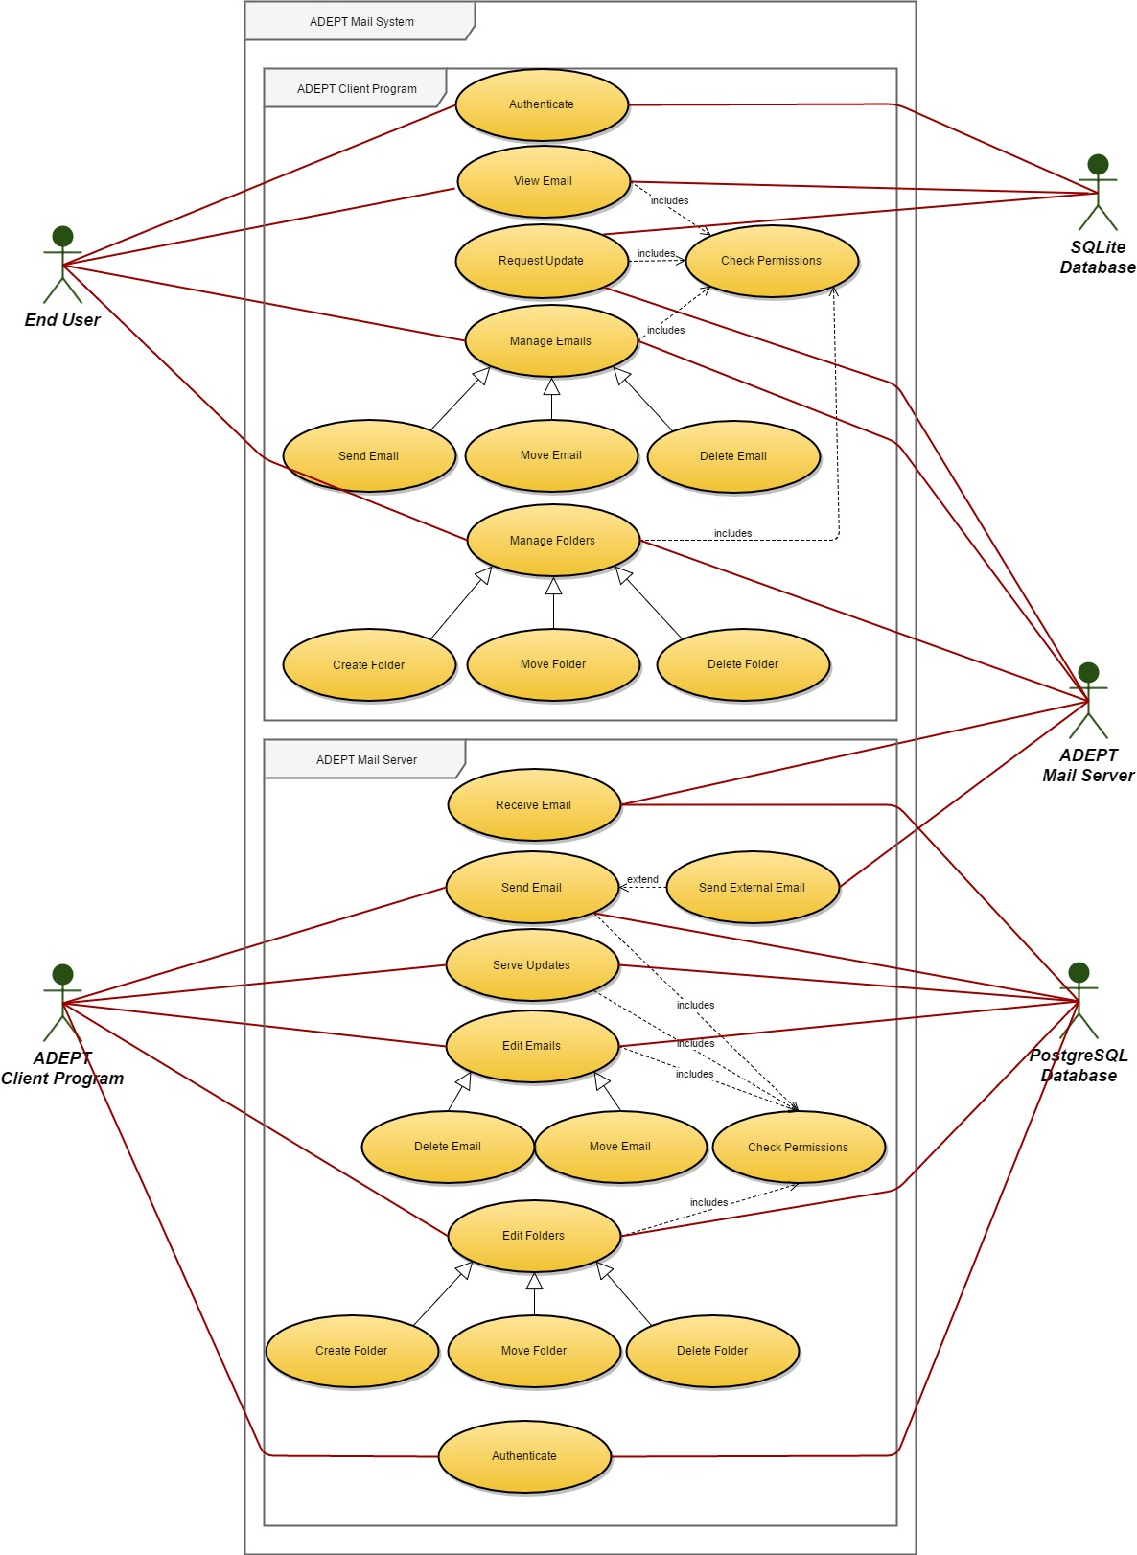

**3.2. Interaction Diagrams**

**3.2.1. ADEPT Client Program Interaction Diagrams**

3.2.1.1. Authenticate

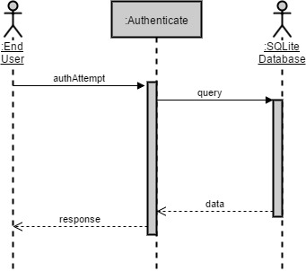

3.2.1.2. View Email

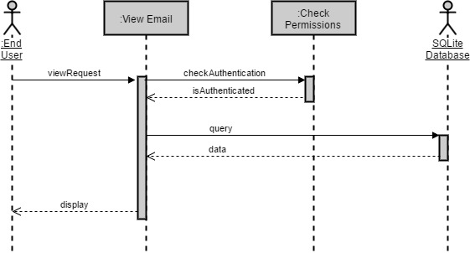

3.2.1.3. Request Update

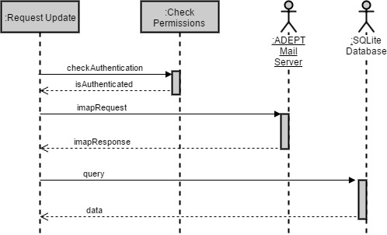

3.2.1.4. Manage Emails

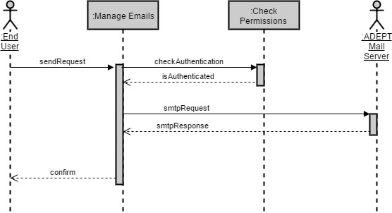

3.2.1.5. Manage Folders

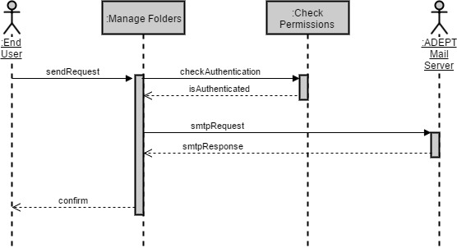

3.2.2. ADEPT Mail Server Interaction Diagrams

3.2.2.1. Authenticate

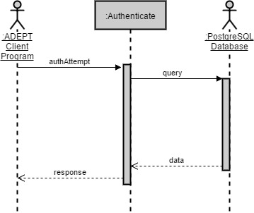

3.2.2.2. Receive Email

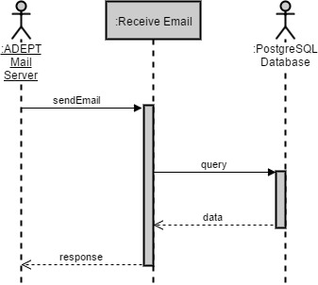

3.2.2.3. Send Email

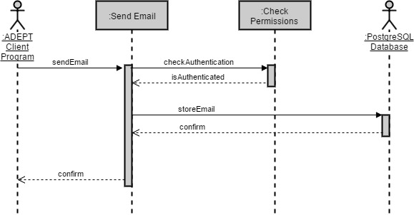

3.2.2.4. Send External Email

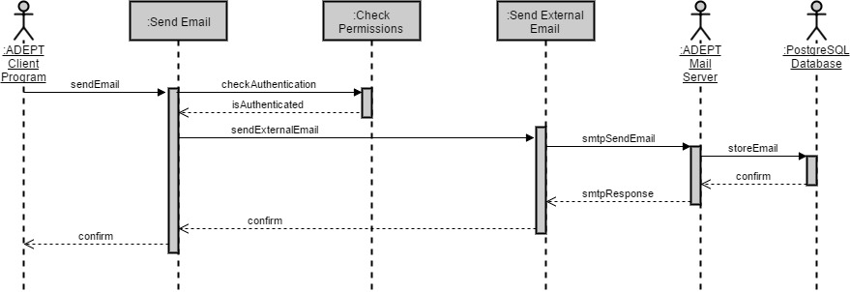

3.2.2.5. Serve Updates

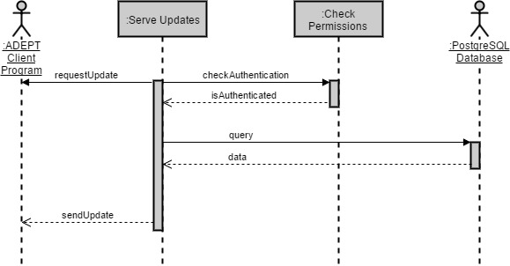

3.2.2.6. Edit Emails

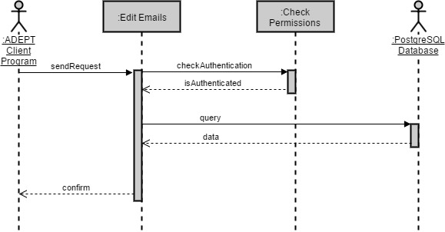

3.2.2.7. Edit Folders

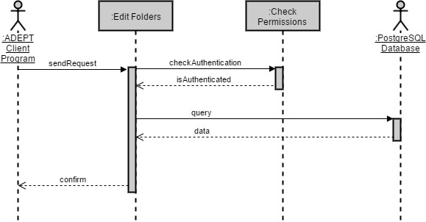

# Function Point Cost Analysis

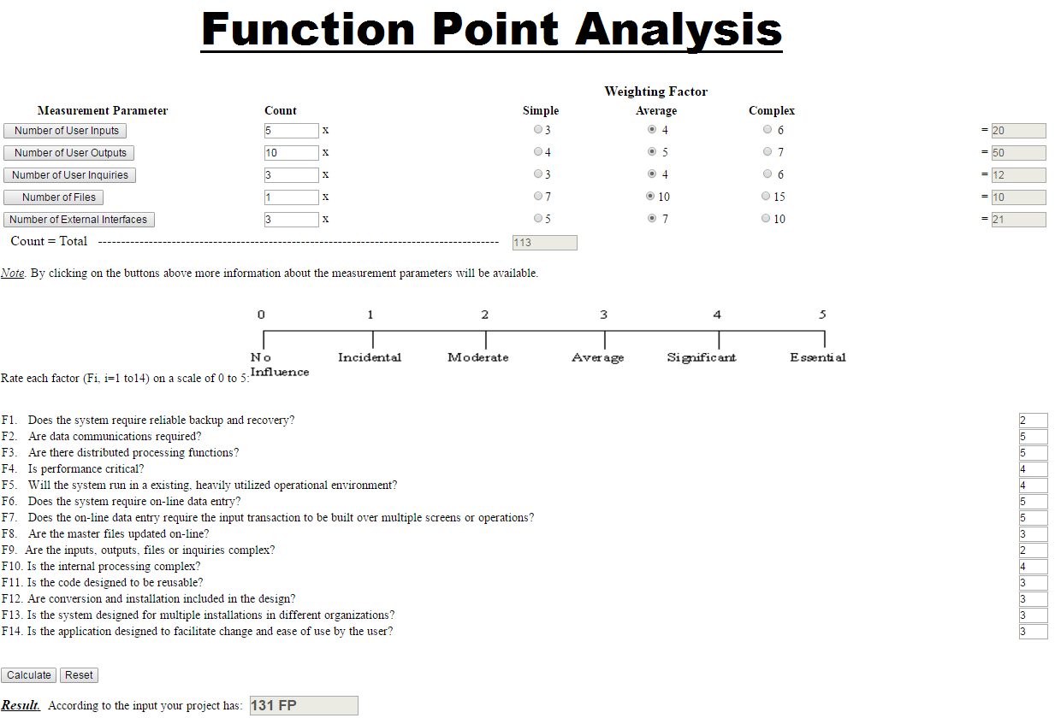

# Database

1. Updated WSD

|  |  |
| --- | --- |
| **Name** | **Role** |
| **Amani Konduru** | Project manager and tester, Document handler, Java Programmer, Database Structure (PostgresSQL schemas) |
| **Benjamin Garber (Daniel)** | Developer and programmer, Servers, Java Programmer |
| **Edward Bull** | Programmer and tester, Java Programmer, GUI tester |
| **Paul David Utesch** | Developer and programmer, Java Programmer |

# Gantt Chart

|  |  |  |  |  |
| --- | --- | --- | --- | --- |
| Create V1 Stories | S-01001 | Ed Bull,akonduru | Done | 1 |
| Document 2 - Requirements Elicitation | S-01017 | akonduru | Done | 1 |
| Learn how to use VersionOne | S-01022 | Ed Bull,bgarber,akonduru | Done | 1 |
| Set up group Github | S-01018 | Ed Bull | Done | 1 |
| Plan Server Database And Write CreateTables SQL Script | S-01019 | Putesch,akonduru | Future | 1 |
| Set up PostgresSQL test server | S-01009 | akonduru | In Progress | 1 |
| Implement Test Database | S-01020 | akonduru | Future | 1 |
| Server ServerController | S-01002 | Ed Bull | In Progress | 1 |
| Server SmtpServer | S-01003 | Ed Bull | In Progress | 1 |
| Server ImapServer | S-01004 | Ed Bull | In Progress | 1 |
| Server SmtpConnection | S-01005 | Ed Bull | In Progress | 1 |
| Server ImapConnection | S-01006 | Ed Bull | In Progress | 1 |
| Server CmdProcessor | S-01007 | bgarber | In Progress | 1 |
| Server QueryGenerator | S-01008 |  | Future | 1 |
| Server SmtpClient | S-01021 |  | Future | 1 |
| Document 2 Title Page | S-01037 | akonduru | Done | 1 |
| Document 2 Problem Statements | S-01038 | Ed Bull | Done | 1 |
| Document 2 RTM | S-01039 | Ed Bull | Done | 1 |
| Document 2 WSD | S-01040 | akonduru | Done | 1 |
| Document 2 Gantt | S-01041 | akonduru | Done | 1 |
| Document 2 Dictionary | S-01042 | Ed Bull,bgarber | Done | 1 |
| Set up PostgresSQL test server | S-01043 | akonduru | In Progress | 2 |
| Implement Test Database | S-01044 | akonduru | Future | 2 |
| Server ServerController | S-01045 | Ed Bull | In Progress | 2 |
| Server SmtpServer | S-01046 | Ed Bull | In Progress | 2 |
| Server ImapServer | S-01047 | Ed Bull | In Progress | 2 |
| Server SmtpConnection | S-01048 | Ed Bull | In Progress | 2 |
| Server ImapConnection | S-01049 | Ed Bull | In Progress | 2 |
| Server CmdProcessor | S-01050 | bgarber | In Progress | 2 |
| Server QueryGenerator | S-01051 |  | Future | 2 |
| Server SmtpClient | S-01052 |  | Future | 2 |
| Collate Document 3 | S-01024 | akonduru | In Progress | 2 |
| Document 3 Title Page | S-01025 | akonduru | Accepted | 2 |
| Document 3 RTM (5 columns) | S-01027 | Ed Bull | Accepted | 2 |
| Document 3 Use Cases and Int. Diagrams | S-01028 | Ed Bull | Done | 2 |
| Document 3 Function Point Analysis | S-01029 | bgarber | Done | 2 |
| Document 3 Database To Be Used | S-01030 | akonduru | Future | 2 |
| Document 3 Updated WSD | S-01031 | akonduru | Done | 2 |
| Document 3 Updated Gantt Chart | S-01032 | Ed Bull | In Progress | 2 |
| Document 3 Dictionary | S-01033 | Ed Bull | Accepted | 2 |
| Document 3 Use Cases Rationale | S-01034 | Ed Bull | Done | 2 |
| Document 3 horizontal prototype | S-01035 | Putesch | In Progress | 2 |

# Glossary

1. **Encryption:** the process of converting data into a code, to prevent unauthorized access. Encryption is the process of transforming data into an unreadable, encrypted form. The transformation is done using one of several cryptographic algorithms that leverage computationally difficult mathematical problems to make reversing the transformation difficult if not effectively impossible
2. **Symmetric Encryption**: Symmetric Encryption uses a key or set of keys to both encrypt and decrypt data. If data is to be shared between two parties, they must both have the key or keys to decrypt or encrypt the data.
3. **Asymmetric Encryption:** Asymmetric Encryption, also known as Public Key Encryption, is a type of encryption where anyone in possession of a public key can encrypt a message. That message can then only be decrypted with a private key. This method is often used for identity authentication because it is computationally expensive. Once authentication is completed, communications will then often transition into symmetric encryption after generating a symmetric encryption key.
4. **End to End Encryptio**n: Only the communicating users can read the messages.
5. **SSL/TLS (Secure Sockets Layer / Transport Layer Protocol):** TLS and the now- deprecated SSL it is based on are network security protocols meant to secure client-server connections using both symmetric encryption for data transfer and asymmetric encryption for identity authentication. While there are many options that can be set in an SSL/TLS session, the foundation of the protocols lie in using encryption to authenticate the identities of the connected parties and to secure the privacy of the data transferred between them.
6. **Server:** a server program awaits and fulfills requests from client programs, which may be running in the same or different computers.
7. **Client:** requesting program or user.
8. **Socket:** Is one endpoint of a two-way communication link between two programs running on the network. A socket is bound to a port number so that the TCP layer can identify the application that data is destined to be sent to.
9. **SMTP protocol:** Simple Mail Transfer Protocol. It is an Internet standard for electronic mail (email) transmission. SMTP was first defined by RFC 821 and updated in RFC 5321.
10. **IMAP protocol:** Internet Message Access Protocol. Itis an Internet standard protocol used by e-mail clients to retrieve e-mail messages from a mail server over a TCP/IP connection. IMAP is defined by RFC 3501.
11. **TCP/IP :** IP (Internet Protocol) is the basic communication language or protocol of the ozInternet. It can also be used as a communications protocol in a private network (either an intranet or an extranet). TCP (Transmission Control Protocol) is layered on top of IP to provide certain network control and data validation features for many internet communications.

# Rational for Use cases

9.1. ADEPT Client Program Use Case Rationales

9.1.1. Authenticate

The Authenticate use case is necessary for any client requests to be authenticated. Without authentication, the Check Permissions use case would always return false and requests would not be allowed to succeed. This affects RTM entry #13.

|  |  |
| --- | --- |
| Use Case Name | Authenticate |
| Participating Actors: | End User, SQLite Database |
| Flow Of Events: | 1. End User makes an authorization attempt. 2. The client queries the SQLite Database with the End User's credentials. 3. The client responds to the End User's authorization attempt. |
| Entry Condition: | The End User has provided authorization credentials. |
| Exit Condition: | The authorization attempt is either approved or denied. |
| Quality Requirements: |  |

9.1.2. Request Update

The Request Update use case is necessary for the client to retrieve emails from the server. This affects RTM entries #8, #10, and #15.

|  |  |
| --- | --- |
| Use Case Name | Request Update |
| Participating Actors: | ADEPT Mail Server, SQLite Database |
| Flow Of Events: | 1. The client checks its authentication. 2. The client requests and receives a mailbox update from the ADEPT Mail Server over an IMAP connection. 3. The client stores the new mailbox information in the SQLite Database. |
| Entry Condition: | The client will perform this action periodically. |
| Exit Condition: | The SQLite database responds with a success or failure of the update. |
| Quality Requirements: | 1. Email information should be symmetrically encrypted prior to local storage using the End User's credentials as a key. 2. The connection is secured over TLS. |

9.1.3. View Email

The View Email use case is necessary for an End User to use the client to view particular emails. This affects RTM entry #12.

|  |  |
| --- | --- |
| Use Case Name | View Email |
| Participating Actors: | End User, SQLite Database |
| Flow Of Events: | 1. End User makes a request to view an email. 2. The client checks its authentication. 3. The client queries the SQLite Database for the email information. 4. The client displays the email to the End User. |
| Entry Condition: | The End User requests a view of an email. |
| Exit Condition: | The email is displayed to the End User. |
| Quality Requirements: | 1. Email information should be symmetrically decrypted prior to viewing using the End User's credentials as a key. |

9.1.4. Manage Emails

The Manage Emails use case is necessary for the capability to send, move, and delete emails. This affects RTM entries #11, #12, and #14.

|  |  |
| --- | --- |
| Use Case Name | Manage Emails |
| Participating Actors: | End User, ADEPT Mail Server |
| Flow Of Events: | 1. End User makes a request to send, move, or delete an email. 2. The client checks its authentication. 3. The client sends the request to ADEPT Mail Server over an SMTP connection and receives a response. 4. The client displays the status of the request to the End User. |
| Entry Condition: | The End User requests an email be sent, moved, or deleted. |
| Exit Condition: | The success or failure of the request is displayed to the End User. |
| Quality Requirements: | 1. The connection is secured over TLS. 2. This use case is inherited by the Send Email, Move Email, and Delete Email use cases. Each use case would send a specific request for steps #1 and #3. |

10.1.5. Manage Folders

The Manage Folders use case is necessary for the capability to create, move, or delete mailbox folders. This affects RTM entries #12 and #14.

|  |  |
| --- | --- |
| Use Case Name | Manage Folders |
| Participating Actors: | End User, ADEPT Mail Server |
| Flow Of Events: | 1. End User makes a request to create, move, or delete a mailbox folder. 2. The client checks its authentication. 3. The client sends the request to ADEPT Mail Server over an SMTP connection and receives a response. 4. The client displays the status of the request to the End User. |
| Entry Condition: | The End User requests that a mailbox folder be created, moved, or deleted. |
| Exit Condition: | The success of failure of the request is displayed to the End User. |
| Quality Requirements: | 1. The connection is secured over TLS. 2. This use case is inherited by Create Folder, Move Folder, and Delete Folder use cases. Each use case would send a specific request for steps #1 and #3. |

10.1.6. Check Permissions

The Check Permissions use case is required by any other use case that needs to authenticate its actions prior to completion. This affects RTM entries #9, #10, #11, #12, #14, and #15.

|  |  |
| --- | --- |
| Use Case Name | Check Permissions |
| Participating Actors: | SQLite Database |
| Flow Of Events: | 1. The client queries the SQLite Database for the credentials of the current user. 2. The client compares its current credentials with those from the database and returns the result. |
| Entry Condition: | The client requests an authentication check. |
| Exit Condition: | The client is either authenticated or not authenticated. |
| Quality Requirements: | 1. The Check Permissions use case is included by the Request Update, Manage Emails, and Manage Folders use cases. |

10.2. ADEPT Mail Server Use Case Rationales

10.2.1. Authenticate

The Authenticate use case is necessary for any client requests to be authenticated. Without authentication, the Check Permissions use case would always return false and requests would not be allowed to succeed. This affects RTM entry #1, #2, #3, #4, #5, #7, and #8.

|  |  |
| --- | --- |
| Use Case Name | Authenticate |
| Participating Actors: | ADEPT Client Program, PostgreSQL Database |
| Flow Of Events: | 1. The ADEPT Client Program makes an authentication attempt. 2. The server queries the PostgreSQL database with the credentials provided by the ADEPT Client Program. 3. The server responds to the ADEPT Client Program's request. |
| Entry Condition: | The ADEPT Client Program makes an authentication attempt. |
| Exit Condition: | The ADEPT Mail Server responds with an approval or denial of the attempt. |
| Quality Requirements: | 1. The connection is secured over TLS. |

10.2.2. Receive Email

The Receive Email use case is necessary for the ADEPT Mail Server to receive an incoming email from another ADEPT Mail Server.

|  |  |
| --- | --- |
| Use Case Name | Receive Email |
| Participating Actors: | ADEPT Mail Server, PostgreSQL Database |
| Flow Of Events: | 1. An external ADEPT Mail Server sends an email to the server. 2. The server queries the PostgreSQL Database to store the email information and receives a confirmation. 3. The server responds to the external ADEPT Mail Server with the status of its request. |
| Entry Condition: | An external ADEPT Mail Server sends an email to the server. |
| Exit Condition: | The server responds with the success or failure of the request. |
| Quality Requirements: | 1. The connection is secured over TLS. |

10.2.3. Send Email

The Send Email use case is necessary for the ADEPT Mail Server to send emails from one hosted client to another hosted client. This affects RTM entries #1, #5, #7, and #8.

|  |  |
| --- | --- |
| Use Case Name | Send Email |
| Participating Actors: | ADEPT Client Program, PostgreSQL Database |
| Flow Of Events: | 1. ADEPT Client Program sends an e-mail to the server over SMTP. 2. The ADEPT Mail Server checks the authentication of the ADEPT Client Program. 3. The ADEPT Mail Server queries the PostgreSQL database with the email information for storage and receives a response. 4. The ADEPT Mail Server responds to the ADEPT Client Program over SMTP. |
| Entry Condition: | ADEPT Client program sends an e-mail to the server over SMTP. |
| Exit Condition: | The server responds to the ADEPT Client Program over SMTP. |
| Quality Requirements: | 1. The connection is secured over TLS. |

10.2.4. Send External Email

The Send External Email use case is necessary for the ADEPT Mail Server to send emails from a hosted client to a client hosted on another ADEPT Mail Server. This affects RTM entries #5, #7, and #8.

|  |  |
| --- | --- |
| Use Case Name | Send External Email |
| Participating Actors: | ADEPT Client Program, ADEPT Mail Server (external), PostgreSQL Database (external) |
| Flow Of Events: | 1. ADEPT Client Program sends an e-mail to the server over SMTP. 2. The ADEPT Mail Server checks the authentication of the ADEPT Client Program. 3. The ADEPT Mail Server sends the email to the external ADEPT Mail Server over SMTP. 4. The external ADEPT Mail Server stores the e-mail in its PostgreSQL Database and responds over SMTP. 5. The ADEPT Mail Server responds to the client over SMTP. |
| Entry Condition: | ADEPT Client program sends an e-mail to the server over SMTP. |
| Exit Condition: | The server responds to the ADEPT Client Program over SMTP. |
| Quality Requirements: | 1. All connections are secured over TLS. |

10.2.5. Serve Update

The Serve Update use case is necessary for the ADEPT Mail Server to respond to requests for mailbox updates. This affects RTM entries #4, #7, and #8.

|  |  |
| --- | --- |
| Use Case Name | Serve Update |
| Participating Actors: | ADEPT Client Program, PostgreSQL Database |
| Flow Of Events: | 1. ADEPT Client Program requests a mailbox update over IMAP. 2. The ADEPT Mail Server checks the authentication of the ADEPT Client Program. 3. The ADEPT Mail Server queries the PostgreSQL Database for the requested mailbox information. 4. The ADEPT Mail Server responds to the ADEPT Client Program over IMAP. |
| Entry Condition: | ADEPT Client Program requests a mailbox update over IMAP. |
| Exit Condition: | ADEPT Mail Server responds with a mailbox update or failure message over IMAP. |
| Quality Requirements: | 1. The connection is secured over TLS. |

10.2.6. Edit Emails

The Edit Emails use case is necessary for the ADEPT Mail Server to serve requests to delete or move emails. This affects RTM entries #1, #3, #7, and #8.

|  |  |
| --- | --- |
| Use Case Name | Edit Emails |
| Participating Actors: | ADEPT Client Program, PostgreSQL Database |
| Flow Of Events: | 1. ADEPT Client Program makes a request to send, move, or delete an email over SMTP. 2. The ADEPT Mail Server checks the authentication of the ADEPT Client Program. 3. The ADEPT Mail Server queries the PostgreSQL Database to fulfill the specified request and receives a response. 4. The ADEPT Mail Server responds to the ADEPT Client Program with a success or failure message over SMTP. |
| Entry Condition: | ADEPT Client Program makes a request to send, move, or delete an email over SMTP. |
| Exit Condition: | The ADEPT Mail Server responds to the ADEPT Client Program with a success or failure message over SMTP. |
| Quality Requirements: | 1. The connection is secured over TLS. 2. This use case is inherited by the Delete Email and Move Email use cases. Each use case would send a specific request for steps #1 and #3. |

10.2.7. Edit Folders

The Edit Folder use case is necessary for the ADEPT Mail Server to serve requests to create, delete, or move folders. This affects RTM entries #2, #7, #8, and #8.

|  |  |
| --- | --- |
| Use Case Name | Edit Folders |
| Participating Actors: | ADEPT Client Program, PostgreSQL Database |
| Flow Of Events: | 1. ADEPT Client Program makes a request to create, move, or delete a mailbox folder over SMTP. 2. The ADEPT Mail Server checks the authentication of the ADEPT Client Program. 3. The ADEPT Mail Server queries the PostgreSQL Database to fulfill the specified request and receives a response. 4. The ADEPT Mail Server responds to the ADEPT Client Program with a success or failure message over SMTP. |
| Entry Condition: | ADEPT Client Program makes a request to create, move, or delete a mailbox folder over SMTP. |
| Exit Condition: | The ADEPT Mail Server responds to the ADEPT Client Program with a success or failure message over SMTP. |
| Quality Requirements: | 1. The connection is secured over TLS. 2. This use case is inherited by the Create Folder, Move Folder and Delete Folder use cases. Each use case would send a specific request for steps #1 and #3. |

10.2.8. Check Permissions

|  |  |
| --- | --- |
| Use Case Name | Check Permissions |
| Participating Actors: | PostgreSQL Database |
| Flow Of Events: | 1. The server queries the PostgreSQL Database for the credentials of the current user. 2. The server compares the current credentials with those from the database and returns the result. |
| Entry Condition: | The server requests an authentication check. |
| Exit Condition: | The current transaction is either authenticated or not authenticated. |
| Quality Requirements: | The Check Permissions use case is included by the Send Email, Server Updates, Edit Emails, and Edit Folders use cases. |