5. Class Diagrams

5.1 Server Class Diagram

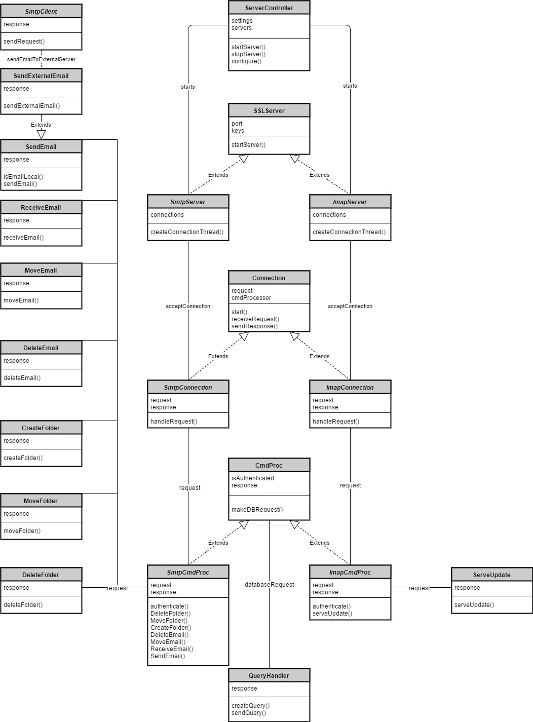

5.2 Client Class Diagram

