Document #3 System Analysis and Design DUE: 21.02.2017 midnight

4. Use cases and Interaction Diagrams- example as per given in class.

4.1. Use Case Diagram

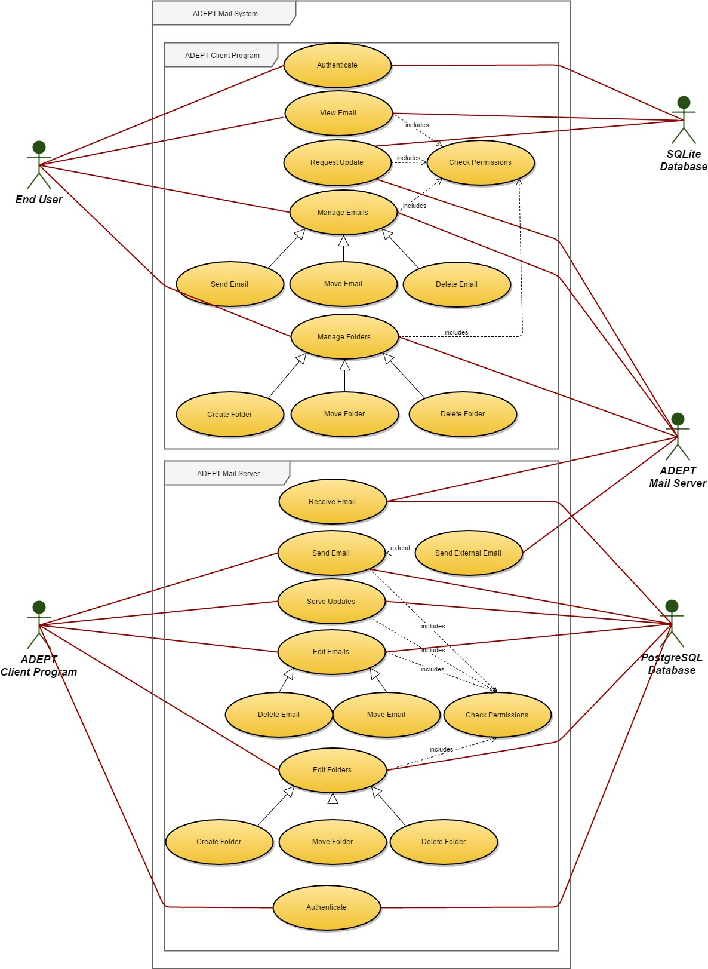

4.2. Interaction Diagrams

4.2.1. ADEPT Client Program Interaction Diagrams

4.2.1.1. Authenticate

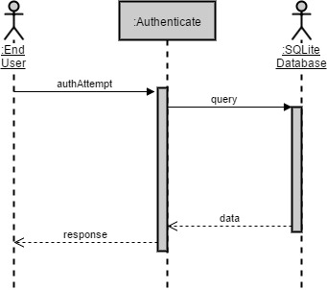

4.2.1.2. View Email

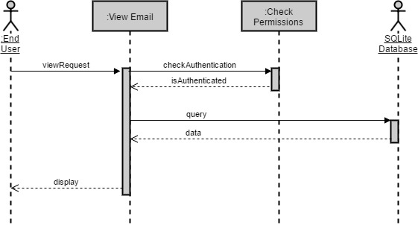

4.2.1.3. Request Update

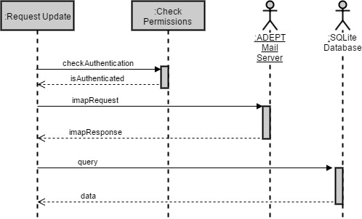

4.2.1.4. Manage Emails

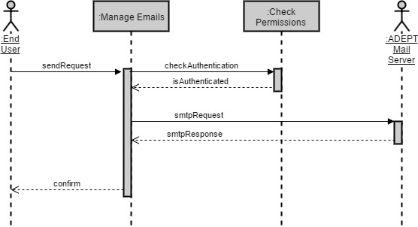

4.2.1.5. Manage Folders

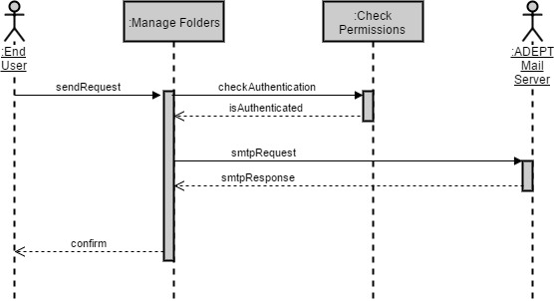

4.2.2. ADEPT Mail Server Interaction Diagrams

4.2.2.1. Authenticate

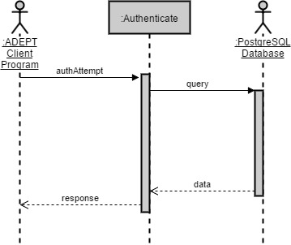

4.2.2.2. Receive Email

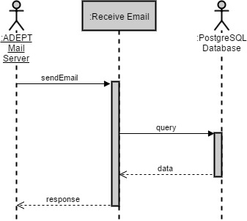

4.2.2.3. Send Email

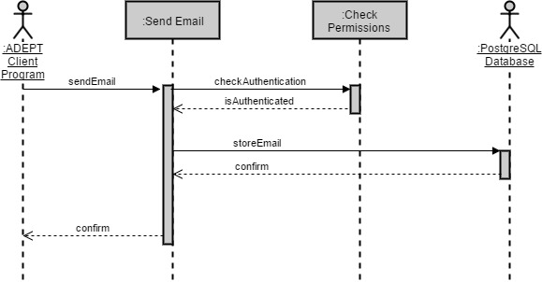

4.2.2.4. Send External Email

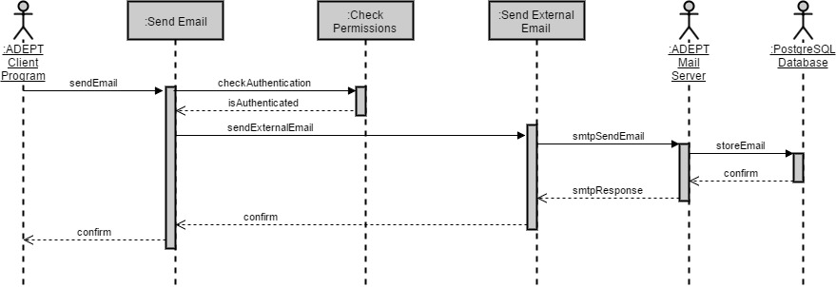

4.2.2.5. Serve Updates

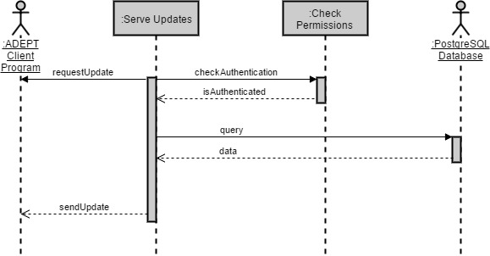

4.2.2.6. Edit Emails

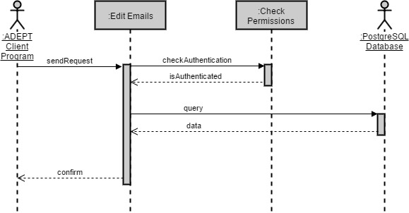

4.2.2.7. Edit Folders

