### 

### Software Engineering- CSC 4350 Spring 2017

An encryption and decryption system for message communication

**ADEPT**

**A**mani Konduru

Benjamin Garber (**D**aniel)

**E**dward Bull

**P**aul David Utesch

**T**eam

**3/24/2017**

Table of Contents

Software Engineering- CSC 4350 Spring 2017 1

I. Requirements Traceability Matrix (RTM) 3

II. Test Cases 4

III. Construction Cost Model (COCOMO) 6

IV. Updated WSD 7

VI. Glossary 10

VII. Rational for Test Cases 11

# Requirements Traceability Matrix (RTM)

|  |  |  |  |  |  |
| --- | --- | --- | --- | --- | --- |
| Entry  # | System Specification text | Type | Build | Use Case Name | Category |
| 1 | The Adept Mail Server shall store user e-mails in a database. | SW | 1 | Send Email, Edit Emails | Server |
| 2 | The Adept Mail Server shall move user e-mails between user-designated mailboxes upon an authenticated request from that user. | SW | 2 | Edit Folders | Server |
| 3 | The Adept Mail Server shall delete user-designated e-mails from its database upon an authenticated request from that user. | SW | 2 | Delete Emails | Server |
| 4 | The Adept Mail Server shall serve user data when authenticated requests are received from the Adept Mail Client via a minimally compliant IMAP protocol. | SW | 1 | Serve Updates | Server |
| 5 | The Adept Mail Server shall send user emails from other Adept Mail Servers upon an authenticated request from that user via a minimally compliant SMTP protocol. | SW | 2 | Send Email, Send External Email | Server |
| 6 | The Adept Mail Server shall receive user emails from other Adept Mail Servers via a minimally compliant SMTP protocol. | SW | 2 | Receive Email | Server |
| 7 | The Adept Mail Server shall encrypt all incoming and outgoing connections using the TLS 1.2 standard. | SW | 1 | Receive Email, Send External Email, Serve Updates, Edit Emails, Edit Folders, Authenticate | Server |
| 8 | The Adept Mail Server shall support multiple concurrent connections. |  | 1 | Receive Email, Serve Updates, Edit Emails, Edit folders | Server |
| 9 | The Adept Mail Client shall request user email data from the Adept Mail Server via a minimally compliant IMAP protocol. | SW | 1 | Request Update | Client |
| 10 | The Adept Mail Client shall store user email data locally in a local database. | SW | 1 | Request Update | Client |
| 11 | The Adept Mail Client shall send user emails to the Adept Mail Server via a minimally compliant SMTP protocol. | SW | 1 | Send Email | Client |
| 12 | The Adept Mail Client shall provide a graphical user interface to allow users to generate requests and view their emails. | SW | 2 | Authenticate, view Email, Manage Emails, Manage Folders | Client |
| 13 | The Adept Mail Client shall require local authentication from any user before executing local requests. | SW | 1 | Authenticate | Client |
| 14 | The Adept Mail Client shall provide remote authentication to the Adept Mail Server prior to executing any requests. | SW | 1 | Manage Emails, Manage Folders | Client |
| 15 | The Adept Mail Client shall locally encrypt and decrypt the subject and body of every email it sends and receives, respectively, using symmetric-key block encryption based on a user provided password. | SW | 2 | Request Update | Client |

# Test Cases

|  |  |
| --- | --- |
| Test-case Identifier | ServerConnectivity |
| Feature | RTM: 4, 5, 7, 8 |
| Feature Pass/Fail Criteria | The test passes if each request receives a properly formed protocol compliant response. |
| Means of Control | IMAP, SMTP direct connections |
| Data | A series of protocol specific commands (both well-formed and mal-formed) and their expected protocol-specific responses. |
| Test Procedure | Using an automated script, the tester will create a series of concurrent connections to the server on both its IMAP and SMTP interfaces. Once each connection is established, a series of commands will be sent and the responses logged in a flat file. The script will then compare each command with its expected response. The tester will verify. |
| Special Requirements | An authenticated account on the test server. |

|  |  |
| --- | --- |
| Test-case Identifier | SendFunctionality |
| Feature | RTM: 1, 5, 7, 10, 11, 12, 13, 14, 15 |
| Feature Pass/Fail Criteria | The test passes if emails and their associated mailboxes are sent from the client, received by the server, and stored in the database. |
| Means of Control | Client UI |
| Data | Placeholder content and names will be used for both the email and mailboxes. |
| Test Procedure | Using an authenticated account, the tester will use the client UI to send an e-mail to another authenticated account on the same server. |
| Special Requirements | Two authenticated accounts on the test server. |

|  |  |
| --- | --- |
| Test-case Identifier | ModifyFunctionality |
| Feature | RTM: 1, 2, 3, 7, 10, 12, 13, 14, 15 |
| Feature Pass/Fail Criteria | The test passes if the e-mail is moved from one mailbox to another mailbox, and then deleted. |
| Means of Control | Client UI |
| Data | Placeholder content and names will be used for both the email and mailboxes. |
| Test Procedure | Using an authenticated account, the tester will use the client UI to move an email from one mailbox to another mailbox. The tester will confirm the move, then delete the e-mail. The tester will confirm the deletion. |
| Special Requirements | An authenticated account on the test server. |

|  |  |
| --- | --- |
| Test-case Identifier | ExternalSendFunctionality |
| Feature | RTM: 1, 5, 6, 7, 10, 11, 12, 13, 14, 15 |
| Feature Pass/Fail Criteria | The test passes if the e-mail is sent and stored from the first server to the second server. |
| Means of Control | Client UI |
| Data | Placeholder content and names will be used for both the email and mailboxes. |
| Test Procedure | Using two test servers, the tester will use the client UI to send an e-mail to the first test server. The e-mail address will not be present on the first test server, so it will be forwarded to the second. The tester will then log in with the target account on the second server and confirm the e-mail was received. |
| Special Requirements | An authenticated account on test server 1. An authenticated account on test server 2. |

|  |  |
| --- | --- |
| Test-case Identifier | UpdateFunctionality |
| Feature | RTM: 1, 7, 9, 10, 12, 13, 14, 15 |
| Feature Pass/Fail Criteria | The test passes if the server receives the update request from the client, sends back e-mail data, and the client updates its local database with that data. |
| Means of Control | Client UI |
| Data | Placeholder content and names will be used for both the email and mailboxes. |
| Test Procedure | Using an authenticated account, the tester will use the client UI to request a mailbox update from the server. Once the update is complete, the tester will verify that all data has transferred correctly. |
| Special Requirements | An authenticated account on the test server. |

# Construction Cost Model (COCOMO)

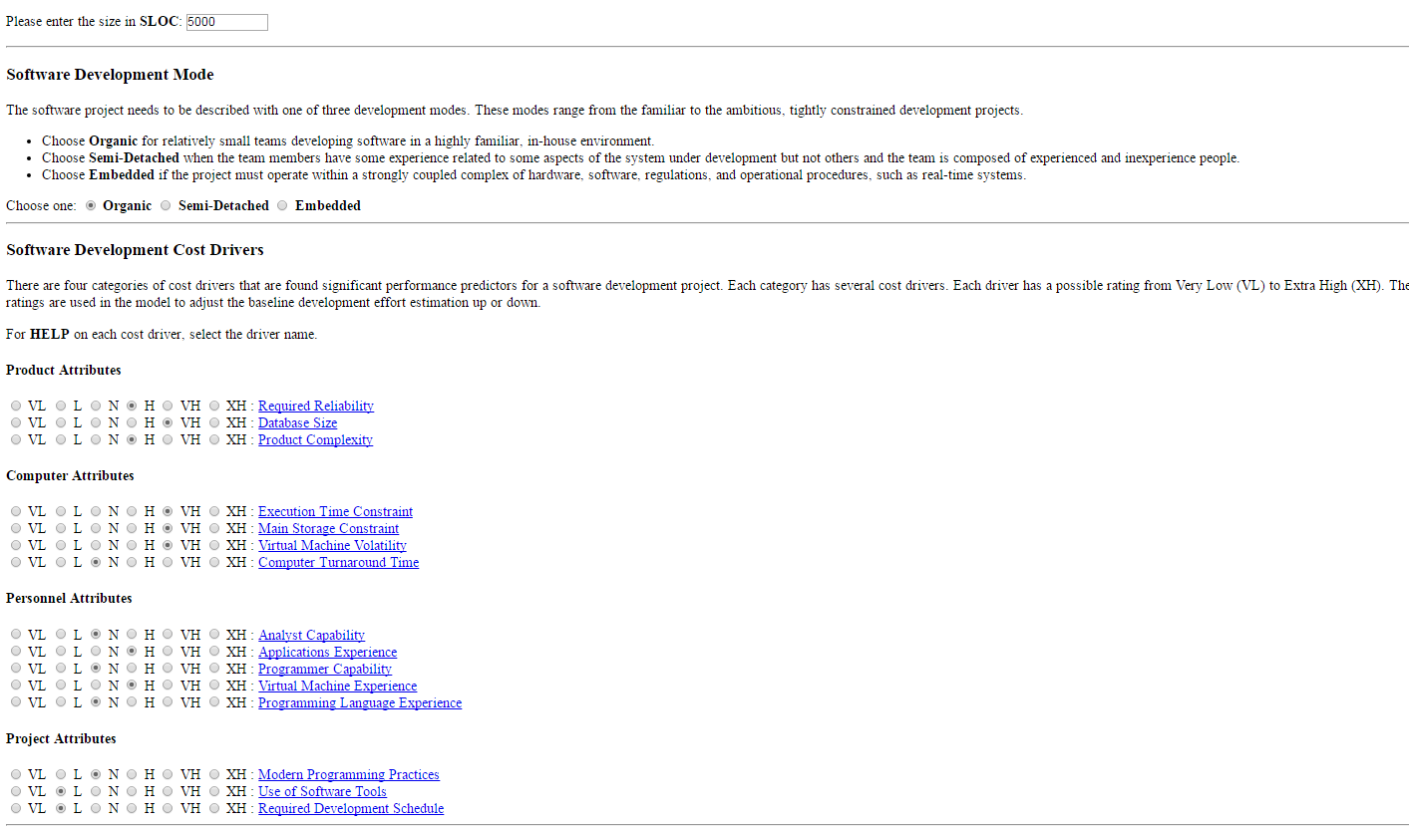

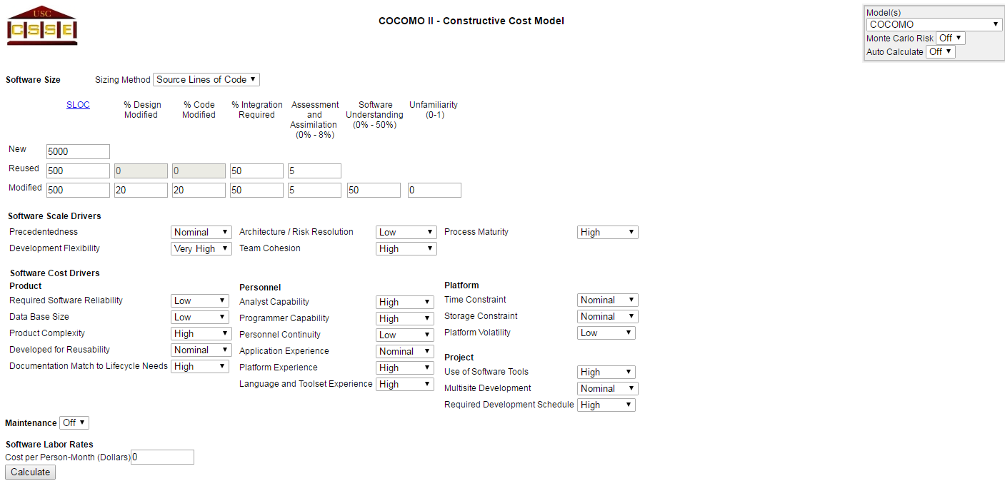

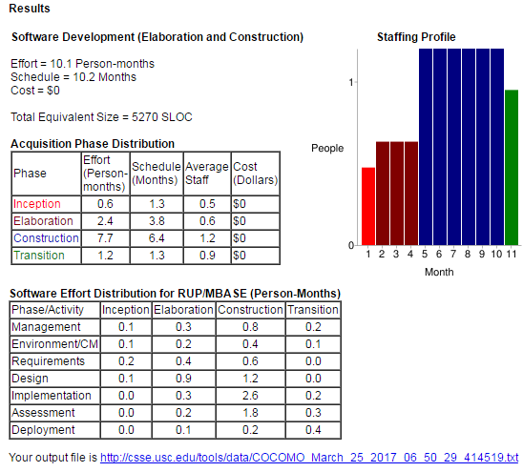

# Updated WSD

|  |  |
| --- | --- |
| **Name** | **Role** |
| **Amani Konduru** | Project manager and tester, Document handler, Java Programmer, Database Structure (PostgresSQL schemas) |
| **Benjamin Garber (Daniel)** | Developer and programmer, Servers, Java Programmer |
| **Edward Bull** | Programmer and tester, Java Programmer, GUI tester |
| **Paul David Utesch** | Developer and programmer, Java Programmer |

1. Gantt Chart

|  |  |  |  |  |
| --- | --- | --- | --- | --- |
| Create V1 Stories | S-01001 | Ed Bull,akonduru | Done | 1 |
| Document 2 - Requirements Elicitation | S-01017 | akonduru | Done | 1 |
| Learn how to use VersionOne | S-01022 | Ed Bull,bgarber,akonduru | Done | 1 |
| Set up group Github | S-01018 | Ed Bull | Done | 1 |
| Plan Server Database And Write CreateTables SQL Script | S-01019 | Putesch,akonduru | Future | 1 |
| Set up PostgresSQL test server | S-01009 | akonduru | In Progress | 1 |
| Implement Test Database | S-01020 | akonduru | Future | 1 |
| Server ServerController | S-01002 | Ed Bull | In Progress | 1 |
| Server SmtpServer | S-01003 | Ed Bull | In Progress | 1 |
| Server ImapServer | S-01004 | Ed Bull | In Progress | 1 |
| Server SmtpConnection | S-01005 | Ed Bull | In Progress | 1 |
| Server ImapConnection | S-01006 | Ed Bull | In Progress | 1 |
| Server CmdProcessor | S-01007 | bgarber | In Progress | 1 |
| Server QueryGenerator | S-01008 |  | Future | 1 |
| Server SmtpClient | S-01021 |  | Future | 1 |
| Document 2 Title Page | S-01037 | akonduru | Done | 1 |
| Document 2 Problem Statements | S-01038 | Ed Bull | Done | 1 |
| Document 2 RTM | S-01039 | Ed Bull | Done | 1 |
| Document 2 WSD | S-01040 | akonduru | Done | 1 |
| Document 2 Gantt | S-01041 | akonduru | Done | 1 |
| Document 2 Dictionary | S-01042 | Ed Bull,bgarber | Done | 1 |
| Set up PostgresSQL test server | S-01043 | akonduru | In Progress | 2 |
| Implement Test Database | S-01044 | akonduru | Future | 2 |
| Server ServerController | S-01045 | Ed Bull | In Progress | 2 |
| Server SmtpServer | S-01046 | Ed Bull | In Progress | 2 |
| Server ImapServer | S-01047 | Ed Bull | In Progress | 2 |
| Server SmtpConnection | S-01048 | Ed Bull | In Progress | 2 |
| Server ImapConnection | S-01049 | Ed Bull | In Progress | 2 |
| Server CmdProcessor | S-01050 | bgarber | In Progress | 2 |
| Server QueryGenerator | S-01051 |  | Future | 2 |
| Server SmtpClient | S-01052 |  | Future | 2 |
| Collate Document 3 | S-01024 | akonduru | In Progress | 2 |
| Document 3 Title Page | S-01025 | akonduru | Accepted | 2 |
| Document 3 RTM (5 columns) | S-01027 | Ed Bull | Accepted | 2 |
| Document 3 Use Cases and Int. Diagrams | S-01028 | Ed Bull | Done | 2 |
| Document 3 Function Point Analysis | S-01029 | bgarber | Done | 2 |
| Document 3 Database To Be Used | S-01030 | akonduru | Future | 2 |
| Document 3 Updated WSD | S-01031 | akonduru | Done | 2 |
| Document 3 Updated Gantt Chart | S-01032 | Ed Bull | In Progress | 2 |
| Document 3 Dictionary | S-01033 | Ed Bull | Accepted | 2 |
| Document 3 Use Cases Rationale | S-01034 | Ed Bull | Done | 2 |
| Document 3 horizontal prototype | S-01035 | Putesch | In Progress | 2 |
| Document 4 #2 | S-01063 | akonduru | Accepted | 2 |
| Document 4 #4 | S-01064 | Putesch | Accepted | 2 |
| Document 4 #5 | S-01065 | Ed Bull | Accepted | 2 |
| Document 4 #9 | S-01066 | Ed Bull,Putesch,akonduru | Accepted | 2 |
| Document 4 | S-01067 | Ed Bull,akonduru | Accepted | 2 |
| Document 6 #3 | S-01068 |  | In Progress | 2 |
| Document 6 #4 | S-01069 |  | In Progress | 2 |
| Document 6 #5 | S-01070 | bgarber | In Progress | 2 |
| Document 6 #9 | S-01071 |  | In Progress | 2 |

# 

# Glossary

1. **Encryption:** the process of converting data into a code, to prevent unauthorized access. Encryption is the process of transforming data into an unreadable, encrypted form. The transformation is done using one of several cryptographic algorithms that leverage computationally difficult mathematical problems to make reversing the transformation difficult if not effectively impossible
2. **Symmetric Encryption**: Symmetric Encryption uses a key or set of keys to both encrypt and decrypt data. If data is to be shared between two parties, they must both have the key or keys to decrypt or encrypt the data.
3. **Asymmetric Encryption:** Asymmetric Encryption, also known as Public Key Encryption, is a type of encryption where anyone in possession of a public key can encrypt a message. That message can then only be decrypted with a private key. This method is often used for identity authentication because it is computationally expensive. Once authentication is completed, communications will then often transition into symmetric encryption after generating a symmetric encryption key.
4. **End to End Encryptio**n: Only the communicating users can read the messages.
5. **SSL/TLS (Secure Sockets Layer / Transport Layer Protocol):** TLS and the now- deprecated SSL it is based on are network security protocols meant to secure client-server connections using both symmetric encryption for data transfer and asymmetric encryption for identity authentication. While there are many options that can be set in an SSL/TLS session, the foundation of the protocols lie in using encryption to authenticate the identities of the connected parties and to secure the privacy of the data transferred between them.
6. **Server:** a server program awaits and fulfills requests from client programs, which may be running in the same or different computers.
7. **Client:** requesting program or user.
8. **Socket:** Is one endpoint of a two-way communication link between two programs running on the network. A socket is bound to a port number so that the TCP layer can identify the application that data is destined to be sent to.
9. **SMTP protocol:** Simple Mail Transfer Protocol. It is an Internet standard for electronic mail (email) transmission. SMTP was first defined by RFC 821 and updated in RFC 5321.
10. **IMAP protocol:** Internet Message Access Protocol. Itis an Internet standard protocol used by e-mail clients to retrieve e-mail messages from a mail server over a TCP/IP connection. IMAP is defined by RFC 3501.
11. **TCP/IP :** IP (Internet Protocol) is the basic communication language or protocol of the ozInternet. It can also be used as a communications protocol in a private network (either an intranet or an extranet). TCP (Transmission Control Protocol) is layered on top of IP to provide certain network control and data validation features for many internet communications.

# Rational for Test Cases