**Exam II: Macroevolution & Phylogenetics (100 pts)**

Name: ____________________________

1. Question 1
   1. What’s (potentially) wrong with running a phylogenetic analysis with concatenated gene sequences (assume hybridization is not a major factor)? Identify the phenomenon that leads to a problem. (5 pts)
   2. Specify the conditions when this problem is expected to be most severe. (5 pts)
   3. Fill out a 5x5 variance-covariance matrix (**V**) for Brownian Motion given the phylogeny and assuming a value of (5 pts)

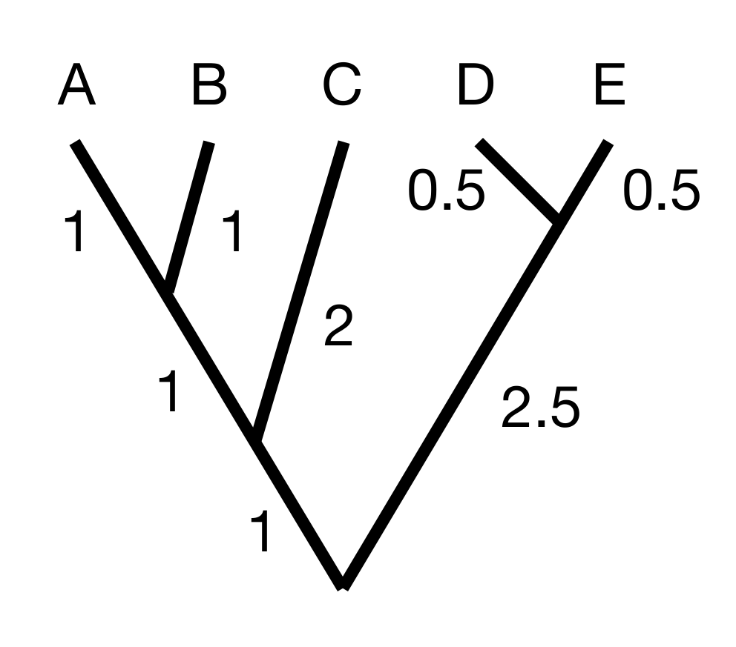  **V =**

* 1. Provide R code for how you would simulate continuous trait data for a single trait using this VCV matrix *without* *using a phylogenetics package*. (5 pts)

1. Compare and contrast traditional methods for time-scaling a phylogenetic tree estimated from molecular data using fossil calibrations against tip-dating methods using the fossilized birth death process. Include two figures (hand-drawn is fine) , one that explains how the fossil is incorporated into the model for node calibration and one that shows how it is incorporated using the FBD process.   
   (10 pts)

1. Consider the following 3 MCMC traces (4 pts):
   1. 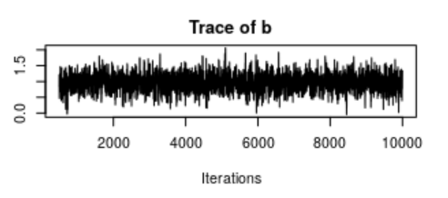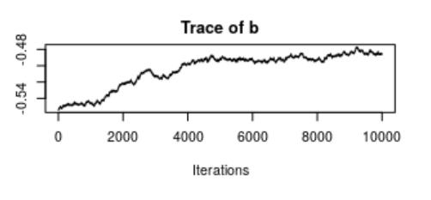

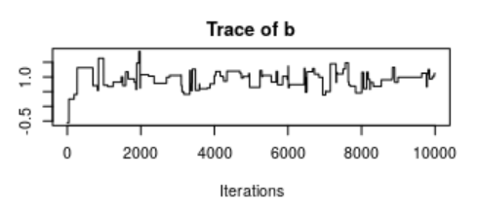

* 1. None of the above

Which of these traces is an MCMC that has too small a proposal distribution? ___

Which of these traces is an MCMC that has too large a proposal distribution? ___

Which of these traces are we sure has converged? ____

Which of these MCMC chains would you use as your best estimate of the parameter *b*? ____

1. Define phylogenetic signal. Explain how single-optimum OU models can be used to measure phylogenetic signal, and how this relates to Brownian Motion. (8 pts)
   1. What is the difference between *model adequacy* and *model selection*? Explain by providing the questions that each approach answers. (5 pts)
   2. You are studying a continuous trait evolving on a phylogeny. You fit the following three models: Brownian Motion (BM), Early burst (EB) and Ornstein-Uhlenbeck (OU). You get the following model fits by AIC. What would you conclude about the pattern of evolution of this trait from this information? (3 pts)

|  |  |
| --- | --- |
| Model | AIC |
| BM | 382.3 |
| EB | 384.3 |
| OU | 384.6 |

* 1. You are unconvinced that any of these models is actually a good description of the patterns in your data. Explain the procedure for a *parametric bootstrap*. (1 paragraph, 5 pts)

(Continued on next page)

* 1. You use the R package Arbutus to conduct a parametric bootstrap for 1000 simulations using the Maximum Likelihood estimates of parameters under a Brownian Motion model and find the following results for six test statistics. 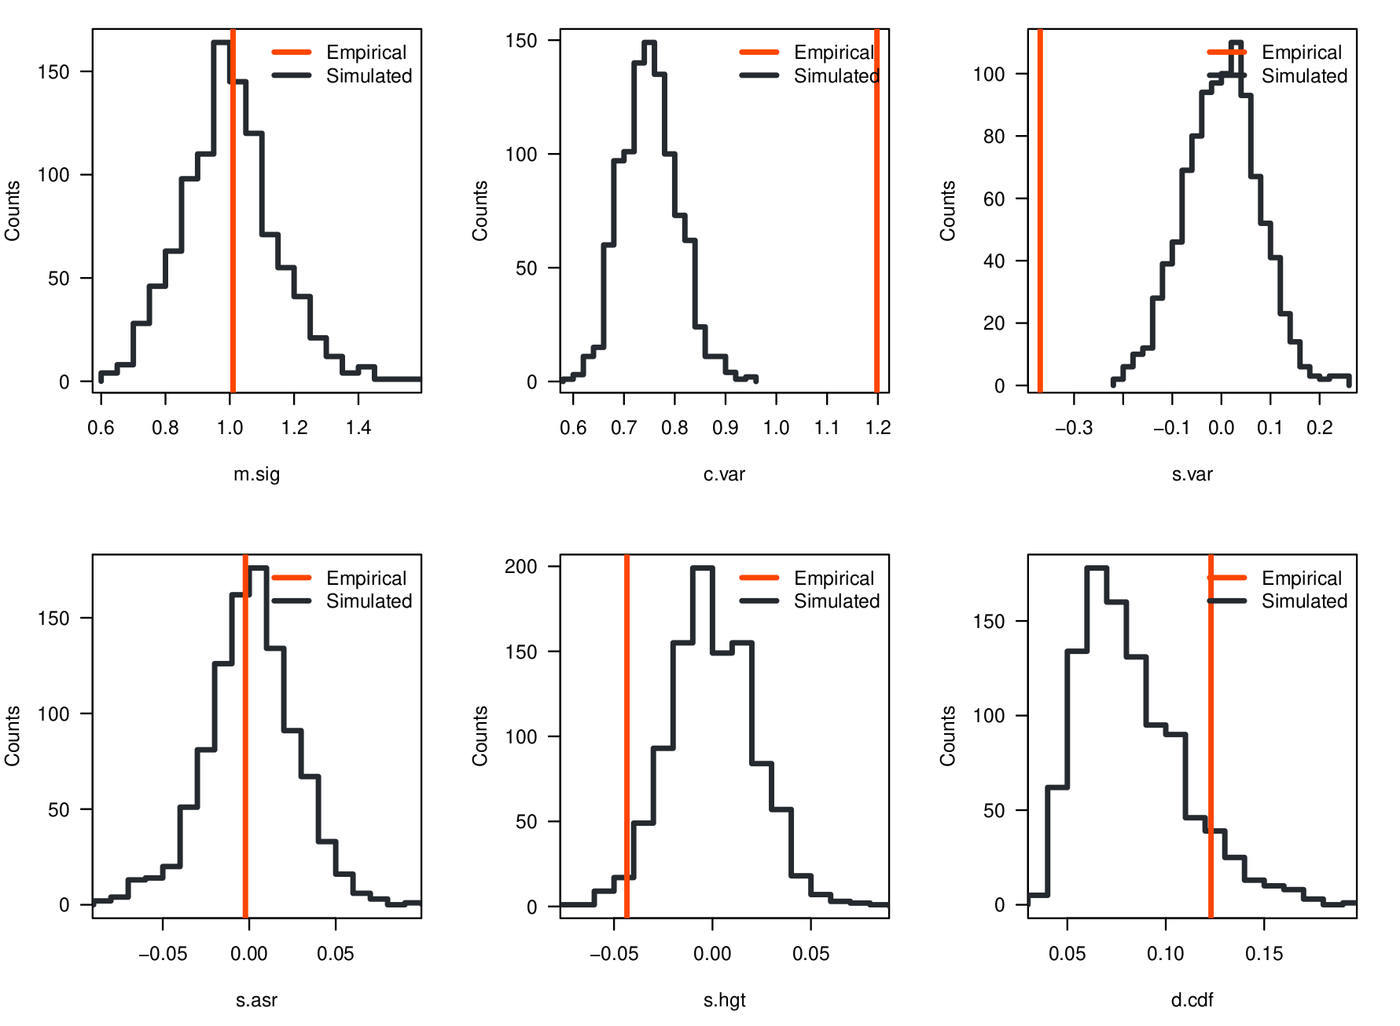

The interpretation of these test statistics is taken from this table (next page) in the Arbutus manuscript (Pennell et al. 2015). Is the model a good model? If not, what do you suspect may be wrong? (1 paragraph, 5 pts)

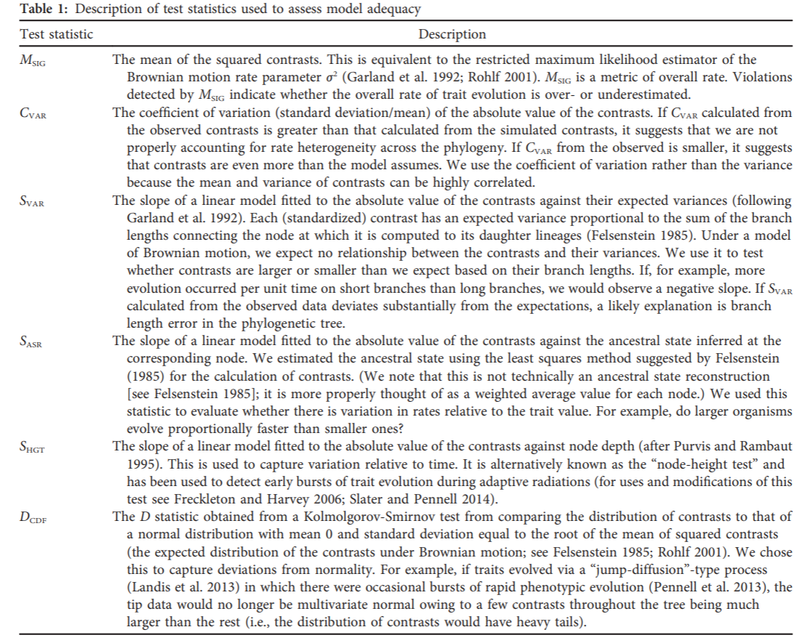

1. Unaccounted for measurement error will increase contrasts (across/at the tips/at the base)____________ of the phylogeny. Resulting in an increase in support for (EB/BM/OU) ___________ models (4 pts).
2. Explain the relationship between Brownian Motion and Ornstein-Uhlenbeck models with:
   1. Genetic drift and natural selection at the microevolutionary scale (1 paragraph, 5 pts)
   2. Macroevolutionary models of trait evolution (1 paragraph, 5 pts)
3. You are teaching a senior undergraduate student about the comparative method. In less than 2 paragraphs (< 2 minutes, you can include a quick sketch or two as well), explain the problem and solution proposed by Felsenstein 1985 in an easily understood way with minimal jargon and equations. (10 pts)
4. In his guest lecture, Dr. Diego Porto presented his work on morphological evolution and the “tweaks” to models that we can use to better reflect evolutionary reality. He presented an example from his own work using the following figure. At each of the focal nodes, there are 7 circles corresponding to 7 anatomical partitions. Filled in circles indicate that that anatomical partition analyzed individually had > 0.90 posterior probability in support of a given node. Explain why some partitions are not filled and do not have strong support for the same relationships, and possibly even conflict with it. (1 paragraph, 8 pts)

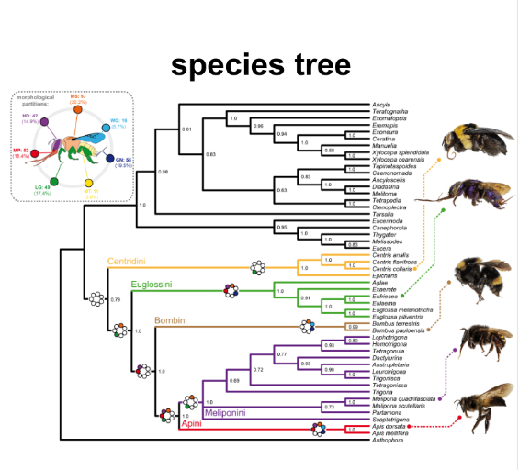

1. Reflect on Prof. Rosana Zenil-Ferguson’s visit, what did you take away most from our discussion? (8 pts, 1-2 paragraphs; open-ended)