# Quiz 2 KB as DB

Name:__________________________

Please write your name on back as well

Consider a knowledge base like follows, basically a KB as a Database, not all records shown, give the various queries:

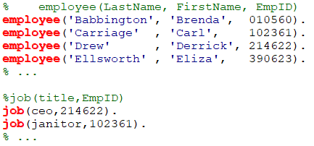

1. Query to find the last name of the C.E.O. (extra information is okay).
2. Query to find out if any employee has the two different job titles.
3. Query to find out if there are any repeated Employee IDs in the KB where the names don’t match.