# Quiz 5

Name:_______________________________

1. (40) Give the parse tree for the following grammar that yields **w=x+y*z^2-16**. **A** is the start symbol.



**A->I = E**



**E->E+T | E-T | T**



**T-> T*F | T/F | F**

**F->P^F | P**

**P->(E) | I | Ds**

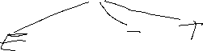

**I->w|x|y|z**

**Ds->D Ds | D**

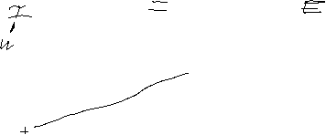

**D->0 | 1 | … | 9**

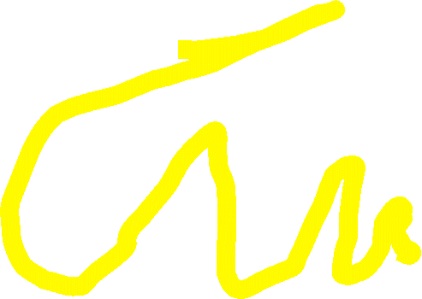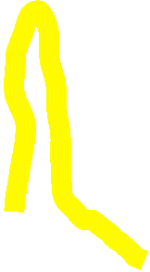

1. (30) Draw a line for each EBNF pattern on the left to each string on the right that could have come from that pattern. Note that I am using non-terminals, here.



**EBNF String (of non-terminals)**

CBC

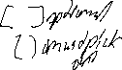

C ( A | B ) [A] C



BBB

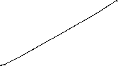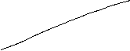

C [ A | B ] {A|C}



BAB

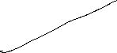

{ B| A } {C | B}



CC

1. (20) Give the EBNF for all strings containing characters **a,b**,**c** that contain at least one **a** (and may have 0 or more of **b** or **c**).

