# Quiz 2 KB as DB Section 002

Name:__________________________

Please write your name on back as well

Consider a knowledge base like follows, basically a KB as a Database, not all records shown, give the various queries:

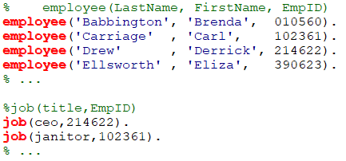

1. Query to find the first name of the C.E.O. (extra information is okay).



1. Query to find out if there are two C.E.O.s for the company. Your query should give their employee IDs.



1. Query to find the full names of everyone sharing a last name (you may assume ‘;’ will be used, or a findall).

