# Midterm 330 Fall 2022, written portion

Name:_______________________________(on back as well)

Sign here __________________ , summarized below, if you will respect the honor code. This and the online/take-home portion of the exam will not be accepted if this is unsigned.

“The Honor Code is **a set of principles established by the University to promote honesty and integrity in all aspects of the campus culture**. It is the responsibility of every student at the University of South Carolina to adhere steadfastly to truthfulness and to avoid dishonesty in connection with any academic program.”

In particular, you may not share any material or discuss either portion of the exam until it is returned in full (this portion should be returned next class).

1. (10) A language with high orthogonality is going to have a ______________ number of similar/redundant features, e.g. to add numbers, perform iteration, etc.
2. (10) Prolog is an example of a(n) ________________ language.
3. (10) ________________ is an example of an imperative language.
4. (10) Define “binding”?
5. (10) What is the difference between late and early binding?
6. (10) The syntax of most programming languages are specified with a __________________ grammar.
7. (10) Checking that the types of variables and the values being assigned the them are correct, for a statically typed language, is done by the ________________ stage of compilation.
8. (10) The output of the lexer, the program that perfoms lexical analysis, is …

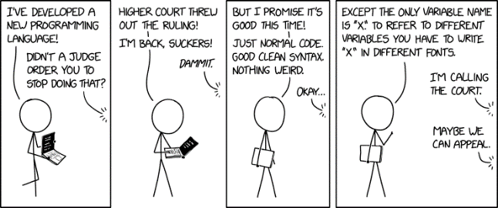

HTML title: “ The worst is when you run out of monospaced fonts and have to use variable-width variables.” (https://xkcd.com/2309/)

<more on next page>

1. (30) Show that the following Grammar is ambiguous by giving two different parse trees with the same yield. The leaves should all be lower case letters (terminals). A is the start symbol.

**T->T*T | T/T | D**

**D-> 0|1|2|3|…|9**

1. (20) Give EBNF for a string having any number of **a**s, **b**s, and **c**s but *not*having **ab**  as a substring.
   1. Negative Examples: **cab, acaabcbbb, ababababababba**
   2. Negative Examples: **cba**, **bcbbacacaa**, **ε //**the last is the empty string
2. (20) Match a the EBNF on the left to the strings they match on the right.

**xyzzzyx**

**[y]{x|y|z}x**

**zyxxxyz**

**(y|z) {x|y|z}**

**yxzyxzyx**

**{x|y}y{y|z}**

**xxxx**