# Quiz 2-001

Name:_______________________________(on back as well)

1. (30) Show that the following context free grammar is ambiguous. **A** is the start symbol. ‘<‘ and ‘>’ characters are terminals, not EBNF.



**A → B|C|ε // ε** is empty string



**B → >> A | A**



**C → > A**

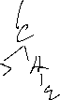

1. (30) Draw a line for each EBNF pattern on the left to each string on the right that could have come from that pattern.

**EBNF String (of non-terminals)**



01000001

1{0|1}



11110011



{0|11}(0|11)



11001000

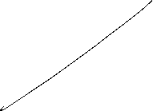

[1]{0|1}0



01100001



0{0|1}1

ε // the empty string



1. (15) Give EBNF for all strings having 1 or more **x**’s followed by 0 or more **w**’s or **y**’s, followed by at most one **z**. Positive examples include: xwz, xyz, ~~yz~~, ~~wz~~, xxxxywyz, xy, ~~y~~. Negative examples include zyx, xwxz, xz, and ε. You don’t have to show the production, but one is enough.



1. (15) Give EBNF for all palindromes of the letters **a**,**b**, and **c**, the terminals. *You must handle even and odd length palindromes****.*** Positive examples include **abba, abccba, bcacb,** and **a.** Negative ones include **abc, ab, acaa, abcabc.** You may assume ε is a palindrome. You may write the separate productions on one line, which is easiest with many productions separated by ‘|’ (e.g.

Digit->0|1|2|3|…|9 // is 10 productions). My answer has 7 productions for palindrome.

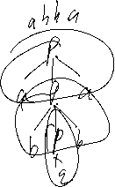

**P →**

