# Quiz 2 - 002

Name:_______________________________(on back as well)

1. (30) Give a parse tree for the following grammar that yields **< < > { { < > } } >** . **A** is the start symbol.



**A -> A { A } | B | ε**



**B-> < A >**

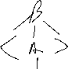

1. (30) Give a parse tree for the following grammar that yields **nut taste slimy**. **nut bad .** (don’t worry about spaces).



**P** is the start symbol.

**P -> S | S P**

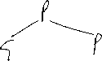

**S -> N VP .**

**N -> rock | ogg | nut | bear | club**

**VP -> V | V A**



**V -> taste | good | bad | smell | hurt**



**A -> good | bad | slimy | smelly**

