Development of the Professional Doctorate in Education Administration/Leadership

With the increasing scrutiny in the professional community of the Ed.D. (Eisenhart & DeHaan, May, 2005; Levine, 2005; Shulman, Golde, Bueschel & Garabedian, April, 2006; UCEA, AERA&NCPEA, 2005), it is even more essential that those developing doctorates in Education Administration-Leadership, especially if such is the University’s first such degree, are clear about goals, rigorous in terms of standards and meet the respective constituencies to be served, including potential students, school districts, community colleges and participating faculty.

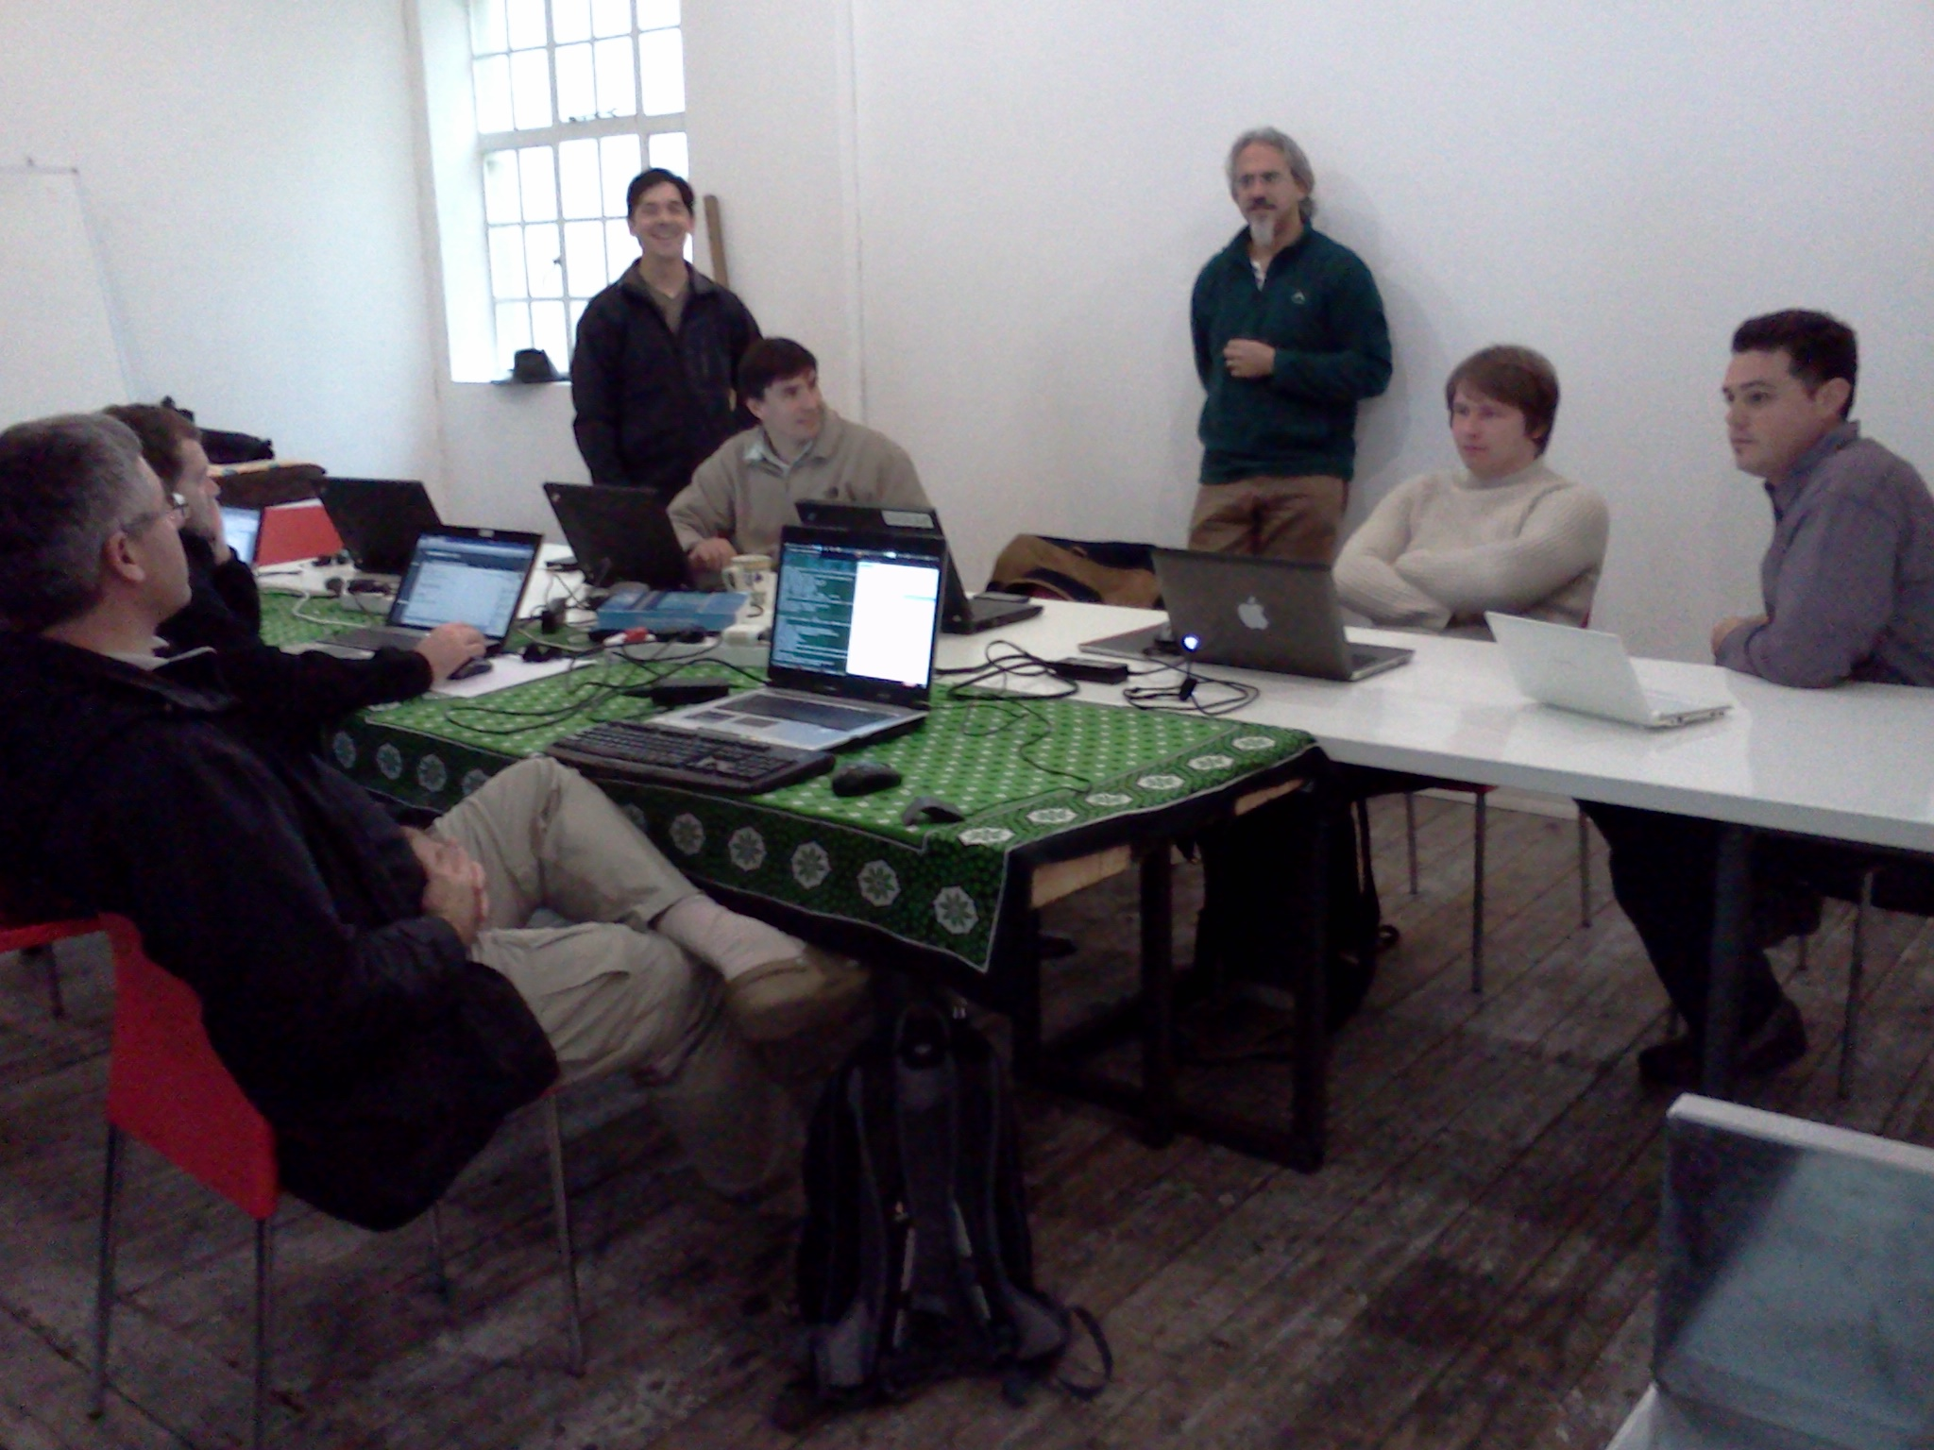

Mission and Goals

It should go without saying that the first step in developing a doctoral program in education is the establishment of clear and specific goals followed by specific objectives. However, too often, vague goals are set forth and program planning becomes mired in multiple agendas, campus politics or leads to objectives that are generic and hazy. Rather than relying on general goals that may be found in the literature (however appealing they may be), by its nature, the applied doctorate should be more reflective of the needs of the various constituencies it will serve. For example, Clifford and Guthrie (January, 1989) note that the 1960 Master Plan for Higher Education in California severed research from practice and eroded the effectiveness of professional education. Richardson (June-July, 1994) argued that research in education suggests that practical inquiry is conducted by practitioners to help them understand their contexts, and practices. He notes that the outcome of that inquiry may be a change in practice, or it may be an enhanced understanding, but is not necessarily conducted for purposes of developing general laws related to educational practice.

Additionally, your state, system or accrediting agency, including the National Policy Board in Educational Administration (2006), may have specific goals or objectives that may need to be included. It cannot be emphasized enough that the goals need to drive program development. At each step, as questions arise, the answers must derive from the goals.

For example, the following core concepts were developed from the California Professional Standards for Educational Leaders and the California State University Presidents Task Force on Education Leadership Programs. When the California Legislature and Governor approved the offering of the Ed.D. degree by the California State University system in September of 2005, they were noted as potential goals of the programs to be developed (Young, 2006). While they are somewhat broad and intended to integrate perspectives from research, theory, and practice and reflect standards for educational leaders and leadership programs in California, they clearly reflect the applied nature of the degree, constituency to be served and specific topics to be addressed.

- Candidates will design plans and strategies for systemic educational reforms.

- Candidates will demonstrate visionary educational leadership in the development, articulation, implementation, and stewardship of a vision of learning that is shared and supported by the school community and by modeling a personal code of ethics and developing professional leadership capacity.

- Candidates will demonstrate leadership of effective instructional strategies in advocating, nurturing, and sustaining a school culture and instructional program conducive to student learning and staff professional growth.

- Candidates will design plans and strategies for internal and external educational accountability systems.

- Candidates will provide a sound, defensible plan of resources and fiscal planning for ensuring management of the organization, operations, and resources for an effective and safe learning environment.

- Candidates will demonstrate understanding of diversity, collaboration with families and community members, responsiveness to diverse community interests and needs, and ability to mobilize community resources.

- Candidates will demonstrate knowledge of, responsiveness to, and ability to influence the larger policy environment and the political, social, economic, legal, and cultural context.

Once the goals have been established, the details of the program can emerge. Generally, these could be organized as objectives or simply statements of specific information. Often, the campus will have established criteria that need to be addressed for the program. The following sections are a comprehensive compilation from many sources developed over the years by the authors and others implementing joint doctoral programs in the California State University System (CCGA, March, 2005; Papalewis & Minnis, 1992a, 1992b). These generic guidelines were most recently organized and presented as a draft for campuses beginning the development of the system’s first independent doctoral program (Young, 2006).

Program Specifics

- The rationale for proposing the program including;
- description of how the proposed program is related to/differs from existing programs, especially to closely related master’s and doctoral programs
- summary of the evidence of student demand for the proposed program
- summary of the employment prospects for graduates of the proposed program and the professional uses of the proposed program
- summary of the importance of the program to the discipline and to meeting the needs of society
- The objectives of the program
- An explanation of how the aims and objectives serve to focus the program
- The full and exact designation of the degree to be awarded (e.g., Ed.D. in Education Leadership)
- The names of the departments, divisions, or other units of the campuses that will have primary responsibility for administering the program
- The names and titles of the individuals primarily responsible for drafting the proposal
- A timetable for the development of the program
- The anticipated date that the program will be implemented

Partners with Public Elementary and Secondary Schools and/or Community Colleges

For all Ed.D. programs it is essential that specific consistencies to be served be included in the planning, implementation and ongoing assessment. Thus, a program plan needs to include:
- A list of public schools and/or community colleges that are partnering with the campus in the development and operation of the proposed program
- The role of school and/or college partners in program design, candidate recruitment and admissions, teaching, and program assessment and evaluation
- Involvement of other campus schools and/or colleges in the program

Inter-disciplinary Collaboration with other Departments in the University

Given the complexities of functions in p-12 schools, community colleges and universities, a comprehensive Ed.D. may include departments outside of a College of Education.

- A description of the relationship of doctoral degree programs to the mission of the campus
- The number, variety, and longevity of the doctoral programs currently being offered and the degree completion rates
- A brief review of the historical development of the field and departmental strength in the field, including the experience of the participating academic units with graduate education (degrees offered, number of degrees awarded, and year in which each graduate degree program was authorized)
- A description of how the proposed program is expected to draw support from existing programs, departments, and faculty

Participating Faculty Members: Tenure Track and Clinicians

The strength and quality of any doctoral degree program is dependent to a large extent on the quality of its faculty, both tenure track and clinical.

- A description of the relationship of the program to the research and professional interests of the faculty
- A description of how the faculty expertise and resources are complementary and create synergies
- Criteria for choosing faculty members for participation in the program, from both campus and P-12/Community college, in addition to any campus guidelines for graduate education
- Faculty vitae, including rank, appointment status, highest degree earned, date and field of highest degree, professional experience, publications, and other information demonstrating faculty commitment to research and ability to chair dissertation committees

Resources

Any review process that includes full university faculty participation will inevitably include questions about resources. This is especially true if the program is the first of its kind to be offered by the College. It becomes essential that the following be included:

- A brief review of existing financial, physical and information resources supporting the program, including research support within the institution, library support appropriate for doctoral degree work, physical facilities, and stability and sufficiency of financial resources
- Description of the ability of the institutions to provide graduate student support, including teaching or research assistantships, fellowship eligibility, and financial aid
- Summary of resource requirements by year for the first five years, including:
- Full Time Equivalent (FTE) faculty
- library acquisitions
- computing costs
- equipment
- space and other capital facilities (including rented facilities, where applicable)
- other operating costs
- description of the intended method of funding (including fee structures, internal reallocation, and external resources) and effects of the method of funding on existing programs
- enrollment projections for the first five years

Detailed Statement of Requirements for the Degree

It will be essential to be very specific about degree requirements. However, it must also be made clear that the Ed.D., while rigorous, is different from the traditional Ph.D., as it represents the professional standards of the field. Model programs from other institutions might be helpful in this regard.

The information should include all of the following elements that are applicable:

- Undergraduate—and, if appropriate, post baccalaureate and master’s level—preparation for admission; other admissions requirements (beyond campus and/or system requirements); and provisions, if any, for conditional admission of selected applicants who do not meet all the requirements for admission
- Criteria for continuation in the program
- Unit requirements
- Specific fields of emphasis
- Required and recommended courses, including catalog descriptions of present and proposed courses
- Sample program, including completion of matrix to demonstrate coverage of core curriculum concepts
- Foreign language requirements, if any
- Other activities required of students (e.g., internships)
- Field examinations, written and/or oral
- Qualifying examinations, written and/or oral
- Dissertation/articles for publication/or other terminal requirement
- Other demonstration of student competence, if any
- Normative time from matriculation to degree, normative time for pre-candidacy and candidacy periods, and incentives to support expeditious time-to-degree
- Provisions for accommodating the enrollment of professionals who are working full time
- Special arrangements for delivery of instruction, (e.g. release fro job responsibilities, etc.)
- Draft catalog copy

Assessment and Accreditation

The campus, system (as applicable) and certainly the regional accreditation agency will require specific information in this regard. Consider:

- A description of the review process that will be used to evaluate the proposed program, including an assessment plan (campus guidelines, system guidelines, state guidelines, etc.). The evaluation could examine:
- number and new programs, applicants, admissions enrollments, degree recipients, time-to-degree, attrition, and public school and community college partners
- extent to which the programs are fulfilling state needs for training based on statewide supply and demand data
- place of employment of students and job placement of graduates
- evidence of effects graduates are having on elementary and secondary school and community college reform efforts and on student achievement
- program costs, and fund sources that were used to finance the programs, including calculation of cost per degree awarded
- cost of the programs to students, amount of financial aid offered, and student debt levels of graduates

- Description of the provision for meeting accreditation requirements, where applicable. For example, the Western Association of School and Colleges (WASC, 2005) Substantive Change Manual focuses on
- planning/Approval and Governance Processes (e.g. processes for governance and for changes in curriculum and for conducting program reviews, program decisions, role of advisory group, if any)
- faculty resources (e.g. additional support for faculty to maintain the new degree level, faculty commitment to research and ability to chair dissertation committees, faculty background and experience to engage in doctoral-level instruction
- financial resources (e.g. start-up costs and how the costs will be covered, minimum number of students necessary to make the program financially viable, three-to-five year budget, including projected income and expenditures, that demonstrates program is fiscally sound
- plan for evaluating educational effectiveness (e.g. plan for how the program will be reviewed, procedures for including the assessment plan in a program review and assessment process involving feedback and revision

Clear goals, based on constituent needs and the knowledge base for education leadership, must be the driving forces and starting point for development of the professional doctorate in education administration-leadership. Too often, programs are begun based on the perceived strength of the existing faculty or as resource generator for the university, which is a legitimate concern for the discipline. Each program developed reflects on the integrity of the field and must be of the highest quality to prepare leaders for the future.

References

Clifford, G. J. & Guthrie, J. W. (1989, January). A brief for professional education. Phi Delta
Kappan, 70 (5), 380-385.
CCGA. (2005, March) Coordinating committee for graduate affairs handbook. Retrieved on
August 31, 2006 from:
http:// www.universityofcalifornia.edu/senate/committees/ccga/ccgahandbook.pdf
Eisenhart, M. & DeHaan, R. L. (2005, May). Doctoral preparation of scientifically based
education researchers. Educational Researcher, 34 (4), 3-13.
Levine, A. (2005). Educating school leaders. The Education Schools Project.
Washington, D.C : CommunicationWorks, LLC,
National Policy Board in Education Administration. (2006). Standards for advanced programs in
educational leadership. Retrieved on August 9, 2006 from: www.npbea.org/ELCC

Papalewis, R. & Minnis, D. L. (1992a). California universities start joint doctoral study in
educational leadership. National Policy Board for Educational Administration: Focus on
innovation: Design for leadership, 3 (2), 7.

Papalewis, R. & Minnis, D. L. (1992b). Intercampus collaboration: Reframing the education of
school leaders. International Journal of Educational Management, 6 (5),
23-26.

Richardson, V. (1994, June-July). Conducting research on practice. Educational Researcher
23 (5), 5-10.

Shulman, L. S., Golde, C. M., Bueschel, A. C. & Garabedian, K. J. (2006, April). Educational
Researcher, 25-32.

UCEA,AERA&NCPEA (2005). Leaders respond to Arthur Levine’s report ‘educating
school leaders’. Retrieved on August 31, 2006 from: http://ucea.org/main.html

WASC (2005). WASC substantive change manual. Retrieved on August 31, 2006 from:
http://www.wascweb.org/senior.

Young, B. (March, 1, 2006). Personal communication.

