CHEMICAL EQUILIBRIUM

Class Notes:

LEARNING OBJECTIVES:
Chemical equilibrium and factors affecting equilibrium;
- Explain what is meant by:
  - Open and closed systems
  - A reversible reaction
  - Dynamic equilibrium
- List the factors which influence the position of an equilibrium
Equilibrium constant;
- List the factors which influence the value of the equilibrium constant
- Write down an expression for the equilibrium constant having been given the equation for the reaction.
- Explain the significance of high and low values of the equilibrium constant.
Application of equilibrium principles;
- Explain qualitatively, given appropriate data, the effects of changes of pressure, temperature, concentration and the use of a catalyst on the concentrations and amounts of each substance in an equilibrium mixture
- Apply the rate and equilibrium principles to important industrial applications.

Introduction:
- In the reaction represented by the equation: it is not possible to reverse the process and in this sense the reaction can be described as one way. The reaction could also be written as:
- In the following reaction represented by the equation: it is possible to reverse the reaction by adding water. This is a reversible reaction. We can use a double headed arrow to show this.
- 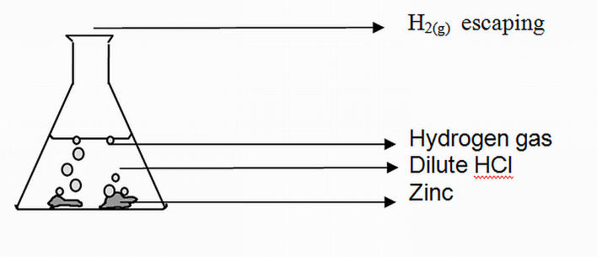
An open system

