Visit Us At Booth #1200

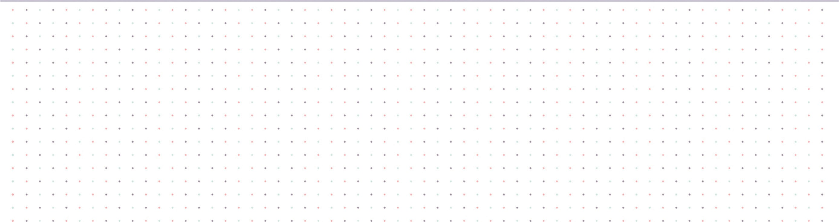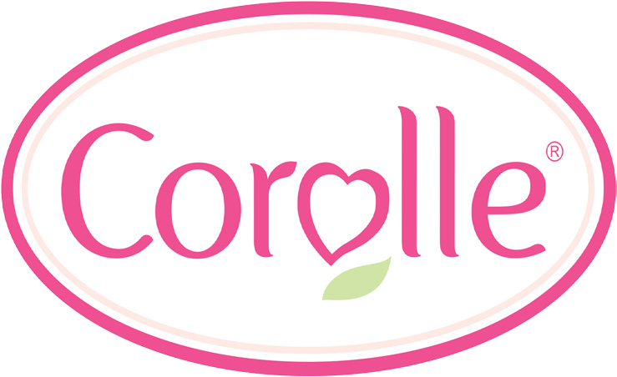

**2017 ASTRA Marketplace & Academy**

© 2017 Corolle, Inc. - One Corporate Drive, Grantsville, MD 21536 - USA - (301) 895 - 3927 - us.corolle.com