**Inventorist Professional Software**

**User Guide for Administrator**

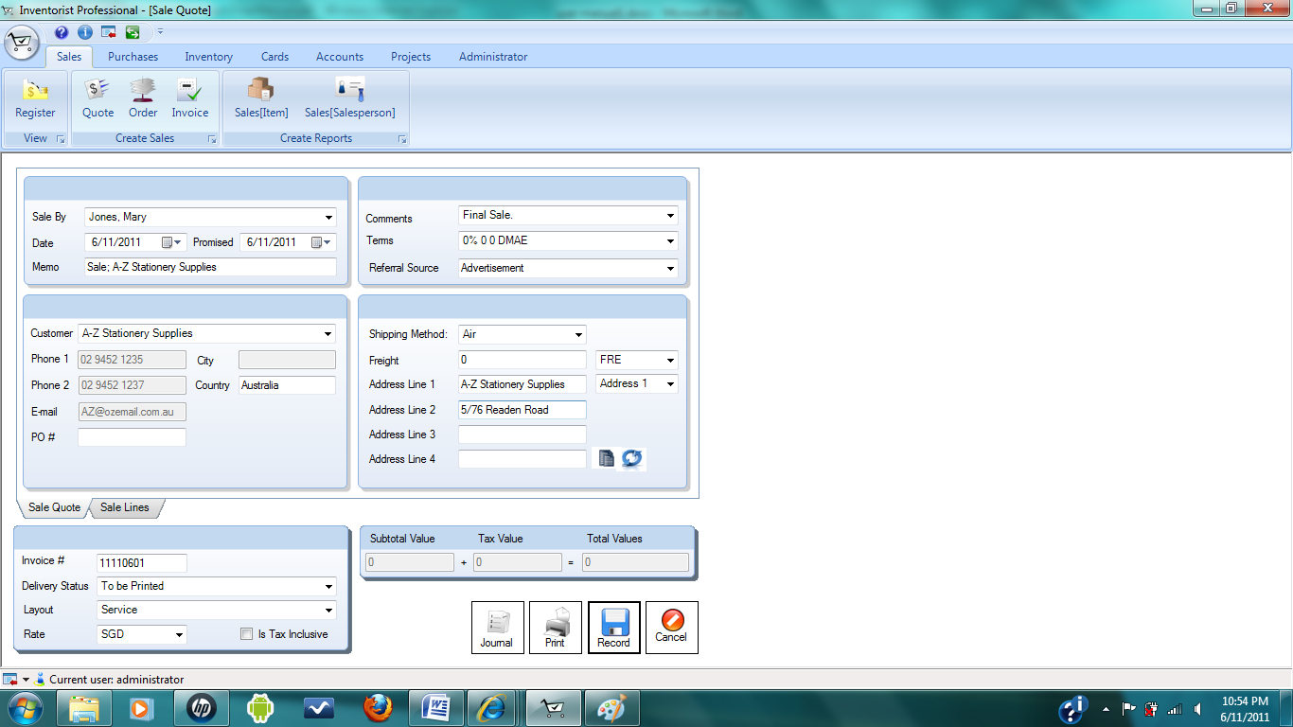

**Contents Page**

Setting Up 4

Set up accounts 4

Review the account lists 5

Update the account 6

Log in feature 6

Creating New User 9

Creating New Role 10

Creating New item size 11

Creating new gender 12

Creating new additional fields 13

**Figures Pages**

Figure 1: Window displaying list of accounts 5

Figure 2: Log in dialog 6

Figure 3: Error dialog appeared for undefined user 7

Figure 4: Error dialog appeared for invalid password 7

Figure 5: Main menu 8

Figure 6: Window showed list of users 9

Figure 7: Dialog to create new user 9

Figure 8: Window showing list of roles 10

Figure 9: Dialog to create new role 10

Figure 10: Window showed list of items created and dialog to create new item list 11

Figure 11: Window showed list of gender 12

Figure 12: Window showed list of additional fields 13

# 

# 

# Setting Up

In this chapter, you will learn about your accounts, log in feature, user accounts and your jobs. It will show the initial set up including setting up accounts, items and jobs.

## Set up accounts

Accounts will keep track of the additions and subtractions that will occur in regular business activity. You need to set up the accounts properly as they are the mainstay of you financial records.

There are six types of accounts which are Asset, Liability, Equity, Income, Cost of Sales and Expense.

**Asset** This type indicates all the things that your company or business possess. They can be cash, cheque account, inventory, equipment, furniture, money that people owe you and etc.

**Liability** This type indicates all the things that your company or business owes. They can be loans, mortgages, credit cards and money that you hold but owed to someone or somewhere else (example: customer deposits).

**Equity** This type indicates your stake in the company (example: retained earnings).

**Income** This includes the money you or your company receive for items or services sold.

**Cost of Sales** This type indicates the direct costs of products and/or services which are sold by your company. The common accounts are raw materials and manufacturing labour costs.

**Expense** This type indicates all expenses that you incurred to run a business. They can be renting office, advertising, travel, legal fees and etc.

## Review the account lists

To review the account lists created

* Go to Accounts ribbon tab
* Click Accounts list view button
* All the accounts created will be displayed under all accounts tab

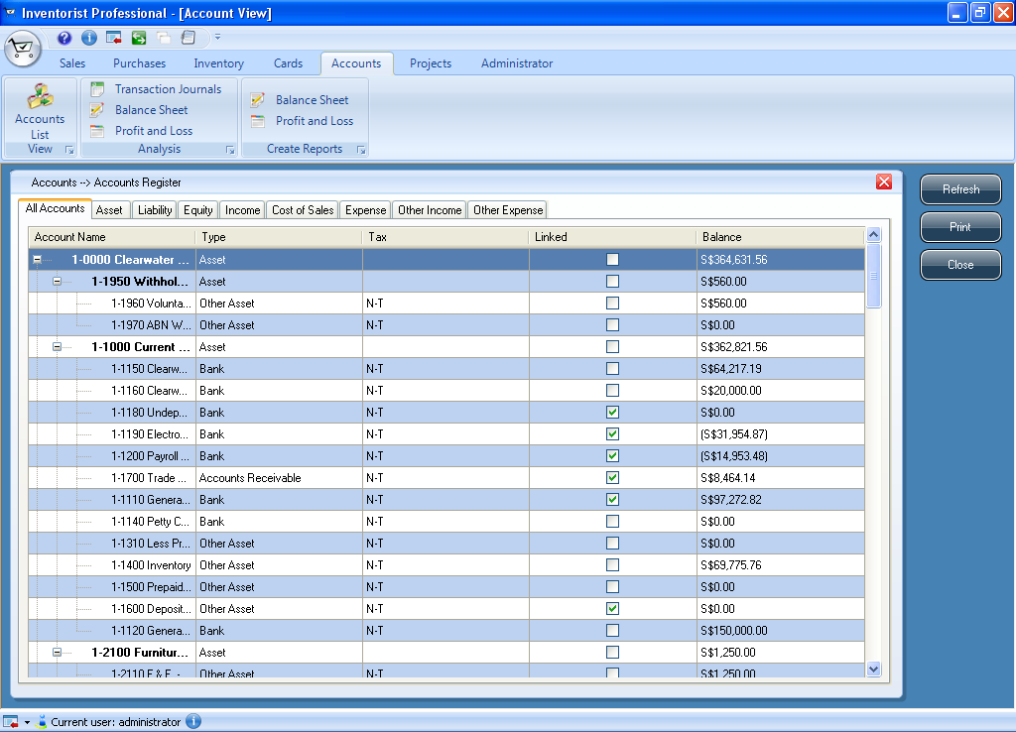

**List of all accounts created**

Figure 1: Window displaying list of accounts

## 

## Update the account

## Log in feature

After launching DacII, first thing you need to do is to log in as a user. There will be default user which is “Administrator” and you also can create new user accounts with different roles. Creating the user will be discussed in later part of this chapter. The followings are steps and information for log in feature.

To log in as a default user:

1. Launch DacII and **default** user name should be “**Administrator**” when log in dialog comes out.
2. Log in as Administrator using password “chen0469”. Same procedure can be used for all users with different roles.
3. If “cancel” button is clicked, DacII will exit.
4. If cross icon  is clicked, DacII will exit.

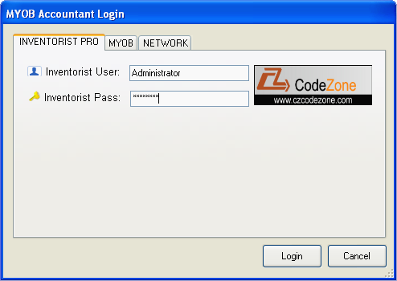

**Enter user name**

**Enter password**

Figure 2: Log in dialog

1. If user name, which has never been created, is used, error dialog is appeared as shown below.

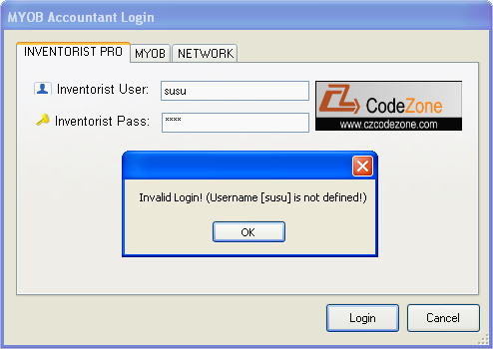

**Dialog appeared when log in with invalid user name**

Figure 3: Error dialog appeared for undefined user

1. If invalid password is used, error dialog is appeared as shown in figure.

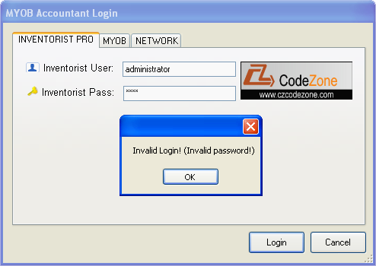

**Dialog appeared when log in with invalid password**

**Figure 4: Error dialog appeared for invalid password**

1. If log in as Administrator, main menu should have all feature tabs which are Sales, Purchases, Inventory, Cards, Accounts, Projects and Administrator as shown below.
2. If log in as user which is not administrator role, “Administrator” tab will not be included in main menu.

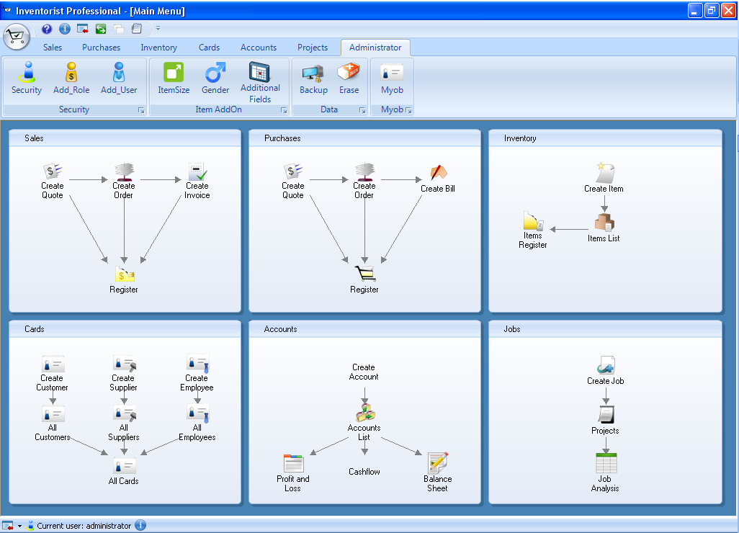

Administrator tab

Figure 5: Main menu

## Creating New User

New user can be created using different roles which can also be created. To create new user, log in to DacII as user with administrator role (log in as default user). After that, do the following steps to add new user:

1. Go to **Administrator ribbon Tab** and click **Add_User button**

**(OR)**

1. Go to **Administrator ribbon Tab** and click **Security button** and click **Create User button** which is at the bottom corner of the window
2. Type user name and password and choose for role and employee.

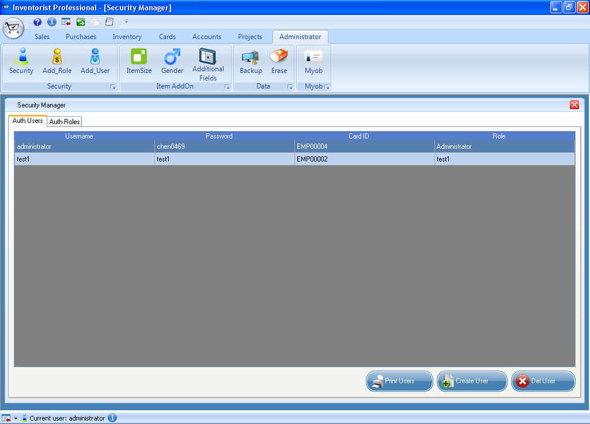

Figure 6: Window showed list of users

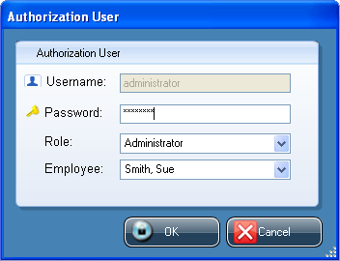

Figure 7: Dialog to create new user

## Creating New Role

As same with user, user role can be created according to their specification. To create new role, log in to DacII as user with administrator role (log in as default user). After that, do the following steps to add new role:

1. Log in as user with administrator role
2. Go to **Administrator ribbon Tab** and click **Add_Role button (OR)**
3. Go to **Administrator ribbon Tab** and click **Security button** and click **Create Role button** which is at the bottom corner of the window
4. Type role name and description and choose for specification.

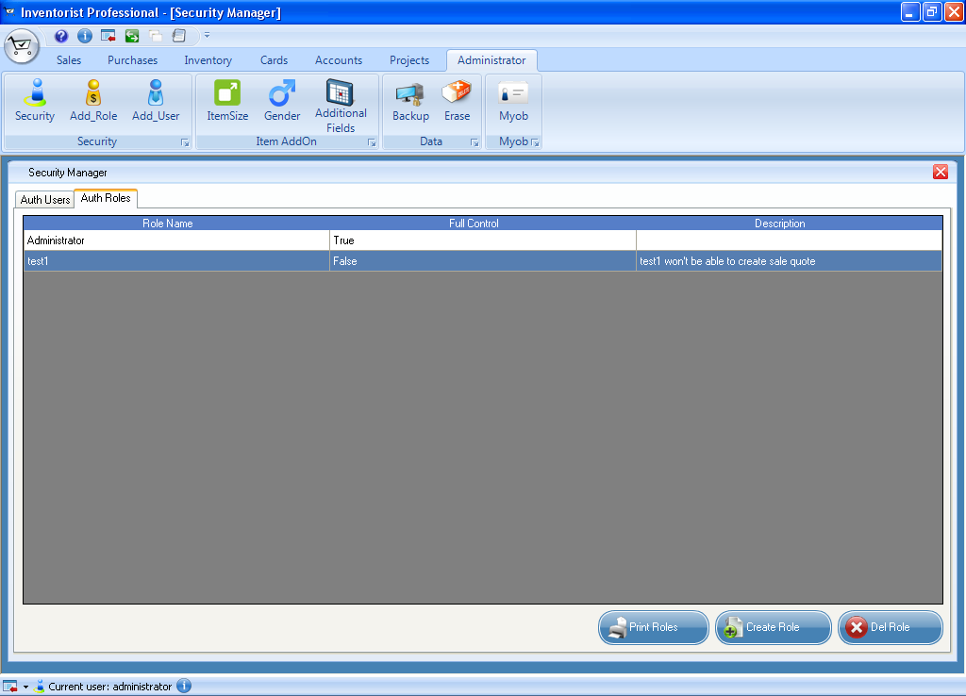

Figure 8: Window showing list of roles

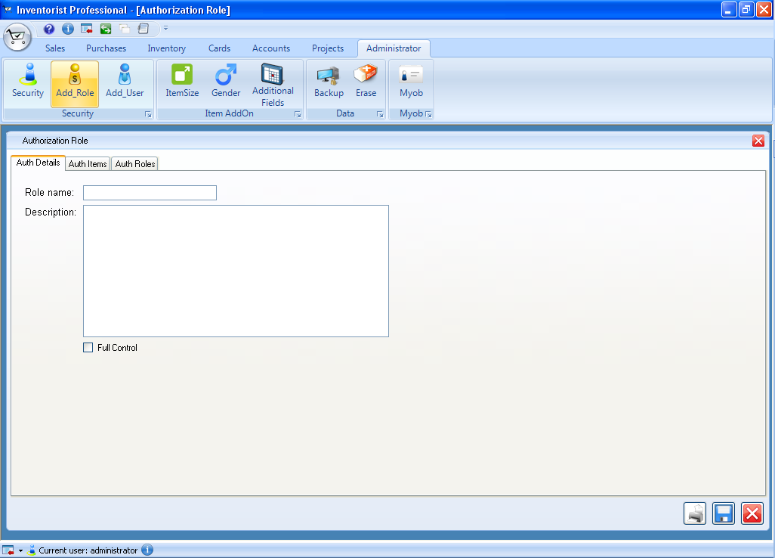

Figure 9: Dialog to create new role

## Creating New item size

Item size can also be defined and created. To create new item size, log in to DacII as user with administrator role (log in as default user). After that, do the following steps to add new item size:

1. Log in as user with administrator role
2. Go to **Administrator ribbon Tab** and click **ItemSize button**
3. Click **Create Item Size button** which is at the bottom corner of the window.
4. Type Item ID which can be short form of item name and description.

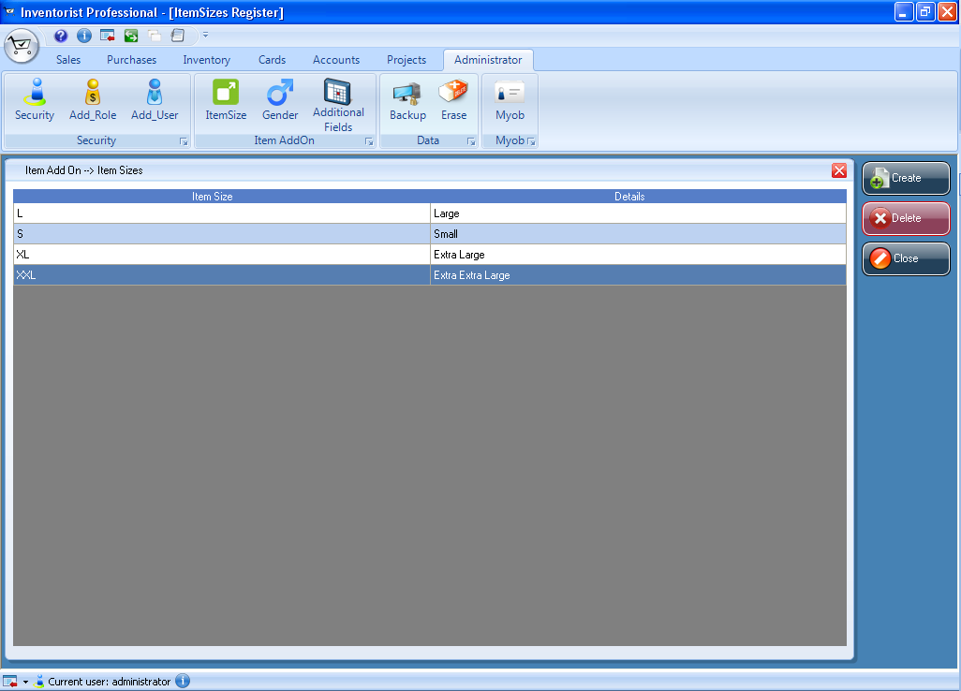

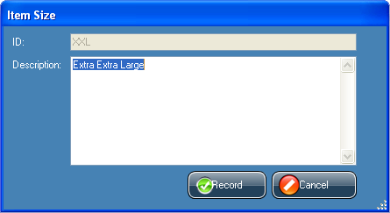

Figure 10: Window showed list of items created and dialog to create new item list

## Creating new gender

Gender description can be defined and created by user and it can also be deleted. The purpose of having this feature is to allow user to use when they need for the system. To create new gender, log in to DacII as user with administrator role (log in as default user). After that, do the following steps to add new gender:

1. Log in as user with administrator role
2. Go to **Administrator ribbon Tab** and click **Gender button**
3. Click **Create Gender button** which is at the bottom corner of the window.
4. Type gender ID which can be short form of gender name and description.

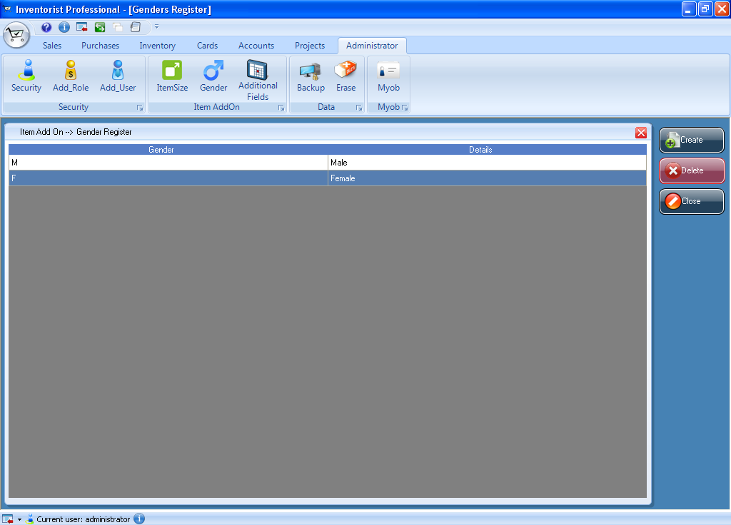

Figure 11: Window showed list of gender

## Creating new additional fields

Any of additional field can be defined and created by user and it can also be deleted. Additional field can be any field related to products or user information and so on (example: Product Code). To create new additional field, log in to DacII as user with administrator role (log in as default user). After that, do the following steps to add new additional field:

1. Log in as user with administrator role
2. Go to **Administrator ribbon Tab** and click **Additional Fields button**
3. Click **Create Data Fields button** which is at the bottom corner of the window.
4. Type Data field name and choose data field type from the drop down list.

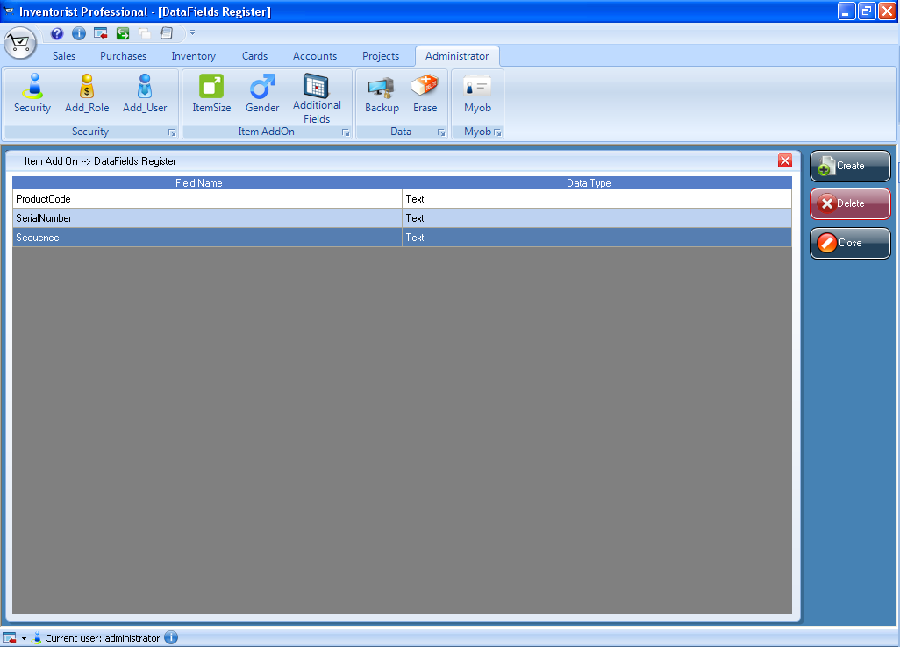

Figure 12: Window showed list of additional fields