Inventorist Plugin User Guide

# Step 1. Install CodeZone Inventorist Plug-in

1. Installing MYOB Accounting18
2. Double-click the Inventorist setup installer to install CodeZone Inventorist, now launch the application from program menu. Figure 1. Present the Inventorist application on launch.

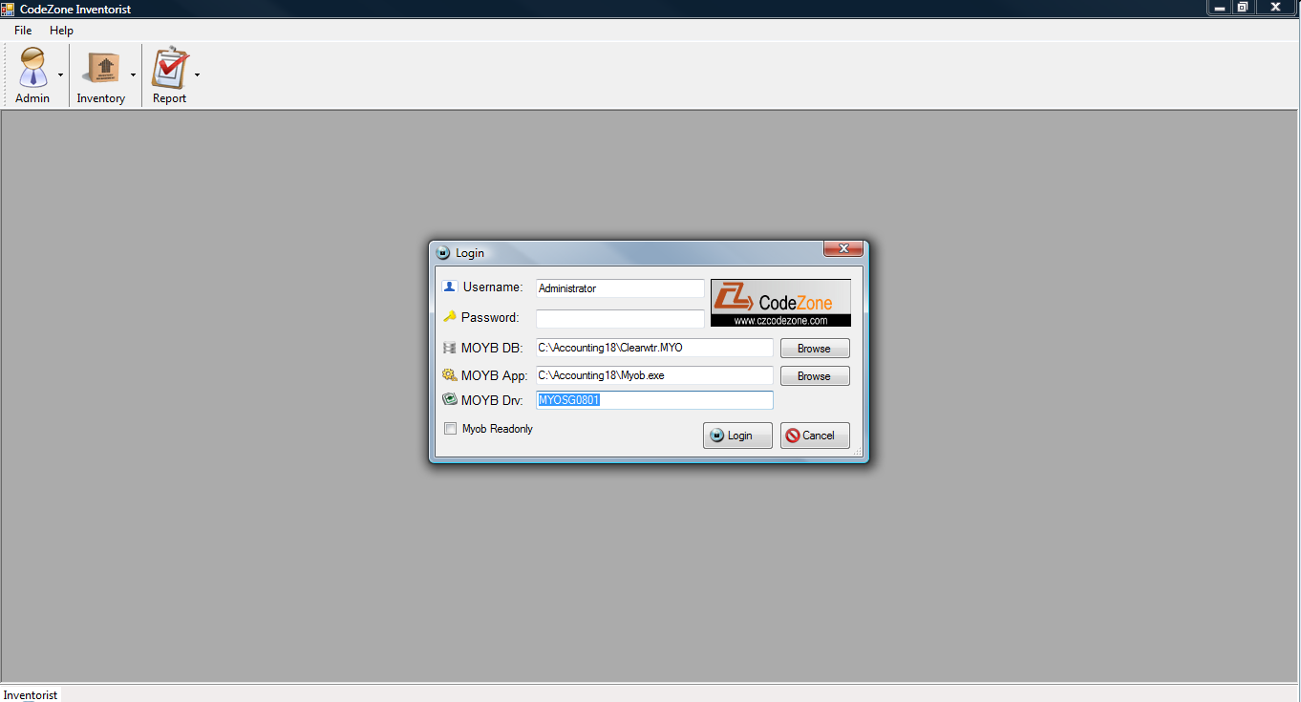

Figure 1

# Step 2. Login Inventorist Plug-in

1. Click the browse buttons to select the MYOB database and application (both locates in the Accounting18 folder, the database will be the Clearwater.myo and the application is the Myob.exe). The Myob Drv field will be the default one if the Accounting18 is installed and used.
2. If the “Myob Readonly” is checked, the Clearwater.myo will be opened in read mode, so no data will be written back into Clearwater.myo from Inventorist plugin
3. Enter username and password, for Accounting18, the “Administrator” can be used as the username and password can be blank if the trial version of Accounting18 is used. The username and password will be the same account used to log in to the Accounting18 (Note that for security reason Inventorist plug-in won’t save the Accounting18 password into its database)
4. Click “Login” to login the plugin.

# Step 3. Inventory Management

1. Click on the Inventory🡪Item List menu to open and “Item Screen” dialog as illustrated in Figure 2.
2. For the tab open (“All Items” as in Figure 2), at the top, select the field and enter wild card text and then press “Search” to filter the listed inventory items (the function is the same as Item List in MYOB).
3. Switch to different tags to view different types of items (sold, bought, inventoried), this is the same as in MYOB Item List
4. Check or uncheck “Show All Fields” and then click on the “Refresh” button to view all the fields listed in the Items database table of MYOB

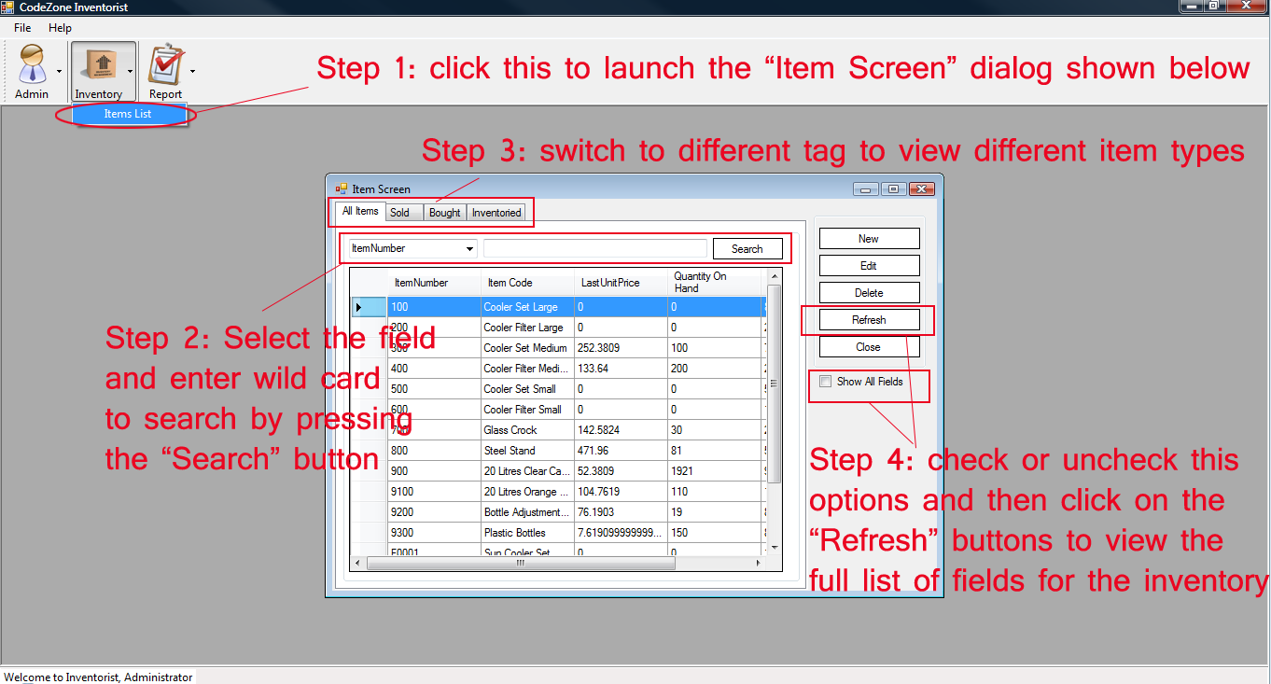

Figure 2

# Step 4 Add and Edit Inventory Item

1. Click on the “New” button of the “Item screen” dialog (Figure 2) to open the “Item” dialog for recording new item (this button will be disabled if the Myob is opened in Readonly mode). As illustrated in Figure 3, the “New Item” dialog is almost identical to the MYOB Accounting18, so should be quite self-explained.
2. Click on the “Edit” button of the”Item Screen” dialog (Figure 2) or double-click the selected item to edit the the the selected item. As illustrated in Figure 4, the “Edit Item” dialog title shows “Edit Item xxx” where “xxx” stands for the ItemNumber. Again this interface is also almost identical to the MYOB Accounting 18, so its operation is also quite self-explained.

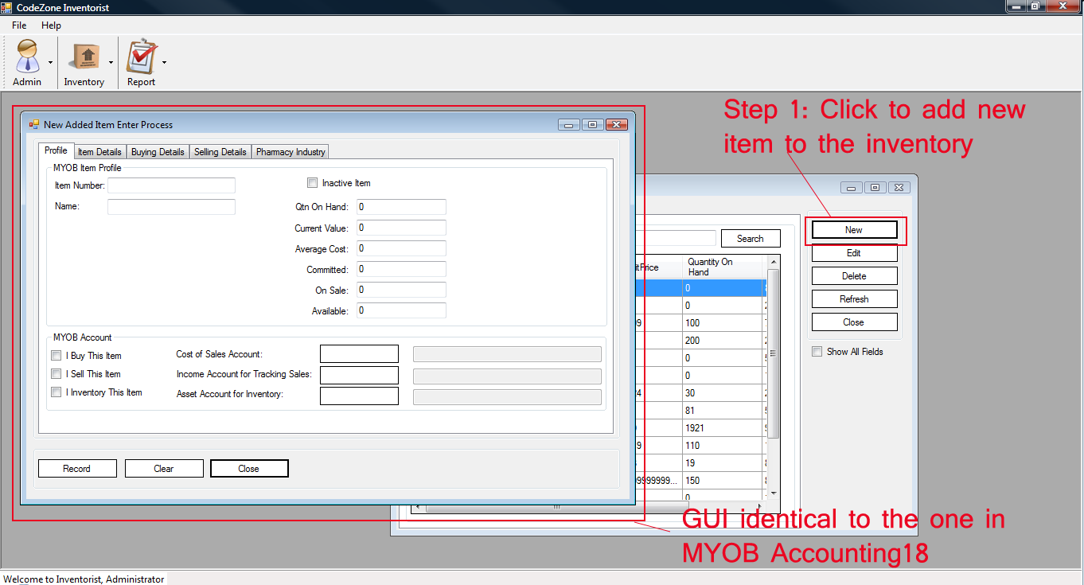

Figure 3

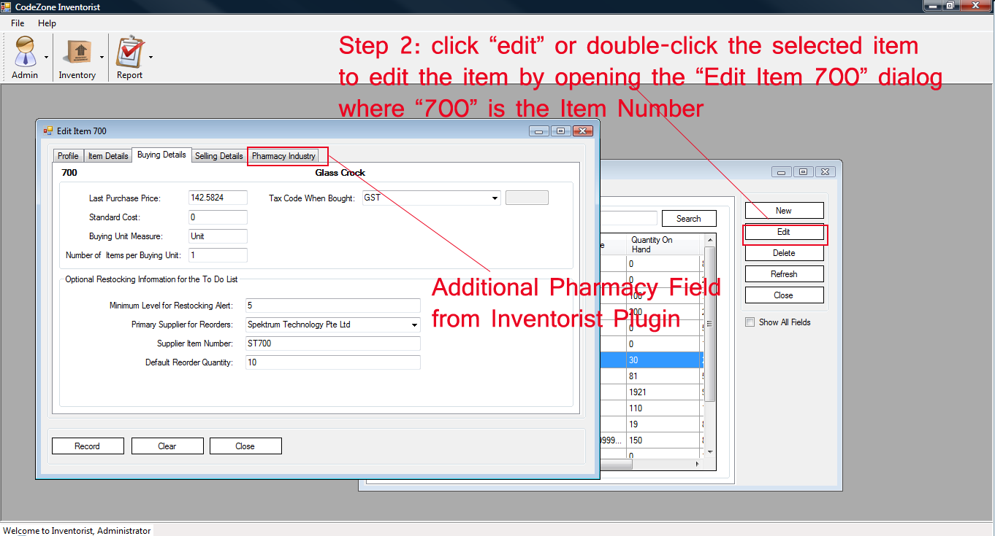

Figure 4

As illustrated in Figure 3 and Figure 4, There is an additional “Pharmacy Industrial” tab which contains the Inventorist plugin’s additional field for “Pharmarcy Industrial” which contains the 3 fields “Manufacturer Date”, “Expiry Date”, “Patch Number”, as illustrated in Figure 5.

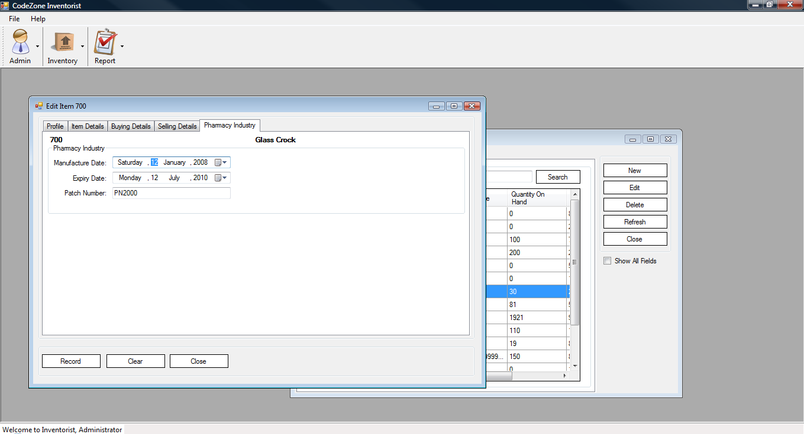

Figure 5

Now if you click “Record” on either “New Item” or “Edit Item” dialog, the MYOB will be saved back to the Clearwater.myo MYOB database (this requires that Myob database not set to “Readonly” as shown in Figure 1), and the “Pharmacy Industry” data for the item will be saved into the Inventorist plugin’s database.

Any data write and read from Inventorist plugin’s data is encrypted using DES encryption algorithm.

The Inventorist plugin implements its database using SQLite database which has the advantage of scalability as well as not requiring any external DBMS (database management system). This advantage can be compared against the “Stockist” plugin which uses mdb access database which is notorious for prone to database corruption when frequently used and db size exceed 2 GB (also mdb access database can be cracked for their password protection).

# Step 5 Reporting

Figure 6 illustrates the reporting of inventory items which shows fields from MYOB (ItemNumber, and ItemName) and fields from the Inventorist plugin (“ManufactureDate”, “ExpiryDate”, “PatchNumber” from “Pharmarcy Industry”) . The reporting can be accessed by selecting “Report🡪Item List”

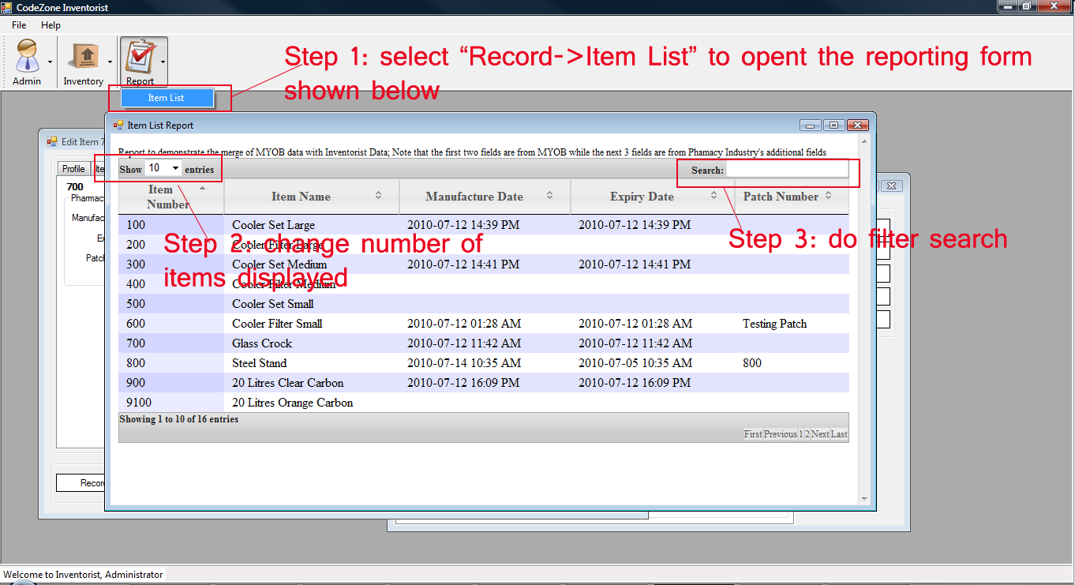

Figure 6

# Step 6: View MYOB Inventory Fields

Inventorist plugin allow user to see all the fields in the MYOB database related to the MYOB inventory, as illustrated in Figure 7. This can be accessed in “Admin🡪MYOB Fields” menu item

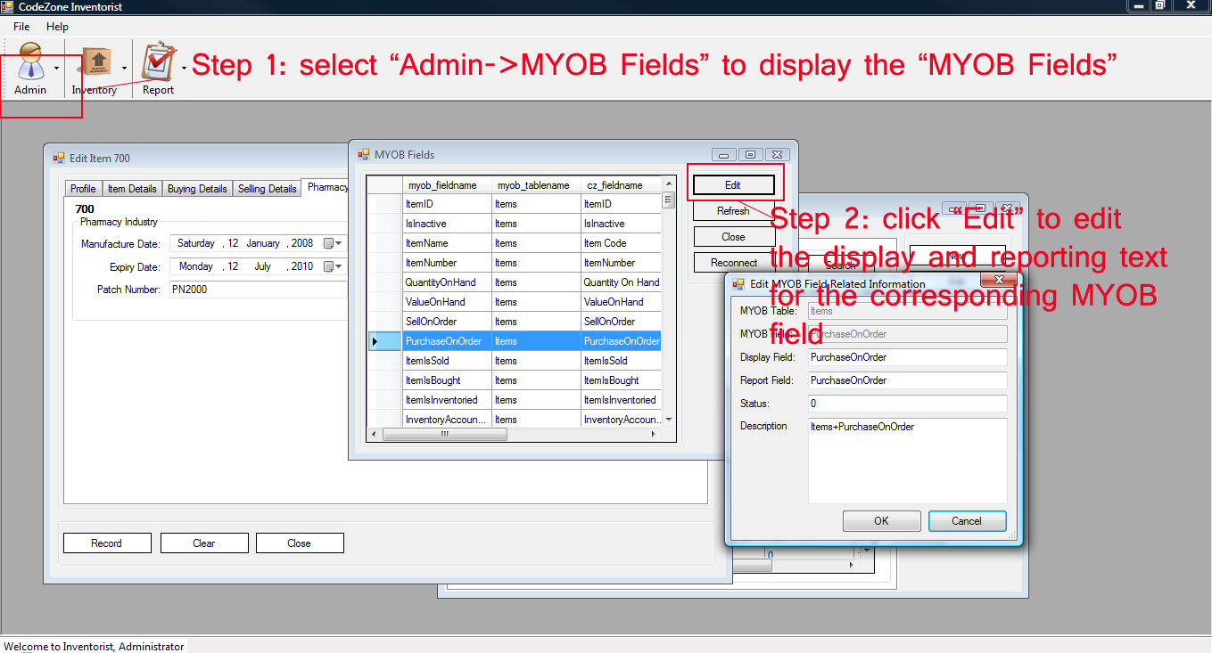

Figure 7

Step 7: Change to Chinese Language Display

Not all the fields have been translated into chinese languages, but user can switch between different languages by going the “Admin🡪Language🡪chinese” or “Admin🡪Language🡪English”. The chinese display gui is shown in Figure 8.   
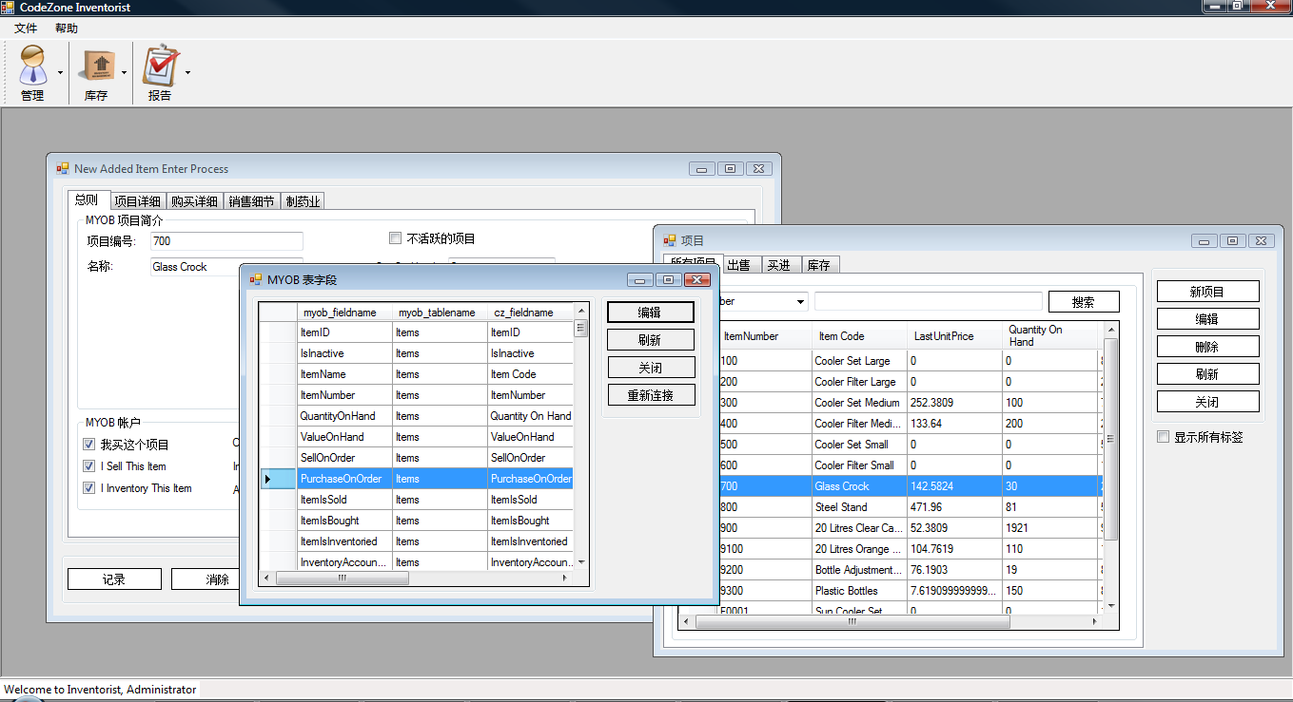

Figure 8

The language setting is saved on the next launch of the Inventorist plugin, as illustrated in Figure 9 when is relaunch of Inventorist plugin when the chinese language is set as the default language.

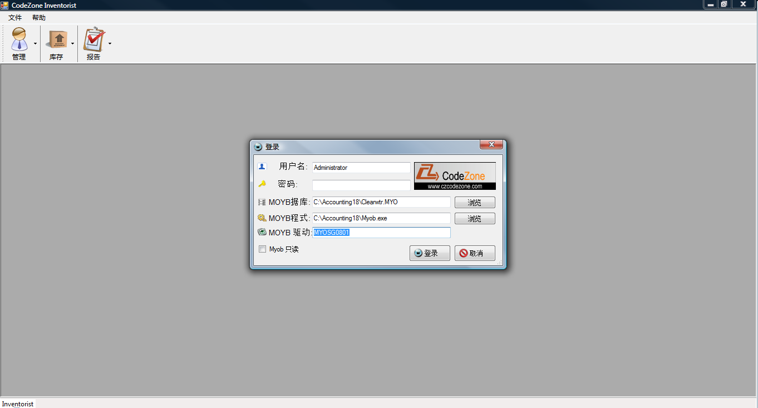

Figure 9

Figure 10 shows the “Item Screen” dialog opened in full screen (by clicking its “maximize” button).

